Leicester City Council Children & Young People’s Service Procedures Manual

A Quick Guide

Welcome to the new Manual. This is a single online source of information for relevant legislation, statutory & non-statutory guidance, good practice and research & learning.

It contains policies, procedures and other information to help you do your job. If you do not already have a desktop link, it is http://www.proceduresonline.com/llr/childcare/leicester_city/index.html

You should still go to the LSCB Manual for multi-agency safeguarding procedures.

Using the Manual
- Open the Manual. Look or click down the Contents list for the areas you need, or try a search.

- Click on the section you want. The core text in each chapter is usually statutory information and other material that applies to all local authorities.

- Make sure you take a look at the local information in the footer of each chapter. This is where you will find a link to Leicester’s own policies, procedures.

- The other key area is Local Resources. This area is under construction and we will be adding more information that is specific to Leicester– policies, procedures, forms, templates etc.

- Easy!

Main areas of the Manual
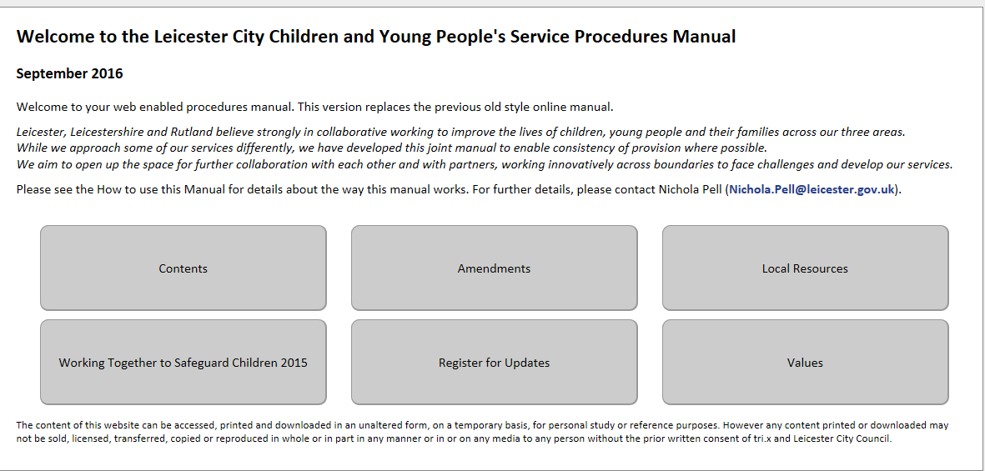

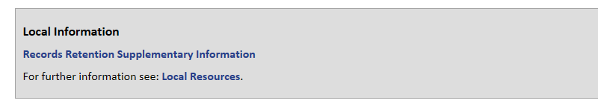

The Manual has been developed with Leicestershire and Rutland. If you need to see their Manuals, follow this link: www.proceduresonline.com/llr/childcare

