Appendix 3
Safer Sleep Risk Assessment and action plan

Expected Date of Delivery
Or
DOB and infant’s name
Parents’ names
Present Y or N
Date of assessment:
Name and title of practitioner completing assessment:
Risk indicators and factors identified | 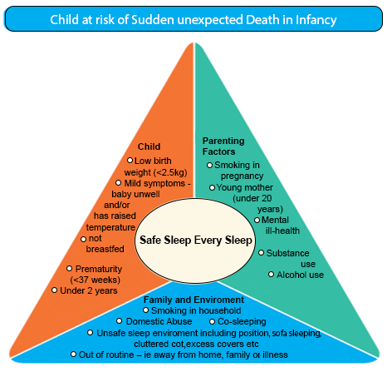
Has the baby’s sleep space been observed Y/N. If No please provide reasons why.
Risks identified by professional.
Advice information and actions taken as discussed with parent.
Is an Early Help Assessment required? Y/N
Does the risk reach the threshold for referral to social care? Y/N
Action plan and review date

