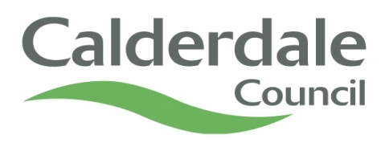

**Linden Brook**

**Children’s and Young People’s Services**

**Medical Consent form**

I agree to the following **medicines** being administered by Linden Brook

staff without consulting a doctor, should the need arise  **YES/NO**

**Paracetamol** for pain relief  **YES/NO**

**Sudocrem** for Urine affected areas (Nappy rash) **YES/NO**

I give consent for staff at Linden Brook to **administer medication**  **YES/NO**

prescribed by a doctor.

I have read the **Medication Policy** and understand the responsibilities I **YES/NO**

have in relation to medication, particularly labelling of medication and

Notification of any changes in medication.

In the event of my child becoming unwell or suffering an accident whilst at **YES/NO**

Linden Brook. I agree to them receiving any necessary **medical treatment**

**recommended by a doctor, including the administration of anaesthetic**

Delete as appropriate

I ...................................................................................................(parent/carer)

give my consent/do not give my consent for the above as indicated

for my child .............................................................................................(child’s name)

Signature .....................................................................................Date.......................