My triggers
Write down all the things that make me
feel Upset, Stressed, Worried, Scared, Frustrated.
These are the changes in me when I am Upset, Stressed, Worried, Scared, Frustrated.
Things I can do to help myself feel better.
What other people can do to
help me feel better.
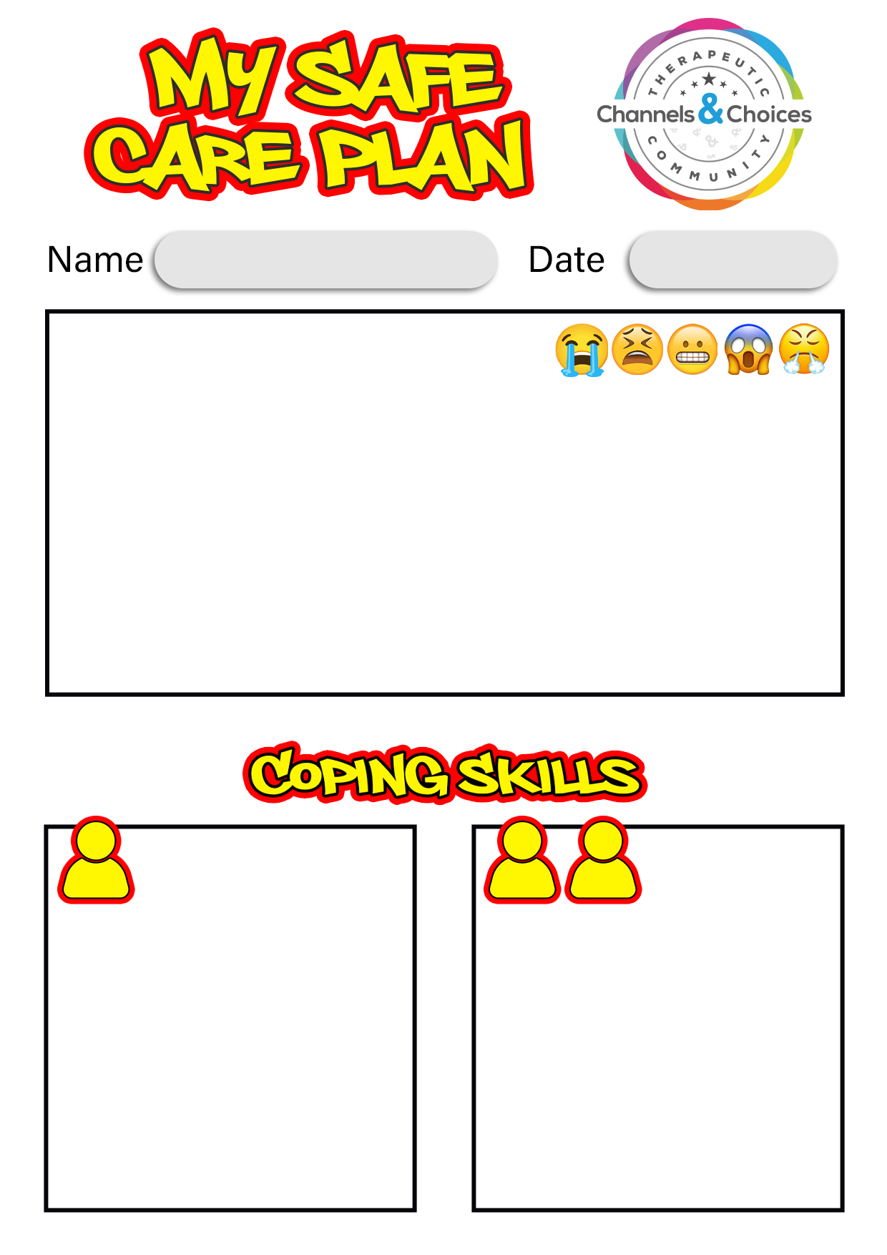

Places I feel comfortable and safe.
What my foster carers and adults around me do to
help me feel comfortable and safer.
What can I do to keep myself safe in the home, in
the community and on technology?
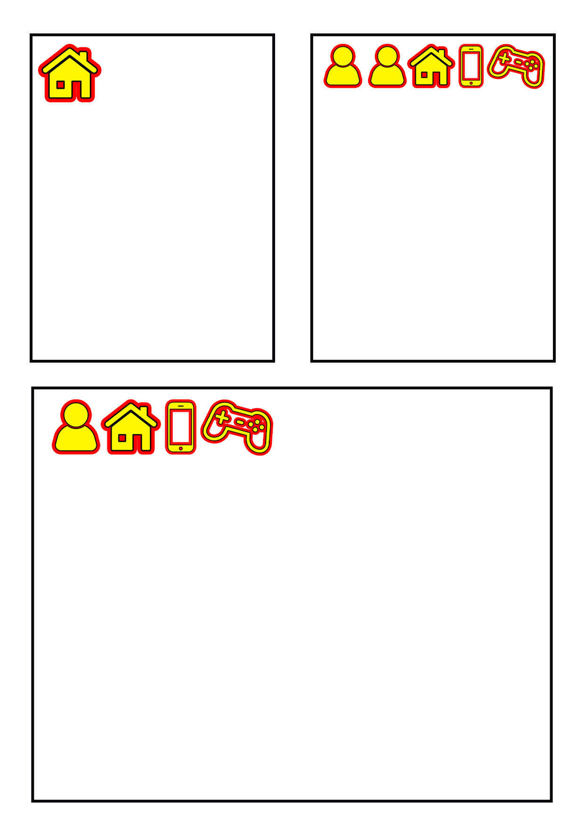

Young Person: |  | Signature: |  | Date:
Foster Carer name: |  | Signature: |  | Date:
Foster Carer name: |  | Signature: |  | Date:
Supervising Social Worker name: |  | Signature: |  | Date:

