 





Circle all the things that make you angry, upset scared or worried

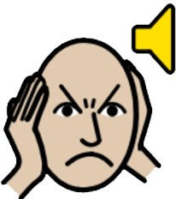l))

Being touched



Being threatened

Being called names, or made fun of



Being told what to do

Loud noises



Being told no

Does anything else make you angry or upset?



When I make a mistake

When I get in trouble

**Signals of frustration.**

**Circle all the ways that you show when you are angry, upset, scared or worried.**

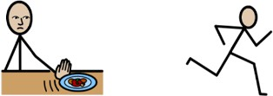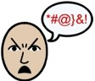@

Clenching teeth

Not eating

Running

Swearing

Being rude

  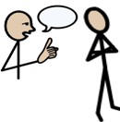  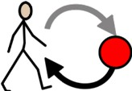

Putting head down

Disengaging Ignoring Pulling faces instructions

Pacing

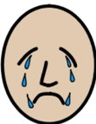 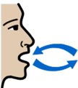 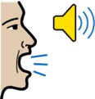 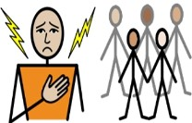 

Crying Heavy breathing Shouting Hurting others Throwing things

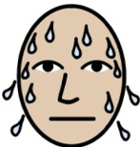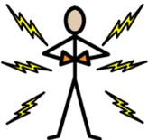

Sweating

Hurting myself Making a fist

Do you do anything else where you are angry, upset or worried?

**Circle what your foster carers can do to help you**

Give me space

Give me verbal

reassurance

Give me physical

affection

**Is there anything else that foster carers**

**can do to support you?**

Distract me

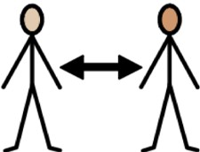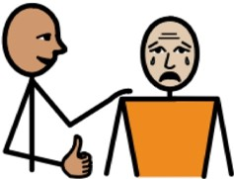



**How do my foster carers keep me comfortable and safe inside and outside of the home?**

|  |  |  |  |  |  |
| --- | --- | --- | --- | --- | --- |
| **Young Person:** |  | **Signature:** |  | **Date:** |  |
| **Foster Carer name:** |  | **Signature:** |  | **Date:** |  |
| **Foster Carer name:** |  | **Signature:** |  | **Date:** |  |
| **Supervising Social Worker name:** |  | **Signature:** |  | **Date:** |  |