



**Effective Marking and Feedback**

**November 2024**



**Introduction**

Feedback has the power to impact both positively and negatively on pupil the performance and self-esteem of all the pupils at Greenfields School. Many, if not all, of the children that attend Greenfields have a very negative view of school and harbour significant barriers towards learning.

It is essential that any feedback or marking has a positive impact on a child’s attitude to learning, rather than reinforce their experience of highlighting their weaknesses. Therefore, all feedback must ask 2 main questions:

**‘Now and Next’**

* What have I done well? Have I achieved my learning objective?
* What can I do to improve my work? / How can I move on to the next step?

This policy sets out how the use of effective marking and feedback is consistently utilised throughout the school.

**Aims**

The aim of this policy is to ensure a clear understanding of the processes and procedures of effective marking and feedback in order to maximise progress and encourage the children to begin to reflect on their own work and learning.

By empowering pupils to be actively involved in understanding how they are making progress, we pave the way for them to take ownership of their learning and recognise their successes.

Effective marking and feedback aims to:

1. Inform the pupils of what they have achieved and what they need to do to improve.
2. Support pupil confidence and self-esteem in learning and boost progress.
3. Support teachers’ assessment knowledge of each pupil in order to plan and refine next steps in learning.
4. Develop consistent processes across the school.

**Processes**

Due to the nature of Greenfields School, there is a high adult: child ratio, therefore most feedback and marking is done with a pupil during a session, often with verbal feedback. There are three main processes for marking and feedback implemented across both key stages:

1. **Teachers’ well considered intervention** – This takes the form of verbal feedback and occurs through effective questioning, to clarify or refocus tasks and enquiry. The aim is to prompt deeper thinking and quickly address misconceptions, as well as allow the pupil to explore and question their learning. Generally this is done on a 1:1 basis during the session and noted down to record and feedback or respond, if necessary.
2. **Light Touch Marking** – This is to acknowledge and recognise attainment and/or progress, success and/or completion of work. Light Touch marking may be displayed through highlighting or marking ‘I can’ statements and ‘S’ or ‘I’ are used to denote Supported or Independent work, which is of particular relevance to the children at Greenfields.
3. **Developmental Marking** – This takes the form of incisive feedback on attainment, success and next steps within a particular session. It is guided by the learning objectives and the pupil’s individual targets. Ideally, the adult and child will recap on the success of the session, based on the learning objectives as well as keep in mind each child’s related individual target. This encourages positive self assessment and reflection, something which all the children at Greenfields School find difficult. Developmental Marking is done on the pupil’s work and should at least 1 area of achievement and 1 area for development/next step. It is expected that at least 1 piece of work, in the core subjects, is marked in this way each week.

**Marking System**

Below is an example of the Greenfields Marking System, which falls in line with the approach from ‘Talk for Writing’ by Pie Corbett:

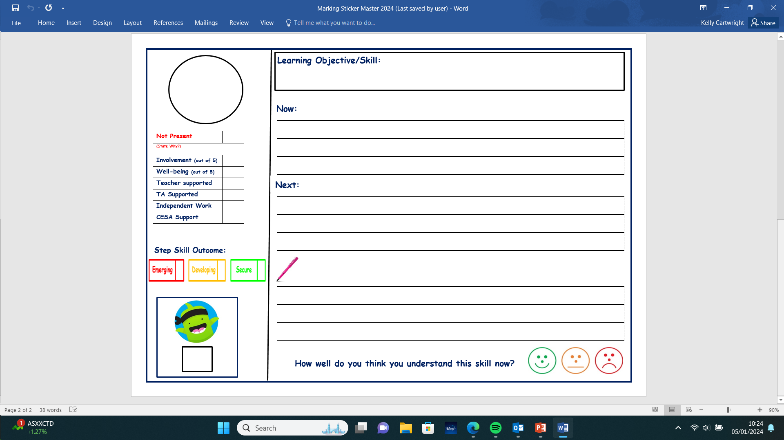

* Teachers mark in green pen stating ‘now’ and ‘next’ feedback
* Teachers highlight the relevant mode of completion of work
* Teaching Assistants mark in Purple
* Teachers allocate an engagement mark 1-5
* Children are expected to ‘feedforward’ in pink ‘polishing pen’

Through this marking procedure we aim to promote a feeling of pride and achievement, build self esteem and embed a culture which rewards self-improvement and endeavour, especially for children who, in most cases, have only experienced feedback/marking in a most negative form.

**Self-Evaluation and Feedforward**

Although there is a clear policy for marking at Greenfields, all staff will encourage the children to reflect on their own work. Allowing and encouraging the children to consider how their work may be improved, is an extremely valuable step for their development in becoming reflective and effective learners in the future. After a marking sticker has been completed by the class teacher or TA, the children are encouraged to ‘feedforward’ in order to self-assess/correct or to stretch and challenge their learning further.