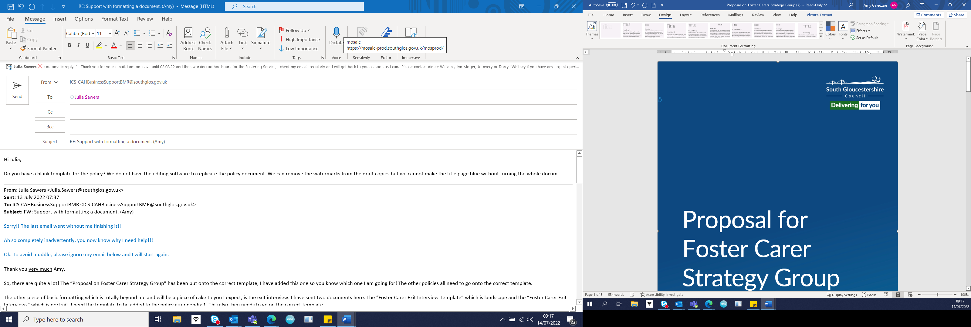

Fostering Service

Guidance for Supervising Social Workers on
Completing a Foster Carer’s
Chronology

Author: Fostering Task Force
Date: June 2020
Reviewed: October 2022 Julia Sawers
Review date: October 2024

Table of Contents
Introduction 2
Importance of foster carers’ chronologies 2
What to put in a foster carers’ chronology 3
Review and updating the chronology 5
Appendix 1 – Chronology template 6

Introduction
The purpose of a chronology is to provide a concise and visual outline of the significant events in a foster carers’ fostering career. A chronology of the foster carer’s life story is completed as part of the initial assessment before approval and presented to the fostering panel along with all the other assessment paperwork.

Once approved, a new chronology is started. It is useful in a variety of ways:

- A chronology helps to track a foster carer’s progress and development. It is the place to see at a glance the training they have undertaken, the support they have given to the Fostering Service through buddying or help with recruitment activity for example, and the children or young people they have cared for. It highlights their strengths over a period of time which can support effective placement matching and better outcomes for children.
- A chronology can help placement stability because it can show how long children and young people live with their carers and it records how many unplanned endings may have taken place. This can help in planning training and support to foster carers
- A chronology also contains the information to see at a glance that all the paperwork and checks associated with the fostering household are compliant with the Regulations, for example the annual review, unannounced visits and statutory checks
- A chronology is important from a safeguarding perspective too. Any allegations or complaints are dealt with individually, but to see them listed on a chronology shows patterns of behaviour or risk which may need further investigation or reflection. Serious case reviews into foster carers’ abuse indicate that if good case recording and chronologies had been completed, the greater scrutiny would have alerted supervising social workers earlier to foster carers actions.

Importance of foster carers’ chronologies
The importance of Foster Carer chronologies has been highlighted in Serious Case Reviews:
SCR 2019/C7637, identified that a lack of recording contributed to a poor assessment of risk. Without adequate recording a chronology cannot be built or developed to identify patterns of concern. – As a result, disclosures of sexual abuse were missed in terms of frequency and duration, 8 children disclosed sexual abuse over a set period of time.
SCR’s in Hampshire were undertaken following 2 separate incidents where children were found to have been abused by their respective foster carer’s, one of the findings from this review was;
‘The accumulation of concerns was not recognised and patterns of behaviour such as using the complaints system to deflect attention away from challenges to their behaviour was not understood sufficiently as a cause for concern.’ - A chronology may have helped to identify these concerns at an earlier point in time.
All the information in a chronology will be recorded in more detail elsewhere on the foster carers file. There is no purpose therefore in writing at length about an incident or event when that is duplicating information. Rather than helping to gain a clearer picture about life in a fostering household, lots of repeated information can lead to writer or reader fatigue. At its best, a well written, concise chronology can record the impact a fostering household has on the children they care for as it charts their fostering journey.

What to put in a foster carer’s chronology
The template which is attached to this guidance is for on-going use once the applicants have been approved as foster carers. For a chronology to be a useful document rather than merely a process to follow, there must be consistency and clarity about what is recorded. The template gives an opportunity to consider the impact of an event on the fostering household and what actions were taken as a result. A professional view has to be taken about what to include in a chronology, but the following table gives some guidance about what is likely to be relevant.

Regulatory data | - Date of approval  - Age range and banding approved for  - Any attendance at foster panel and why  - Date of DBS and health checks, any information about the impact this might have on fostering  - Date of annual review, if the actions from the last review were completed and whether the PDP and welcome to home booklet were updated.  - Date of unannounced visit  - Notifiable incidents, including accidents to children, illnesses and children or young people who go missing and whether they have a return home interview
Decisions made by the Fostering Service about the foster carers | - Any changes to the visiting pattern  - If the foster carer moves banding  - Any additional payments  - Actions during an investigation, including independent support offered  - Foster carers who become buddies
Information about the fostering practice of the foster carers | - Any compliments or “thank you’ s” to the foster carers  - Foster carers ability to advocate for themselves or children in their homes, - when they asked for help, why and what happened  - Any complaints, standard of care concerns and allegations. What the impact was on the household, especially the child in care and how these matters were resolved  - Any occasions when the fostering family were hard to engage with the child’s plan  - Attendance at training, support groups and engagement events which demonstrate a pattern of engagement with the Fostering Service
Information relating to the foster carers themselves. | - Big life events, starting new relationships or finishing relationships  - Bereavements  - New employment, redundancy or retirement, the potential anxiety this brings about income or time commitment  - New course of study or new qualifications, especially if the learning is relevant to children  - Health issues and the impact on the children in their home  - Involvement with the police, if it is not already covered above
Information relating to looked after children in the home | - Attendance at child in care review, PEP meeting or Court hearing, placement planning meetings  - Any particular successes or difficulties perhaps with school, family time or health, day to day information will be in recording and case notes, but a chronology might begin to pick up a foster carer having a particular pattern of success in supporting children to develop a skill or a hobby, or particular pattern of difficulty, for instance supporting a young person through teenage years  - Children or young people who moved out of the home in an unplanned way, this may show patterns or triggers about why certain behaviour or circumstances are difficult for the carers to manage.  - Family holidays or requests for respite

Information relating to the foster carers’ own children and family | - Big life events for their own children. It might include if they become grandparents  - Family stress  - Perhaps an adult child who was a great practical help has left home  - An elderly parent needing additional support  - A birth child taking important exams  - A family member becoming unwell or with police involvement  Only add details which will have an impact on their fostering capacity and on the household as a whole, this chronology is not to record the foster carers’ own family life story. It should not be intrusive; it should only be relevant to fostering

Review and updating the chronology
Without reviewing it, the chronology is just a list of events and has no value.
Supervising social workers will add to the chronology as relevant events happen. It is a living document which should be updated quarterly. Part of the process of updating, is to look through the past few months and reflect on the impact of the events on their fostering. It forms part of the foster carers’ annual review because it feeds into the analysis of the past year.
Team Managers for foster carers should regularly review the chronology to ensure it is up to date and reflects the current plan of support and supervision of the household. They must review it in supervision with the supervising social workers at least every two months to ensure it is up to date and includes the relevant information.

FOSTER CARERS’ CHRONOLOGY
Foster Carers’ Name:
Foster Carers’ ID Number:
Date/Source | Significant event | Impact | Action taken
The date of the event should be in this column.  Where did the information come from and who told us? | A description of who, where, what when how and why. | A description of how this event may have impacted upon the fostering household especially the child or young person in care.  This can be fact or professional opinion based on information received or research considered, it is important to differentiate between the two when making a record. | What happened as a result of the event and analysis of the impact? What did we do?

