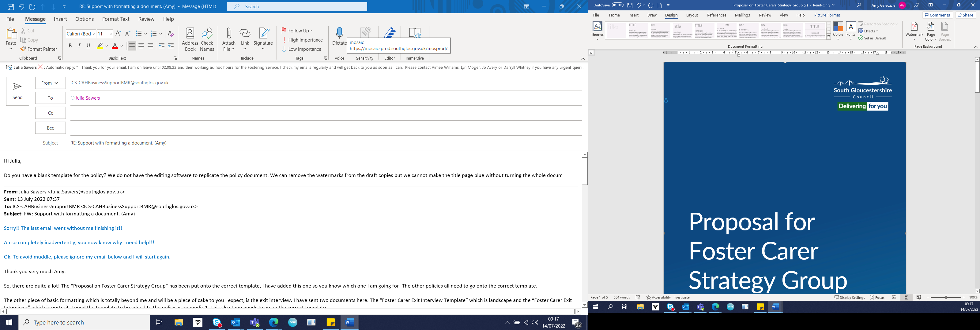

Fostering Service

Exemptions Policy

Date: June 2022
Review date: June 2024

Exemptions Policy

Contents:

Introduction | Page 2
Regulatory framework | Page 2
Planned placements | Page 3
Emergency placements | Page 5
Other Local Authority or Independent Fostering Agency’s foster carers living in South Gloucestershire | Page 5
Appendix 1 Exemption Request Form | Page 7
Appendix 2 Letter to carers | Page 9

Introduction

This policy sets out the process to follow when an exemption from the usual fostering limit or a temporary change in registration is needed.

Regulatory framework:

- The Children Act 1989 Schedule 7 Foster Parents: Limits on number of foster children
- Fostering Regulations (England) 2011
- The Care Planning, Placement and Case Review (England) Regulations 2010
- The Care Planning, Placement and Care Review and Fostering Services (Miscellaneous Amendments) Regulations 2013
- The Children Act 1989 Guidance and Regulations Volume 4: Fostering Services (2011)
- Assessment and Approval of Foster Carers: Amendments to the Children Act 1989 Guidance and Regulations Volume 4: Fostering Services (July 2013)
- Fostering Services: National Minimum Standards 2011

If more than three children are placed in one fostering household, then normally, that household should be registered with the Local Authority as a Children’s Home. There are some specific situations when this is permitted though:

- The foster children are all siblings in relation to each other, or

- The Local Authority within whose area the foster carer lives exempts the foster carer from the usual fostering limit, and

- The foster carer’s terms of approval allow it, - any terms of approval must be compatible with the number of children the foster carer is caring for even if an exemption to the usual fostering limit has been granted unless the placement is an emergency or for less than six working days.

The “terms of approval” are not just the number of children a foster carer may look after but also any other specific factors such as the age range, gender, type of placement, such as long term or short term etc.

A ”nominated manager” or Agency Decision Maker (ADM), is allowed to make an interim decision to alter the approval of the foster carer with immediate effect, before the matter is presented to a Fostering Panel, as long as the Fostering Service
- makes a statement setting out if the foster carers or anyone in their household will have additional support needs as a result of the change and how the needs will be met, and,
- the foster carer gives written agreement to the change of their terms of approval.

If the terms of approval are not changed within six working days, the additional children must leave the foster home.

Planned placements

When children are to be placed in a foster home in a planned move, for longer than six days and the number of children would exceed the permitted number the foster carers are approved to care for, an exemption should be requested from the ADM. The process in South Gloucestershire for obtaining an exemption is as follows:

 | Process:
1. | The need for an exemption will be identified by the placement finding officer when they are seeking to place a child or children in a foster home. They will alert the supervising social worker and discuss the suitability of the foster home to meet the needs of the children. If the allocated supervising social worker is not available, then the duty social worker will do this.  The conversation is just a “first thoughts” discussion about the viability of the idea. They will need to consider the practical arrangements for the household,  - How will everyone get to school?  - What about sleeping arrangements?  - How will the carers manage family time or doctor appointments? Etc.  They should also consider the needs of all the children in the home and the skills of the carers to meet these needs. This will include a discussion with the social workers for other children living there, and a conversation with the birth children. If possible, it would also be helpful to gather the IRO’s view.  Finally, there should be a creative discussion about how the Fostering Service can support the household so that all the needs of all the household members can be met.  If they agree that this could be a suitable placement, then the manager should be informed. The manager needs to know when the placement is required.
2. | If the manager agrees that this placement could work well, they request the supervising social worker to prepare an application for an exemption. Please see appendix 1.  At this stage the manager also indicates what additional support or training they might authorise to practically help the carers manage the needs of all the children.
3. | The supervising social worker completes the exemption request form and the exemption letter template, please see appendix 2, which is passed to the team manager. The letter template informs the foster carers of their new approval.
4. | The team manager reviews the form and when they consider all the information is complete, they pass this along with the letter to the ADM
5. | The ADM reviews the information on the form and either seeks clarification or agrees the exemption adding their reasons to the form and any possible conditions. They upload this to Mosaic.
6. | The ADM signs the letter written to the foster carers informing them that they have had a change of approval. They upload this to Mosaic.
7. | The ADM adds a case note to Mosaic ticking the “significant event” box recording the change of approval decision.
8. | The children can be placed once the ADM has signed the form, and the supervising social worker has sent the letter to the carers and received in return their written agreement to the change.
9. | The supervising social worker prepares an updated foster carer agreement for the foster carers reflecting their new approval and passes it to the ADM for signature. The supervising social worker sends it to the foster carers and stores a copy on Mosaic along with a case note recording the action is complete.
10. | The supervising social worker books a date at the next available foster panel for the carers’ approval to be reviewed.  The paperwork required for panel is the latest annual review report and the exemption application form.

In South Gloucestershire, we will ask our Foster Panel to monitor all exemptions every six months. The Foster Panel Chair will report on them in their annual report.

The Fostering Service is responsible for recording the ending of the exemption when it is no longer required. This will be completed by the supervising social worker who has responsibility for ensuring approval accuracy in the case records.

Emergency placements

If children need to be placed in an emergency, or out of hours with a foster carer and this exceeds their usual fostering limit, the placement can be made with the approval of a senior manager. This arrangement can last up to six working days without altering the terms of the foster carers’ approval. However, if it is likely that the children will stay beyond six working days with those carers, the process outlined above needs to be followed and should be started as soon as possible to ensure the paperwork is in order before the six working days pass.

Other Local Authority or Independent Fostering Agency’s foster carers living in South Gloucestershire

A Local Authority cannot grant an exemption to the usual fostering limit to a foster carer living outside their area. It is the responsibility of the other Local Authority (OLA) or the Independent Fostering Agency (IFA) to apply for an exemption to South Gloucestershire, for all their foster carers who live in South Gloucestershire, if they exceed the usual fostering limit.

If the OLA or IFA require an exemption, they should notify the ADM immediately and then prepare and send in the following paperwork:

- The foster carers original assessment and their most recent annual review, and
- The visiting pattern and support provided to the carers
- A brief description of the needs of the children currently living with the foster carers and how the carers are meeting those needs
- The background and needs of the children who are to be placed with them and any additional support requirement anticipated
- The completed form to be found in Appendix 1

The exemption cannot be agreed until all this has been submitted. The ADM will prioritise reading the documentation as soon as it is received.

If agreeing to the exemption, the ADM will prepare and send a letter for the foster carers following the template found at
appendix 2. The foster carers will be asked to return the letter to South Gloucestershire Fostering Service for our records.

Appendix 1

Request for a Temporary Change in Registration or Exemption to the Usual Fostering Limit

FOSTER CARER’S DETAILS
Name of foster carer:
Address of foster carer:
Name and ages of any birth or adopted children living in the family or any children living under an SGO. This should also include any adult placed under the Shared Lives scheme who may need more attention:
Ethnic origin and culture of foster carer. This will include the type of family activities and pursuits engaged in, as well as religion and pastimes:
Supervising social worker:
Date originally approved:
Date of last review:
Current terms of approval and specifically what needs to be altered to accommodate the proposed child(ren):
Current children placed with carers (with dates):
Name of children’s social worker and their views on proposed exemption:
Do the foster carers smoke? The SGC policy states that no child under five, or with a disability or with a respiratory illness will be placed with smokers.
Do the foster carers have any pets and does the child/ren moving to live with them have any allergies to pets?
Any work commitments for the foster carers or planned holiday arrangements which would prevent them from being available to the children:

DETAILS OF CHILD/REN OR YOUNG PERSON’S TO BE PLACED
Child/young person:
Date of birth of child/young person:
Ethnic origin and culture of child/young person, any specific health needs or disability:
Child’s social worker:

REPORT ON TEMPORARY EXTENSION OF CARER(S) FOR PARTICULAR CHILD(REN)
Brief background on the circumstances, needs and resilience of the children to be placed in this home. What is the impact of the trauma they have experienced? Is their behaviour trauma-informed? Are they angry? Aggressive? Withdrawn? What is helping them gain some self-esteem and confidence? How do they self-regulate? What can the foster carers do to encourage this further and help the child feel safe?
How the carer(s) can meet the child’s needs:
The size of the foster home, how many bedrooms are there and what are the proposed sleeping arrangements:
The practical arrangements, including transport, to ensure all the children are able to fulfil their usual schedule including attending school, hobbies and family time:
Potential risks/needs and plans to mitigate these:
Additional support to be provided and by whom:
Date agreed to return to Panel with full annual review or addendum report if placement is likely to continue:

Social worker name and signature: | Any additional comments: | Date:
Team manger name and signature: | Any additional comments and recommendation: | Date:
Service manager name and signature: | Comments and reason for agreement with any condition imposed or reasons for refusal: | Date:

Appendix 2


Department for Children, Adults and Health

Date:

Dear Foster Carer (NAME),

I am writing to confirm that as agency decision maker, I have accepted an application from your supervising social worker to exempt you from your usual fostering limit of XX children.

You are now approved to foster:

(LIST CHILDREN ALREADY IN PLACEMENT AND THOSE MOVING IN)

This exemption is agreed until (INSERT DATE). The exemption will be considered at our fostering panel before that date.

(ADD ANY OTHER CONDITION TO WHICH THE EXEMPTION IS SUBJECT)

To help you manage this we are offering (LIST ADDITIONAL SUPPORT IF ANY).

I know that this has all been discussed with you and that you agree to this temporary change of approval. The Fostering Regulations require that you inform us in writing that you agree to this change so please could you sign the enclosed copy of the letter and return it to your supervising social worker.

Thank you so much for being willing to care for these additional children. It will make all the difference to the children.

Yours sincerely,

Aimee Williams
Service Manager
Fostering, Adoption and Waypoint

~~~~~~~~~~~~~~~~~~~~~~~~~~~~~~~~~~~~~~~~~~~~~~~~~~~~~~~~~
To be completed by the foster carers and returned to the supervising social worker:

I agree to this change in my fostering approval

Signed:

