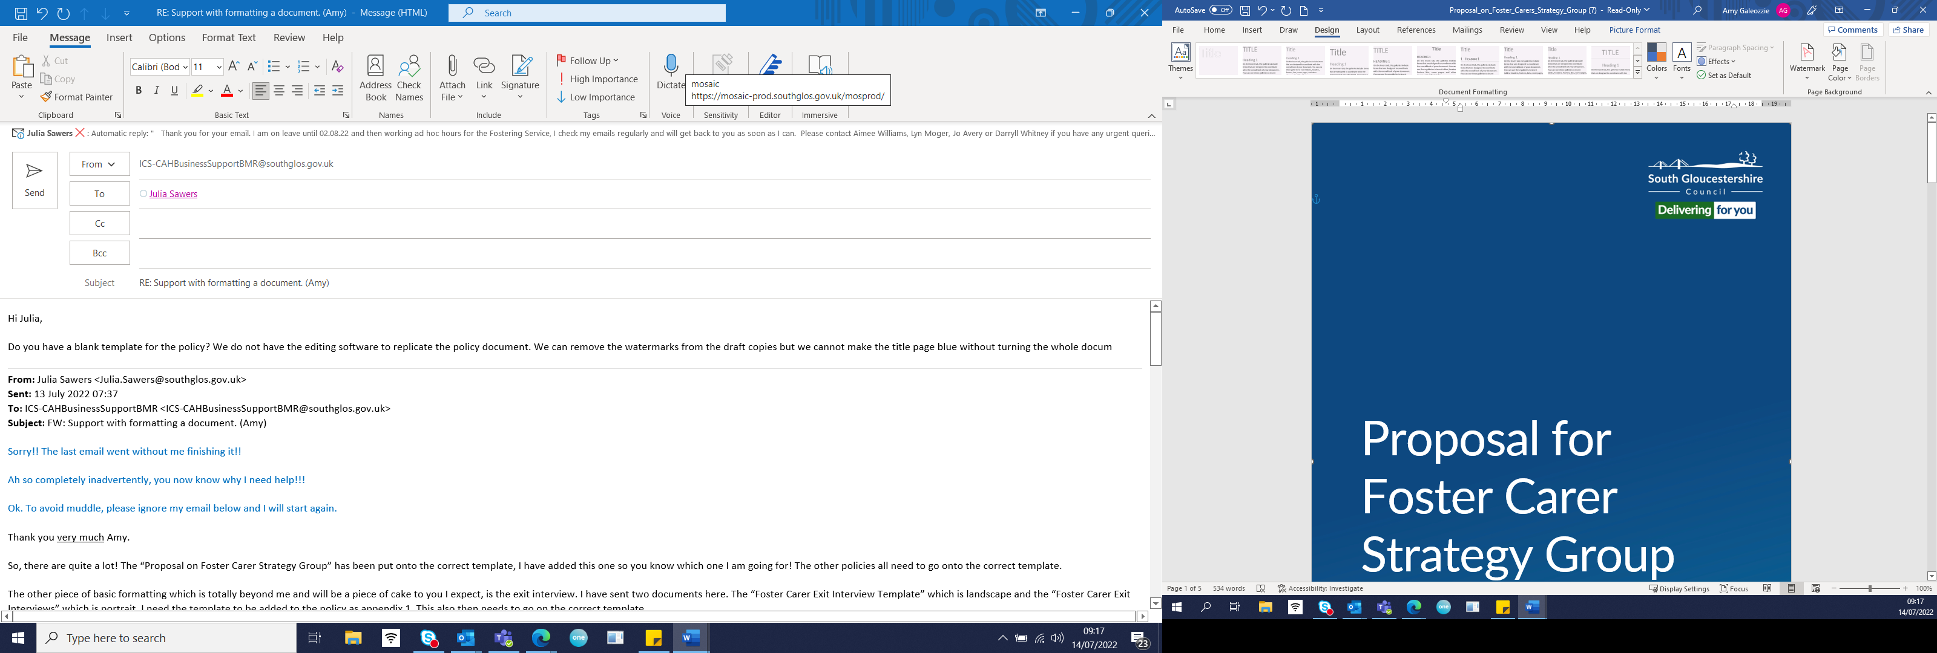

Fostering Service

Foster Carer Annual Review
Process and Guidance

Author: Julia Sawers, Fostering Task Force
Date: 27 May 2020
Reviewed: October 2022. Julia Sawers
Review date: October 2024

Table of Contents

Introduction and legal basis 2
Process for foster carers’ annual reviews 3
Appendix 1 Timeline and actions for annual review ……………………………………………………………………… .5
Appendix 2 Manager’s Checklist - Documents Required for Management Scrutiny for a Foster Carer’s Annual Review ……………………………………………………………………………………………………………………..7
Appendix 3 Report of Foster Carers Chaired Review ……………………………………………………………………….8

Introduction and legal basis

Fostering is a regulated activity and under the law there are certain tasks which must be completed: reviewing foster carers’ approval at least once every year is one of those tasks.
Regulation 28 of the Fostering Regulations 2011 addresses annual reviews, and this is expanded in the Fostering Guidance, Volume 4 of the Children Act 1989 which states:
5.60. Approval of all foster carers must be reviewed within a year of approval, and thereafter whenever felt necessary, but at least annually. The review must consider whether the foster carer and their household continue to be suitable. The fostering service must make whatever enquiries it considers necessary to inform this judgement which may include checks in relation to any new members of the household. Specifically, it must take into account the views of the foster carer, any child placed and the responsible authority for any child who has been in placement during the previous year. In practice, the latter will mean obtaining the views of the social worker for any child in placement since the last review.
5.61. A written report of the review must be prepared, and in the case of the first review this must be presented to the fostering panel for a recommendation. If it is decided, taking account of any recommendation from the fostering panel if applicable, that the foster carer and their household continue to be suitable, then the foster carer must be notified in writing.
5.62. If the fostering service is of the view that the foster carer and their household are no longer suitable, or that the terms of approval should be amended, he must issue a determination and follow the procedures referred to in the section on the Independent Review Mechanism, …. , before making a decision.
There are four main areas every annual review needs to consider:
1. The quality of the care provided to children by the foster carers
2. The foster carers’ own development
3. The quality of support and training the foster carers have received from the Fostering Service in the past year
4. Whether approval is still suitable for these carers and whether their specific approval remains appropriate

A foster carer’s annual review is an important part of safeguarding children.
Regulations on their own will not keep children safe. They do provide a really helpful framework to make sure supervising social workers remain curious about the quality of care offered to children and for them to be as confident as possible that children will thrive in the care they receive.

Process for foster carer’s annual reviews
In order to meet the requirements of the regulations, a bundle of documents must be completed so that we can be confident of the quality of care offered by the foster carers and so that we are able to make a judgment about their on-going approval.
The first annual review is considered by the Fostering Panel in accordance with the Regulations. In South Gloucestershire, every third annual review thereafter also is presented to the Fostering Panel. This is good practice. The process for the reviews in the intervening years also needs to be robust so that the reviews do not drift out of timescale.
In order to be absolutely clear about the date an annual review happens, once all the reports have been completed and read off by the foster carer and the manager, a meeting will be held and the date of that meeting is the date of the annual review. A timeline for the process and actions of annual review preparation can be found at Appendix 2.
Consultation documents are required under the regulations from the social worker for the child, the child or young person in care and the foster carers. These are minimum regulations, in South Gloucestershire, we also want to know the views of all the children in the foster home and will ask the foster carer’s own birth children too. In order to gain a fuller picture of the household, consultation forms will be sent to the IRO and to the school. It may be appropriate for health and other professionals to complete a consultation form as well. It is advised that the supervising social worker sends out consultation forms after every placement throughout the year, that way the information is gathered in readiness for the annual review report. The supervising social worker will send a request on Mosaic for the consultation form to be completed along with an email to let the social worker or IRO know that the request has been sent. If consultation forms are not returned within three weeks, a second email will be sent with the child care manager and consultant social worker with responsibility for fostering copied in.
Annual review meetings will be independently chaired by the Agency Advisor. This ensures the foster carer is able to be open about the support they have received from the Fostering Service. Chaired review meetings also prevent any collusion between the supervising social worker and the foster carer, and they can resolve any matters of concern or dispute and celebrate good practice. Appendix 3 is the template for completing the record of the meeting.

South Gloucestershire Practice Standards for Supervising Social Workers 3.6 reads:
Annual review reports are an assessment of the previous year of fostering. They should be completed within a year of the last review and given to foster carers to read off before the review meeting. They will be evidence-based and analytical. They will include a wide range of feedback including from the foster carer, the children within the household, the child/ren’s social worker(s); the IRO and school should also be approached for feedback. The bundle of documentation for an annual review includes the updated carers’ chronology, the personal development plan of the carers, the safer care policy, the health and safety form, the welcome to home booklet and any pet assessment forms. The report will assess whether the carer is suitable to continue to be registered as a foster carer, whether they are on the correct skill banding and whether the approval is still appropriate. The report will also include the reflections of the foster carer on their year of fostering and their development plan for the year ahead.

A list of these documents can be found at Appendix 2. This is the standard we intend to meet with all foster carer annual reviews.
It is the supervising social worker’s responsibility to ensure that all the paperwork is ready and complete for the review meeting. However just as we prepare for our own annual appraisal, it is the foster carers’ responsibility to update the Welcome to Home booklet, the Family Safe Care policy, their Personal Development Plan and to complete their consultation feedback.

Appendix 1

Timeline and actions for annual review
Process | Date
On allocation of a new foster carer, check the date the annual review meeting is due
Two months before date meeting is due, book the annual review meeting or book a panel slot.
Send out the consultation feedback forms which need to be completed by others, - the social workers, foster carers, children of carers, fostered children, IRO and other professionals. If not received within 3 weeks, escalate to your manager and to the consultant social worker with responsibility for fostering
Ask foster carer to update their Welcome to Home Booklet, their Safe Care Policy and their PDP and give them a date by when it should be sent back to supervising social worker, if not received escalate to your manager
Supervising social worker ensures that the Unannounced Visit has been completed within 12 months of the last one, that the DBS and medical checks are up to date, that the health and safety and pet forms are reviewed
Supervising social worker writes review report drawing on all the information available, it does not necessarily require a review visit, the information should be available to the supervising social worker from their contact throughout the year. The report should be analytical, and evidence based. It should include:

Tasks or actions completed or outstanding from the previous review
Progress for the year and how we know it
Any changes in the past year, eg birth of a grandchild, work commitments, health issues, family changes and what impact this has on the children in their care
Any unplanned endings, allegations, complaints or concerns
How Family Time has been managed
Carers’ own development, compliance with the requirements for their banding
Actions from the review including who is responsible for the actions with timescales
Clear recommendation for on-going approval, or if change to approval is recommended, this has to be put in writing to the foster carers and considered by the Fostering Panel if the foster carers do not agree.
Two weeks before meeting date, send all the review documentation to the manager for their comments and observations, they have one week to read it all off and pass it to the agency adviser to chair the meeting.
One week before meeting date, send out the review documentation to the foster carers in readiness for the meeting, they do not need to send it back because their views will be heard, discussed and recorded at the meeting.
Hold the review meeting, if at all possible, both carers should attend. The meeting is not to change the content of the review report, it discusses the past year of fostering and what impact the carers have had on children and young people. It also considers what impact fostering has had on the fostering family and what further support is required.

The supervising social worker completes a box on the form as a resume of the meeting listing any areas of disagreement, agreement, future tasks and training required.

At the meeting the supervising social worker signs the review report on Mosaic and sends it to the manager, this triggers the data collection on Mosaic as the date of the review. The workflow for the manager to green tick informs the manager that the meeting has been held and they can open it up to see the outcome as recorded in the additional box above

The supervising social worker updates the chronology.

The agency adviser writes the review meeting report which is attached as Appendix 3 and uploads this onto documents on mosaic.
The manager signs off the review report on Mosaic, adding in the date of the meeting as the date of the annual review.
Supervising social workers email FosteringPanel@southglos.gov.uk and state clearly in the subject box ‘Non panel Review’. State the name of the carer, date of annual review and registration in the email. As the carer already has a copy of their review, the panel administrator only needs to send them their re-approval letter.

If the review is to go to panel, it is passed to the panel administrator within timescales to be presented to panel
The panel administrator then emails out the re-approval confirmation letter to carers and the Foster Carer Agreement.

The supervising social worker ensures the Foster Carer Agreement is signed and uploaded onto the system.

Appendix 2
Manager’s Checklist - Documents Required for Management Scrutiny for a Foster Carer’s Annual Review
(Not for panel reviews, please see appendix 4 of the “Process for Papers going to Fostering Panel” document for a list of documents to be presented to panel)
Document | Tick if present
Annual review report

Feedback form from foster carers

Feedback form from each child in care in the family home
Name of child:
Name of child:
Name of child:

Feedback form from children of carers living in the family home
Name of child:
Name of child:
Name of child:

Feedback forms from children’s social workers
Name of social worker:
Name of social worker:
Name of social worker:

Feedback form from IRO
Name of IRO:
Name of IRO:

Feedback form from other professionals such as, school and health,
Name of other professional:
Name of other professional:

Health and safety form

Welcome to Home booklet

Personal Development Plan

Family Safer Care Policy

Chronology updated

Pet Form

Appendix 3
Report of Foster Carers Chaired Review
Name of foster carer

Name of foster carer

Address of foster carers

Date of original approval

Current approval

Date of last review

Date of this review

Name of supervising social worker

Name of social worker who has written this review report if different from above

What has worked well over the past year for the fostering family and the children and young people in their care?

Include reflections on the consultation documents.
What are the areas for development?

Include reflections on the consultation
documents.

What needs to happen during the next year?
(Please be specific and add actions and timescales)

Do the carers continue to meet the criteria for their banding?

Date next review meeting is due

Name of chair of meeting:
Signature:

Date:

