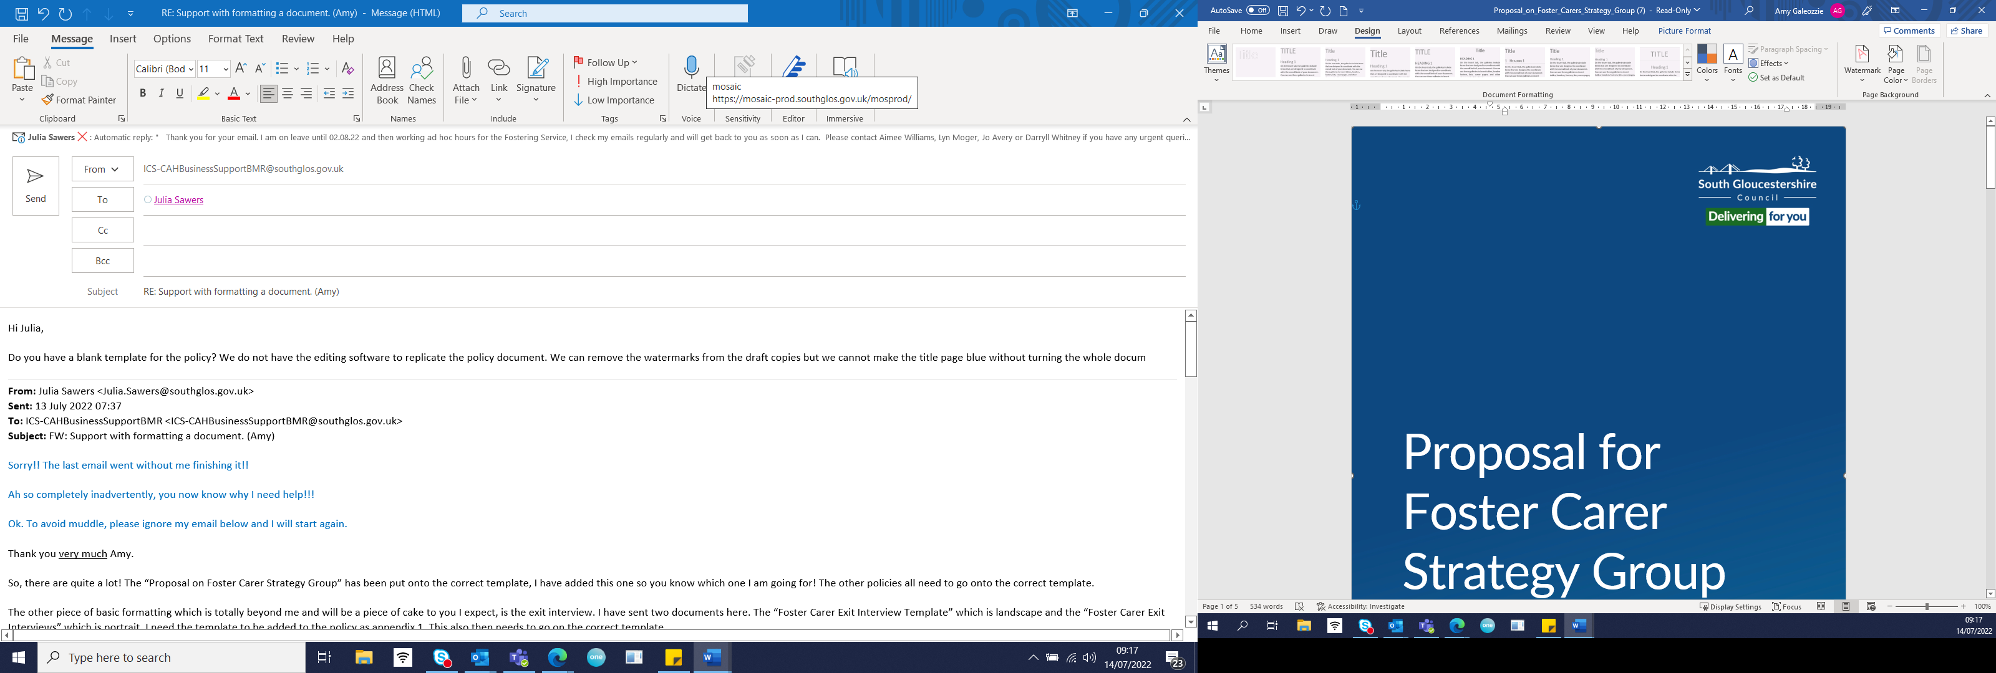

Fostering Service

Foster Carer Resignations
Process and Guidance

Author: Aimee Williams
Date: May 2020
Revised: July 2022. Julia Sawers
Review Date July 2024

Introduction
South Gloucestershire’s aim is to retain all of our Foster Carers by providing effective support, guidance, supervision and training, unless they are failing to provide a good standard of care and are not meeting the National Minimum Standards for fostering. Foster Carers, however, may decide to resign for a variety of reasons and so this guidance sets out the process to follow should that happen.

Legislative guidance
Regulation 28 (13) of the Fostering Services (England) Regulations governs the resignation of a Foster Carer. Statutory guidance is also given in Assessment and Approval of Foster Carers: Amendments to the Children Act 1989, Guidance and Regulations Volume 4 Fostering Services.

Resignations
Where carers are planning to resign, it is expected that they give serious consideration to the impact on any children living with them. Unless there is no other preferable option, they should wherever possible be supported either to help the child/young person remain with them until they were due to leave anyway or to give sufficient notice, so that suitable alternative arrangements can be made. The child should be properly prepared for the move, in such a way that they do not experience feelings of loss and abandonment. The expectation must be that young people should move in a positive manner, with an event to say goodbye which will be agreed according to the wishes of the young person and the carer. Photos and memories should be obtained to help the young person have an understanding of their stay with the carer and enhance their understanding of their time looked after in that home.
When a Foster Carer does give notice of their wish to resign from the role, this must be given in writing. Once written notice has been received by the fostering service, it is good practice for the Fostering Team Manager to write to the Foster Carer detailing the following:

- The date that the resignation takes effect, which is 28 days after receipt of the notice.

- Informing them that they will be removed as approved Foster Carers from South Gloucestershire’s register of approved Foster Carers on the date that their resignation takes effect.

- Requesting they return their foster carer ID cards to the office, enclose a stamped addressed envelope to make this easier.

- Any additional text thanking the carer for their service or offering sympathies etc. will be included in the letter at the discretion of the Fostering Team Manager.

- The letter will also need to offer them an ‘exit interview’ and advise the Foster Carer that if they make an application to foster to any fostering agency or another Local Authority then a reference will be requested from South Gloucestershire, and we shall be obliged to share any cause for concerns related to their fostering career with South Gloucestershire as well as the positive aspects of their care.
When the foster carers’ ID badge is received, a case note should be made on Mosaic recording this, and the badge should be shredded.
The Foster Carer cannot withdraw their notice once it has been received by the Fostering Team, nor can the Agency Decision Maker decline to accept the resignation. Should a Foster Carer who has resigned subsequently wish to foster again, they will need to be assessed under the procedure for Assessment and Approvals of Foster Carers Procedure which can be found on South Gloucestershire’s policy and procedure website (Tri-X).
There is no requirement for the fostering panel to be notified of resignation, however resignation reports are completed on Mosaic and submitted to the panel as part of its monitoring role. A copy of the Foster Carers written resignation and any feedback from them or accompanying documentation should be included with the panel paperwork. It should also include a note that the foster carer ID cards have been returned.

Foster Carers wishing to transfer to another authority
Where carers wish to transfer to another agency, whether or not a child is in placement, the Transfer Protocol and related principles developed by The Fostering Network should be followed and can be found here and here:

Foster Carers who resign during investigations or reviews of their ability to foster
A Foster Carer can choose to resign from fostering at any time, including during the course of a review or an investigation. Under the Fostering Regulations, once a Foster Carer has put in writing their intention to resign from fostering, their resignation comes into force automatically after 28 days of the date of their letter. This means that some carers may resign before any investigation is completed or any panel has considered the reports.

In such circumstances, if the investigation report is not finished, South Gloucestershire will continue with a fact-finding report so that the detail of what has been alleged is considered as fully as possible. This, or the full investigation report if complete, will be submitted to the fostering panel. Instead of an annual review report also being written and presented to panel, a short resignation report will be written. This report will include the resignation letter received by the Foster Carers and any actions which South Gloucestershire would have undertaken if the carers had not resigned. As with all paperwork which is submitted to the fostering panel, it must be shared with the Foster Carers in advance, and they should be invited to comment or respond. Their comments would also form part of the bundle of paperwork which is submitted to the foster panel.

The purpose of this still going to panel despite the Foster Carers’ resignation is:

- So that all views can be heard and that the process for reaching recommendations is transparent. The Fostering Panel is the most appropriate forum for this to take place.

- This information will provide the basis of a recommendation to refer the Foster Carer for inclusion on the list of individuals barred from engaging in regulated activity with children, held by the Disclosure and Barring Service. In such cases it is good practice for the fostering panel to be asked to form a view regarding this. The Department of Health and Social Care would expect the documentation presented to panel and the panel minutes to be available when they are considering whether a referral should be made to the Disclosure and Barring Service.

- For panel to note the resignation and the circumstances under which it was offered.

- To ensure that whoever made the allegation is reassured that they were listened to and their concerns were taken seriously.

- To be confident that if the former carers applied to foster for another agency, as full a record as possible of the reason for the investigation is on their file and would be shared with a new agency as part of the agency reference.

Following the foster panel meeting, the Agency Decision Maker should write to the Foster Carers and inform them of any advice or comments that the foster panel had, and to let them know that the paperwork from panel will be held securely on their file.

Exit Interviews

Any Foster carer that resigns will be offered an exit interview by the Agency Advisor and the process for this can be found on Tri-X. It is therefore important that the Agency Advisor is informed of any resignations.

