Fostering Service

Process and Paperwork for Fostering Panel

Authors: Fostering Task Force

Date: September 2020

Date reviewed: September 2022. Darryll Whitney

Next review date: September 2024

**Fostering Panel Process and Paperwork**

The Fostering Services regulations 2011, National Minimum Standards for Fostering, and The Children Act 1989 Guidance and Regulations Volume 4: Fostering Services all offer instruction about the Fostering Panel.

The purpose of this policy is to set out the process and the paperwork which is required for the South Gloucestershire fostering panel.

The role of the fostering panel is to scrutinise the work of the Fostering Service. The panel makes recommendations about foster carers to the Agency Decision Maker and provides robust feedback on the quality and effectiveness of the work presented to panel.

**Process and timeline**

This policy contains a work flow deadline for all panel business at **Appendix 1**.

The administration of the panel is a complex task, the panel members are allowed five working days within the Regulations to read the paperwork and in order for this to happen, all papers need to be submitted in good time. Following panel, the Agency Decision Maker has seven working days from submission of the final minutes to make a decision and then a further five working days to ensure the foster carers are informed of the decision.

**Paperwork**

In South Gloucestershire, the fostering panel considers:

* Initial assessments of foster carers
* Regulation 24 assessments of connected carers
* First annual reviews
* Every subsequent third annual review
* Annual reviews following an allegation against a foster carer and following some standard of care concerns and complaints
* Resignations and De-registrations of foster carers
* Feedback on the quality of reports by the fostering panel to the Fostering Service.

Each of these matters requires different paperwork and the list required is attached at A**ppendix 2 to 8.**

**Appendix 1**

**Workflow Process and Deadlines for Presentation of reports to Fostering Panel**

|  |  |  |  |  |
| --- | --- | --- | --- | --- |
| **Timeline** | **SSW/ASW** | **Team Manager** | **Agency Advisor** | **Panel Administrator** |
| **25 working days prior to panel** | The supervising or assessing social worker completes the fostering report and passes this to the team manager 25 days ahead of the set panel date. |  |  | The panel administrator sends the provisional agenda to the team managers and agency advisor 25 days ahead of the set panel date. |
| **23 working days prior to panel** |  | The team manager quality assures the report within two working days and suggests any amendments, returning this to the supervising or assessing social worker |  |  |
| **20 working days prior to panel** | The supervising or assessing social worker makes the recommended amendments to the report and shares this with the foster carers/applicants within three working days. | The team manager attends the panel agenda meeting | The agency advisor attends the panel agenda meeting | The panel administrator coordinates a panel agenda meeting with the agency advisor and team managers to agree the final agenda, depending on progress with reports at this point |
| **19 working days prior to panel** | The supervising or assessing social worker highlights the changes that were requested by the first quality assurance and sends this to the agency advisor for the second quality assurance, together with all other required paperwork |  |  |  |
| **16 working days prior to panel** |  |  | The agency advisor quality assures the report and all documentation for the second time within three working days and suggests any further amendments. |  |
| **13 working days prior to panel** | The supervising or assessing social worker makes any further amendments required and again highlights these returning them to the agency advisor within three working days |  |  |  |
| **10 working days prior to panel** |  |  | The agency advisor has one final quality assurance of the report and all documentation within three working days |  |
| **9 working days prior to panel** | The supervising or assessing social worker makes any final changes to the report and shares this with the foster carer or applicants within two working days |  |  |  |
| **7 working days prior to panel** | The supervising or assessing social worker sends the report and all supporting documentation to the panel administrator |  |  | The panel administrator collates all the reports and supporting documentation and sends this to the independent panel chair and panel members |

**The Panel Agenda needs to be agreed at a meeting 20 working days ahead of the Panel Date. The Panel Administrator will send out the provisional agenda to the Team Managers and the Agency advisor 5 working days ahead of this meeting.**

N.B There cannot be any flexibility in the timing of this process due the need to QA, make amendments and send to panel members in good time. Any report that has not been shared with the Foster Carers prior to being sent to the Agency Advisor, will not be processed at the scheduled panel. The panel agenda will be set 25 working days ahead of the scheduled panel date to allow time for completion of this process, ahead of the identified deadlines.

**PROCESS FLOWCHART FOR POST PANEL RECOMMENDATION TO ADM**

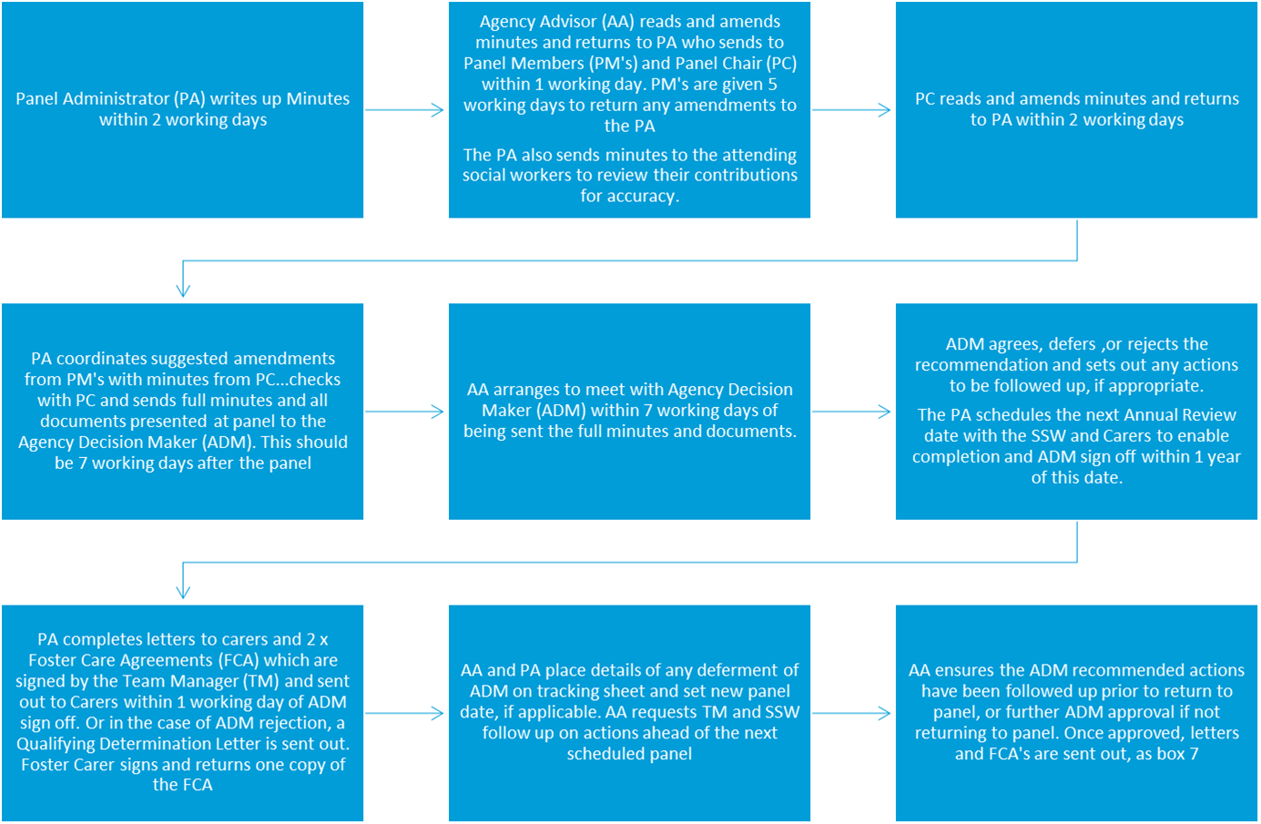

**Appendix 2**

**Documents Required when Taking A Mainstream or Short Break Carer Assessment To Fostering Panel**

|  |  |  |
| --- | --- | --- |
| **Document number** | **Document** | **Tick if present** |
|  | **Front sheet**  A brief explanation of what is coming to panel and why. This must be signed by the assessing social worker and counter signed by the manager. |  |
|  | **Index**  A list of all the paperwork submitted in numerical order following this checklist of documents. |  |
|  | **Home study report CoramBaaf Form F**  This should be signed by the applicant, the assessing social worker and the team manager. If it is a new partner assessment, the previous annual review for the established carer should also be included in the paperwork. |  |
| **1, 2, 3** | **References from three referees**  Only two are required if a single applicant |  |
| **4, 5, 6** | **Reports of visits to three referees**  These need to be countersigned by the referees with confirmation that they are happy to be shared with the applicant. They should be weighted by the assessing social worker  Only two are required if a single applicant |  |
| **7 a, b, c etc** | **Interviews with all children of the applicant(s)**  These need to be countersigned by the family member if over 18 with confirmation that they are happy to be shared with their parent |  |
| **8 a, b, c etc** | **Interviews with all other members of the household**  These need to be signed by the household member with confirmation that they are happy to be shared with the applicant |  |
| **9 a, b, etc** | **Previous partner reference**  This should be signed with confirmation that it can be shared with the applicant |  |
| **10** | **Health report from the medical advisor** |  |
| **11** | **School references** |  |
| **12** | **Previous work with children references** |  |
| **13** | **Employment references** |  |
| **14** | **Ecomap** |  |
| **15** | **Genogram** |  |
| **16** | **Foster carers personal chronology of significant events** |  |
| **17** | **“A weekend in our home” written by the foster carer(s)** |  |
| **18** | **Welcome to home booklet** |  |
| **19** | **Safe care policy** |  |
| **20** | **Foster carer profile** |  |
| **21** | **Feedback from the Skills to Foster training course** |  |
| **22** | **Health and safety form** |  |
| **23** | **Pet assessment form** |  |
| **24** | **DBS, where necessary, the ADM decision about any offences** |  |
| **25** | **Any other documentation or evidence which has been referenced in the main report** |  |

**Documents if a Carer is Transferring from an Agency**

|  |  |  |
| --- | --- | --- |
| **Document number** | **Document** | **Tick if present** |
|  | **Front Sheet**  Reason for transfer and date of resignation or transfer arrangement |  |
| **26** | **Transfer Report** |  |
| **27** | **Original Fostering Network A10/ or CoramBAAF Form F assessment** |  |
| **28** | **Latest Review from Agency** |  |
| **29** | **Previous Minutes & Decisions if possible** |  |
| **30** | **Reference from Service Provider** |  |
|  | **Renewed references (see above)** |  |

**Appendix 3**

**Documents Required for a Connected Person Application**

|  |  |  |
| --- | --- | --- |
| **Document number** | **Document** | **Tick if**  **present** |
|  | **Front sheet**  A brief explanation of what is coming to panel and why. This must be signed by the assessing social worker and counter signed by the manager. |  |
|  | **Assessment report**  The report should include a section completed by the child’s social worker about the needs of the child. The section written by the supervising social worker should include evidence of how these carers will meet the needs of each child in the household, including any birth children. The template used in South Gloucestershire is suitable for Court applications for SGO’s. Additional information is required for the fostering panel. This should be presented as an addendum completed on the template to be found at **Appendix 4.**  This should be signed by the applicant, the assessing social  worker and the team manager. |  |
| **1, 2, 3** | **References from three referees**  Only two are required if a single applicant |  |
| **4, 5, 6** | **Reports of visits to three referees**  These need to be countersigned by the referees with confirmation that they are happy to be shared with the applicant. They should be weighted by the assessing social worker  Only two are required if a single applicant |  |
| **7** | **Interviews with children who are to be placed**  Where possible, it is expected for a separate interview to be ehld with each child who will be placed. |  |
| **8 a, b, c etc** | **Interviews with all children of the applicant(s)**  These need to be countersigned by the family member if over 18 with confirmation that they are happy to be shared with their parent |  |
| **9 a, b, c etc** | **Interviews with all other members of the household**  These need to be signed by the household member with confirmation that they are happy to be shared with the applicant |  |
| **10 a, b, etc** | **Previous partner reference**  This should be signed with confirmation that it can be shared with the applicant |  |
| **11** | **Health report from the medical advisor** |  |
| **12** | **School references** |  |
| **13** | **Previous work with children references** |  |
| **14** | **Employment references** |  |
| **15** | **Ecomap** |  |
| **16** | **Genogram** |  |
| **17** | **Safe care policy** |  |
| **18** | **Health and safety form** |  |
| **19** | **Pet assessment form** |  |
| **20** | **DBS, where necessary, the ADM decision about any offences** |  |
| **21** | **Any other documentation or evidence which has been referenced in the main report** |  |
| **22** | **Addendum report answering fostering questions not held within the SGO Form C template.** |  |
|  | **EXTENSIONS**  In exceptional circumstances extension may be requested. A front sheet detailing reasons and application time frame  (NB Request a new panel date if extension agreed)  Viability including dated ADM confirmation to the placement |  |

**Appendix 4**

**Addendum for SGO Assessments Being Presented to the Fostering Panel**

Please provide an assessment and analysis in regard to the applicants understanding and capacity to act as a Foster Carer for South Gloucestershire Council in line with the NMS for fostering (2011).

1. **Working effectively with others.**

Is there evidence that the applicant can, or has the potential to work effectively as a member of a team?

Does the applicant have a realistic understanding of the role of a foster carer in working alongside others?

Does the applicant demonstrate an understanding of why children need foster care, and can they empathise with parents in anyway?

Do they demonstrate an understanding of how contact might affect children and do understand the value of maintaining contact?

Have there been discussions about the management of contact whilst they are registered as foster carers and prior to SGO?

Has delegated authority been explored with the applicants?

|  |
| --- |
|  |

1. **Preparation, training, and expectations within fostering as outlined in the NMS (2011).**

Do you feel that the applicant has been sufficiently prepared for fostering?

How realistic is the applicant about the fostering task?

How much preparation for fostering have they undertaken themselves?

Are there any gaps in their knowledge in relation to the fostering task? How do you propose that these will be covered?

|  |
| --- |
|  |

1. **Anticipated impact of fostering.**

What changes do you feel the applicant may have to make to their lifestyle to accommodate fostering?

|  |
| --- |
|  |

1. **Understanding of safer care.**

How well has the applicant understood the idea of safer caring?

How realistic and effective do you feel their approach to safer caring will be?

Are you satisfied that the whole family has taken on board the importance of safer caring?

Are there any vulnerable areas for the supervising social worker to monitor?

Does the applicant have a good understanding of confidentiality and know when, and with whom, to share information about the child?

|  |
| --- |
|  |

1. **Training and development.**

Please identify areas for future training or development that have been identified through the course of the assessment.

What are the applicants understanding of the training support and development standards for foster carers?

|  |
| --- |
|  |

1. **Any other evidence that supports the assessment in relation to the expectations of foster carers.**

e.g., recording, attendance at support groups, notifiable incidents etc.

|  |
| --- |
|  |

|  |  |  |
| --- | --- | --- |
| **Name of social worker:** | **Signature:** | **Date:** |
|  |  |  |
| **Name of manager:** | **Signature:** | **Date:** |
|  |  |  |

**Appendix 5**

**Documents Required when Taking an Annual Review to Panel**

|  |  |  |
| --- | --- | --- |
| **Document number** | **Document** | **Tick if present** |
|  | **Front sheet**  A brief explanation of what is coming to panel and why. This must be signed by the assessing social worker and counter signed by the manager. |  |
|  | **Annual review report**  This should be signed by the foster carer, the supervising social worker and the team manager |  |
| **1 a, b, c etc** | **Consultation documents with the children in placement and all children placed in the past year** |  |
| **2 a, b, c etc** | **Consultation document with the carer’s own children** |  |
| **3 a, b, c etc** | **Consultation documents for all the social workers who have children in placement** |  |
| **4** | **Updated welcome to home booklet** |  |
| **5** | **Updated safe care policy** |  |
| **6** | **Foster carers PDP** |  |
| **7** | **Any other documents referred to in the report** |  |
| **8** | **Panel minutes from original approval and ADM** |  |

**EXEMPTIONS (5.4 of the Guidance)**

If placements over the usual fostering limit of 3 are ongoing an exemption report that has been updated and the last review should be presented to panel on a 6 monthly basis. Include Panel Minutes and ADM Decision sheets.

**Appendix 6**

**Documents Required when Taking an Allegation to Panel**

|  |  |  |
| --- | --- | --- |
| **Document number** | **Document** | **Tick if present** |
|  | **Front sheet**  A brief explanation of what is coming to panel and why. This must be signed by the assessing social worker and counter signed by the manager. |  |
|  | **Allegation investigation report**  This must be signed by the foster carer, the investigating social worker and the team manager.  The report should include any transcripts of interviews held as part of the investigation and any other evidence which is referenced in the report. |  |
|  | **Response from the foster carer to the allegation report**  If they have chosen not to write a response, please make a note of that on the front sheet |  |
|  | **Annual review report**  This must be written following the investigation specifying the change of circumstances and any changes in approval sought, detailing allegation(s), outcome and recommendations |  |
|  | **Consultation documents with the children in placement** |  |
|  | **Consultation documents for all the social workers who have children in placement** |  |
|  | **Welcome to home booklet**  Updated by the foster carers |  |
|  | **Safe care policy**  Updated by the foster carers in the light of the allegation |  |
|  | **Panel Minutes from original approval and minutes from any other attendances at Panel in the last 3 years** |  |
|  | **Previous ADM Decision Sheets** |  |
|  | **Original assessment report if original approval was within 5 years** |  |

**Appendix 7**

**Documents Required for a Resignation or De-Registration**

|  |  |  |
| --- | --- | --- |
| **Document number** | **Document** | **Tick if**  **present** |
|  | **Front sheet**  A brief explanation of what is coming to panel and why. This must be signed by the assessing social worker and counter signed by the manager. |  |
|  | **Resignation report,**  This should include name and address of carer(s), date of resignation and reasons. Overview of fostering experience.  Confirmation that the carer(s) have seen the report |  |
|  | **Carer(s)’ resignation feedback form** |  |
|  | **Copy of the exit interview.**  If a carer has resigned, then the matter will not be noted at panel until the exit interview is complete.  If a carer is to be de-registered, then this needs to be presented to panel as soon as possible. For these situations, an exit interview may not always have been completed. |  |
|  | **Foster carers written notice** |  |
|  | **Other relevant reports if applicable** |  |

**Appendix 8**

Department for People

**Fostering Panel Quality Assurance Form**

|  |  |
| --- | --- |
| **Date of panel:** |  |
| **Name of social worker, (author):** |  |
| **Name of Manager:** |  |
| **What was good in the panel paperwork?** |  |
| **What were the gaps in the paperwork presented to panel?** |  |
| **What learning is there for the social worker and manager in the future? This might be things to improve on and good practice to share.** |  |

|  |  |  |  |  |  |
| --- | --- | --- | --- | --- | --- |
| **OVERALL JUDGEMENT** | **OUTSTANDING** | **GOOD** | **REQUIRES IMPROVMENT** | **INADEQUATE** | |
| **REASON** | | | | |

|  |  |
| --- | --- |
| **Gradings for Quality Assurance:** |  |
| **Outstanding** | The paperwork was complete, or any gaps were accounted for and all papers were signed and dated as required. The report flowed well and contained detailed evidence and good analysis. The subject of the report, whether carers or children “came alive” and their view was clearly expressed in the paperwork. The recommendation to the panel was easy to understand because the evidence was in the report leading to the conclusion. |
| **Good** | The paperwork was complete, or any gaps were accounted for but not everything was signed and dated, the voice of the carer and/or the child was clear. There was good evidence and analysis, but some aspects of the information were unclear, and some questions remained about why the recommendation was being suggested. |
| **Requires Improvement** | There were some gaps in the paperwork and there was no explanation about this. There was reference to the carers or child’s view in the report. The report did not cover all the necessary information for a recommendation to be clear, there was little analysis and panel had many questions to gain the information they needed to make a recommendation. |
| **Inadequate** | The paperwork was not complete, there was no explanation why anything was missing and the gaps in the information meant that the matter had to be deferred. The views of the child or the foster carers were seldom noted. |