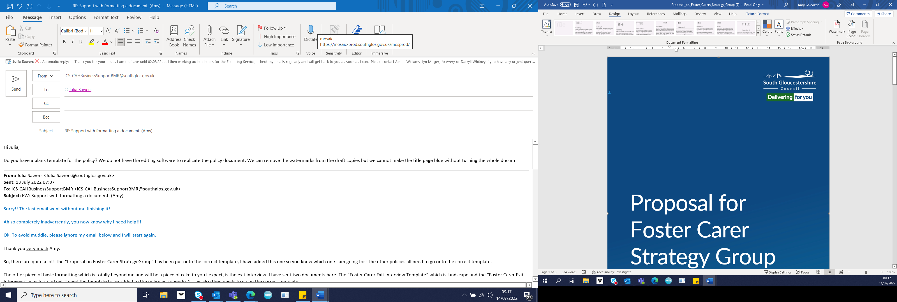

Fostering Service

Smoking and E Cigarette (Vaping) policy for Foster Carers

Authors: Kathy O’Mahony, Fostering Task Force
Date: April 2020
Reviewed: October 2022. Julia Sawers & Liz Dando
Review date: October 2024

Contents
 | Content | Page
 | Introduction | 2
 | References | 2
 | The law | 2
 | The impact of smoking on health | 3
 | Smoking policy for foster carers | 3
 | E-cigarettes or vaping | 4
 | Young people who smoke | 5

Introduction
South Gloucestershire Council is committed to ensuring that all children and young people in care are able to live healthy lives. This policy puts out our position with regards to foster carers smoking and the use of e-cigarettes.

The health risks of smoking are well known. Smoking is the single biggest cause of preventable ill health and premature death in the UK and is the biggest cause of inequalities in death. Exposure to second-hand smoke also presents a serious risk to a child’s health. Tobacco smoke contains over 4,000 poisonous toxins such as hydrogen cyanide, arsenic and formaldehyde which are left on clothes and furnishings within a home. Having a parent or carer who smokes significantly increases the likelihood that a child will smoke. It is therefore in the interests of all children to be raised in a smoke free home, ideally by non-smoking carers.

E-cigarette use or ‘vaping’ has been increasingly common since 2012 and there are currently around 3.6 million e-cigarette users (vapers) in Great Britain. The most common reasons for vaping are to quit smoking or cut down on smoking and the vast majority of vapers are current or ex-smokers. Current evidence demonstrates that vaping is significantly less harmful than smoking.

References
This policy should be read alongside:
- ASH, (Action on Smoking and Health) and the Fostering Network, “Foster care, adoption, smoking and vaping”. June 2022
- South Gloucestershire Tobacco Control Strategy

The law
The law relating to smoking and vaping can be found in:
- The Health Act 2006
- Children and Families Act 2014
- Nicotine Inhaling Products (Age of Sale and Proxy Purchasing) Regulations 2015

The relevant legal information is contained in the table below:
Activity | Tobacco and cigarettes | E-cigarettes
Smoking/vaping or allowing someone else to smoke/vape in private vehicles carrying under 18’s | Illegal since 2015 | Not currently prohibited
Sale to under 18’s | Illegal since 2005 | Illegal since 2015
Proxy purchasing (purchasing tobacco or e-cigarettes on behalf of someone under the legal age) | Illegal since 2014 | Illegal since 2015

The impact of smoking on health
There are many studies conducted into the health impact of smoking on children. The references for the following information can be found in the document already highlighted above: ASH, (Action on Smoking and Health) and the Fostering Network, “Foster care, adoption, smoking and vaping”. June 2022
Children are particularly vulnerable to the damaging effects of second-hand smoke because of their smaller, maturing and developing organs. Some research results show:

- They have 5 times the risk of Sudden Unexpected Death in infancy.
- 17,000 hospital admissions per year due to parental smoking.
- Bronchitis and pneumonia rates increase and can lead to long term respiratory problems.
- Increased rates of asthma by 50%.
- Increased rates of glue ear
- Exposure to second-hand smoke may impair mental development and lead to neurobehavioral disorders and increased risk of behavioural problems in school age children.

Any illness will have additional secondary impacts, for example, absence from school due to ill health might have the potential for a child to miss out on learning and development.

Smoking policy for foster carers
The aim of the council is to work towards placing all children in non-smoking households.
- All carers should be encouraged to stop smoking. Carers will be asked to seek medical advice about the risks of smoking in the home and given support to make a plan to stop smoking.
- Children under 5 will not be placed with foster carers where anyone who lives in the household smokes either indoors or outdoors.
- Children with disabilities who have existing respiratory problems, eg asthma, heart problems or glue ear, or other medical conditions deemed relevant by the medical advisor, must not be placed with foster carers who smoke.
- Where a child has come from a non-smoking household they will be matched with a non-smoking household. A child should never be moved to a placement that poses greater health risks than their current circumstances.
- Every effort will be made to take into consideration the views of children and families regarding potential foster placements where carers or household members’ smoke. All older children, who are able to express a view, have the right to request a non-smoking fostering family.
- Fostering applicants who have successfully given up smoking will not be approved to foster children under the age of 5 years or those listed under (4) above, until they have given up smoking successfully for a minimum period of 12 months. This is because relapse rates in the first three to six months are high; after six months the risk of relapse is less, and the likelihood of stopping permanently after 12 months is high. The carers commitment to stopping smoking should be monitored through foster carer medicals and annual reviews. A minimum 12 months cessation is required to be considered a non-smoker.
- If children are living with foster carers who smoke and they develop medical conditions such as outlined in (4) above, this will be discussed with the foster carers by the supervising social worker with advice from the medical adviser. Any decisions about a change of practice within the household will be put in writing to the carers and considered in the foster carer annual review.
- For new carers information from this policy will be covered at the recruitment stage.
- Carers who do smoke are expected to create a smoke free home. A smokefree home is a home where nobody smokes inside, - this includes leaning out of a window or door with a cigarette so that cigarette smoke is not drifting in from people smoking outside. The advice is that a person should take seven steps outside if they need to smoke and close all doors and windows to stop smoke drifting inside. It is best to remove lighters and ashtrays and to encourage visitors to smoke outside. Anyone who smokes is advised not to smoke in front of children and young people.
- In all connected care placements, both long and short-term fostering, the additional health risks to the child of being placed in a smoking household need to be carefully balanced against the benefits of the placement for the child. Where children and young people are placed with connected carers, we recognise that the bond between the child and their carer is likely to be significant. In such situations, this policy should be used as best practice, every effort should be made to encourage the carer to give up smoking and create a smoke-free home for the child. Smoking cessation plans should be discussed with the foster carer who should be signposted to obtain professional advice.
Electronic Cigarettes (Vaping) policy for Foster Carers
There is a significantly reduced risk in vaping compared to smoking. The use of e-cigarettes has become more widespread and can provide a route for smokers to help them reduce or give up smoking. Such products have been developed more recently and due to this, the evidence about their use in terms of effects on health continues to evolve.
Public Health England reports published in 2015 and updated in 2018 concluded that e-cigarettes are significantly less harmful than tobacco, whilst acknowledging that they are not completely risk-free products. (McNeill et al (2015, 2018).

Information about e-cigarettes is laid out below:
- E-cigarettes are also known as vapes and are not the same as tobacco cigarettes.
- Unlike cigarettes, e-cigarettes do not contain or burn tobacco and do not produce tar or carbon monoxide. As such, e-cigarettes are not covered by legislation applying to smoking or tobacco.
- Most e-cigarettes contain nicotine in an e-liquid which is heated and delivered orally to users in the form of vapour, rather than smoke. This means that e-cigarettes are vaped rather than smoked. E-cigarettes are much closer to licensed nicotine products, such as sprays, patches and gum, than they are to cigarettes.
- Nicotine is an addictive substance. However, the greatest harm caused by cigarettes comes from the other toxic chemicals released in cigarette smoke when tobacco is burnt, including carbon monoxide and tar.
- Other components of e-liquids are vegetable glycerine, propylene glycol and flavourings.

South Gloucestershire does not preclude foster carers due to their usage of e-cigarettes/vaporisers, however this policy will remain under review as more research is conducted.

The following guidelines should be adhered to:
- If carers, or other members of the household, are using e-cigarettes/vaporisers, they should do so only when children (of all ages) are not present.
- Carers should not vape in the car.
- E-cigarettes/vaporisers cannot be sold to children/young people under 18 years in the UK. Carers should not purchase such items for young people under 18.
- Equipment used for e-cigarettes/vaporisers must be kept safely and out of reach of young children. There has been an increase in cases of poisoning of young children associated with ingesting the liquid used.
- Foster carers need to be mindful that their behaviour provides a role model for the children in their care and they must consider the effect of vaping on children and young people.

Young people who smoke
Foster carers should be given appropriate support and guidance to address the smoking behaviour of children in their care, including enabling them to access specialist support to quit from healthcare professionals.

Foster carers should actively encourage children and young people who smoke to seek advice and guidance to help them give up. Some useful information and tools are available free on the Smokefree website; this includes kits and apps that may be useful to work with children and young people.

Vaping is not a recommended substitute to smoking for children under age 18 and children who are vaping should be supported, with advice from healthcare professionals, to use licensed nicotine replacement therapies instead.

Carers are expected not to enable smoking by looked after children, for example by ensuring that they do not provide cigarettes or tobacco for them, and cigarettes should never be used as a reward for good behaviour.

Foster carers must not purchase cigarettes or tobacco for children and young people under the age of 18 years. It is illegal for young people themselves to buy or be sold cigarettes or tobacco.

