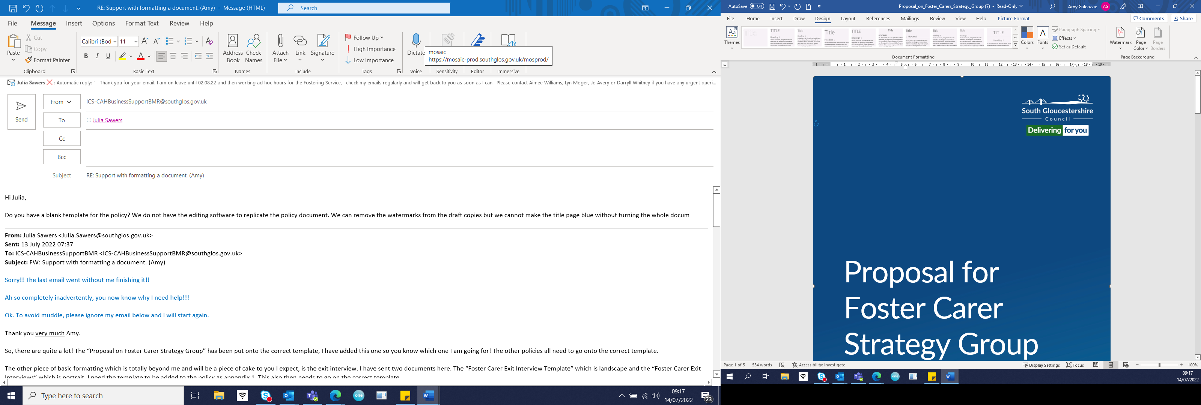

Fostering Service

Unannounced Visits to
Foster Carers
Best Practice Guidance

Authors: Aimee Williams and Fostering Task Force
Date: January 2020
Reviewed: October 2022 Julia Sawers
Review date: October 2024

Introduction

Unannounced visits to the fostering household are an important part of safeguarding. The purpose of the visit is to ensure that the standards required of a fostering household are maintained at all times, and not just when a visit is made by appointment. By undertaking an unannounced visit, we can be reassured that the standards of cleanliness and hygiene are maintained, that the child or young person is incorporated fully and equally into the home and that the description of family life which is relayed verbally to a supervising social worker in supervision visit, is observed and evidenced in the unexpected visit.

Legal Framework

Unannounced visits are required in fostering regulations, this guidance sets out how we will be compliant with the regulations.
National Minimum Standard 21 is about the supervision and support of foster carers. In this it is stated that:

“Each approved foster carer is supervised by a named, appropriately qualified social worker who has meetings with the foster carer, including at least one unannounced visit a year.”

This is further reinforced in paragraph 5.67 of the Fostering Guidance (2011) which states:

“Every foster carer should be allocated an appropriately qualified social worker from the fostering service (the supervising social worker) who is responsible for overseeing the support they receive. It is the supervising social worker’s role to supervise the foster carer’s work, to ensure that they are meeting the child’s needs, and to offer support and a framework to assess the foster carer’s performance and develop their skills. They must make regular visits to the foster carer, including at least one unannounced visit a year.”
Fostering Guidance (2011) paragraph 3.82 states that:

“The Fostering service must have a written health and safety policy, which should be covered in the assessment and training of foster carers. Foster carers should be supported to ensure that their homes are free of avoidable hazards, in keeping with family life. Every foster home must be visited without appointment by a supervising social worker of the fostering service at least once a year, as a check on the standards of care being provided”.
National Minimum Standard (10.5)

“The foster home is inspected annually, without appointment, by the fostering service to make sure that it continues to meet the needs of foster children”.

South Gloucestershire’s Policy and Best Practice Guidance:
1. All supervising social workers have the responsibility to ensure that a minimum of one unannounced visit within every 12-month period is made to the carers they are allocated.

2. We aspire to a non-allocated supervising social worker making the unannounced visit. This is due to learning from serious case reviews where foster carers had been allocated the same supervising social worker for over eight years and they groomed their supervising social worker to “not notice” or ask questions about their household. Experienced foster carers can also coach new social workers which can lead to manipulation. Because of this abuse occurred unchallenged. (City and Hackney Safeguarding Children’s Board. 2014). Both foster carers need to be challenged about their practice and a “fresh pair of eyes” from an unallocated social worker can be a helpful way to monitor what is happening in the household. (Croydon Safeguarding Children’s Board. “Claire” 2017). The benefit of an unallocated worker means that person would be visiting without pre-existing detailed knowledge of the carers and can therefore make fresh observations.
3. Best practice in South Gloucestershire will be that a second unannounced visit is undertaken and one of these will be completed by an unallocated social worker. This would exceed National Minimum Standards.
4. At the unannounced visit all areas of the home should be seen; the garden and any out-buildings as consideration should be given to issues of health and safety of the security of any equipment or chemicals stored.
5. The social worker should be checking that standards are consistent throughout the home e.g., bedrooms for looked after children are of the same standard as other bedrooms within the foster home.
6. If any children are sharing a bedroom, it should be checked that a bedroom sharing assessment is completed and up to date.
7. If the foster carers are not at home and the looked after child or young person is home, the social worker should check what the arrangements are for the supervision of the child or young person (e.g., alternative carer, or if there is none when the carer is expected home). However, if the alternative carer is not known to the social worker, then the visit should not continue and will need to be undertaken again. Best practice would mean that at least one unannounced visit per year should include both carers, foster children in placement and carers own children.
8. If it is not possible for the social worker to see all areas of the home and undertake appropriate checks a further unannounced visit should be completed.
9. If the social worker visits and does not get an answer then a note should be left for the carer to say the social worker has called and this should be recorded on the fostering file as an attempted visit.
10. A write up of the visit should be given to the foster carer in the next supervision visit and it should be recorded that the carer has received this. The team manager should also be informed in supervision that an unannounced visit has taken place so that compliance in this area can be tracked. It must be clearly recorded on Mosaic as an unannounced visit so that it can also be reported on.
11. Any issues arising from the unannounced visit should be addressed at the time of the visit and reinforced at the next supervision session.

12. Unannounced visits must be ‘unannounced’ with the carers given no prior warning. They could take place at any point of the day/evening, and over weekends. They should however be attempted when you would reasonably expect the children to be there, e.g., not visit during school hours or when you know they will be at a planned after school activity.

