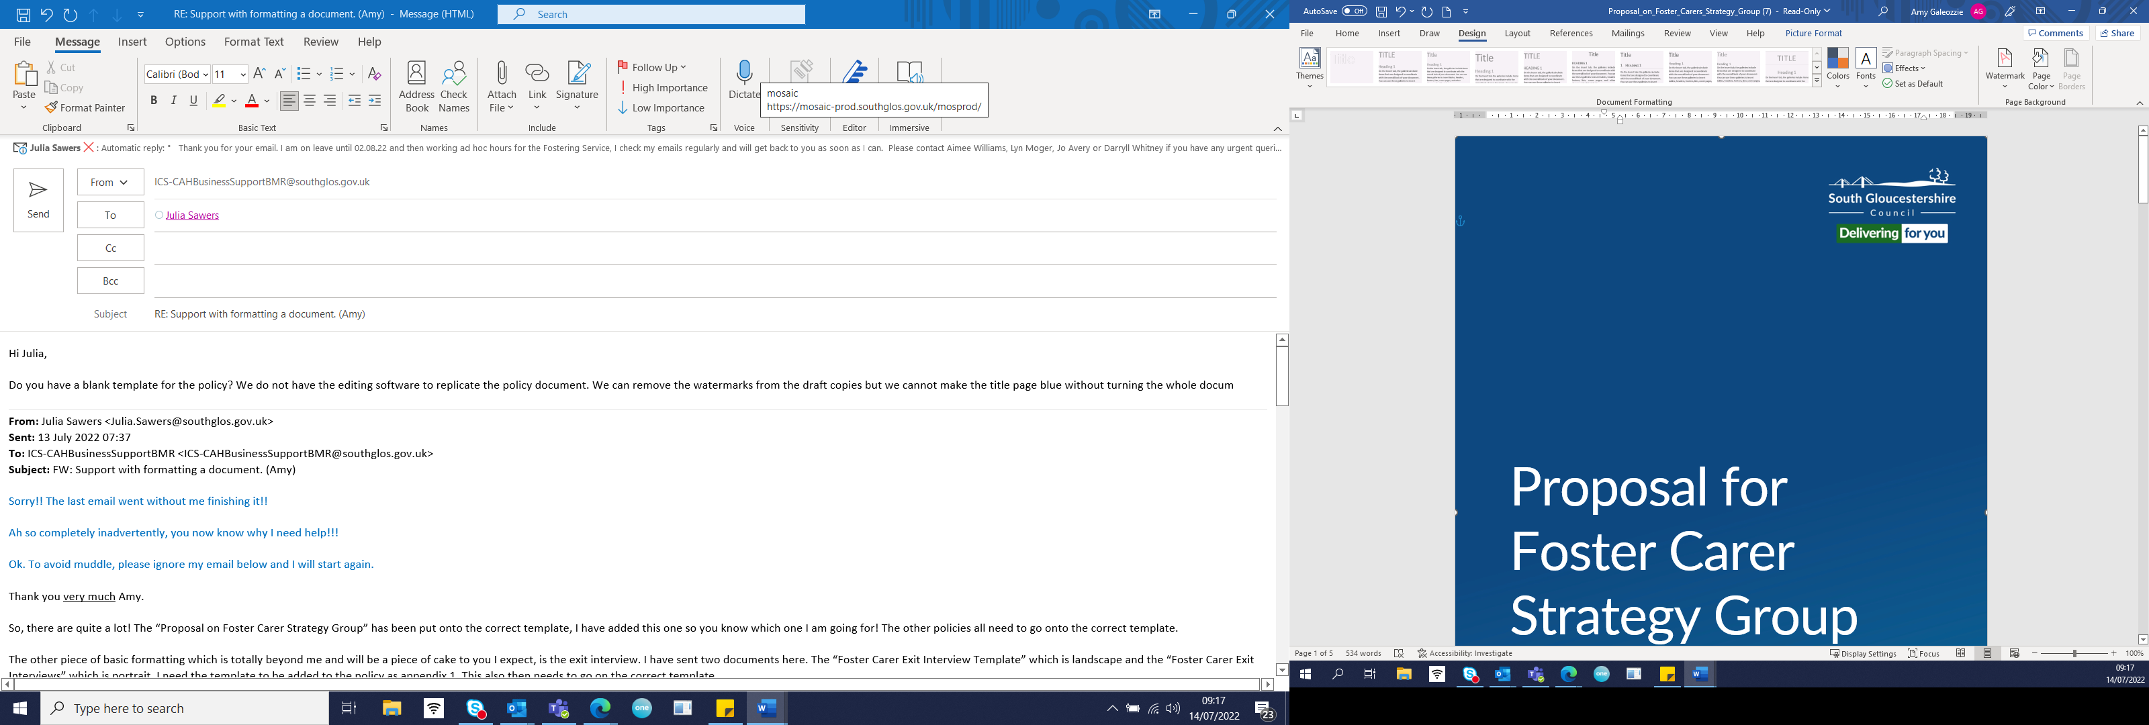

Fostering Service

New Partner Policy

Author: Julia Sawers Fostering Task Force
Date: June 2022
Review: June 2024

Introduction

South Gloucestershire Fostering Service values family life and sees it as a really positive environment for children to grow and thrive. Foster carers may be approved when they are single and in time form a new partnership or significant relationship during their fostering career. The Fostering Network define a new partner as:

“A significant person with whom the foster carer is having or intending to develop an intimate relationship, which is committed and serious”.

This policy sets out how South Gloucestershire Fostering Service will work with foster carers who want to introduce a new partner into the fostering dynamic whilst at the same time keeping in mind the potential impact of this on any child in care living with them. We want to balance the needs for the children to have stability and feel safe in their home with the rights of the carers to develop their personal lives.

All assessment is fundamentally about safeguarding vulnerable children. We want to transparently balance being confident that the new partner will not have any improper intent towards any children with not being unduly intrusive in a developing relationship. In addition, we want to consider what skills and understanding the new partner might bring to the family. Fostering is not simply about practical parenting; it is necessary to understand children’s trauma in order to know how best to care for them. A child who has had many inconsistent, or unsafe, adults in their life is likely to find it hard to accept someone who is new. It is possible that a new adult in the household will affect the child and may trigger memories of adversity; they may equally add great value to family life for the child. It is really important that we are mindful about how any change in arrangements might appear to a child and work together to mitigate any difficulties for them. The child will need reassurance that the same carer will continue to undertake their care. At regular periods through the emerging relationship, the supervising social worker should make sure they speak to the child and hear how they are feeling about the changing family circumstances.

Legislative and practice guidance

The Fostering Services (England) Regulations 2011

- Regulation 27: Approval of foster parents
- Regulation 28: Reviews and terminations of approval
- Schedule 5 (2)(b)(ii)): Changes to household composition

Children Act 1989: fostering services, Volume 4: statutory guidance on fostering services for looked-after children

- 5.31: “The Regulations refer only to approval of individuals. Where two people will be sharing the care of a child, whether they be a couple or any other partnership, they should be jointly assessed and approved as foster carers. Where a single foster carer takes a partner who will be sharing the care of any foster children, they must discuss this with their supervising social worker so that agreement can be reached about the best way to update their assessment and to assess the partner for approval as a foster carer within an appropriate timescale.”

Disclosure and Barring Service: guidance for children's social care providers and managers

Non-resident partners of foster carers: “Providers and managers must show that they have an effective policy to monitor foster carers’ relationships. They should guide foster carers on how to manage non-resident partners’ access and responsibilities for the children and young people they foster.”

Foster carer agreement

Under the Regulations, no one can foster without signing a foster carer agreement. This is like a contract laying out the requirements placed on foster carers in caring for children, and the expectations they can have of South Gloucestershire to support and supervise them.

Page 6 of South Gloucestershire’s foster carer agreement states:

“The Foster Carer agrees to inform their fostering social worker of:
- any change in the composition of the household
- any other event affecting carers’ capacity to care for any child/young person placed such as separation/divorce,”

It is therefore a requirement that the foster carer informs the supervising social worker when circumstances surrounding their relationship status alters.

Stages of a new relationship

We acknowledge that relationships develop in different ways and at different speeds. We do not wish to push new partners into a more committed relationship than they are ready for due to our assessing requirements, equally we need to be confident that any fostered children are safe and will thrive.

At each stage of a developing relationship there are actions for the foster carer and for the supervising social worker. See the various stages below:

- Early stages of getting to know a new partner
- The relationship is developing and there is a likelihood that the new partner will become a regular visitor to the home
- Safeguarding checks are completed
- Firmly established relationship and the new partner joins the home.

- Early stages of getting to know a new partner.

When a foster carer has met someone who might become a new partner, they should inform the supervising social worker (SSW). The new partner should not know anything about the fostered children nor visit the foster home at this stage. The SSW should not ask any intrusive questions about the new partner whilst the foster carer is just getting to know the person and whilst they are finding out if a relationship might develop.

The foster carer will be thoughtful of the impact on any children living with them if they are out very frequently in the evening or away at weekends meeting the new partner. It is expected that they will make safe choices under delegated authority about who might babysit the children living with them.

As the emerging relationship develops, the foster carer should tell the new partner of the requirement for safeguarding checks to be made about anyone who might be a regular visitor to the home or join the household. Nobody has frequent unsupervised contact with looked after children without checks being undertaken.

- The relationship is developing and there is a likelihood that the new partner will become a regular visitor to the home

As the emerging relationship develops to this new phase, the foster carer should inform the SSW. A Disclosure and Barring Service check should be undertaken on the new partner; this means that the SSW will meet the new partner when they confirm their identity documents for the DBS check and will provide an opportunity for them to answer any questions about fostering. In addition, with the new partner’s consent, the SSW should undertake a South Gloucestershire Local Authority check.

The SSW should tell the child’s social worker of the emerging relationship and the measures in place to support the carer and the child in this phase.

- Safeguarding checks are completed

Once the safeguarding checks have been processed and show no adverse information, then the SSW, the child’s social worker and foster carer should consider how the relationship with the new partner will be broached with the child and how they will be introduced. At every stage, all the adults should be mindful of the potential impact on the child. The SSW should ensure they speak with the child to hear their views about the new person. This should be recorded as a separate case note. The exact nature of the developing relationship should not be explained to the child because it is still fragile and may not be permanent. If the relationship does not last, it could appear to the child to be another adult who is not reliable in their life. At this stage all the practical care for the child will remain with the foster carer and delegated authority is given only to them.

Overnight stays by the new partner should not be planned too soon, as children will benefit from getting to know their carer’s new partner first. Foster carers need to speak with their SSW to agree the best timescale around overnight stays commencing. The impact upon the fostering household and individual children needs to be carefully monitored by the SSW through regular visits and supervision meetings. The SSW should make sure they speak to the child alone to hear their views and any worries they might be carrying. The new partner will need to understand about the expectation for a full fostering assessment if they move into the foster home permanently.

- Firmly established relationship and the new partner joins the home

There is an assumption that new partners joining a foster home will be involved with the care of the children. It is for this reason that a fostering assessment should be well underway before the new partner joins the home and all normal statutory checks and references need to be taken up. The new partner must complete the Skills to Foster training.

As with any fostering assessment, the home study CoramBAAF F form should be completed about the new partner. The assessment should also cover information about the new relationship:

- how the couple will manage living together and fostering together
- how their respective parenting styles and their roles will blend or complement each other
- how their relationship would cope with stress and family life and how supportive the new partner will be
- where a new partner has children, whether the children will join the household or be regular visitors and the impact of this
- the impact on children in the household as the relationship has developed, and the quality of the relationship between the children and new partner
- how will confidentiality be discussed, agreed, and maintained?
- how will safer caring practice in the house be reviewed, updated, and supported?
- how will the views/feelings of the child/ren cared for be heard and explored?
- will there be a move to another property?

This information, along with the foster carer’s original assessment and most recent annual review should be presented to the foster panel within six months of the new arrangements.

Following a positive recommendation from panel and the agreement of the Agency Decision Maker, the new partner is approved as a general mainstream foster carer. At this stage, they should also be named in the delegated authority document.

Exceptions to this process

It is hoped that through focusing on the need to safeguard all children, foster carers and their new partners will be willing to follow the process as above. It is understood however, that this may not fit with their plans, and we want to be sensitive in working with them whilst maintaining a strict emphasis on safeguarding.

- What if a new partner wants to be assessed but does not want to move in?

In these circumstances we will undertake the assessment as explained above. The difference will be in explaining the situation well to the children living there so that there is consistency in their experience of the presence of safe adults in their life.

- What if the new partner wants to move in but not be assessed?

Any consideration of a partner purely as a household member raises significant issues, - how realistic it is for a live in partner not to share the care of a child. Despite them not wishing to have an assessment they must have the safeguarding checks undertaken: this is not optional. The supervising social worker will hold an open discussion about the reasons why the new partner is reluctant to be assessed. We will undertake a review of the impact of a new adult joining the fostering household as would happen with any other new adult, precisely clarifying the actual role in relation to the care and contact with the children living there. We would want a clear demonstration that the new partner will not be sharing the care of a child, along with consideration of how this could impact upon children and the household dynamics.

A further point to consider is that if a new partner who was not assessed as a foster carer, had an allegation made against them, the Fostering Service would not offer them support in the way we would support an approved foster carer.

- What if a new partner moves in without informing the supervising social worker

It is important to be really clear that all checks and considerations are made with safeguarding as the main objective. If a foster carer moves an adult partner into their home without informing the Fostering Service, they have broken their fostering agreement and the matter will need to be referred to the Fostering Panel as a Standard of Care matter with a review of their fostering arrangements.

Written with information from The Fostering Network Practice Information Note February 2022

