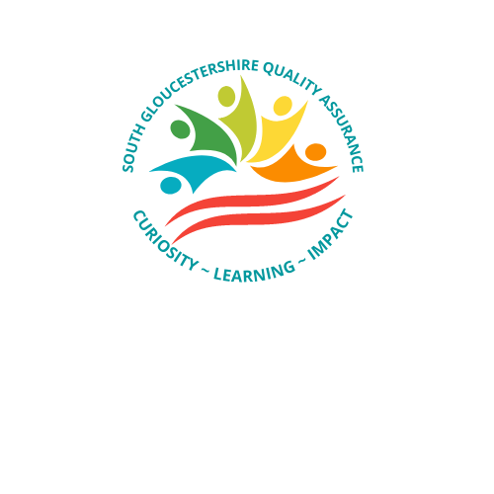

Quality Assurance – Closing the Loop

CLOSING THE LOOP / SHARING THE LEARNIING
Effective QA activity enables us to reflect on the effectiveness of our practice standards and how these support us in achieving positive outcomes for children. With reflection comes challenge and the opportunity to learn from what works and change that which needs to be different.
Closing the Loop, learning and making a difference for children is the responsibility of us all, our QAF is rooted in reflection, feedback, and learning; this Closing the Loop Document sets out some of the ways we hope to achieve this. The cycle for closing the loop occurs using a systemic approach with each element reinforcing the others.
- Self-reflection – exploring your own practice standards and those of others.
- Supervision – opportunity to reflect, learn from each other, challenge and develop practice standards and improve outcomes for children.
- Team meetings – sharing of information, reflecting on trends, performance data and audit outcomes, working together to achieve consistency for children and their families.
- DMT – oversight of the big picture and what areas need to be prioritised to retain focus whilst reviewing the pace of change which is taking place.
- QA SMT – reviewing the collective QA data, identifying trends and patterns, and developing a response to these.
- QAOF – drawing together the experience, sharing the learning and confirming what actions are required to progress situations, services, responses, and outcomes for children.
How will we know we are making a difference and learning from what we do?
- Children are kept safe.
- Children are supported to thrive and achieve.
- Children can remain connected to their families, friends, and communities.
- Feedback provides us with a clear narrative as to what works and the impact we had on children and their families/carers.
- Audit activity highlights what’s working well, and outcomes judged to be Good continue to increase.
- Audit judgments linked to inadequate features reduce.
- Performance data will indicate an upward trend in timeliness.
- Supervision and direction for plans will be visible and up to date on children’s records.
- Case notes will tell a story which helps us to understand the impact of help provided to children and their families.
- Collaboration with partner agencies will support children to feel safe, connected and thriving.
- Families will be supported to manage/ be involved with safety/wellbeing plans enabling children to be safe and remain connected.
- Quality of assessments is seen to improve.
- Review of plans is timely enabling right help at the right time.
- Staff will tell us they feel supported and able to work with children and their families; enabling confidence and retention to increase.
- There will be consistency in what we do, how we do it and when it is done.
Activities which support closing the Loop, sharing the learning, and making a difference for children.
The following activities support how we close the loop, these are not exclusive, but they are the minimum of what we need everyone to do in order that we can support making a difference for children whilst raising standards in how we do things.
Activity | What we need to do
Audit Activity | We need to use audit activity to support driving forward plans for children, share, and learn from what works, and make changes to practice where it does not meet the standards expected.  - Practitioners will use audits to reflect on practice standards and what action if any needs to be taken to improve outcomes.  - Managers will reflect on audits within supervision and use the findings to identify actions which would be of benefit for the child.  - Managers will share audit findings in Team meetings enabling reflection and learning to take place within teams.  - Service managers will use audit findings to inform and update service area development plans enabling themes and emerging trends to be responded to.  - Every Inadequate audit will have a SM response recorded within 1 week of the audit being returned, setting out reflections and what steps need to take place to move this from the position of inadequate.  - Every TM will respond to inadequate audits within 1 week setting out updates, reflections and actions which will move this from a position of inadequate and improve the outcomes for the child.  - Inadequate audits will be reviewed every month by the QA manger to ensure matters are progressing for children.  - Learning Briefs are produced on a regular basis which highlight audit findings and what we can learn from this.  - Quarterly Audit analysis reports are produced which are used by SMT and DMT to inform improvement plans, training needs, sharing good samples of work, and holding each other to account.
Learning Briefs, and QA audit analysis reports | These reports are produced to share the findings setting out what is working well and what areas of practice require additional focus. They contain examples of good practice, links to resources, policies, and tips. They reflect on feedback and highlight patterns and trends which may need to respond to.  - Teams need to use these reports and reflect on the learning bot on an induvial and team level.  - SMT and DMT will use the reports to inform training needs, improvement plans and areas for focused intervention.  - SMT will use the quarterly report to identify areas for improvement within their service area, this will be reviewed at the next quarter.
Team Meetings | Within South Gloucestershire we expect every team to meet a minimum of monthly, we want practitioners to feel involved and therefore we seek their views on what’s going well and what are the barriers/difficulties within their practice. We want practitioners to share pieces of work, seek support, help, and challenge on what was undertaken. We want to develop a culture of high support, reflection, challenge, and learning.
Training & Development Activities | Feedback from QA activity shapes future learning opportunities within the organisation, this enables us to review policies and procedures and ensure the training programme reflects the level of practitioner need.  Additional ad hoc workshops will be available to respond to practice and learning matters as they arise.
Performance data | Performance data is produced at different times of the month, we expect TM and SM to use and share the data within teams so that collectively we can target gaps and identify trends in need.
Feedback | Feedback from audits, complaints, compliments, and any other source of information is used by SMT to identify strengths and areas for improvement, this information is shared within the service areas in order that we can reflect on the voice and use that to further develop the help which is provided.

