South Gloucestershire Council’s

Placements Sufficiency Strategy

for Children in Care and Care Leavers

2023-2027

Content

* Introduction
* Methodology
* Headlines
* South Gloucestershire Sufficiency Requirements
* Related Documents and Strategies
* National Context
* South Gloucestershire Population
* Statistical Analysis
* Outcomes
* Costs and Funding
* Commissioning Arrangements
* Service Areas

System Approach

Family Support and Kinship Care

Special Guardianship

Adoption

Foster Care

Residential Care

Unaccompanied Asylum-seeking Children

Care leavers

**INTRODUCTION**

Priority 1 of the Council plan creating the best start in life for our children and young people.

(Link to Council Plan)

This sufficiency strategy has been developed to support the council to deliver its vision and ambitions for children and young people and to meet its statutory duties.

The Sufficiency Duty, under Section 22G of the Children Act 1989, requires the council to take steps to ensure, as far as practicable, we can provide children in care with homes that meet their needs, within our area. This involves making sure there is a sufficient range and number of providers capable of meeting the differing needs of our children in care and care leavers.

We recognise that the ability of the Council to meet its duties relies on responding to and managing demand as well as managing the market and that the key priority is ensuring that children and young people are supported to develop and thrive in the most enabling environment possible. We believe that there are three principal ways, through this strategy, in which we will achieve this outcome:

* Sufficiency – Establishing whether we have enough of the right range of provision, and in the right proportion, to support these outcomes for children, young people and families and to plan robustly for those areas where supply is short
* Quality – Determining whether we have effective, local and high-quality services to support these outcomes for children, young people and families and to plan to improve quality where we are concerned
* Value for Money – Ascertaining whether we have the right balance of cost and impact in the provision we commission to support these outcomes for children, young people and families and to take steps where we feel we can drive down cost without compromising quality and outcomes.

The sufficiency duty applies in respect of all children who are defined as “looked after” under the Children Act 1989 and to ensure that the local authority delivers its corporate parenting responsibility for children in care as they transition to independence after 18, the strategy also covers provision of placements of placements for 18+ care leavers.

Methodology

This strategy will identify strengths, gaps and opportunities within the current market and establishes the development required both internally and externally locally to find better ways of meeting the needs of looked after children.

South Gloucestershire Council will work to the following priorities:

* To deliver outstanding services to the children, young people and families we work with
* Children and their voice will always be at the centre of what we do.
* To support families and communities to play their role in keeping children safe and enabling them to thrive
* To work with families to identify their strengths and build on these to enable children and young people to thrive within their family wherever possible.
* Where needed, we will intervene decisively to ensure the immediate safety of children

South Gloucestershire aim to do this by ensuring children, young people and families consistently receive high quality practice, support and intervention, at the time when they need it and at a level that meets their assessed needs.

In addition to consulting on any market position statements and policies that are developed as a result of this strategy, we will build key performance indicators into our contracts that service development must be co-produced with children and young people and their families.

Headlines

* South Gloucestershire Councils Children in Care (CIC) population has fluctuated since 2021 with significant increases in the numbers of unaccompanied asylum-seeking children entering the Area. In 2018 only 6% CIC were unaccompanied asylum -seeking children in July 2022 that figure had increased to 21% and the total number of CIC was 278 look forward to July 2023 and the CIC population is 214 young people with 14% of those young people being unaccompanied asylum- seeking children. South Gloucestershire Council expects variances to continue in the CIC population.
* Although the CIC numbers have decreased since July 2022 The Council has seen the costs of all placements rising significantly. There is also a lack of placement availability that can meet the needs of our children and young people.
* The number of young people needing residential Childrens homes provision (Not Residential Schools see SEND Strategy) has been consistently between 18 and 24 young people at any one time mostly placed out of area due to oversubscribed independent Childrens homes within South Gloucestershire or homes not being able to meet the needs of children.
* The number of young people placed with independent fostering agencies have also reduced from 46 young people in July 2022 to 35 young people in July 2023 this is due to a lack of availability from the independent market and this has seen an increase in the number of young people being placed in independent 16 plus accommodation.
* There is insufficient step-down provision from crisis placements to stable children’s home placements, into foster care, or return home. The Fostering Service is undertaking a review of its banding levels in order to create a banding level for carers who are able to provide step down placements for children from residential care to foster care.
* In 2022, the Therapeutic Parenting Pathway Project (TPPP) combined with the Families Together Service to create the ‘Waypoint’ service which aims to prevent children coming into care unnecessarily, support a return home if children do come into care by facilitating reconciliation work, and to provide support placement stability and to prevent placement breakdowns.

South Gloucestershire Sufficiency Requirements

* Increased in-house & independent foster placements within South Gloucestershire borders or in reasonable traveling distance of South Gloucestershire with experienced foster cares that can meet the varying needs of young people. Cares that can work with young people that are ready to step across from residential to more mainstream long-term placements in preparation for adulthood including foster carers that can meet the changing demographics of young people coming in to care and are representative of their needs.
* Residential homes that can meet the needs of complex and challenging young people with a range of needs including Special Educational Needs and Disability. That can work to step across from fostering or independent living preparing children and young people for independence.
* Registered 16 plus independent accommodation that can work with Children in care and care leavers which can support young people into education employment and training and prepare them for their own tenancy including placements for unaccompanied asylum-seeking children.
* Support our care leavers to remain with their foster carers through ‘staying put’ arrangements as they transition towards independence. We also need to increase our supported lodgings provisions for those older children entering care who wish to live within a family home but have more independence in line with their transition to adulthood.
* Suitable accommodation options for care leavers that enable them to access appropriate levels of support as they transition to independence. This also includes ensuring that they are tenancy ready and registered to bid on the housing register.
* Increase provision of local ‘parent and child’ placements that can contribute to parenting assessments without the need for parents to move to residential parenting assessment units which are often not located within their own local community. We need local provision to support parents to remain in their local communities where they can access their support networks whilst having their parenting capacity assessed.
* Regional Partnership with Adoption West to ensure that children with a plan are adoption are matched to appropriate ‘forever families’ and increase use ‘Early Permanence’ placements to progress permanence planning for young children as a priority.
* Promote the use of family network meeting prior to children coming into care to ensure that all family and friends options have been explored to enable children to be placed in their own family and friend network if they are unable to remain living with their birth parents.
* Promote the use of Special Guardianship to support children growing up within own family and friends network and provide legal permanence without the need for ongoing statutory involvement.
* Develop more shared care options to support families experiencing stress so that children and young people can remain living with their families whist we provide intensive therapeutic support to address the issues and strengthen family relationships.

Related Documents and Strategies

Links to

Regional Market position statement

Send Strategy

Corporate parenting strategy

Corporate Parenting Equality Impact Assessment

Local offer for care leavers

Joint Housing Protocol for Care Leavers

Placement Process

Permanence policy

Stable Homes Built on Love Govt Strategy

Children Act 1989

The Care Planning, Placement and Case Review Regulations 2010

[The Children Act 1989 guidance and regulations (publishing.service.gov.uk)](https://assets.publishing.service.gov.uk/government/uploads/system/uploads/attachment_data/file/1000549/The_Children_Act_1989_guidance_and_regulations_Volume_2_care_planning__placement_and_case_review.pdf)

[Fostering Guidance -](https://assets.publishing.service.gov.uk/government/uploads/system/uploads/attachment_data/file/274220/Children_Act_1989_fostering_services.pdf)

National Context

### Nationally out of the nearly 12 million children living in England, just over 400,000 (3%) are in the social care system at any one time. Just over 82,000 of these children are children in care as at 31st March 2023, across England, 152 LAs were responsible for ensuring and overseeing the effective delivery of social care services for children. We inspect these LAs to see how their children’s services are performing. (National Statistics)

### Local Authorities report significant pressures in providing enough good homes for children in care.

* Local Authorities are suggesting increasing demand for residential care, for children with complex needs and not enough specialist provision locally to meet the needs of the Children and young people. Demand is outstripping supply across the placements market and Local Authorities are competing for the same placements.
* Staying Put legislation introduced in 2014 allows young people to remain in their foster homes post 18; whilst this provides stability and security for the young people it reduces the number of available foster beds for young people coming into care.
* Nationally the Market is not responding fast enough to keep up with the growing need and provision is not equitable across the country. Demand is outstripping supply and Local Authorities are competing for the same placements.

South Gloucestershire Population

South Gloucestershire is largely rural in area but most of its population lives within the fringe of Bristol.

Over 40% of South Gloucestershire is covered by the green belt (green space) which surrounds and separates Bristol and Bath. It covers an area of 536.5 km2 and has a population of 290,423 as of the [2021 Census](https://beta.southglos.gov.uk/census).

South Gloucestershire has seen a 10.5% increase in residents since 2011.

Its growth in population over the last 10 years is higher than all of its neighbouring authorities, Bristol, Bath and North East Somerset, North Somerset and Gloucestershire ([ONS](https://www.ons.gov.uk/)).

The median age of residents of is 40. Like elsewhere in the country the population is aging.

Since 2011 there has been a 22% increase of people aged 65 years and over. There has been an 8% decrease in those aged 15 to 19, an 8% decrease in those aged 40 to 44, and a 7% decrease in those aged 45 to 49.

As of 2021, 8.8% of the district’s population were of black and minority ethnic origin.

In 2021, 30,643 (10.6%) residents of South Gloucestershire were born outside of the UK.

The top 5 non-UK countries of birth of residents are Poland, India, ‘other EU countries’, Romania and Germany and other EU countries ([Nomis](https://www.google.com/url?sa=t&rct=j&q=&esrc=s&source=web&cd=&ved=2ahUKEwiCicimudX7AhWQUsAKHVn7BpsQFnoECAkQAQ&url=https%3A%2F%2Fwww.nomisweb.co.uk%2F&usg=AOvVaw0vhfzLNO-83a_ib07jJEPm)).

Statistical Analysis

Children in care category of needs when accommodated

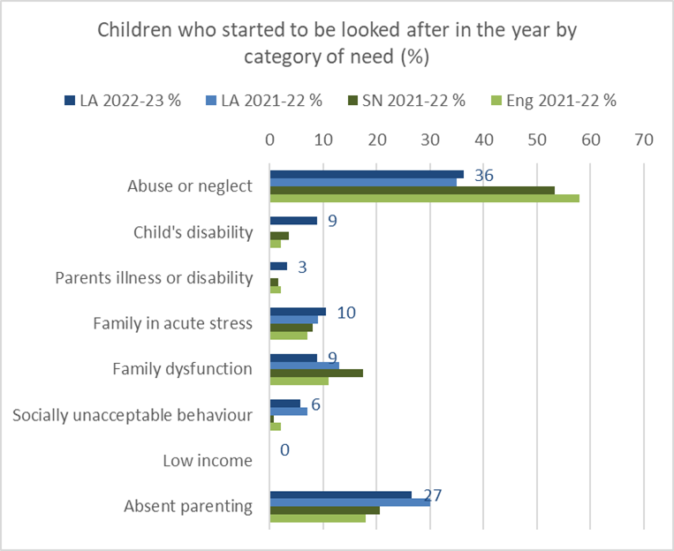

Placement types

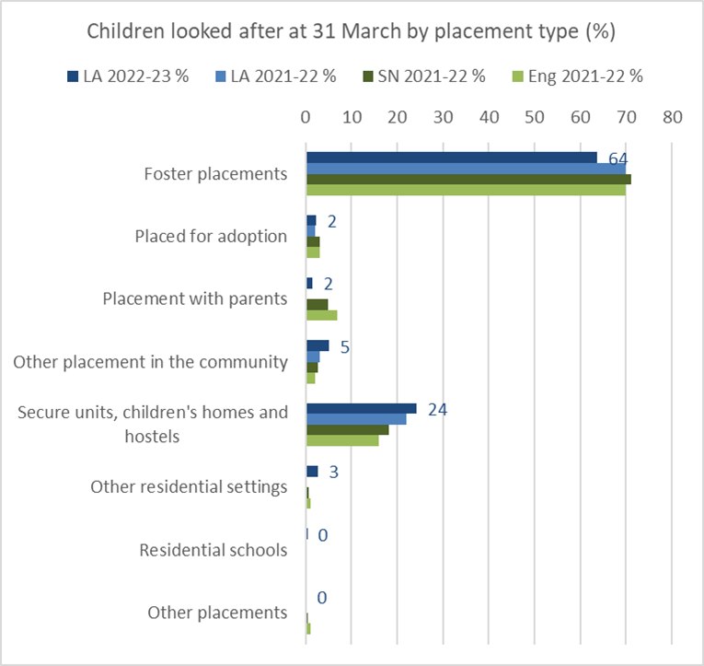

Percentage of children and young people placed Out of borough

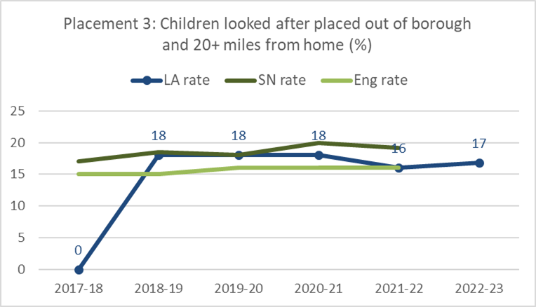

Percentage of children with three plus moves in 12 months

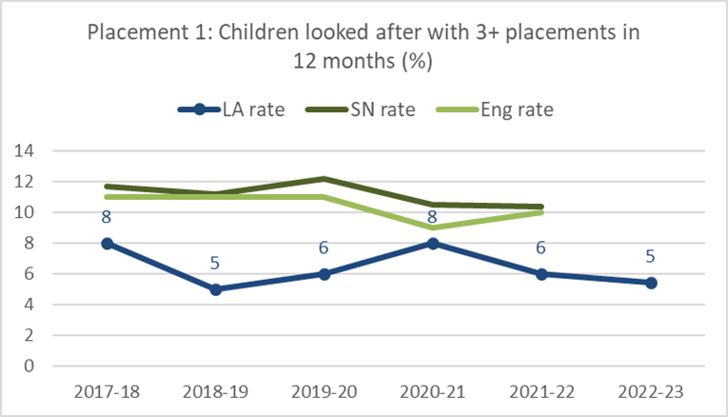

Percentage of Children and young people accommodated with for 2 plus years in the same placement.

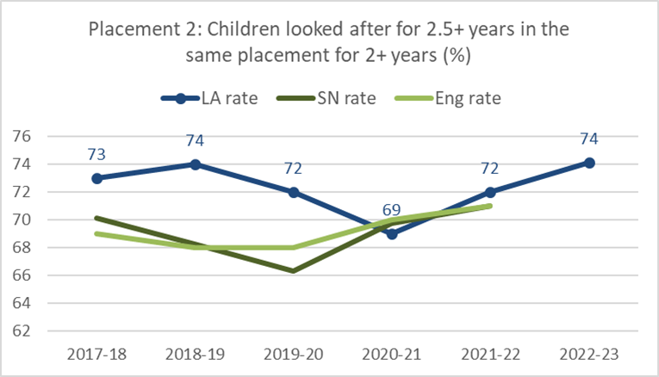

Outcomes

Our Corporate Parenting Equality Impact Assessment identifies that in relation to the experiences and life chances of care experienced people, a wide range of significant disparities have been identified in comparison to the population at large. Our Corporate Parenting Strategy 2023 – 2025 is clear on its vision, priorities and actions to improve outcomes for children in care and care leavers.

‘Corporate Parenting is the term used to refer to the responsibility of the council, to provide the best possible care and protection for children and young people who are ‘looked after’. At the core of this responsibility is the moral duty to provide the kind of support that any good parents would provide for their own children. This includes enhancing the quality of life of looked after children as well as simply keeping them safe.’ (*House of Commons Children, School and Family Committee, March 2009*)

**Vision**

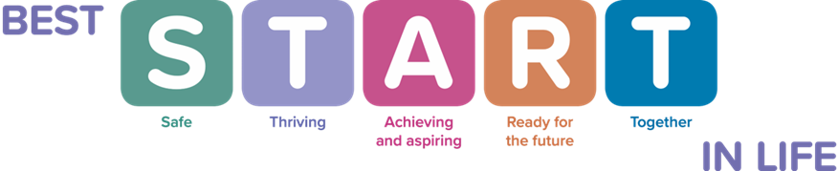

In South Gloucestershire, putting the vision into practice means that we will:

* always act in the best interests of every child and young person in our care, promoting their physical and mental health and wellbeing.
* always promote high aspirations and to secure the best outcomes for every child and young person in our care, encouraging them to express their views, wishes and feelings, and proactively take them into account.
* always ensure that every child and young person in our care has access to the services they need to ensure they thrive.
* always make sure that every child and young person in our care is safe, with stable home lives, relationships and education or work
* ensure that every child and young person in our care is thoroughly prepared for adulthood and independent living.

As Corporate Parents, we will ensure our children and young people feel cared for and valued by providing a standard of care that gives them stability and security so they will have the best possible chance to achieve good outcomes and a quality adult life. In caring for children and young people of varying ages, experiences and needs, there is a need for different kinds of placements, so we will make sure that there is a sufficient choice of placements within the borough. We also recognise the importance of listening to children and young people and responding proactively to them. We will seek their views about their care experience and explore with them how we can improve their lived experiences.

We will strive to make sure that children have a positive experience whilst being in care, by affording them good quality care and support, a stable placement that meets their needs, a positive relationship with their Social Worker and access to advocacy service when needed. We also know that permanency needs to be secured at the earliest possible point to ensure each child benefits from a stable, nurturing family.

Stable homes built on love is the strategy of the UK Government for children’s social care. The vision of this strategy is:

*“For Children to grow up in loving, safe and stable families and, where that is not possible, care provides the same foundations, so that all children can achieve their potential.”*

The strategy contains six pillars:

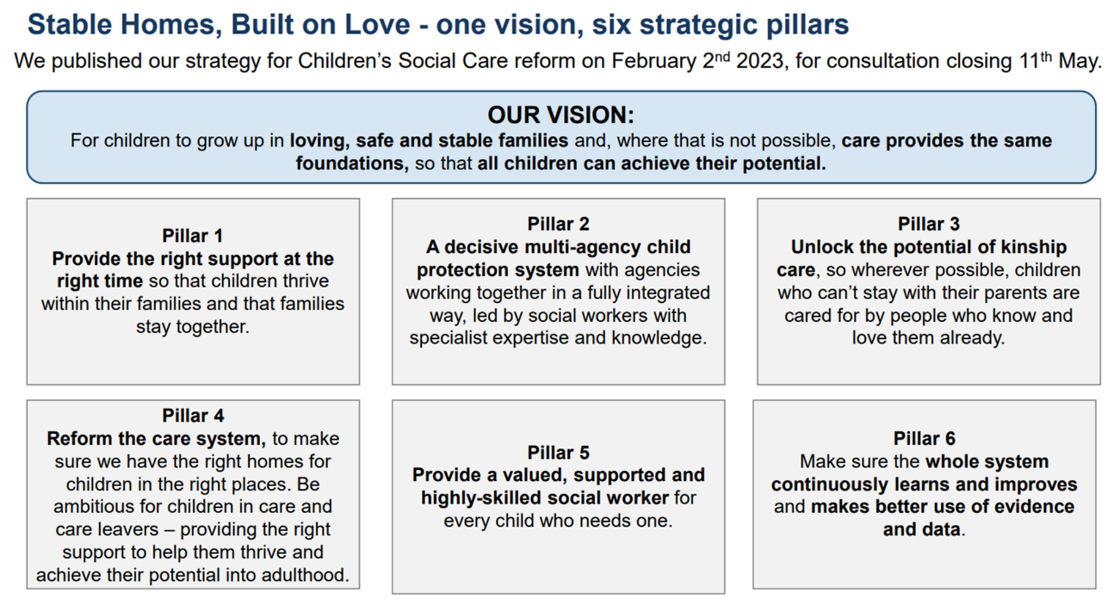

## Pillar 4 of the Strategy relates to children in care. The Government’s vision is that where children need to come into care, we provide them with stable, loving homes close to their communities. Children’s loving and safe relationships with both their families and care givers will be prioritised, and they will be listened to and have their needs advocated for.

The strategy states that a family-based home is best for most children to live in. Where children need specialist residential or therapeutic care, this should be provided as close to their home as possible.

To achieve this, the Government aims to transform the way we provide homes for children in care and care leavers, and to be far more ambitious for these children. Progress will be measured across six missions as follows:

•Mission 1: every care-experienced child and young people will feel they have strong, loving relationships in place

•Mission 2: we will see an increase in high-quality, stable and loving homes available for every child in care local to where they are from

•Mission 3: we will strengthen and extend corporate parenting responsibilities towards children in care and care leavers across the public sector

•Mission 4: we will see an improvement in the education, employment and training outcomes of children in care and care leavers

•Mission 5: we will see an increase in the number of care leavers in safe, suitable accommodation and reduce care leaver homelessness

•Mission 6: we will work closely with health partners to reduce the disparities in the long-term mental and physical outcomes of care-experienced people

In South Gloucestershire, we are committed to achieving positive outcomes for children in care; these missions form part of our sufficiency strategy to ensure that we are able to put “love, relationships and a stable home at the heart of being a child in care” in everything we do for our children in care and care leavers.

Spend 2020-2023

In house Fostering Service

|  |  |  |  |
| --- | --- | --- | --- |
|  | 2022/23 | 2021/22 | 2020/21 |
| Total | 2,970,645 | 3,080,315 | 2,308,031 |
|  |  |  |  |
| Independent Fostering Agency |  |  |  |
|  | 2022/23 | 2021/22 | 2020/21 |
| Total | 1,671,036 | 2,102,825 | 1,925,679 |
|  |  |  |  |
|  |  |  |  |
| Independent Residential children’s homes | |  |  |
|  | 2022/23 | 2021/22 | 2020/21 |
| Total | 5,788,374 | 4,772,887 | 4,728,316 |
|  |  |  |  |
| Care leavers 16 plus Care leavers support and accommodation | | |  |
|  | 2022/23 | 2021/22 | 2020/21 |
| Total | 2,902,333 | 2,915,515 | 2,838,582 |

Commissioning Arrangements

The Council has a mixed economy for delivery of placements for children in care and care leavers with internal provision and a range of consortia arrangements to secure placements from the independent children’s marketplace.

Internal

Foster Placements

Staying put Placements

Adoption placements

Parent and child

Special Guardianship

External

Fostering Placements

Residential placements

Housing related support placements

Semi-independent placements

Parent and child

The Council uses what is commonly known as dynamic purchasing system's these have seen some benefits with serval Local Authorities working together to create common process for establishing price, placement methodology, form of contract and quality assurance. Although The Dynamic purchasing systems have provided serval benefits the marketplace as not developed within South Gloucestershire or the Southwest as was anticipated, and demand is out stripping supply with the Authorities competing with each other for the same placements.

Looking forward South Gloucestershire will continue working in partnership with other Local Authorities and independent providers sub regionally, regionally and nationally to develop more sophisticated services that can be accessed by our children and young people at the right time in the right place with the right service to meet needs.

Service Areas

System Approach

We have developed a comprehensive placement and permanence planning process to ensure that we have a whole systems approach when considering the placement of children in care. In South Gloucestershire, we believe that every child has the right to a family life. Wherever possible we will support children to live with their parents or family. When this is not possible we take responsibility to ensure that they live with supportive and nurturing families. In the event that living in a family home is not an option we will make every effort to ensure they live in a children’s home which replicates family life as closely as possible.

Once in care every effort will be made to either plan for the safe return of children to their families or have a permanent alternative family as soon as possible. The next preferred option will be in-house fostering or Independent Fostering Agency (IFA) placement so that their right to a family life is upheld. Placement in a residential setting will only be taken as a last resort when all other options have been exhausted.

Placement matching will consider closely all the needs of the child/children in placement. Wherever possible siblings will be placed together unless assessment determines that it is not in their best interests.

All plans and reviews will be made, wherever possible, with the participation of the child. The child will be consulted on every decision and their views taken into consideration. There may be times when, as a good parent, decisions are made with which the child does not agree, such decisions will be clearly explained, and the views of the child will be noted.

Where children are not expected to return to their parents’ care planning for a permanent placement will happen as quickly as possible. The preferred options will be adoption, child arrangement orders, special guardianship orders or long-term fostering.

Some children cannot live in a family environment, usually due to a combination of complex factors including the child’s experiences and management of presenting risk. In these cases, placement in a caring and nurturing children’s home will be sought with due attention to the matching process. Wherever this is the case, plans for coming out of the children’s home and into a family environment such as fostering should be explored at every opportunity. It should never be the case that residential care is seen as a lifelong option and step down should be considered at every review from the point of entry into the children’s home. Where it is necessary to use a children’s home they will be small and replicate a stable and happy family home as far as possible.

Good social care practice recognises the following principles when working with children and their families:

• Time is a crucial element in work with children and should be reckoned in days and months rather than years.

• Parents should be expected and enabled to retain their responsibilities and to remain as closely involved as is consistent with their child’s welfare, even if that child cannot live at home either temporarily or permanently.

• If children have to live apart from their family, both they and their parents should be given adequate information and helped to consider alternatives and contribute to the making of an informed choice about the most appropriate form of care.

• Continuity of relationships is important and attachments should be respected, sustained and developed. • A change of home, carer, social worker or school almost always carries some risk to a child’s development and welfare.

• All children need to develop their own identity, including self-confidence and a sense of self-worth

Family Support and Kinship Care

The Children Act 1989 guidance and regulations Volume 2: care planning, placement and case review July 2021 reinforces the key principle of the 1989 Act that children are best looked after within their families, with their parents playing a full part in their lives, unless compulsory intervention in family life is necessary. In South Gloucestershire, we are committed to supporting children to live with their parents wherever possible. We have developed our ‘Families together’ service which works with families to support young people aged between 11-17 years to remain living at home with their parents, where this is risk of breaking down. If family breakdown has occurred, the Families Together service works with the children and their parents to support reunification home to the family as soon as possible.

One of the pillars of the Stable Homes, Built on Love Strategy is to “Unlock the potential of Kinship Care, so wherever possible, children who can’t stay with their parents are cared for by people who know and love them already.”

Where a child cannot remain living at home with their parents, we will always look first to other family members who may be able to care for the child and enable the child to remain living within their own family network. Where possible, we will always seek to achieve this without the need for ongoing statutory intervention and will promote the use of private arrangements and legal options such as Special Guardianship Orders where the plan is for the child to be raised within the family network. Where ongoing statutory intervention is required, we will assess family members as Connected Foster Carers for the child and provide social work support to the child and carers to support the child’s development. Our Connected Carers are assessed and supported by our Fostering Service.

Foster Care

Foster care can play an important role in supporting families to stay together, by providing a placement or a series of short breaks to help families under particular stress and struggling to meet their children’s needs. Deciding to use a foster placement can be a valuable choice for a child or young person and their family. However, compulsory intervention in family life is sometimes necessary in order to safeguard a child and promote their welfare.

The Children Act 1989 Guidance and Regulations Volume 4 recognises that any good parent wants to make sure their children enjoy good emotional and physical health, an excellent education and a wide range of opportunities to enjoy their childhood so that they have every chance to grow up into successful, well rounded and mature adults. In South Gloucestershire, we are responsible for securing this for the children we look after. For the majority of looked after children the quality of the care provided by foster carers is an essential part of that parenting.

Over 60% of South Gloucestershire’s children and young people in care placed with foster carers. This breakdown as follows:

33% placed with in-house foster carers

15% placed with IFA carers and

13% placed with connected carers

South Gloucestershire Fostering Service:

At the end of March 2023, there were 118 fostering households approved in South Gloucestershire. Of these, 86 offered mainstream fostering provision and 32 are family and friend’s carers. The majority of our mainstream fostering households offer short-term care (42%) and short breaks (26%). The remaining households offer other placement types including emergency, parent and child and share the care places. Most of our fostering households offer multiple types of foster carer, which is in line with previous years.

Within the reporting period 13 mainstream households were both approved and deregistered, resulting in a net gain of 0 for the year ending 31 March 2023. 38% of deregistration’s were within two years of approval, while 23% had been fostering for the local authority for 10 or more years. Over the last three years we have seen an average loss of 9 (16%) mainstream households per year. Our resignation rate is in line with the South West average of 16%.

93% of our approved foster carers are White with over a third of our children and young people in care are from ethnic minorities. We need to recruit a wide range of foster carers who can meet their needs and promote all aspects of their individual identities.

Over a third of our newly approved foster carers in-year are in their 30s. We will continue to target prospective foster carers in their 30s and 40s as research shows those foster carers approved in the 25 to 29 age bracket cease fostering due to the carers adopting or taking a special guardianship order for the child or children.

The largest group of our approved mainstream foster carers are in their 50s (40%). According to national statistics this age bracket made up the highest proportion of deregistration’s last year (25%). Taking this into account South Gloucestershire could potentially lose 16 fostering households next year due to retirement. We therefore need to ensure our foster carers feel supported and our retention offer is competitive to encourage our carers to continue fostering.

We will aim to increase the number of local in-house fostering placements through a multifaceted marketing and recruitment strategy to enable improved outcomes for our children and young people in care. In 2023/24, the Fostering Service will aim to recruit a net gain of five mainstream households and increase placement capacity by nine beds.

Dynamic purchasing System for independent fostering Placements

South Gloucestershire is part of the North Southwest sub regional Dynamic purchasing system for independent fostering placements and will remain committed to working in partnership with other Local authorities and like-minded independent providers in the future to help meet the needs of looked after children and children in care.

Special Guardianship

The Adoption and Children Act 2002 introduced Special Guardianship and Special Guardianship Orders. Special Guardianship is an order made by the Family Court that places a child or young person to live with someone other than their parents on a long-term basis. The person with whom the child is placed will become the child’s Special Guardian. A Special Guardian could be a member of the child own family network, a person connected to the child, such as a family friend, or a foster carer who has previously looked after the child on behalf of the Local Authority.

A Special Guardianship Order (SGO) has several benefits:

* It gives a child the security of a long-term placement.
* The child's birth parents retain shared parental responsibility.
* It gives the Special Guardian day-to-day control (jointly, if there are several Special Guardians).
* It makes the care arrangements more legally secure than a child arrangement order.
* It enables the child to maintain stronger links with their birth family than if they were adopted.
* The Special Guardian is considered in the same way as a ‘parent’ of the child for benefits purposes.
* Special Guardians are treated by the benefit system as if the child was their own.
* Special Guardians are eligible to claim Child Benefit and Child Tax Credit, entitlement depending on their level of income.

We will continue to review the way we assess and support family members to care for children, including the use of Special Guardianship Orders to secure the legal permanence of the child with their carer.

The Adoption Measure Performance Table below demonstrates an increase in children leaving care through the granting of Special Guardianship Order. This has increased year on year since April 2020. Within the Apr2022-Mar2023 reporting year, 123 children left care of which 18 (14.6%) left care due to Special Guardianship Orders being granted. In addition to supporting potential carers for a child to apply for a Special Guardianship Order, South Gloucestershire Council recognises the ongoing need for support to Special Guardians, which includes emotional, practical and financial support. We are currently supporting 212 Special Guardianships within the service.

s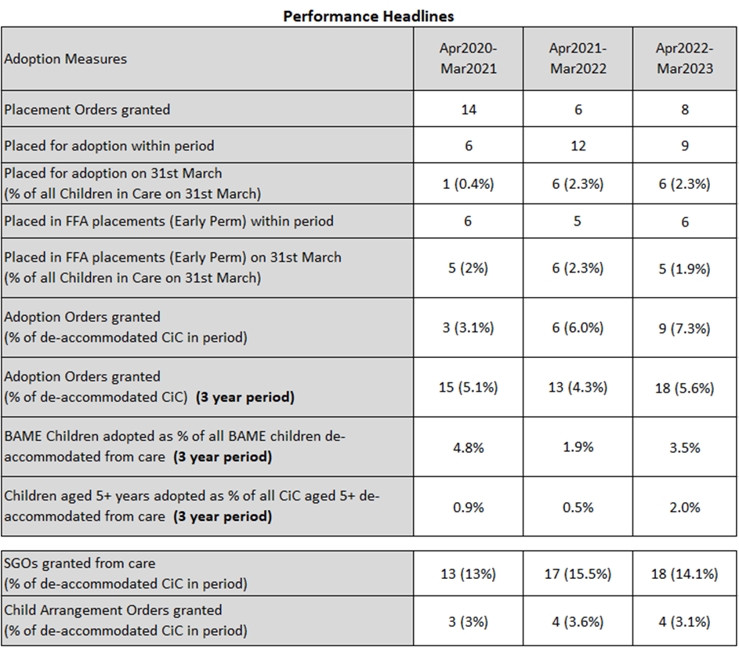

Adoption

Adoption is the legal process by which a child or a group of siblings who cannot be brought up within their birth family become full, permanent and legal members of their new family. Adopters become the child's legal parents with the same rights and responsibilities as if the child was born to them. Adoption gives children a second chance of stability, permanence, and the love and nurture that all children need. The outcomes for adopted children are better than for those who stay in care. However, many children have experienced early childhood trauma and therefore it is important that we are able to provide consistent, specialist support to adopters to help them give their adopted children the best possible chance of a brighter future.

Adoption West is a Regional Adoption Agency (RAA) commissioned by Bath and North East Somerset Council, Bristol City Council, Gloucestershire County Council, North Somerset Council, South Gloucestershire Council and Wiltshire Council. The agency is a local authority company wholly owned by the aforementioned local authorities. As a separate legal entity from the local authorities Adoption West is registered with Ofsted as a Voluntary Adoption Agency.

The performance measure table above shows that 9 children from South Gloucestershire were adopted in the year 2022-23, compared to 6 children adopted the previous year. However, we also currently have 5 children who are subject to a placement order but are still waiting to be matched. This has decreased from 12 last year but the concern is that across the region, there has been a decline in the number of adopter approvals and we need to work with Adoption West to ensure that there is a sufficient number of adopt approvals to enable children to be placed for adoption. The majority of adopter approvals (95%) were from White British backgrounds, and this is disproportionate to the ethnicity of children with ADM decisions in 2022-23. A concern for us is that two children still waiting to be matched are from White British / Asian heritage with some additional needs and family finding is still ongoing after waiting between 6-12 months for a match.

The process from a child entering care to be moving in with their adoptive family still takes too long and we need to work with the Legal System to improve timescales for legal proceedings in order to secure more timely permanence for children.

Residential Care

South Gloucestershire Council is the Lead for a sub-regional residential Dynamic Purchasing System. This delivers a common process for establishing price, placement methodology, form of contract and a quality assurance framework. These types of arrangements will continue to play a role in the future as a way of efficiently accessing what the market provides and South Gloucestershire will look to renew the arrangements in 2025

Our aim is that in the future most looked after children will live within, or near to, our borders. This involves local, small provision, that can meet specific needs of children within a flexible set of services. The Council will therefore look at a developing an innovative model with a strategic partner that will provide a step across approach to support reunification into the family setting. Homes for young people with complex and challenging behaviours, needing intensive support - for those we have difficulties finding placements that can meet their needs. And long-term placements for the young people in care for 2-3 years before reaching the age of 18, with emphasis on preparing for adulthood, with strong links to education, employment planning, care leavers accommodation.

Unaccompanied Asylum-seeking Children

* The Council have seen an increase in the number of unaccompanied asylum-seeking children coming into our care through the National Transfer Scheme who need housing and support. Since 2015 130 unaccompanied asylum-seeking children have become the responsibility of South Gloucestershire Council.
* The Council are currently accommodating a number of unaccompanied young people in semi-independent placements. The Council is regularly reviewing how the pathway is working and if services at all levels are delivering the required outcomes. The Council are therefore looking at remodelling services to able to help meet the growing population of unaccompanied young people. The Council will also look to work more closely with 16 plus independent providers and develop new contracting arrangements to help meet the needs of the young people.
* The Council will continue to commission support services for unaccompanied young people which helps them integrate into the local community and guides them through the asylum process.

Care leavers

* The Council have developed a supported housing pathway for care leavers (and homeless young people) as previous provision wasn’t fully meeting the needs of the most vulnerable, higher need young people which were being placed out of county in semi-independent placements. We therefore commissioned 18 new higher need spaces with 24 hours support available where these young people can be supported to learn independent living skills and move through the pathway to independence.
* The pathway consists of 100 spaces of high support, medium support and low support which young people can access and leave at any point. The Council commissions a resettlement service available for when young people move into their own accommodation so they can be supported to settle in as well as a floating support service for those who are living in their own accommodation but may need some additional support to sustain their tenancy.
* For a small number of young people who aren’t able to live with others due to level of need and vulnerabilities we developed a housing first model where young people are given a flat and provided with intensive support to sustain their tenancy.
* With fluctuating numbers of children in care and with the general population of South Gloucestershire increasing we are regularly reviewing these services to ensure we have what we require and are meeting the needs of the young people coming through from Transitions to Independence team and Housing; as well as identifying what we may need going forward so we are fit for the future.