 |  | HS/001 - Infection Control P&P
 |  | Category |  | Version | Last Reviewed
 |  | H/S |  | Ver 01 | May 2024
The Policy and Procedure applicable to the Childrens Residential Services:

Children’s residential homes |  | Children’s respite/ short breaks
Yes |  | Yes |  | Yes | Yes
P&P CONTENTS
- Introduction  - Policy  - Procedure  - Handwashing  - Respiratory hygiene and coughing  - Personal Protective Equipment  - Collecting specimens  - Staff testing and staff sickness.  - Outbreaks of communicable disease  - Outbreaks of Viral Gastrointestinal disease  - Cleaning during an outbreak  - Laundry procedures  - Staff uniforms/ non uniform  - Additional safety considerations- gov guidelines  - Cleaning procedures  - Waste disposal  - Risk assessment |  |  |  |  |  | Content only Specific to Services
Terminology Used: | ‘Person’/ ‘People’ – any person/people who use the service.  ‘Care worker’ - anyone that is supporting/assisting an individual receiving a service, i.e. / Support Workers / Care Staff or non- specific roles  ‘Care staff’/’ ‘Staff member’ – includes senior staff, team leaders, assistant managers, managers, or not specific roles.  ‘Third-party care agency’ – any external service which is commissioned to support the person in conjunction with Service Delivery staff.  .  ‘The Service’ – any type of service provided by Service Delivery.
1 | Introduction
1.1 | The purpose of this policy and procedure is to set out how effective infection control will be maintained within the services we operate and the responsibilities of staff in relation to this. |  |  |  |  | ALL
2 | Policy
2.1 | Effective infection prevention and control is an essential part of safe working practices and measures to reduce the risk of infection to staff and the children we support. |  |  |  |  | ALL
2.2 | We will achieve this through robust risk assessment, applying good hygiene standards and controls and training for our staff. This includes for example ensuring that all staff understand the importance of good hand washing technique and supply and appropriate use of Personal Protective Equipment (PPE) |  |  |  |  | ALL
2.3a | Infection control leads (ICL) Champions will be identified within the service and local management should agree with the ICL how to support and enable them to fulfil the additional expectations involved. Each ICL will:  - Be responsible for the infection prevention (including cleanliness) management at the service.  - Oversee local prevention of infection policies and their implementation including monitoring correct adherence to PPE expectations.  - Have the authority to challenge inappropriate practices,  - Have the authority to set and challenge standards of cleanliness.  - Contribute on request to an annual statement for residential services with regard to compliance with practices on infection prevention and cleanliness and make it available on request.  - Ensure that there is evidence of appropriate action taken to prevent and manage infection.  - Participate as required in ensuring that internal audits related to infection control (including handwashing audits) are undertaken and any actions are implemented.  - Participate in any additional training sessions offered by the SCC Infection Control Lead
2.3b | IPC champions who will uphold the team IPC standards and undertake quarterly hand washing audits. |  |  |  |  | IPC champions
2.4 | Safe working practices will be adopted for managing laundry in order to minimise the risk of infection and for maintaining a clean and safe environment. |  |  |  |  | ALL
3 | Procedure
3.1 | Handwashing
3.1a | Effective handwashing can prevent infection by removing dirt and micro-organisms using liquid soap. Hands should be washed:  - Before starting work and going home  - Before and after giving direct contact with an individual.  - Before eating, preparing, or handling food  - Before administering medications  - After any activity that contaminates the hands or when hands are visibly soiled  - After using the toilet  - After sneezing/blowing the nose  - After cleaning activities  - Any other occasions when hands are thought to have been contaminated, such as when there is an outbreak of D/V, or by other bodily fluids.  - Before putting on and taking off PPE |  |  |  |  | ALL
 | Your 5 moments of hand hygiene at the point of care:  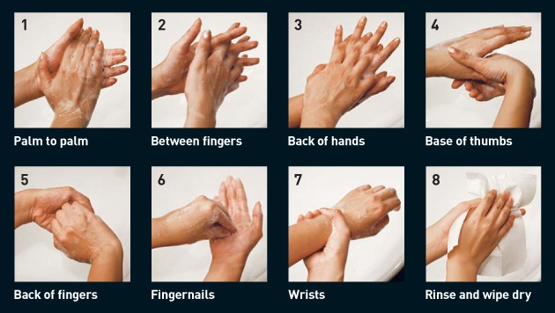  Handwashing technique should take 40 to 60 seconds. |  |  |  |  | ALL
3.1b | Alcohol hand rub is recommended for routine hand decontamination, because:  - It increases compliance with hand decontamination.  - It is quicker and easier to use.  - It is better tolerated by the hands.  - It can be provided at the point of care.  - It can be used when liquid soap is not available.  - However, alcohol gel/rub will not remove dirt or organic material and is not effective against Norovirus.  - Alcohol gel/rub is flammable and must be correctly stored. |  |  |  |  | ALL
3.1c | People of the Muslim faith - and Alcohol-Based Hand Gel  In accordance with the ‘Muslim Spiritual Care Provision’ in the NHS (MSCP) advice, alcohol-based hand gel contains synthetic alcohol and does not fall within the Muslim prohibition against natural alcohol. Therefore, people of the Muslim faith can use such gels. If arm sleeves are used for religious purposes, they must be removed before hand washing and then replaced with a new pair (NHS IPC Manual 23).  Bar Soap  Bar soap must not be used by staff at the service. |  |  |  |  | ALL
3.1d | How to use alcohol handrub  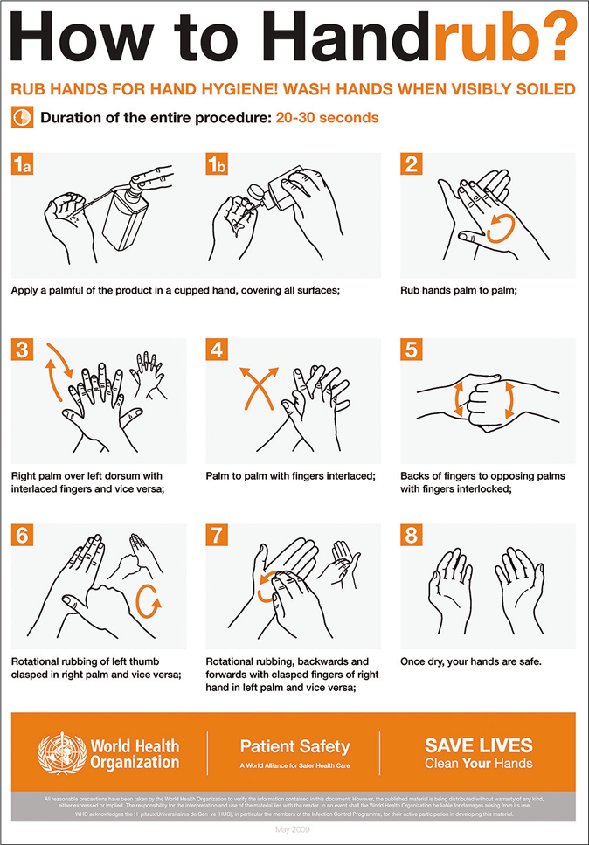  Hands must be physically clean before application. See diagram for technique and wash hands after 5 applications or hands feel sticky. |  |  |  |  | ALL
3.1e | Hand Drying  - Improper drying can re-contaminate hands that have been washed.  - Dry thoroughly where possible, use disposable paper towels, do not use reusable cotton towels and ensure that hands are dried thoroughly.  - Dispose of paper towel into bins with foot-operated pedals  - Do not touch the bin with hands. |  |  |  |  | ALL
3.2 | Respiratory hygiene and coughing
3.2a | Cover your nose and mouth when you cough or sneeze.  Coughing and sneezing increases the number of particles released by a person, the distance the particles travel and the time they stay in the air. If an infected person coughs or sneezes without covering their nose and mouth, it will significantly increase the risk of infecting others around them. By covering your nose and mouth, you will reduce the spread of particles carrying the virus.  Cover your mouth and nose with disposable tissues when you cough or sneeze. Put used tissues in a bin and immediately wash your hands or use hand sanitiser. If you do not have a tissue, cough or sneeze into the crook of your elbow, not into your hand. |  |  |  |  | ALL
3.2b | ALL
3.2c | Clean your surroundings.  Surfaces and belongings can be contaminated with COVID-19 and other germs when people who are infected touch them or cough, talk or breathe over them. Cleaning surfaces will reduce the risk of you catching or spreading infections.  Clean surfaces in your home often. Pay particular attention to surfaces that are touched frequently, such as handles, light switches, work surfaces and electronic devices such as remote controls. |  |  |  |  | ALL
3.3 | Personal Protective Equipment (PPE)
3.3a | Staff must wear appropriate PPE if there is any risk of exposure to blood or body fluids. PPE includes gloves and aprons and, where there is a risk of airborne or droplet infection, appropriate masks, and eye protection.  The choice of PPE depends on the activity, outbreaks, and the anticipated risk of exposure to body fluids. This includes wearing appropriate PPE when handling all used, soiled and contaminated linen (including aprons and gloves if contamination by blood or body fluids is likely). All PPE should be in date and stored in a dry secure place to prevent contamination. |  |  |  |  | ALL
3.3b | Face masks  Face masks and eye protection should be worn when there is a possibility of splashing of blood or mucous/bodily fluids, or if chemicals/detergents may get into the eyes or in circumstances as advised within government guidance for the care setting.  In communal settings, face masks of all types can be used for source control and can be worn sessionally (that is for a maximum of 4 hours) unless the worker is providing personal care or cleaning the room of someone with suspected or confirmed COVID-19 or is carrying out an aerosol-generating procedure (AGP).  All visitors to the service are encouraged to follow the same PPE recommendations as staff.  Consider asking the person to wear a face covering:  - when coming into close contact with someone at higher risk of becoming seriously unwell from COVID-19 or other respiratory infections  - when COVID-19 rates are high and the person will be in close contact with other people, such as in crowded and enclosed spaces.  - when there are a lot of respiratory viruses circulating, such as in winter, and the person will be in close contact with other people in crowded and enclosed spaces. |  |  |  |  | ALL
3.3c | Gloves  The use of gloves does not replace the need for hand hygiene. Gloved hands must not be washed or cleaned with alcohol hand rub. Hands must be washed after the removal of gloves.  The use of gloves will be based on an assessment of the risk of contact with blood, body fluids, secretions and/or excretions, non-intact skin, mucous membranes, hazardous drugs, and chemicals, e.g., cleaning agents.  Where a risk exists, gloves will be worn to protect the Care Worker and/or the Individual.  In addition, gloves must be worn in specific circumstances as advised within government guidance for the setting.  The service will supply nitrile gloves as an alternative for those who have latex allergies. Gloves used in our services are single-use and must be disposed of immediately after completion of a procedure or task and after each Individual, followed by hand hygiene. Care must be taken not to touch the face, mouth or eyes when wearing gloves.  Gloves will be stored in their original containers, away from direct sunlight, heat sources and liquids, including chemicals. The area will be clean and must protect the gloves from contamination. |  |  |  |  | ALL
3.5 | Staff testing and staff sickness
3.5a | Please refer to the current government guidelines and information on covid testing and on isolation relevant to the care setting.  - Staff with diarrhoea and vomiting must not attend work but must phone in to report sickness absence.  - Should the condition persist, it may be necessary not to return to work until medical clearance by a GP is given.  - Staff must not attend work until they are clear for 48 hours after the last symptom has stopped in order to prevent the spread of infection.  - Where required, staff should obtain advice from their GP on any available and recommended vaccinations.  - Covid vaccinations and flu vaccinations whilst not mandatory are strongly encouraged to minimise risk to people who receive care and support. The service will facilitate staff access to vaccinations and regularly reviews the immunisation status of the workforce. |  |  |  |  | ALL
3.6 | Outbreaks of Communicable diseases
3.6a | An outbreak is defined as 2 or more linked cases of the same (confirmed or suspected) infection occurring around the same time and associated with the service or location and should be reported to the UK Health Security Agency (UKHSA) Health Protection Team for collation and advice. The UKHSA is responsible for advising on outbreak control and monitoring the outbreak.  - Telephone: 0344 225 3861 - Email (Mon-Fri 9am-5pm): SE.AcuteResponse@ukhsa.gov.uk.  Portable fans are not recommended for use during outbreaks of infection or when a person is known or suspected to be infectious. If all alternative cooling arrangements have been exhausted a risk assessment for use of a fan should also include:  Availability of the manufacturers’ information and advice on how to maintain and decontaminate the fan, which must be consistent with the contents of this policy and any associated national policies. When fans are not in use they should be stored clean and in a clear plastic bag.
3.6b | Support workers must be aware of signs of infection and how to report them to managers. Where staff get a communicable disease, they should seek advice from a GP. In instances where a staff member gets a communicable disease through their work activity a RIDDOR report may be required. |  |  |  |  | ALL
3.6c | Local business continuity plans should include how to respond to the impact of a communicable disease on delivering a safe service. |  |  |  |  | ALL
3.7 | Outbreaks of Viral Gastrointestinal disease
3.7a | This type of disease is usually caused by Norovirus and is a short-lived illness typically lasting between (12 to 60 hours). It is characterised by nausea, profuse vomiting that is often projectile in nature, diarrhoea, and abdominal pain. Criteria to consider on suspecting an outbreak are:  - Vomiting  - Duration of illness (12-60 hours)  - Cases often in clusters up to 48 hours apart due to an incubation period of 15-48 hours  - Individuals and staff affected.  Report an outbreak to UKHSA and your line manger. |  |  |  |  | ALL
3.7b | It is important to isolate Individuals in their own room with their own toilet facilities where available. It is important that strict isolation procedures are implemented, and Individuals must remain isolated until 48 hours after normal bowel habits have returned and/or vomiting has stopped. |  |  |  |  | All
3.7c | During an outbreak, individuals should not leave the service unless for clinical management. Healthcare professionals must be made aware that the Individual is infected. |  |  |  |  | All
 | If an outbreak is confirmed, the Registered Manager, in consultation with the health protection team, may close the service for new admissions. Restrictions on the movement of staff must also be paramount. In these cases, the service must stay closed for 72 hours after the detection of the last new case and the Health Protection Team will be involved in any decision making. |  |  |  |  | All
3.8 | Cleaning during an outbreak
3.8.a | Surfaces and belongings can be contaminated with COVID-19 and other germs from people who are infected by touch or coughing, as they talk or breathe over them. Cleaning surfaces will reduce the risk of you catching or spreading infections.
3.8b | Cleaning should be increased to twice daily during an outbreak with a standard clean using detergent followed by a further clean of all areas using a hypochlorite solution.
3.8c | Pay particular attention to contact areas such as taps, toilets, door handles and light switches.  Hypochlorite 1000ppm should be used to decontaminate all surfaces after washing with warm water and detergent.  Alternatively, use a combined detergent/chlorine-based disinfectant solution.  Staff must work in accordance with task and activity specific risk assessments and be aware of and follow COSHH guidance.  All cleaning cloths must be disposable and discarded after each use. Strict attention must be paid to colour coding and cleaning equipment. If possible, yellow equipment should be used for rooms in isolation.  Do NOT use the same cleaning equipment in rooms of both symptomatic and non-symptomatic Individuals. Ideally, a separate cloth, mop head and bucket should be used for each area.  Mop heads must be laundered or discarded at the end of each day. If washing mop heads the water temperature needs to be 65 degrees.  Isolation rooms must be cleaned last.  Aprons and gloves used in affected areas must be disposed in clinical waste bins.  Cleaning schedules to be implemented and completed in the event of an outbreak.
Relevant Forms: | Cleaning schedules
3.9 | Laundry procedures
3.9a | Laundry Equipment  Laundry equipment is to be serviced regularly and maintained in full working order. The equipment should be used in line with manufacturers' guidelines including cleaning of filters and removal of accumulated lint and fluff from tumble driers.
3.9b | 3 categories of laundry  Clean- laundry that has been washed and is ready for use and should be stored away from used laundry
3.9c | 3 categories of laundry  Used – used laundry not contaminated by blood or body fluids. All dirty linen should be handled with care, and attention paid to the potential spread of infection.  Handle used laundry safely by wearing a single use or washable apron to protect your clothing if necessary or when there is risk of contamination.  Things to avoid:  - shaking or sorting laundry on removal from beds  - placing used laundry on the floor or any other surfaces  - re-handling used laundry.  - placing inappropriate items in or overfilling the laundry receptacle
3.9d | 3 categories of laundry  Infectious – laundry used by a person known or suspected to be infectious and/or linen that is contaminated with blood or body fluids, for example faeces.  Ideally red water-soluble bags should be used which can be placed unopened into the washing machine.  Do not wash infectious laundry by hand. It is advised that dirty linen is washed before infected or soiled linen. The machine should not be overloaded so that items are allowed to circulate during the wash.  Staff should ensure that they are not mixing infected or soiled linen with another person’s laundry and that the clothing is appropriately named.  Staff should always wash their hands if they have come into contact with any soiled linen whilst not wearing gloves and in between handling different categories of laundry. Wherever possible hand washing facilities should be available where the laundry is undertaken. Staff should also appropriately dispose of aprons or gloves in the soiled waste bin to prevent cross contamination.  Use separate containers for transporting clean laundry, and used or infectious laundry, and wash infectious laundry separately.  If laundering the clothing of a person with an infectious illness, these should be laundered at the highest temperature possible recommended by the manufacturer. For delicate items of infectious laundry consider using a laundry bleach or alternative laundry disinfectant. Heavily soiled items should have a pre-wash cycle or sluice cycle selected where available.  The process should aim to avoid the possibility of dirty laundry contaminating clean laundry.
3.9e | Key principles of safe handling of laundry:  - wash hands between handling clean and used or infectious laundry  - prevent cross contamination between clean and used or infectious laundry.  - use separate containers for clean and used or infectious laundry.  - do not shake used or infectious laundry.  - do not place used or infectious laundry on the floor or on surfaces.  - use an apron to protect staff member’s clothing from used or infectious laundry.
3.10 | Staff uniforms
 | When you are working you are required to wear appropriate clothing. If you have a uniform, you are expected to wear it.  Whatever you are wearing should be clean, laundered and suitable for providing personal care, where appropriate. Uniforms and workwear should be washed at the hottest temperature the fabric will tolerate. Heavily soiled items should be washed separately to eliminate the risk of cross contamination.  When providing direct, hands-on care, workers should be ‘bare below the elbows.’ Long hair should be tied up and off the collar. If wearing a head scarf, it should be unadorned and tied neatly. Lanyards and neckties should not be worn during personal care. Workers should wear clean clothes at the start of each shift and change immediately if clothes become visibly soiled or contaminated.  Where employees are non-uniform wearers the general principles of this policy apply. |  |  |  |  | ALL
3.11 | Preventing and controlling infections - GOV.UK (www.gov.uk)  https://www.gov.uk/government/publications/health-protection-in-schools-and-other-childcare-facilities/what-infections-are-how-they-are-transmitted-and-those-at-higher-risk-of-infection
3.12 | Cleaning procedures
3.12a | Best practice for cleaning  1.In the absence of an outbreak a neutral detergent or wipes should be used for cleaning the environment.  2.The removal of dust or organic matter is important to ensure the environment is physically clean. Disinfection should be applied when there is an outbreak of infection illness, such as respiratory infection or infectious diarrhoea.  3. Wear protective clothing appropriate to the task e.g., apron and gloves. Prepare a fresh cleaning solution, appropriately diluted for each task Make up only the quantity required in a clean, dry container. Only mix cleaning products where this is specifically identified as being safe by the manufacturer, and where a risk assessment has been completed.  4. Work from clean to dirty areas: Start cleaning in the cleanest areas and finish in the dirtier areas, e.g., when cleaning the bathroom, leave the toilet until last and use a separate cloth  5. Work from high to low areas  This helps to prevent cross-infection as it stops contamination of clean areas from dirty areas. When cleaning or disinfecting, clean all surfaces using an ‘S’ shaped pattern from clean to dirty, top to bottom, taking care not to go over the same area twice. This cleaning motion reduces the number of microorganisms that may be transferred from a dirty area to a clean area.  6. Leave all surfaces clean and dry  It is important to leave cleaned surfaces as dry as possible. This helps to prevent mould and bacterial growth Air drying is acceptable for large surfaces, but small areas should be dried with clean, disposable paper towels/cloths.  7. Change cleaning solutions and cloths if visibly soiled or contaminated with body fluids  One of the main causes of contamination is the use of one cloth for all cleaning. Change your cleaning solution and cloth when it looks dirty so that you are removing dust and dirt or microorganisms that would contaminate surfaces and are not just moving it from one area to another. Use a separate cloth for different areas.  Colour coding must be applied to cleaning equipment in all areas. All staff should be familiar with colour coding. New staff should be made aware as part of their induction.  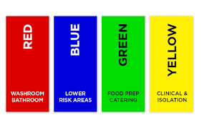  6. Wash your hands after removing gloves  Dirty hands and dirty gloves soil clean surfaces. Remove protective clothing and wash hands before carrying out other duties.
3.12b | Cleaning equipment should be cleaned thoroughly after use and stored dry in a clean and secure place. Mops should not be left soaking as this can present an infection hazard. Mops must be wrung out and stored upright to dry. Mop heads should be disposable or laundered as per risk assessment, daily in food preparation areas and where, used to clean a room where someone is isolating and weekly in other areas. |  |  |  |  | ALL
3.12c | Monitoring of standards of cleanliness  Cleaning schedules have been produced for guidance on cleaning tasks and frequency – these cover particular areas and additional cleaning required in the event of an outbreak or deep cleaning/ spring cleaning.  All staff should take responsibility for monitoring the cleanliness of the environment. Managers walkarounds also include elements relating to this policy such as cleanliness, spot checks of cleaning schedules, safe storage of hazardous materials etc and infection control audits undertaken by IPC leads. |  |  |  |  | IPC champions
3.12D | Safe use of cleaning materials  All cleaning chemicals, which are hazardous to health have been risk assessed and have relevant COSHH data sheets – see COSHH guidance within SCC Health and Safety manual. |  |  |  |  | Housekeeping All
3.12e | Use of disinfectants  Disinfectant solutions should be prepared by competent staff, who are aware of safe use of the products. Disinfectants should only be used for the following:  To disinfect food preparation areas, in particular, dirty situations where blood or faeces are present.  To disinfect rooms where a person has a known or suspected infection or where the environment has been contaminated with blood or body fluids.  During an outbreak and when directed by the Infection Control Team, or UKHSA.  No disinfectant acts instantly, it should be left on the surface for the manufacturers recommended contact time or left to air dry.  All disinfectants must be appropriately labelled in line with chemical labelling requirements and stored in accordance with COSHH regulations and the substance specific COSHH Risk Assessment.  Gloves and plastic aprons must always be worn when handling disinfectants. Eye protection should also be available.  When disinfection is required, use chlorine releasing tablets or if not available household bleach at the following dilutions shown in the table below should be used. If an item is unsuitable for disinfecting with household bleach an alternative product may be used. At minimum, the product should be effective against bacteria and viruses and if the service user is known or suspected to have Clostridioides difficile, a sporicidal produce must be used.  Disinfection Dilution guide  Environment contaminated with blood/blood-stained body fluid  Household bleach 10,000 parts per million (ppm) available chlorine Dilution of 1 in 10, e.g. 10 ml of household bleach in 100 ml of water or 100 ml in 1 litre of cold water  Environment contaminated with body fluid (not blood/blood stained), or when the service user has a known infection  Household bleach 1,000 ppm available chlorine Dilution of 1 in 100, e.g. 10 ml of household bleach in 1 litre of cold water |  |  |  |  | ALL
3.13 | Waste disposal
3.13a | The SCC Health and Safety manual includes a section on waste. Section E2 Appendix 3 - Clinical waste (sharepoint.com)  In addition, there is an action card that summarises how to dispose of the key types of waste produced in our services. |  |  |  |  | ALL
3.14 | Risk assessment
Environmental risk assessments and health and safety audits are considered under health and safety policies. However, risk assessments are also carried out where risks are present, to protect individuals from the harm of acquiring an infection. See separate Covid risk management policy.

It is expected that an infection risk assessment should be carried out before a person starts using the service. The assessment should include all factors which place the person at a higher risk of catching or spreading infection and may include:

symptoms:
history of current diarrhoea or vomiting
unexplained rash
fever or temperature
respiratory symptoms, such as coughing or sneezing

contact:
previous infection with a multi-drug resistant pathogen (where known)
recent travel outside the UK where there are known risks of infection.
contact with people with a known infection.

person risk factors:
vaccination status which will assist assessment of their susceptibility to infection and allow protective actions to be taken when necessary.
wounds or breaks in the skin.
invasive devices such as urinary catheters
conditions or medicines that weaken the immune system.

environmental risk factors, such as poor ventilation in the - setting. Ventilation is an effective measure to reduce the risk of some respiratory infections, by diluting and dispersing the pathogens which cause them. Open windows and vents more than usual – even opening a small amount can be beneficial.

All relevant staff are responsible for having an awareness of the risk assessments and the actions necessary to reduce the risk of infection.

Staff vaccination against Hepatitis B The Green Book on Immunisation - Chapter 18 Hepatitis B (publishing.service.gov.uk) Chapter 18 - 11 Hepatitis B Chapter 18: Hepatitis B 4 February 2022

Relevant Forms: | Cleaning schedule – Infection outbreak  Cleaning schedule – deep or spring cleaning  Cleaning schedule bedrooms  PLD Infection control audit  Infection prevention and control risk assessment  Practice observation tool (handwashing and PPE)
Other resources: | Internal resources:  SCC Health and Safety manual on Our Surrey webpages  E1 is SCC policy on control of Substances Hazardous to Health (COSHH)  SCC Guidance for staff Protection against blood borne viruses. This includes information about Hepatitis B and C , spillage of body fluids, sharps injuries, being bitten or scratched , vaccination etc BBVpolicydocumentforSCC-2020.pdf (sharepoint.com)  E2 Appendix 1 Decontamination and single use devices  E2 Appendix 3 Clinical Waste  G3 includes Riddor reporting  External resources:  - The Department of Health, (2015), The Health and Social Care Act 2008 - Code of Practice on the prevention and control of infections and related guidance.  Health and Social Care Act Code of Practice  DHSC, (2022), Infection prevention and control: resource for adult social care. [: https://www.gov.uk/government/publications/infection- prevention-and-control-in-adult-social-care-settings/infection-prevention-and-control- resource-for-adult-social-care  DHSC, (2022), COVID-19 supplement to the infection prevention and control resource for adult social care. [Online] Available from: https://www.gov.uk/government/publications/infection-prevention-and-control-in-adult- social-care-covid-19-supplement/covid-19-supplement-to-the-infection-prevention-and- control-resource-for-adult-social-care  - National Infection prevention and control manual for England  NHS England » National infection prevention and control manual (NIPCM) for England  UK health security agency, (2022), Living safely with respiratory infections, including COVID-19. [Online] Available from: https://www.gov.uk/guidance/living-safely- with-respiratory-infections-including-covid-19  National Institute for Health and Care Excellence, (2017), CG139 - Healthcare- associated infections: Prevention and control in primary and community care. [Online] Available from: https://www.nice.org.uk/Guidance/CG139

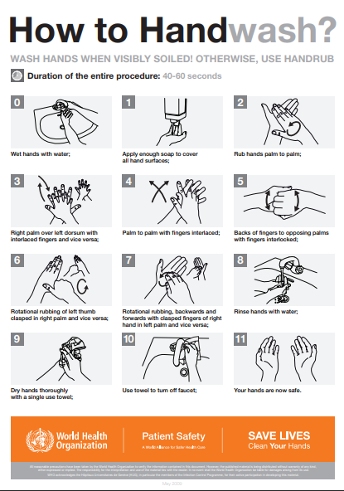

Version control information | V2
Created by: | Sue Wynne - Infection Prevention and Control Nurse
Date: | June 2023
Approved by: | Jo Rabbitte
Review date: | June 26

