RAC Process Guide

Proforma
About.
- RAC stands for Referral And Complex cases team, it is a Multi-Disciplinary Team (MDT) of professionals that decide on referrals for services within the Learning Disability Services team.
- The committee also monitors the level of current risk status of service users and advises the relevant professionals of services to provide.
When and Where.
- The RAC meeting occurs weekly on Wednesday between 10:00-12:00 O’clock.
- The Admin team is responsible for booking the room in which the meetings take place.
- The meeting is chaired by the Unit manager.

Process
The Duty/Intake team
New external referrals are sent to the duty inbox. And for new referrals that come in via post or personally come to the Learning disability team, duty is the first line of screening.
The duty team member should then fill in the FACE social Care Screening Form together with the referrer. The duty team member then sends a diversity Form to the referrer.
Finally, the duty team member fills in the RAC Referral Form and sends it to the Admin inbox.
Internal Referrals.
The referrer is to fill in the RAC Referral Form and send it to the Admin inbox.
Admin inbox
The details of the referral should be put on AIS and RIO.
The RAC Referral Forms a compiled ready to be presented in the RAC meeting.
RAC Meeting
The meeting is chaired by the Unit Manager or one of the professionals in their absentia.
The RAC referrals are discussed and a decision is made on each of them.
The Admin team to record the outcomes decided and send the action points to the relevant professionals.
After RAC Meeting.
The Admin team updates AIS and RIO with the outcomes from the RAC meeting.
The duty team sends out letters to referrers informing them of the outcome of their referrals.

RAC WORK FLOW
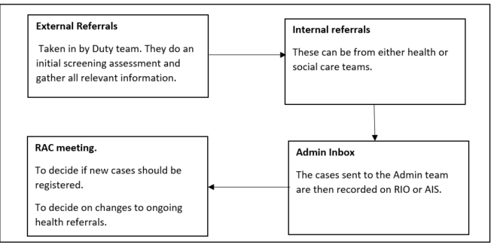

NB: All referrals including internal are to be sent to RAC. This is to provide a fail-safe process to cover referrals that might go unattended for various reasons.

