Creating a SMART plan

Common Errors in SMART Plans
The most common errors that are made in SMART plans are that the statements are;
- Vague
- Action not outcome based
- Not evidence based and measureable
- Unachievable
Below are some examples of common errors and how they could be amended to be SMART.
Statement | Error | Corrected Statement
Complete healthy living chart | This is an action not an outcome | The healthy living chart will be completed weekly with the child and their responses noted and measured in line with the accompanying Likert scale
Make sure the children achieve their potential | How would you do this? | This statement is very vague By measuring each child’s achievement and comparing it with their Fischer Family Trust estimated grades it can be seen if they are meeting their potential
Bob and Sue want to feel safe | This is very vague and in its current form, unachievable | Bob and Sue’s attendance to be monitored daily. Records are being kept as to how often their parents are attending rehabilitation clinics to help with their alcohol misuse.
Charlotte’s emotions to be measured | How would this be measured so that progress can be seen? | Charlotte’s emotions to be measured weekly using the SEN Feeling Chart. Targets as to how to improve this will be discussed with Charlotte during the meeting.

Example of SMART Planning
The example below shows an effective way a practitioner has applied SMART Planning to their work.
Safety Statement - What is to be achieved | What needs to happen? | Who will be responsible? | When does it need to be done?
All the children need to continue to access education regularly to reach their full potential | Ms Smith to ensure the children's attendance at School and punctuality improves from 63% to 85% | Ms Smith | 23.7.13
 | Mr Johal to meet with Lacy and Sam and with Ms Smith to talk about any difficulties that have arisen and offer supportive interventions | Mr Johal (school attendance officer) | Weekly sessions - reviewed on 23.7.13

SMART plan template
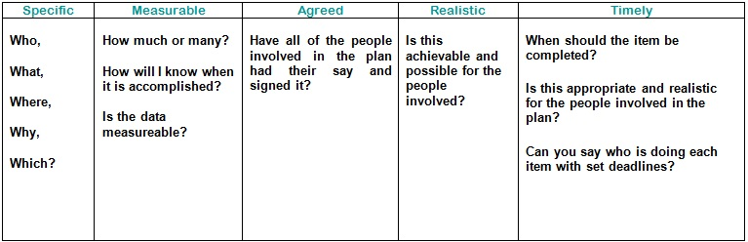

Checklist
When creating a SMART plan, ask yourself the following questions:
1. Is my plan in as much detail as possible including details on who, why, where, which, what?
2. Is my plan clear in what I am trying to achieve?
3. Does my plan say how I will measure each part?
4. Does my plan clearly show who is responsible for each part?
5. Are the expectations in my plan appropriate and realistic in regards to the needs of the child or young person?
6. Are the expectations in my plan appropriate and realistic in regards to the needs of the family?
7. Does my plan take into consideration the specific risks identified and needs of the child, young person and family?
8. Does my plan clearly show when I expect each stage to be completed?
9. Have the parents and the child or young person had their say in regards to the plan?
10. Is my plan signed by myself, the parents and the child or young person involved?

