Disabled Children and Young People’s Team
0-25
(Social Care)

Eligibility and Functions

This document outlines the eligibility for support from the team, the pathways or referral routes and the function of the team including assessment, care planning, reviewing and preparing young people for adulthood.

- Introduction
The Disabled Children and Young People’s Team is part of the Integrated 0-25 Special Educational Needs and Disability Service. The team is a specialist team supporting and safeguarding children and young people up to the age of 25 years old with disabilities. Within the service there are two Assessment and Support Pods focusing on the needs of children under 18 and a Preparing for Adulthood Pod. The later Pod work with young people as they approach adulthood completing adult care assessments and putting in place support for when young people become adults.
This documents offers clarity as to the structure and processes within the service for all stakeholders including children, young people and their families as well as other agencies such as schools and health partners.

- Structure
The Disabled Children and Young People’s Team consists of three Pods or small teams overseen by Practice Leads. The team is within the Education Directorate and maintains close links with Children and Adult Social Care Services.
The structure is as follows:
Group Manager
Team Manager
3 PODs (Practice Teams)
- Assessment and Support Pod 1
- Assessment and Support Pod 2
- Preparing for Adulthood Pod
The team access occupational therapy support either through a contracted service or a post within the team.

- Social Care Eligibility Criteria
In order to receive support from the Disabled Children and Young People’s Team a child or young person must first meet criteria for support from Children or Adult Social Care.
3.1 Children
The initial contact with Children’s Services is the Triage and Multi Agency Safeguarding Hub (MASH) Team. This team makes an initial decision as to whether an assessment is required based on the London Consortium Continuum of Help and Support 2016. This has been used to develop Newham’s Pathways to help and support as indicated below.

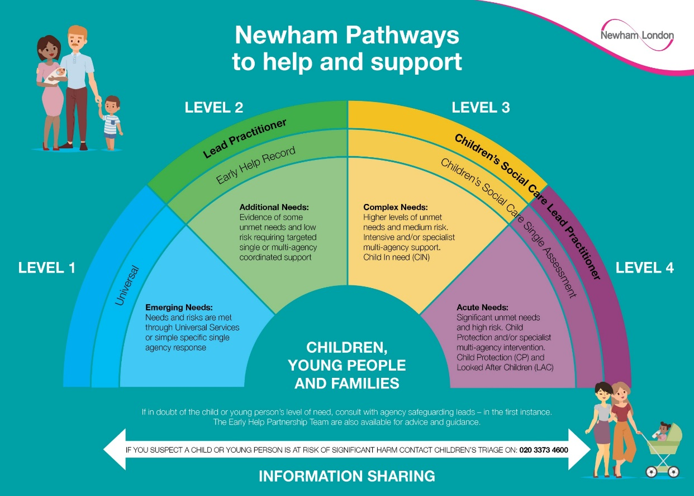

If the level of need is such that an assessment is required this is referred to Disabled Children and Young People’s Team where the concern or risk relates to a child’s disability. Where the concern or risk is either of a safeguarding nature or relates to the whole family this is assessed by the Assessment Team. For instance a case where domestic violence is impacting on all the children will be assessed by the Assessment Team.
The Disabled Children and Young People’s Team provide a social worker within the Triage and Multi Agency Safeguarding Hub 9 - 2.30 am to support information gathering and decision making.
3.2 Adult
Young People under 18 open to the Disabled Children and Young People’s Team are managed with the Assessment and Support Pods. Around the age of 17 ½ years old an adult care (The Care Act 2014) assessment, where applicable, is completed by the Preparing for Adulthood Pod to determine whether they are eligible for adult social care support. Arrangements are put in place to ensure a smooth transition to the Preparing for Adulthood Pod on their 18th birthday.
New referrals for adults are made through Adult Social Care Access Team. If required and where the adult has an Education, Health and Care Plan, they are referred to the Disabled Children and Young People’s Team for assessment. All Adult safeguarding cases not open to the team and those adults where there is no Education, Health and Care Plan are managed within Adult Social Care.

- Disabled Children and Young People’s Team Criteria
The Disabled Children and Young People’s Team works with children and young people with complex needs relating to a learning disability and/ or physical disability. A specific diagnosis does not automatically mean that a child would be eligible or is best supported within the team. The team’s focus is with children with significant needs and will fit one or more of the criteria outlined below:
- Severe or profound learning disability
- Severe or profound physical disability
- Complex health needs expected to last more than one year
- Severe or profound communication difficulties
- Severe development delay
Examples of children and young people who would meet the criteria would be a family in need of support in relation to non verbal child with autism or a child with limited mobility and associated health issues requiring constant use of a wheelchair. Examples of children and young people who would not meet the criteria for the team are children with high functioning autism or a child requiring a wheelchair for a few months following an accident or operation.
Within Newham we feel it is important that families only have one social worker and point of contact. The decision as to which Pod or Team will be based on the individual families circumstances. As general guide families where the concerns or risks are focussed on the child’s disability will be managed with the Disabled Children and Young People’s Team and those where concerns or risks relate to all the family will be managed within one of the Intervention Teams.

- Children and Young People under 18

  - Single Assessments
Where children are considered potentially eligible for social care support they are assessed using the Assessment Framework shown below. There are three main areas considered to determine the support required:
- Child’s Developmental Needs
- Parenting Capacity
- Family and Environmental Factors
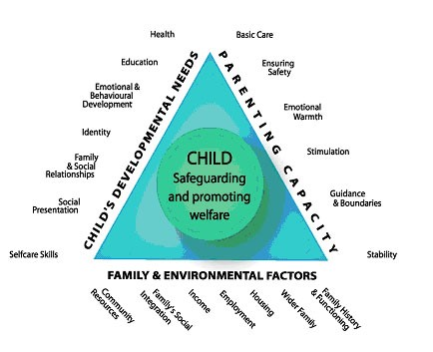
It is important to note that whilst a child may have significant needs where families have the ability and support available they may not require or be eligible for social care support. However other families where a child’s disability does not impact significantly on a day to day basis but where there are issues around parenting capacity/ ability and limited support networks, social care support may be needed.
During the assessment of a child or young person consideration is given to which team is best placed to meet needs in line with Disabled Children and Young People’s Team criteria. The team will provide assistance to the Assessment Team if there is specific issues around disability which require specialist assessment.
  - Planning, Reviewing and Visiting
Following an assessment by the Disabled Children and Young People’s Team a Child in Need plan is drawn up with families to meet needs. This may involve continued social care input from the team such as a care package, direct payments, other short break provision, social work intervention, signposting or referring to other agencies.
Where it is agreed that the Disabled Children and Young People’s Team will continue to be involved a Child in Need plan is reviewed and updated every six months to monitor progress. The Practice Lead for the Pod will chair these meetings.
The social worker will visit families at least every 4 weeks to ensure the support is having a positive impact. However for some cases where there is an established support package in place visiting frequency would be determined by the Practice Lead or Team Manager recording this on the child’s file. However as a minimum visiting frequency will be at least every 8 weeks.

5.3 Change of circumstances
Where there is a change of circumstances identified either at a CIN review or by the social worker a new single assessment will be completed to inform a revised child in need care plan and the support level required.
As a minimum a single assessment will be completed on a child every two years by social workers to ensure the support in place is meeting the needs of the child.
  - Transfer Panel
Following assessment or CIN review it is felt that the child should be supported by another team e.g. early help or an intervention team this is managed through the normal transfer process and confirmed at the weekly Transfer Panel.

  - Support Available
Universal/ Targeted – Local Offer
All children with disabilities and their families should be able to access universal support such as sports centres, museums, parks and other activities.
Additional targeted activities are available such as cinema sessions for children with autism. Both universal and targeted activities are promoted through Newham’s Local Offer: www.newham.gov.uk/Pages/Category/Special-educational-needs.aspx
Social Care
Following a single assessment, subject to eligibility, a care plan is developed to support the child and the family. Where support is above what is available within the community or from other services a care package may be developed. This could include a direct payment, provision of agency care or respite care.
Where there are cost implications this needs to be agreed by the relevant Manager depending on their authorisation level and the Care Package Panel. Social Workers will provide details of needs and risks and the potential options so that a decision can be made to best meet the needs of the child.
- Young Adults

  - Preparing for Adulthood
Within the Disabled Children and Young People’s Team there is a Preparing for Adulthood Pod or Team. This Pod supports young people through transition to adulthood and takes on case responsibility at age 18. Where a young person is open prior to their 18th birthday within the Disabled Children and Young People’s Team young people will be assessed for eligibility for adult social care in line with the Care Act 2014. Young people remain within the service until they complete their education or until the age of 25 years old, whichever is sooner.
For new referrals, where the adult is in education and they have an Education, Health and Care Plan, the team will complete an assessment for eligibility based on the Care Act 2014, otherwise the case will be managed within Adult Social Care. The Access Team in Adult Social Care is the first point of contact in this instance.
6.2 Adult Social Care Eligibility Criteria
Adult Social Care assessments are based on the Care Act 2014. An adult meet the eligibility criteria if:
- the adult’s needs arise from or are related to a physical or mental impairment or illness
and
- as a result of the adult’s needs the adult is unable to achieve two or more of the outcomes specified below
and
- as a consequence there is or is likely to be a significant impact on the adult’s well-being
Specified outcomes are :
- Managing and maintaining nutrition
- Maintaining personal hygiene
- Managing toilet needs
- Being appropriately clothed
- Being able to make use of the adult’s home safely
- Maintaining a habitable home environment
- Developing and maintaining family or other personal relationships
- Accessing and engaging in work, training, education or volunteering
- Making use of necessary facilities or services in the local community including public transport, and recreational facilities and services
- Carrying out any caring responsibilities the adult has for a child.
For the purposes of the above an adult is regarded as being unable to achieve an outcome if the adult:
- is unable to achieve it without assistance
- is able to achieve it without assistance but doing so causes the adult significant pain, distress or anxiety
- is able to achieve without assistance but doing so endangers or is likely to endanger the health or safety of the adult or of others
- is able to achieve it without assistance but takes significantly longer than would normally be expected
As a consequence of being unable to achieve these outcomes, there is, or there is likely to be, a significant impact on the adult’s well being.
Further information can be found on the www.newham.gov.uk website.

  - Adult Social Care Assessment
The Adult Social Care (Care Act) Assessment has been developed in line with The Care Act 2014 and is completed in partnership with the young person and family.
When completing the assessment the social worker will also take these factors into consideration:
- Consent – Where there are issues around ability to consent to the assessment consideration will be given to the use an advocate within the process to ensure the young person’s voice is heard.
- Deprivation of Liberty (DOLs) – Where there are issues which affect the movement and freedom of a young person, consideration of an DOLs assessment will be made.
- Mental Capacity Assessment – Where there is evidence that consent is required by the young person however there are concerns about their mental health or ability to make decisions in their best interests a mental capacity assessment may be required.
- Financial Assessment – As part of the assessment a financial assessment will be required to determine what will be funded by the Local Authority and any contribution from the young person.
- Continuing Health Care – For young people with complex needs consideration will be given to whether continuing healthcare funding should be applied for.

  - Planning and Review
Where a young person is assessed as eligible for adult social care support a Support Plan is developed with the young person and their family where applicable. This Support Plan is reviewed at least annually to ensure that the support being provided meets the young person’s needs. Reviews and reassessments can be undertaken at any point whenever there is a change in the adult’s circumstance.
  - Resources
There are a number of universal services available for young people within the community. Where eligible for Adult Social Care support this may include Direct Payments, Agency Care, Supported Living, Shared Lives and respite care.

- Carers Assessments
A carer has the right to a Carer’s Assessment where they are caring for a child with a disability or a young person.
Where a child or young person with a disability is being assessed by the Disabled Children and Young People’s Team, the single assessment or Adult Social Care Assessment will consider the carer within the assessment. However carers have the right to an individual assessment and this will be completed where felt appropriate or requested.

- Social Care Contact Details

Triage/ MASH Team - Children’s Social Care 0203 373 4600
Access Team - Adult Social Care 0208 430 2000
Disabled Children and Young People’s Team 0203 373 3280

