

**Resolution Form – CLA/CP/FGC Reference Guide**

**Children and Families Service**

**For**

**Buckinghamshire County Council**

**October 2017**

DOCUMENT HISTORY

|  |  |  |  |
| --- | --- | --- | --- |
| Date | Produced By | Document Version | Comments |
| 17.10.2017 | Lee Innell & Caroline Ash | 1.0 | Initial Version |
| 18.10.2017 | Lee Innell | 1.1 | Corrections |
| 23.10.2017 | Lee Innell | 1.2 | Updates following OMG |
| 24.04.2018 | Lee Innell | 1.3 | Updates |

**Table of Contents**

1 Summary 1

2 Resolution Form 2

2.1 Index 2

2.2 Resolution Form – Main Heading 2

2.3 Informal (Social Worker) Section 3

2.4 Stage One (Team Manager) Section 3

2.5 Stage Two (Head of Service) Section 4

2.6 Stage Three (Service Director) Section 4

2.7 Stage Four (Executive Director) Section 4

2.8 Stage five (CAFCASS) Section 5

2.9 Resolution Details 5

3 Delegating Stages 6

3.1 Delegating a Section 6

3.2 Completing a Delegated Section 8

3.3 Reactivating a Delegated Section 8

3.4 Retracting a Delegated Section 10

4 Miscellaneous / Troubleshooting 12

4.1 Missing Information after Retracting un-finalised delegated section 12

4.1.1 Solution 12

4.2 Resolution Form not updating 13

4.2.1 Solution 14

# Summary

Buckinghamshire Children’s Social Care Resolution Process sets out the purpose and procedure for Independent Reviewing Officers (IRO’s), Child Protection Conference Chairs (CP Chairs) and Family Group Conference Coordinators (FGC Coordinators) when raising a concern in relation to a child who is receiving a service from Buckinghamshire Children’s Social Care. This serves to avoid ‘drift’ and to ensure that we make timely decisions based on clear assessment.

It is always the intention to seek resolution for any concerns as soon as possible and informally whenever possible.

By replacing the current process that involves sending emails and word document attachments that have to be saved onto LCS case notes and Content Server, this proposal is to have a form on LCS that captures every resolution raised by an IRO, CP Chair or FGC Coordinator. The form would be a ‘standalone’ form and does not impact on workflow. By using this method we will be able to collate real-time information about the progress of all resolutions, what the resolution was and what impact the resolution had for the child. The concerns are collected into themes so that we can monitor areas for team and service improvement. Because the form includes all responses to through the process of each resolution, it will make it much easier for managers to see what has taken place at the stages before it reaches them.

# Resolution Form

## Index

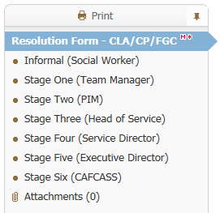

## Resolution Form – Main Heading

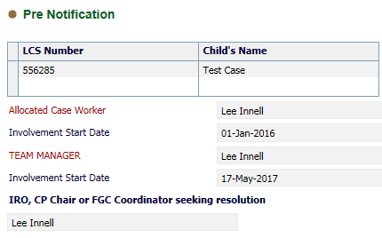

Most of the information will be brought in automatically from the child’s demographics. If there is no recorded *Team Manager* or *Allocated Case Worker* they will need to be recorded here. This will then feed back into the child’s demographics.

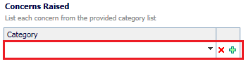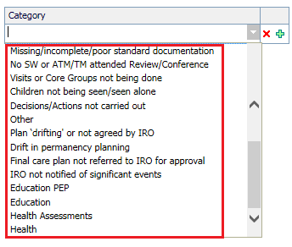

Multiple concerns can be raised by using the green plus icon on the right. The *Concern Raised* can be selected from the *Category* drop down list.

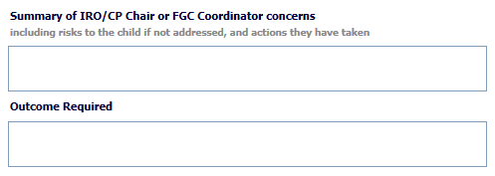

The *Escalation* section can be used to activate the various stages needed; either one or more can be selected depending on how many levels of escalation are required.

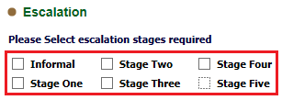

## Informal (Social Worker) Section

This section is to be delegated to the *Social Worker*. They only need to complete the *Stage 1 - Response from Social Worker* section.

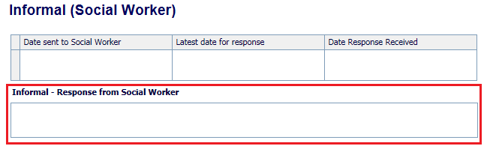

The Dates will need to be recorded by the IRO, CP Chair or FGC Coordinator.

## Stage One (Team Manager) Section

This section is to be delegated to the *Team Manager*. They only need to complete the *Stage 1 - Response from Team Manager* section.

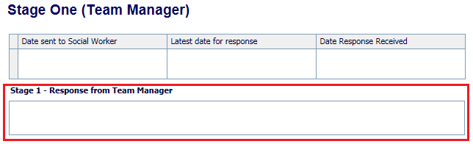

The Dates will need to be recorded by the IRO, CP Chair or FGC Coordinator.

## Stage Two (Head of Service) Section

This section is to be delegated to the *Head of Service*. They only need to complete the *Stage 3 - Response from Head of Service* section.

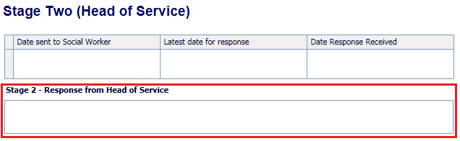

The Dates will need to be recorded by the IRO, CP Chair or FGC Coordinator.

## Stage Three (Service Director) Section

This section is to be delegated to the *Service Director*. They only need to complete the *Stage 4 - Response from Service Director* section.

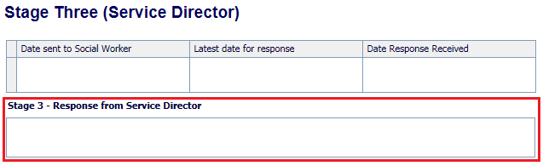

The Dates will need to be recorded by the IRO, CP Chair or FGC Coordinator.

## Stage Four (Executive Director) Section

This section is to be delegated to the *Service Director*. They only need to complete the *Stage 5 - Response from Service Director* section.

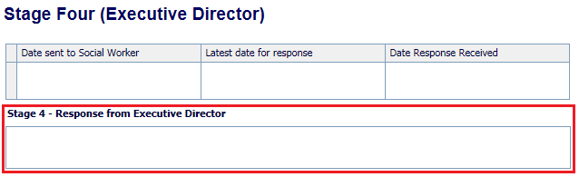

The Dates will need to be recorded by the IRO, CP Chair or FGC Coordinator.

## Stage five (CAFCASS) Section

This section is to be recorded by the IRO, CP Chair or FGC Coordinator on behalf of CAFCASS. They will complete the *Stage 6 - Response from CAFCASS* section, using the information provided by *CAFCASS*

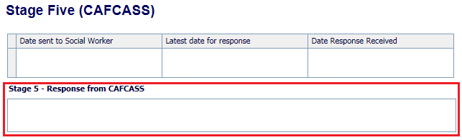

The Dates will need to be recorded by the IRO, CP Chair or FGC Coordinator.

## Resolution Details

At the end of each stage there is a resolution section that is to only be completed by the IRO, CP Chair or FGC Coordinator.



If the answer is *Yes* then the following question is asked



If the answer is *No* then the following question is asked



# Delegating Stages

## Delegating a Section

To delegate a section, click on the *Delegate* heading in the banner at the top of the form.



Select the Section that needs to be *delegated* by clicking on it

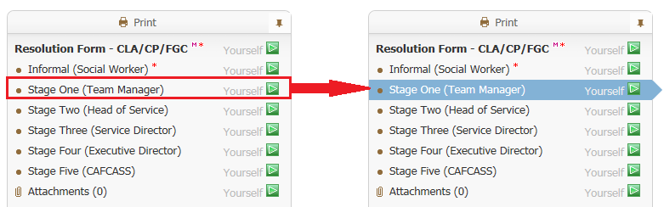

Once the section to be *delegated* has been selected, click on the *Add New Contributor*

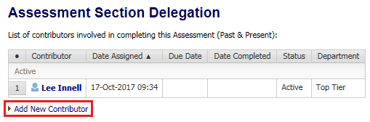

Either enter the name of the person the section is being *delegated* to in the *Assessor* box, or click on little *blue people* to use the address book.

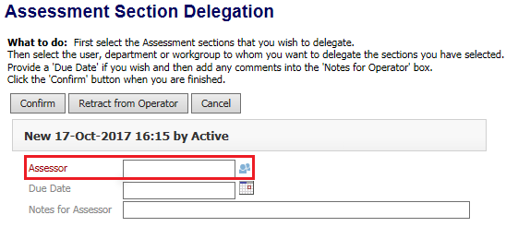

Once someone has been selected click on the *Confirm* button



A pop-up message will appear, click on the *ok* button

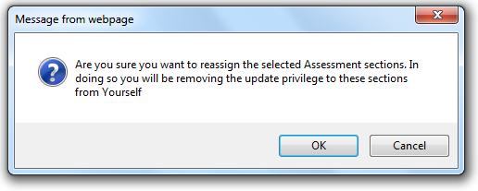

The following pop-up may also appear, if it does click on the *Save and Delegate* button

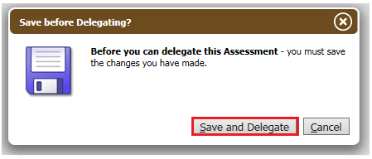

The section will now show as assigned to the selected person, and will also show as an active contributor.

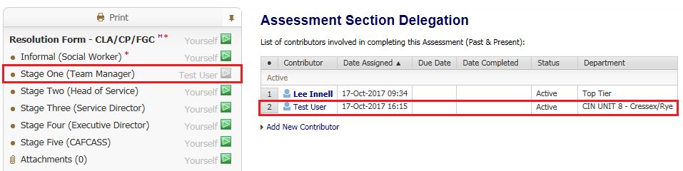

Please note that once a section is delegate the only person that can record any information within the section, is the person it is currently assigned to. The owner of the *Form* can recall the delegated section and re-delegate it if necessary.

## Completing a Delegated Section

The delegate section will appear as a task in the selected users work tray



The active section can then be completed.

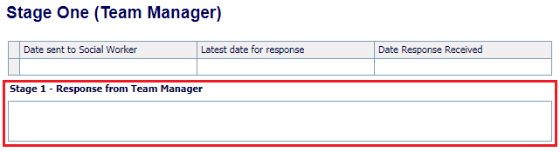

Once the information has been recorded, click on the *Finalise my Assessment Sections*



This will complete the delegated section, and end the active contribution for that user. The delegated section will also show as completed.

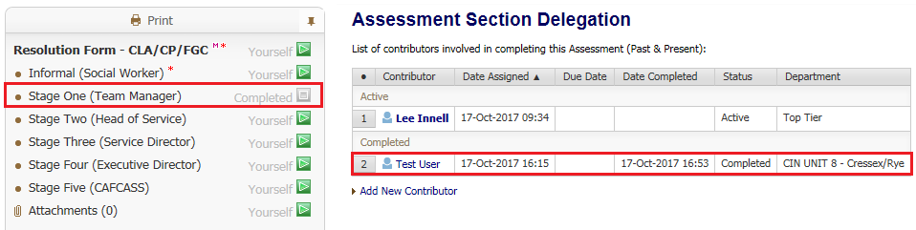

## Reactivating a Delegated Section

Once a delegated section has been completed, it can no longer be edited. The IRO, CP Chair or FGC Coordinator will need to reactivate the delegated section in order to complete the *Resolution* details.

To reactive a delegated section, click on the *Delegate* tab



The click on the name of the person the section that needs to be reactivated was assigned to

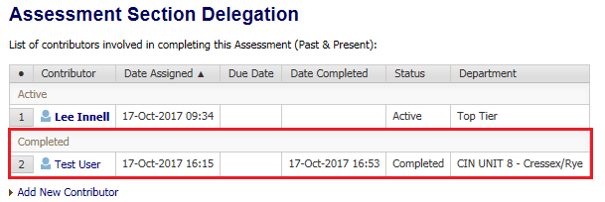

Click on the *Activate Complete Sections* to reactivate the completed delegated section

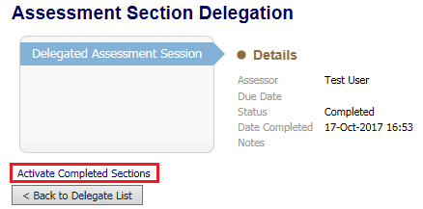

Click on the *Ok* button on the pop-up that appears

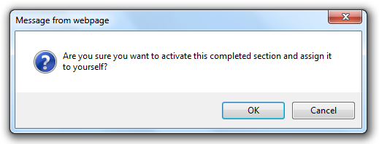

The previously completed delegated section is now active again, and can be edited

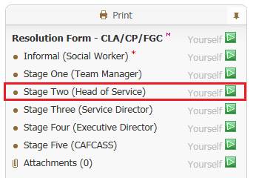

## Retracting a Delegated Section

If a delegated section needs to be retracted (eg. delegated section not completed in time), click on the *Delegated* tab

On the right hand side of the screen, under the *Assessment Section Delegation* heading, click on any part of the white section for the person that work has been delegated to.

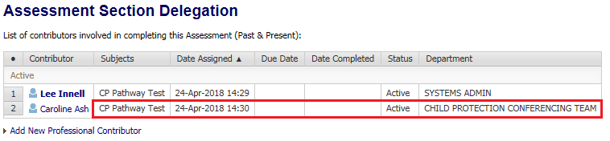

* Note – The status of this section should say *Active*. Also do not click on the name of the person as that will take you out of the form and into the address book.

A *Reason* and *Note* must be recorded before the section can be retracted

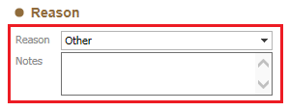

Once both questions have been answered, click on the *Retract from Operator* button

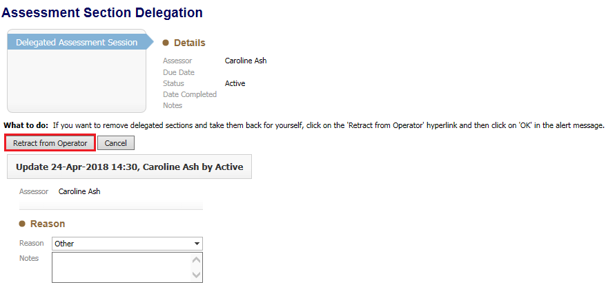

The Delegated section will now be returned to you

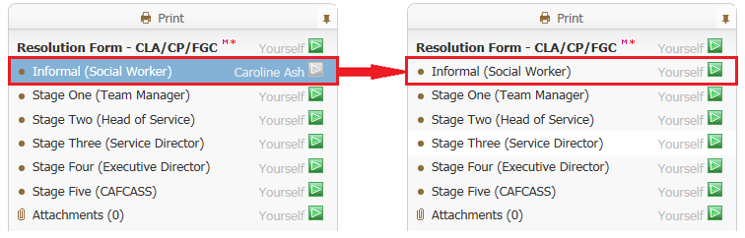

The previously delegated section will now show as having a status of *Retracted*

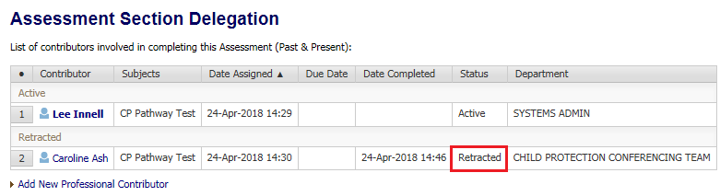

# Miscellaneous / Troubleshooting

## Missing Information after Retracting un-finalised delegated section

An assessment section has been delegated out to a worker. The worker fills in their answers but doesn’t click the *Finalise My Assessment Sections* button. You decide to retract the delegated section, as you need to finish off the *Resolution Details* section. When retracted all of the answers are blanked out, and it appears that the question has not been answered.

Question answered by user but not finalised

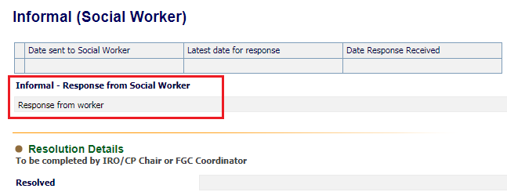

Question after an un-finalised section has been retracted

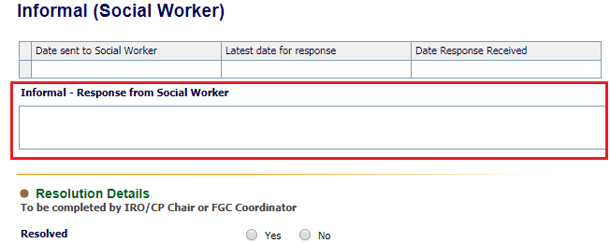

### Solution

Ask the person who has the delegated section to Finalise it. Only retract the delegated section if you are prepared to lose the information recorded.

If the section has already been retracted there is unfortunately nothing that can be done to get the information back.

## Resolution Form not updating

When viewing the Resolution form you are not able to see that answers to the questions, when the delegated person has written something and finalised the form. It appears as if the question hasn’t been answered, but if anyone else looks at the form the answers can clearly be seen.

Question answered by Delegated worker

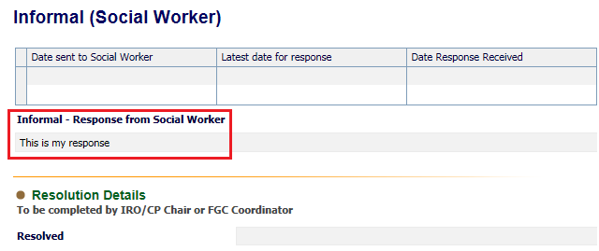

This is what you see

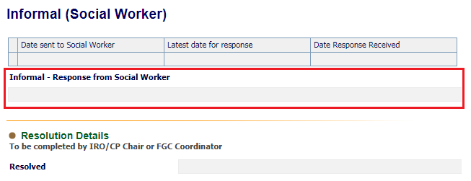

The question appears blank even though it has been answered. Looking at the Delegation tab it also appears that the worker hasn’t finalised their section

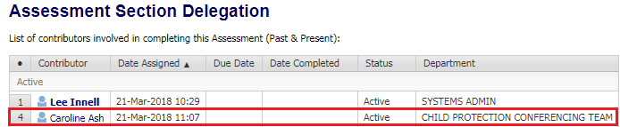

### Solution

Go into the form, and then click the *Close* button

cid:image006.png@01D3C105.95291090

Once clicked if you then go back into the form, all the recorded information will show.

This is happens if you click on the *Home* button or just leave the page. If you do this the following message will pop-up

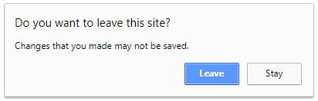

If you click on the *Leave* button, it will take you out of the form, but also leaves the form cached the way it was. This means any changes made by the person the form is delegated to will not be seen. In order to prevent this from happening you must always click the *Close* button after you have delegated the form.