**Young Carers**

**Strategy and Action plan**

**2012 – 2015**



Document Governance:

|  |  |
| --- | --- |
| Title | Young Carers Strategy and Action Plan |
| Purpose/scope |  |
| Subject key words |  |
| Priority |  |
| Lead author & contact details | Rachael Foster  Commissioning Specialist  [Rachael.foster@telford.gov.uk](mailto:Rachael.foster@telford.gov.uk) |
| Date of report | January 2012 (Emma Pyrah)  Updated March 2014 (Rachael Foster) |
| Version | Draft – Version 2 |
| Sign-off status |  |
| Period applicable |  |
| Distribution/circulation |  |

Contents

**No table of contents entries found.**

**1. Introduction**

**1.1 Definition:**

The term “young carer” is taken to include children and young people under 18 who provide regular and ongoing care and emotional support to a family member who is physically or mentally ill, disabled or misuses substances. The term does not apply to the everyday and occasional help around the home that may often be expected of or given by children in families and is part of community and family cohesion.

The key features are that:

“Caring responsibilities are important and relied upon within the family in maintaining the health, safety or day to day well-being of the person receiving support or care and/or the wider family.”

*(Source: ADASS and ADCS 2012: Working together to support young carers and their Families)*

**1.2 Types of Caring: “*the caring task is something that never stops”***

The tasks undertaken by children and young people vary, according to the nature of the illness or disability, the level and frequency of need for care, the structure of the family, etc. A young carer may undertake some or all of the following:

* practical tasks such as cooking, housework and shopping
* managing the family budget, collecting benefits and prescriptions
* physical care such as lifting
* personal care such as dressing, washing, helping with toileting needs
* giving medication or physiotherapy
* ensuring safety
* looking after or ‘parenting’ young siblings
* giving emotional support or worrying
* interpreting (either because of a hearing or speech impairment or because English is not the first language of the family

*(Source: Children’ Society 2012: Whole Family Pathway)*

**1.3 National Context:**

Improving outcomes for carers is a priority for this government as reflected when **Recognised, valued and supported: next steps for the carers strategy** was published in 2010. The report sets out the national policy direction for young carers and it’s plans for change over the next decades building on the previous vision and outcomes (**National Carers Strategy 2008: Carers at the Heart of 21st century Families and Communities –** See Appendix 1)

The Coalition Government has committed to working with carers and carers’ organisations towards the following four priority areas:

* Supporting those with caring responsibilities to identify themselves as carers at an early stage, recognising the value of their contribution and involving them from the outset both in designing local care provision and in planning individual care packages.
* Enabling those with caring responsibilities to fulfil their educational and employment potential.
* Personalised support both for carers and those they support, enabling them to have a family and community life.
* Supporting carers to remain mentally and physically well.

The government is clear that effective **whole family approaches to assessment** are essential to improving support for adults and young carers alike. In October 2013 the government announced plans to provide a legislative framework that will support local authorities to consider the needs of the whole family; deliver co-ordinated packages of support and protect children and young people from excessive or inappropriate caring roles.

**1.4 Legislative Framework** *(Source Department of Health Carers Bill Fact Sheet 8)*

1.4.1 The **Care Bill (2013-14),** which has now completed all of its stages in the House of Commons,gives local authorities a responsibility to assess a carer’s own needs for support. This replaces the existing law, which says that the carer must be providing “a substantial amount of care on a regular basis” in order to qualify for an assessment. This will mean **more** carers are able to have an assessment. This is comparable to the legal right of the people they care for.

* + 1. The Care Bill does not deal with assessment of people under the age of 18 who care for others. However, they can be supported under the law relating to children. The Government has amended the **Children and Families Bil**l, to give young carers similar rights to assessment as other carers have under the Care Bill. It is likely to come into force September 2014.
    2. The Bill says we can make rules (called regulations) about how assessments of adults should be carried out to ensure a clear and consistent approach. This can include a requirement to have regard to the needs of that adult’s family as part of that adult’s assessment. This could include assessing what an adult needs to enable them to fulfil their parental responsibilities towards their children, or to ensure that **young people do not undertake inappropriate caring responsibilities**.
    3. Transition for children’s to adult care and support services:

*(Source Department of Health Carers Bill Fact Sheet 11)*

The Bill says that if a child, young carer or an adult caring for a child (a ‘child’s carer’) is likely to have needs when they, or the child they care for, turns 18, the local authority **must** assess them if it considers there is ‘significant benefit’ to the individual in doing so. This is regardless of whether the child or individual currently receives any services or requests an assessment.

1.4.6 It goes on to say that when an assessment is carried out, information should be given about whether the young person, child’s carer or young carer is likely to be eligible for care and support as set out in the Care Bill when they turn 18. The person should receive advice and information about what can be done to meet or reduce the needs they are likely to have, as well as what they can do to stay well, and prevent or delay the development of needs.

* 1. **Local Context**

1.5.1 Telford and Wrekin –A Co-operative Council

Telford and Wrekin Council is committed to working together with residents, partners and local organisations to collectively deliver the best we can for Telford and Wrekin with the combined resources we have. The Council Medium Term Plan includes the vision to:

“**As a Co-operative Council work with our communities to create ‘Telford and Wrekin – the Place of Partnership, Enterprise and Innovation”**

**Our priorities are to:**

* put our children and young people first
* protect and create jobs as a 'Business Supporting, Business Winning Council'
* improve local people's prospects through education and skills training
* protect and support our vulnerable children and adults
* ensure that neighbourhoods are safe, clean and well maintained
* improve the health and wellbeing of our communities and address health inequalities
* regenerate those neighbourhoods in need and work to ensure that local people have access to suitable housing

At the centre of how we approach this are our Co-operative Values of Openness and Honesty, Ownership, Fairness and Respect, and Involvement, coupled with a commitment to Make Every Contact Count

* + 1. Health and Well Being Board (See Appendix 1)

The Health and Wellbeing Board is now established and has consulted with local people and partners on what the most important local health issues are. The Board has published a **Health and Wellbeing strategy** that includes priorities for its work and limited resources. These are based on local data about services and community needs in the borough. Improving the health and wellbeing of unpaid carers is one of the priorities for the Board.

1.5.3 Review of Services for Adult Social Care and Children, Families and Schools

Published for consultation in February 2011 this review set out a high level vision and framework for future service delivery. It proposed new and radically different ways of organising, integrating and providing services against a back drop of reducing levels of public service funding from the Government. The Review has shaped the subsequent restructuring process which aims to bring together teams, reduce costs and maximise efficiency whilst maintaining key services.

At the heart of the proposed approach is a strong emphasis on effective prevention andintervention, with a much greater focus on enabling self-help and self-service for those who are able. The re design of services ensures that vulnerable children and families with significant needs receive the right co-ordinated help and support from the right services at the right time in the right place.

* + 1. Strengthening Families Programme

Building on the **Think Family** approach and in response to the Government’s **Troubled Families Programme** the use of a key worker model has become a key element to us achieving improved outcomes for families. Having a single consistent point of contact to facilitate the development of trust and engagement of families, a key worker is central to our Strengthening Families programme. It will also facilitate the whole family approach required to fulfil our requirements within the new legislative framework for young carers.

**2. Understanding Need**

**2.1 The National Picture**

*(Source: Commissioning Services for Young Carers and their families 2012)*

Young Carers:

* 22% of young people under 16 in the UK (2.6 million) live with a hazardous drinker
* 50% of young carers care for ten hours or fewer per week; one third for 11–20 hours per week; and 16% for over 20 hours per week. 2% care for more than 50 hours each week
* 68% of young carers are bullied in schools and having a caring responsibility is one

of the main characteristics of young people aged between 14 and 16 who have

been bulled

* Over 39% of young carers had not informed their teacher or any member of staff that they were a young carer
* 27% of young carers (aged 11–15) miss school or experience educational difficulties (40% where children care for a relative with drug or alcohol problems)

Young Adult Carers:

* Young adult carers aged between 16 and 18 years are twice as likely to be not in

education, employment, or training (NEET)

* There are 61,051 young carers aged 16–17 in the UK.26
* There are 229,318 young adult carers aged 18–24 in the UK
* As young people grow older they become more heavily involved in caring and there

are differences between young men and women among the 16–28 age groups.

In relation to domestic tasks and intimate care. 85% of young women are doing

domestic tasks compared to 68% of young men, while one third of young women in

this age range are providing intimate care compared to 17% of young men

**2.2 The Local Picture**

*(Source: Telford and Wrekin JSN – 2011 Census and Young Cares Data Base 2011)*

Young Carers:

* There is estimated to be 600 young carers in Telford & Wrekin, which equates to 3.5% of the estimated total number of carers overall. At the end of September 2011 there were 193 young carers on the Young Carers Support Service database.
* There is a small but significant number of young carers who report caring for someone for 50 or more hours per week.
* National census data on young carers’ age, gender and ethnicity is not available, however, local data indicates that young carers are most likely to be female (60%) and to have their ethnicity recorded as White British (88%)
* The majority (43%) of young carers are aged between 12-15 years although an increasing number of referrals are being received for younger carers in the 8-11 years age group
* Young carers are most likely to be caring for their mother and the most likely reason being mental health issues and/or physical disability
* 55% of young carers being supported in the borough live in areas of the 10% most deprived (2010 Index of Multiple Deprivation).
* The majority of young carers (74%) were recorded as caring for one person, although a significant minority (26%) were caring for 2.

Young Adult Carers:

* In September 2011 there were 59 young adult carers aged 16-24 years known to the Young Carers Service and Adult Carers Service. 33 were aged 18-24 years, nine were aged 17 years and eighteen were 16 years.
* 38% were assessed at the top level of need. 69% were caring for their mother.

**2.3 What Young Carers are saying nationally:**

*(Source: Commissioning Services for Young Carers and their families 2012)*

For over a decade there has been considerable consultation of the needs of young carers and their families. The messages have been very consistent; young carers say that they want:

* More help for the person they care for.
* To choose the level of caring they do and to get breaks.
* To not feel so worried and guilty.
* An education, an independent future and a career.
* To do the fun things that other young people do.
* Understanding and flexibility.
* Continuity in key worker support

While parents say that they want:

* Quality support to look after their children, before and beyond the point of crisis.
* More understanding, less discrimination.
* Parent support groups.
* Child-centred provision (for example, for hospital visits).
* Freedom from fear of removal.
* Continuity in key worker support.

The primary message from young carers has consistently been the need for more support for the person they care for. A second point of note is the need cited by both young carers and their parents to have the **continuity of a key worker.**

**2.4 What Young Carers tell us locally:**

*(Source – Young Carers Service Evaluation Autumn 2011)*

2.4.1 Telford and Wrekin Young Carers Service is commissioned by the local authority and is a project held by Telford and Wrekin Council for Voluntary Service (CVS); it has been delivered by CVS since 2005. The main aim of the service is to support young carers and their families and to help reduce levels of inappropriate caring. The service offers a variety of support from intensive one to one sessions to respite activities for the young carer, activities for the whole family and youth clubs.

The following tiers of support ensure that young carers and their families receive the right help at the right time.

Tier 1: Young carer experiencing significant difficulties because of the caring role and would benefit from a period of intensive 1 to 1 key worker support.

* I have their mobile number if I need them which I have done on a couple of occasions
* Fantastic
* The support is great and it is easy to get in touch with them
* All the staff are friendly and helpful, brilliant opportunity for the children

Tier 2: Young carer experiencing some difficulties because of their caring role and would benefit from guidance and an ongoing support with a responsible adult outside the family such as a befriender or LA early intervention worker.

*“My son has started on the befriending programme and within a short time span it has proved to be of immense benefit to him. His own opinion of his self worth, self respect and self confidence has grown as a result. The care and time taken to match him to the best befriender possible for him has given him a positive role model who he respects, trusts and feels safe with. To have someone he can turn to, he can talk to and who actually listens is enabling him to take full advantage of opportunities afforded him because he has someone there for him if things do not work out as they should. As a single mother with mental health issues I acknowledge I am not always able to do that nor am I always the best person to do so”.*

Tier 3: Young carer experiencing few difficulties because of their caring role but would benefit from respite activities and peer support including youth club, leisure activities and/or specific topic specific workshops.

* It’s great to get out somewhere and to enjoy myself and mom loves me to get out
* Lots of fun things to do
* Gives my daughter an outlet and opportunity to do things she wouldn’t do with me
* Activities during the school holiday are a real bonus
* Gives my child time away from me
* Good for learning social skills having time out
* It gives me a good chance to do something I would like to do

**2.5 What the parents of Young People are telling us locally:**

(Source – Young Carers Service Evaluation Autumn 2011)

Question: As a parent of a Young Carer what type of support do you feel is the most important for your child? (Total number of returns 27 representing 13% of active young carers on the database)



Do you have any other ideas on what support would be useful?

* Getting families in contact with other families in similar situation
* Help young carers to understand the disabilities of those they care for a bit better so they don’t feel its their responsibility to do the caring
* Build on self esteem and confidence
* Making sure families are OK
* Emotional support in times of crisis or when things get too much as situations can change rapidly

**3. Commissioning Plan**

3.1Telford and Wrekin Young Carers Service has been funded through the Local Authority as follows:

|  |  |  |  |  |
| --- | --- | --- | --- | --- |
|  | **2010/11** | **2011/12** | **2012/13** | **2013/14** |
| Family and Young Carers Path Finder Funding (non recurring) | £111,584 | 0 | 0 | 0 |
| Core budget (recurring) | £90,830 | £91,000 | £91,000 | 0 |
| Carers budget: young carers allocation (recurring) | 0 | 0 | £6,000 | 0 |
| Young Carers Service slippage (non recurring) | 0 | 0 | £20,000 | (£20,000) |
| Externally secured Funding (non recurring) |  |  |  | (£7,000) |
| **Total Value of contract** | **£202,414** | **£91,000** | **£117,000** | **£90,000** |

3.2 The pathfinder funding enabled the expansion of the service to include four key worker roles (including one focussing on transition for adult carers), targeting families with multiple and complex needs using a whole family approach. This funding came to an end in **March 2011** and whilst no recurring source of funding was secured it was agreed that the pathfinder elements should continue into **2011/12** using pathfinder slippage monies and reserves.

3.3 Breakdown of Core funding (£90K) expenditure 2013/2014:

|  |  |
| --- | --- |
| 12 hours Manager post (24hrs funding provided by adult services) | £11,168 |
| 36 hours key worker | £23,115 |
| 30 hours befriending | £19,130 |
| Running costs | £14,000 |
| Management costs | £4,462 |
| Activities / transport | £12,000 |
| Volunteer expenses | £6,000 |
| **Total** | **£89,875** |

In addition to this Telford and Wrekin Young Carers Service secured funding in March 2012 from Children in Need for **£29,569** which funded and 18hr activity worker post and an 18hr key worker post.

3.4 At the end of 2013/2014 Telford and Wrekin Young Carers Service have a projected total expenditure of £119,444 and as such had budgeted to further decrease their spend by £6000 on their running costs and a reduction of 6 hrs on the core funded key worker in 2014, bringing their total projected expenditure budget down to £111,105,

3.5 This left a shortfall in the budget going forward into 2014/2015 with an impact on front line service delivery. As such we have agreed to:

* Address the shortfall of £28K left by the removal of Children in Need funding for the next 12 months through reclaimable funds, on the understanding that Telford and Wrekin Young Carers Service will actively pursue external funding opportunities within the charitable sector.
* Work with Telford and Wrekin CVS to maximise funding opportunities afforded through the Government’s Troubled Families programme.

3.6 The plan below support delivery of this strategy and identifies area for further development moving forward

**Vision:**

**Young Carers are supported and enabled to live a full life as well as being protected from excessive or inappropriate caring responsibilities**

| **Key Actions** | **Lead** | **Timescale** | **Performance Measures** | | **Source** |
| --- | --- | --- | --- | --- | --- |
| **Outcome 1: Those with caring responsibilities are supported to identify themselves at an early age** | | | | | |
| Implement a range of borough wide promotional activities to help young people to recognise themselves as carers and to learn about the support available.  “Make sure information is easily available at times that suit young people, like evenings and weekends. I should be able to access information whilst at school or college e.g. via the school library” (Making it real for Young Carers) | Provider | March 2015 | Increase in number of young people identified as providing unpaid care  Increase in number of young people registered with the Young Carers Service  Increase in number of self referrals into the Young Carers Service | Census provision of unpaid care (0-24 year olds)  Bi annual monitoring of Young Carers Contract  (Objective 2 of Monitoring Schedule)  Bi monthly monitoring of Young Carers Contract  (Objective 1 of Monitoring Schedule) | |
| Support the identification of hidden carers in school, further and higher education, in and out of employment in a way that reaches young people who do not associate themselves as carers. | Provider | March 2015 |
| Raise awareness and understanding amongst relevant agencies in identifying young carers. | Provider | March 2015 |
| Develop child / young people friendly materials that explain young carers new rights under the amendments to the Children and Families Bill. | Provider | September 2014 |
| Maximise opportunities to identify hidden carers during Carers Rights week and Carers Rights Day. | Provider | March 2015 |
| In depth work with GP Surgeries, hospitals and pharmacies to identify hidden carers and raise awareness of support services them.  “Be open about what’s going on with the person I care for. Don’t keep useful information too private”( Making it real for Young Carers) | Provider | Beyond March 2015 |

|  |  |  |  |  |
| --- | --- | --- | --- | --- |
| **Key Actions** | **Lead** | **Timescale** | **Performance Measures** | **Source** |
| **Outcome 2: Service provision for young carers is child focussed and family orientated as a result of a whole family approach** | | | | |
| Agree and endorse the content of a joint Memorandum of Understanding between Adult and Children’s Services to work together to support young carers and their families. | Commissioning Specialist | July 2014  H&WB Board | Increase in number of young carers identified at assessment of adult or child who needs support.  Increase in number of referrals from Adult Social Care.  Increase in number of referrals from professionals across Children and Family Services (multi-agency).  Increase in the number of young carers assessments carried out. | Adult Social Care  Disabled Children’s Team  Bi monthly monitoring of Young Carers Contract  (Objective 2 of Monitoring Schedule)  Bi monthly monitoring of Young Carers Contract  (Objective 2 of Monitoring Schedule)  Bi monthly monitoring of Young Carers Contract  (Objective 3 of Monitoring Schedule) |
| Agree and formalise a pathway which:   * starts with the assessment of the needs of the adult or child who needs care and support * considers of the remaining needs for support for a young carer in the family * ensures that the Local Authority (LA) is fulfilling its duty to undertake an assessment of a young carers needs for support on request or on the appearance of need. | Commissioning Specialist | September 2014 |
| Review Adult Services eligibility criteria for support so that they take into account their parenting responsibilities and the functioning of the family.  “We need support for the whole family and to think about the needs of the adult as a parent to support the young carer” (Making it real for Young Carers) | Commissioning Specialist  Adult Services | September 2014 |
| Align the assessment of a young carer with an assessment of the adult that they care for / whole family assessment.  “Arrange assessments and reviews at a time when I can be available so that you can hear my opinion and include me in planning and support” (Making it real for Young Carers) | Commissioning Specialist  Adult Services  Provider | September 2014 |
| Maintain a key worker approach to initiate and  undertake assessments; draw up support plans and support and advocate for families. | Commissioning Specialist  Provider | September 2014 |
| **Key Actions** | **Lead** | **Timescale** | **Performance Measures** | **Source** |
| Ensure we have capacity to fulfil our obligations in relation to the Children And Families Bill. | Commissioning Specialist  Provider | September 2014 |  |  |
| Identify and support those families with the most complex needs through the Strengthening Families Programme | Commissioning Specialist  T&W CVS | May 2015 | Increase number of families achieving the PBR criteria for the Government “Troubled Families” programme | Quarterly PBR results – Strengthening Families Tracking Officer |
| Use the re-launched “Integrated Working Tool Kit” to ensure a co-ordinated and integrated response to family need. | Commissioning Specialist  CAFL Group Managers | March 2015 | Increase in the number of CAF and TAC meeting attended. | Bi monthly monitoring of Young Carers Contract  (Objective 7 of Monitoring Schedule) |
| **Outcome 3: Young Carers and Families are fully involved in the development and delivery of individual care packages and local support services** | | | | |
| Align the assessment of a young carer with an assessment of the adult that they care for.  “Arrange assessments and reviews at a time when I can be available so that you can hear my opinion and include me in planning and support” (Making it real for Young Carers) | Commissioning Specialist  Adult Services  Provider | September 2014 | Increased percentage of young people involved in Car Plan reviews  Details of user feedback of services including surveys and complaints  Schedule of Young Care meetings and key issues raised | Bi monthly monitoring of Young Carers Contract  (Objective 6 of monitoring Schedule) |
| Ensure that mechanisms are in place for enabling young carers and families to engage in the ongoing development of service provision. | Commissioning Specialist  T&W CVS | March 2015 |

|  |  |  |  |  |
| --- | --- | --- | --- | --- |
| **Key Actions** | **Lead** | **Timescale** | **Performance Measures** | **Source** |
| **Outcome 4: Young Carers have the same access to education and employment choices as their peers** | | | | |
| In depth piece of work to with schools to overcome the barriers faced by Young Carers to achieving at school.  Suggestions for inclusion:   * Weekly school peer support group. * One-to-one support for young carers. * Personal, social, health and economics education lessons, citizenship lessons or * assemblies on young carers’ issues. * Training for all staff and governors. * Young carers peer mentoring or buddying scheme. * Additional curriculum support or homework clubs. * Information detailing support   “Schools need to know we are young carers. There should be an identified teacher for young carers” (Making it Real for Young Carers) | Provider | Beyond March 2015 | Percentage of schools engaged with Carers Service  Increased attendance at school.  Increased percentage of Young Carers achieving level 2 at the end of Key Stage 1.  Increased percentage of Young Carers achieving level 4 at the end of Key Stage 2.  Increased percentage of young carers at Yr 11 achieving 5 GCSE A*-C including English and Maths.  Decrease in percentage of Young Carers who are NEET | Bi monthly monitoring of Young Carers Contract  Impulse (T&W Council)  Impulse (T&W Council)  Impulse (T&W Council)  Impulse (T&W Council)  Future Focus Data Base |
| Ensure Young Carers linked to Future Focus Advisor / Career Coach and make links with Strengthening Families Employment Advisor (for benefit checks) | Provider  TF Co-ordinator | March 2015 |
| Build on the Mentoring and Befriending project to improve engagement of Young Cares with education, employment and training | Provider | March 2015 |
| Provide support to young carers so that they can complete homework and revise for exams  There are real issues about time for homework, I am busy doing other things like washing, making coffee for mum etc(Making it Real for Young Carers) | Provider | Beyond March 2015 |

|  |  |  |  |  |
| --- | --- | --- | --- | --- |
| **Key Actions** | **Lead** | **Timescale** | **Performance Measures** | **Source** |
| **Outcome 5: Young carers are supported to remain mentally and physically well** | | | | |
| Develop and deliver a range of age appropriate activities in consultation with Young Carers with the aim of developing new skills , having fun and providing a break from caring  “It helps to meet other young people in similar situations and to have our own space to talk” (Making it Real for Young Carers) | Provider | March 2015 | Increased percentage of Young Carers on data base attending group support and activities  Evidence of positive impact of the activity | Bi monthly monitoring of Young Carers Contract  (Objective 5 of monitoring Schedule) |
| Maintain a key worker approach to initiate and  undertake assessments; draw up support plans and support and advocate for families | Commissioning Specialist  Provider | March 2015 | Percentage of Young Carers showing improvements in emotional well being  Percentage of friendships showing improvements in physical health  Increased percentage of Young Carers who are a healthy weight | Bi monthly monitoring of Young Carers Contract |
| Improve the skills, self esteem, resilience of Young Cares through befriending and mentoring  “Young Carers should be helped to understand how the skills we have developed in caring can be useful in the world of work e.g. prioritisation, planning and sorting out and managing emergencies” (Making it Real for Young Carers) | Provider | March 2015 |
| Make links with the Healthy Families Practitioners within the Children and Family Locality Services | Provider | March 2015 |
| Provide advice and activities to help young carers to manage the physical demands of being a carer e.g. first aid  “As a young carer I need to learn about first aid and taking care of my body when I am providing care” (Making it Real for Young Carers) | Provider | Beyond March 2015 |

|  |  |  |  |  |
| --- | --- | --- | --- | --- |
| **Key Actions** | **Lead** | **Timescale** | **Performance Measures** | **Source** |
|  | | | | |
| Outcome 6: Young Carers receive seamless support through to becoming Adult Carers | | | | |
| Provide a designated transition worker to lead on formal assessment of need and development of an individual support plan | Provider | September 2014 | Increased number of assessment completed  Decrease in percentage of Young Carers who are NEET | Bi monthly monitoring of Young Carers Contract  Future Focus data base |
| Provide a group sessions specifically for transition aged Young Carers | Provider | March 2015 |
| Identify opportunities for Young Carers approaching / in transition to access adult carers activities where appropriate | Provider | March 2015 |

**Appendix 1**

**National Carers Strategy 2008: Carers at the Heart of 21st century Families and Communities**

Vision:

Carers will be universally recognised and valued as being fundamental to strong families and stable communities. Support will be tailored to meet the individuals’ needs, enabling carers to maintain a balance between their caring responsibilities and a life outside caring, while enabling the person they support to be a full and equal citizen.

Outcomes:

* Carers will be respected as expert care partners and will have access to the integrated and personalised services they need to support them in their caring role.
* Carers will be able to have a life of their own alongside their caring role.
* Carers will be supported so that they are not forced into financial hardship by their caring role.
* Carers will be supported to stay mentally and physically well and treated with dignity.

Children and young people will be protected from inappropriate caring and have the support they need to learn, develop and thrive and to enjoy positive childhoods.

**Telford and Wrekin Health and Wellbeing Priorities**

Vision:

To improve the health and well being of our communities and address health inequalities.

Priorities:

* Reduce teenage pregnancies
* Reduce the number of overweight children and adults
* Reduce the number of people who mis-use of alcohol and drugs
* Improve differences in life expectancy in the borough particularly for people from deprived communities, black and minority ethnic groups, people with heart disease or cancer and among the male population
* Improve emotional health and wellbeing of Borough residents
* **Improve unpaid carers health and wellbeing**
* Support people with specific health needs to live independently for as long as possible
* Support people with dementia
* Support people with autism

**Appendix 2: The Local Picture**

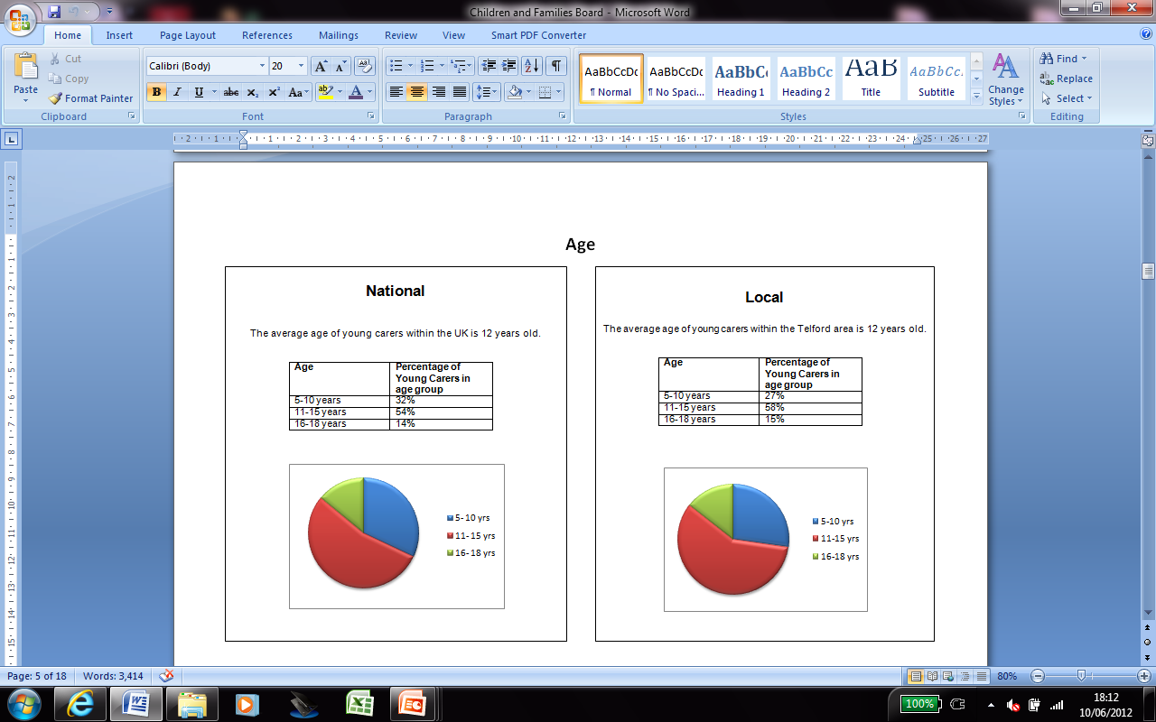

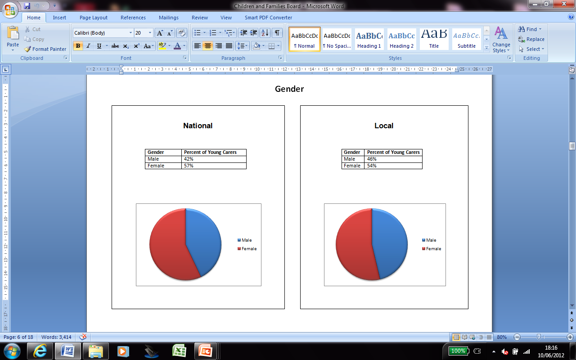

**Appendix 2 (Continued): The Local Picture**

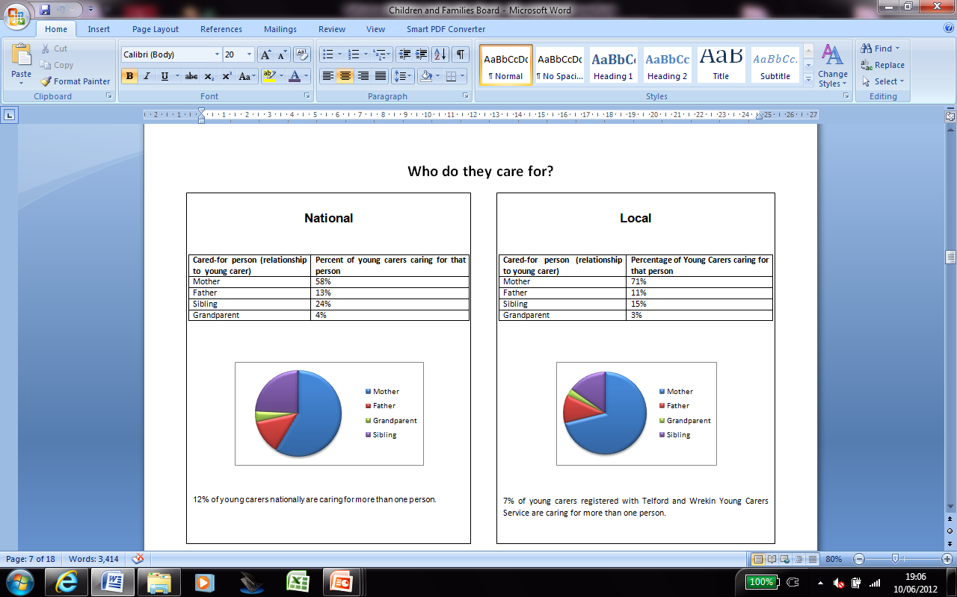

**References:**

Working Together to Support Young Carers and their Families. A Template for a Local Memorandum of

Understanding [MoU] between Statutory Directors for Children’s Services and Adult Social Services. August 2012.

[*www.adcs.org.uk/download/misc/working-together-to-support-young-carers-adcs-adass.pdf*](http://www.adcs.org.uk/download/misc/working-together-to-support-young-carers-adcs-adass.pdf)

Whole Family Pathway. Children’s Society 2012: [www.youngcarer.com](http://www.youngcarer.com)

Commissioning Services for Young Carers and their families. Carers Trust. Phelps, D (2012)

[www.carers.org/sites/default/files/commissioning_services_for_young_carers_and_their_families_final_copy_for_web.pdf](http://www.carers.org/sites/default/files/commissioning_services_for_young_carers_and_their_families_final_copy_for_web.pdf)

Making it Real for Young Carers. Carers Trust, ADASS and TLAP May 2013

<http://www.thinklocalactpersonal.org.uk/_library/MIRyoungcarersFINAL.pdf>

Young Carers Strategy and Action Plan Draft (2012 – 2015). Pyrah.E (January 2012)

Telford and Wrekin Health and Wellbeing Strategy 2013 / 2014 to 2015/2016

<http://www.telford.gov.uk/downloads/file/4123/hwb_priorities_consultation_may_2012>

Telford and Wrekin Medium Term Plan 2013/2014 / 2015/2015

<http://www.telford.gov.uk/info/200009/performance/842/council_plan>

Department of Health – Care Bill Fact Sheets

<https://www.gov.uk/government/publications/the-care-bill-factsheets>