Project Initiation Document (PID)

Adult Social Care
Adults with Learning Disabilities

Author: Victoria Worthington, Service Delivery Manager, Community Casework
Date: November 2017
Approval Date
Version v1

Contents

1 | Introduction
2 | Aim
3 | Principles
4 | National Context
5 | Local Context
6 | Our Approach
7 | Supporting People with Complex Needs
8 | Key Principles

1 Introduction
The purpose of this document is to set out how the Early Help and Support Service will meet the needs of adults with a learning disability within the context of national guidance, wider local plans and available resources.

Early Help and Support provides a multi-disciplinary service with Social Workers, Early Help Practitioners and Therapy staff working with adults with a learning disability from the age of 18. The service also supports young people in transition moving into adult social care from children’s services.

We are committed to working with people with a learning disability, their family/carers and other partners particularly the NHS voluntary & Community Sector, local providers of care and support, to develop services for people that help them to live as independently as possible.

The services broad functions are:
Community Social Work and Adult Safeguarding
- Delivering adult statutory social work requirements
- Assessment, Planning and Timely Reviews
- Promote direct payments, where people are eligible
- Supporting people to exercise choice and control over their own lives whilst safeguarding those who may be at risk

Community Early Help and Support
- Whole Family Working, focus on early help and prevention using short term intervention
- Deliver a strengthening families whole family working approach
- Supporting hospital admission avoidance and delayed transfer of care

2 Aim
We aim to provide quality support in a personalised way so that people with a learning disability their families/carers can receive the assistance they need in a way that enhances their independence and enables them to lead meaningful and valued lives within their own communities

3 Principles
Our principles confirm a vision for the future in which all people with a learning disability in Telford are full and equal citizens with the same rights to:
- Live healthy and independent lives with appropriate support to develop their maximum potential
- To have choice and control over decisions which affects all aspects of their lives with responsive advice and support where necessary
- Live their lives as active participants within their communities maintaining social and family relationships and networks which are important to them
- Have access to general and specialist services that are responsive to their individual needs, circumstances and preferences.

4 National Context
The service is delivered within the context of national legislation and quality developments relating to the care and support of people with learning disabilities.

The Care Act 2014 provides the primary overarching legislative framework for the provision of statutory support and services for people with learning disabilities and their carers. Other relevant legislation and statements of National policy include:

- Valuing People (2001) and Valuing People Now (2009)
- Mental Capacity Act (2005)
- Think Local Act Personal – Making it real
- Children and families Act (2014)
- No voice unheard, no right ignored – a consultation for people with learning disabilities, autism and mental health conditions (Green Paper March 2015)
- Building the right support (2015)
- Winterbourne View Transforming Care (2015)
- Building the right support (NHS England, ADASS &LGA, October 2015);

5 Local Context
Telford’s transformation plan “Shaping Our Future” reflects the national agenda and sets a clear direction locally for ensuring a fair system of social care and support where the resources made available reflect the individuals assessed needs, strengths, assets, circle of support and a whole family approach.

Increased financial pressures make it even more important to work collaboratively to make best use of resources. To achieve this we will be working inclusively with people, families and communities to create individual and community led and mainstream solutions to enhance people’s quality of life, meet statutory duties and show value for money.

Having choice and control, core to a good life, does not mean being entitled to increased funding. It does mean supporting people to:

- get the best from the money they are eligible for
- receive the support and services they are entitled to
- maximise non-paid support from family, friends and community

6 Our Approach
If we are to achieve our vision it is essential that we fully understand the aspirations of people with a learning disability, and that we are committed to providing support which enables individuals to realise their aspirations at a pace that is realistic for them.
To achieve this we will adopt a “progression approach” that ensures care and support planning helps people achieve the maximum level of skills, confidence and independence.
The approach will enable people to move on and will actively manage support in line with each person’s progression. This will ensure care and support requirements reflect need and are reviewed and amended overtime with statutory care and support services withdrawn in line with the individual’s progress towards greater independence.
Our approach will be underpinned by:
- Strength based assessment of a person’s abilities and needs
- Differentiation of maintenance needs (what is required to safely support current abilities) and development needs, things that help the person acquire the ability to be more independent and thus have reduced needs in the future
- Goal directed support planning
- Positive risk enablement and management
- Outcome based reviews.

“Progression” Implications for Practice

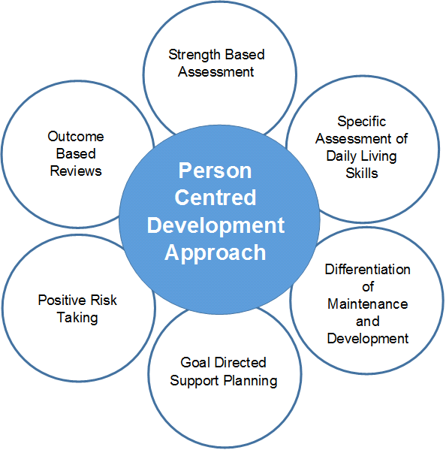

The progression approach will be embedded in all early help and support functions including early intervention, prevention, transition work, assessment, support planning and review processes.

7 Supporting People with Complex Needs
As part of the Transforming Care Partnership we will work closely with health and other agencies to ensure proactive, planned and co-ordinated support for people with a learning disability and/or autism who display behavior that challenges, including those with a mental health condition. Support will focus upon:
- Highly-personalised, life-long person-centred plans and care and support packages,
- Highly skilled carers able to deliver expert support including proactive / reactive strategies for managing challenging behaviour in the community.
- Proactive identification / treatment of physical and mental health problems
- Day-to-day support in the community informed by the expertise of multi-disciplinary specialist health/social care professionals (stepped up in intensity at times of crisis).
- Access to mainstream services / activities (taking into account, where relevant, risks posed to others) means the individual lives a purposeful and fulfilling life.

8 Key Priorities
We have developed a number of key priorities that reflect what people with a learning disability and their families/carers have told us so far.

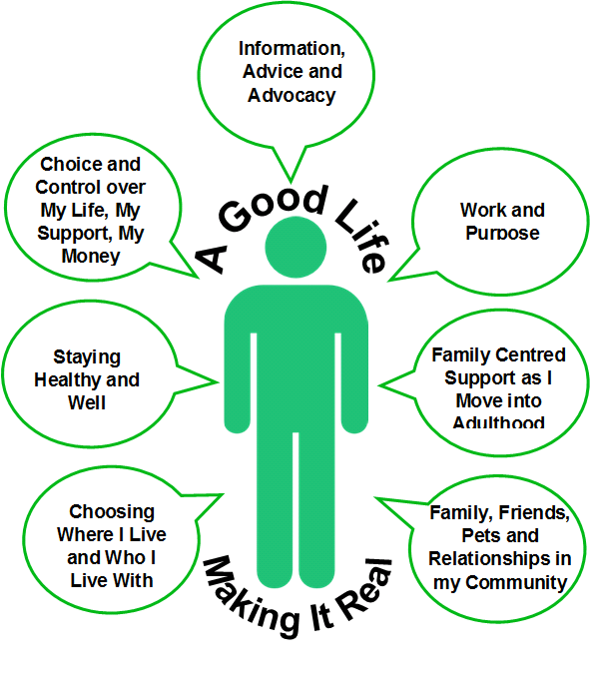

Life not a service
Good lives happen when people have good support and a voice that is
valued, respected and listened to

Priority 1) Information advice and advocacy
- Ensure a full range of advocacy support is available to people e.g. Statutory, Community, Self-Advocacy
- Ensure support to help people plan changes throughout their lifespan

Priority 2) Supporting people to stay healthy and well
- Ensure person centred planning includes support to maintain health and wellbeing
- Work with health colleagues to ensure a co-ordinated approach to meeting health needs and access to a full range of healthcare as appropriate including General Practitioner, Learning disability Nursing, Physiotherapy, Occupational Therapy, Psychology, positive behavioural support etc.

Priority 3) Supporting people with education, training, and occupation including paid employment
- Ensure person centred planning supports opportunities to access education, training and occupation to maximise full potential and achieve each person’s aspirations
- Support people to move away from traditional building based day time activities and to access mainstream facilities in their communities
- Work collaboratively with partner organisations to help people access paid employment opportunities

Priority 4) Supporting people to move into adulthood
- Ensure transition to adulthood planning starts from the age of 14 with Young People and their Families, and is informed by clear information about adult health and social care services, plus community and work opportunities
- Work collaboratively with partner agencies including education and health to ensure transition to adulthood plans focus upon opportunities for young people to become more independent, confident and healthy throughout their lives

Priority 5) Supporting people to choose where to live in accommodation that meets their needs
- Ensure that people are fully aware of all options for meeting their housing needs, and have choice and control over where they live, whom they live with and who provides support.
- Maximise creative opportunities for independent living including shared ownership, private tenancies, shared lives etc.
- Focus on increasing independence of those in Residential Care to ensure people are supported to move onto more independent living

Priority 6) Supporting people to have choice and control over the support they need
- Ensure people have access to information, advice and advocacy for assessments and reviews and to enable people to plan their support that is appropriate for each stage in their life
- Maximise the use of Direct Payments and Individual Service Funds to give people real choice and control.
- Ensure there is easy access to information, advice and advocacy in relation to Personal Budgets from the age of 14 along with support to manage employment and finance

Priority 7) Supporting people to maintain relationships with families, friends and local networks
- Ensure person centred planning enables people to maintain and develop personal relationships, networks and wider connections in their local communities
- Support opportunities to access a full range of mainstream community resources reducing the reliance on specialist and funded provision.
- Ensure a whole family approach to recognising the importance of family and friends in enhancing quality of life and reducing reliance on services
- Ensure that families and friends are involved in the development of person centred Support Plans
Priority 8) Supporting parents
- Ensure parents have access to information, advice and advocacy as appropriate
- Ensure parents are fully involved in person centred planning and are supported to make plans for the future during each stage of the natural lifespan
- Support parents to develop contingencies to manage critical events and plan for emergencies
- Enable parents are supported to sustain parenting roles including identifying needs through carers assessments and the provision of appropriate support

