**West Sussex – Practice Guidance**

IROs are qualified social workers with at least five years’ experience, and who have acquired the right skills to carry out this role.

**Child Ceases to be Looked After**

**What do I need to consider?**

* For a child who is looked after under s20 of the Children Act 1989 we need to be confident that if consent is withdrawn by the person with PR who requests that the child is returned home, the child will be safe.
* If there is any doubt, or if the care plan stipulates that in this event, legal advice should be sought immediately. The decision to return the child must be made without delay as immediately that consent is withdrawn we have no authority to hold the child.
* The assessment should be updated.
* In making the decision to cease looking after a child, the Authority must assess:-The suitability of the child’s proposed accommodation and maintenance when he/she ceases to be looked after; and-What services and support the child might need and who they might contact for support;-Where the child is returning home, what services and support the parent might need and who they might contact for support ;-The Local Authority must also ascertain the child’s wishes and feelings about the proposed plan for their care(having regard to their age and understanding), and consider them;-Consideration must also be given to the wider context of the family and environmental factors.
* The IRO must be consulted.
* The decision making form (below) should be completed and sent to the GM to authorise and add comments.
* The Form should be forwarded to the Head of Service (the Nominated Officer) who will consider the following:
* The young person’s wishes and feelings have been ascertained and considered;
* The decision to cease to look after the child will safeguard and promote their welfare;
* The support that the child and parent receive via the Children’s Services Department and partner agencies will be effective in supporting the child being safeguarded and promote the child’s well-being and best interests;
* The IRO has been informed.

**Statutory Requirements**

* Where a child has been looked after for more than 20 working days and is 16 or under, the Nominated Person must approve the request.
* For all 16/17 year olds the DCS must give approval.
* Following discharge from care all children will become a Child in Need

**What if the young person who is 16/17 does not agree?**

Essentially the decision by the DCS is to ensure that there is sufficient oversight and scrutiny with regard to the assessment of a young person’s needs and the support required to meet those needs. Ultimately if they refuse to agree to s20 – legally we cannot force them and dependent upon the risks – our only option would be to proceed to court.

As a minimum we need to evidence that we have explained the situation clearly and they are able to understand the options and make an informed decision which should be sent in writing to the young person.

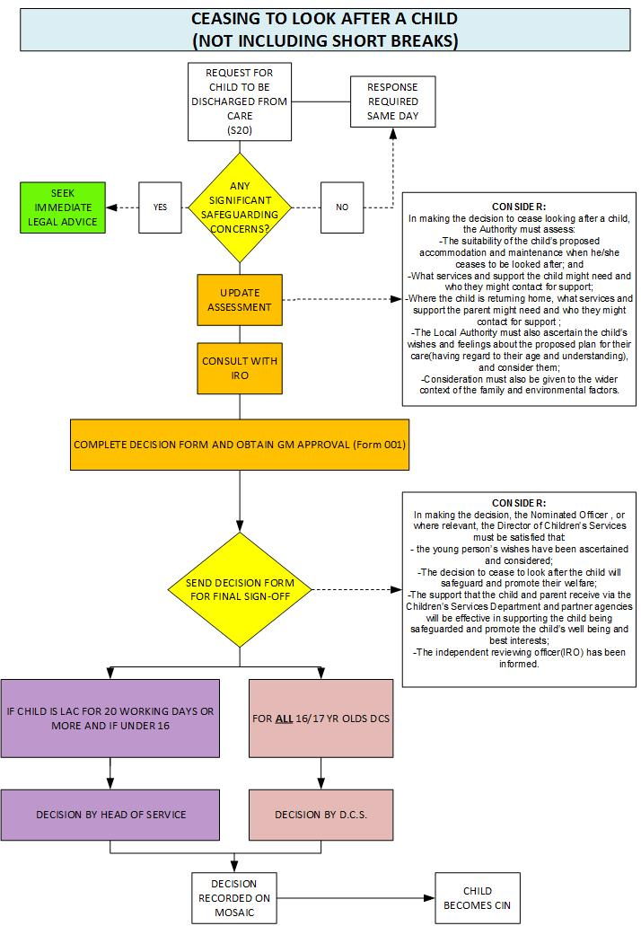

**Reference Points;**

 