Strengthening Families Approach to Practice in Bucks Children’s Social Care (CSC)
Strengthening Families (SF) is a whole system ‘approach’ for working with children and families.
It underpins the key functions of CSC including assessment, planning, intervention and review:
- Assessment – reviewing strengths and weaknesses in the family’s situation. This means being clear about the risks (historic and current) and exploring with the family how these can be addressed to meet the children’s needs. We also need to determine what still needs to be discovered about the family (grey areas).

Practice:
- Review and analyse past referrals and identify particular concerns exploring how these impact on the child(ren).
- Apply a professionally curious approach and hypothesise about potential outcomes and interventions required.
- Liaise with other agencies whilst actively involving the family in the assessment process.
- Rate the child’s position of safety using the 1-10 scoring system. 1 equating to high risk and need for removal of the child to 10 where the family are fully able to support, care for and protect their child.

- Planning – This requires proactive working with the family working out what needs to be done to improve the children’s lives. It also involves gathering further information from them and other agencies to consolidate the assessment.

The parents need to be challenged about the changes required to minimise the risks to their children (this includes relationships, substance misuse, mental health vulnerabilities, financial concerns etc).

The parents need support to identify what they need to do to improve their children’s lives. This might include establishing child focused activities, regular meal times, bed time routines and improved home environment.

Intervention needs to focus on whether the parents have capacity to make the necessary changes in the children’s time line of needs and whether the necessary support networks are available/ in place.

Practice:
- A values based approach informs the process of gathering information from the family about their situation and should involve other agencies in determining the best way to move forwards.
- A SMART plan needs to be drawn up collaboratively with the family where it is clear what is expected and by when.

- Intervention – The practitioner needs to establish with the family what needs to be done. This entails drawing up the goals/ objectives to be met, the actions required and the timeline and individual(s) undertaking them.

This needs to include direct work with the children and families and includes improving parental skills and understanding. This should also involve direct support to review and improve child focused communication, child centred activities and the child’s home environment.
Practice: Direct work undertaken with parents and children.
- Direct work with parents might include undertaking life story work with them; helping them tell their story and learn where they are in their lives.
- It might also include motivational interviewing, positive re-framing and encouraging mindfulness particularly in terms of considering their children’s needs in a child focused manner and VIG type approaches.
- It might include facilitating direct support for parents to resolve substance misuse and alcohol dependency problems.
- Direct work with children might include structured play activities, the three houses, protective behaviours work etc.

- Review – Progress needs to be reviewed with families on an ongoing basis.

Each visit provides an opportunity to review progress in an open and honest way. It can be reinforced and tested out by gaining feedback from other agencies and monitoring the family and child’s progress.
Practice:
- Progress reviews need to be undertaken in a collaborative way with open, honest feedback provided and new goals established as required.
- Parents need to be encouraged to share their own thoughts about their progress and what they think has changed and how they know this.
- Three houses exercise (or similar) can be undertaken with children at intervals to determine if there has been any change in their outlook/ experiences.

- Evaluation: Parents and children should be encouraged to provide feedback about the service provision.

Practice:
- This needs to be incorporated in to ongoing service development and evaluation.
- Practitioners need to focus on their own approaches and test out whether their skills and knowledge are sufficiently focused on children and families’ needs.

The SF approach is built on a good knowledge and skills base. These include:

- Communication skills
- Collaborative planning
- Time limited and focused practice
- Empowerment
- Relationship building
- Cognitive/ behavioural approaches
- Reflective
- Negotiating
- De-escalation techniques
- Risk assessment
- Analytical and evaluative (‘professional curiosity’)
- Undertaking direct work with children (all ages)
- Undertaking direct work with adults
- Parental mental health vulnerabilities
- Abusive relationships/ adult safeguarding
- Motivational interviewing
Values:
The SF approach is underpinned by values which need to inform our communication and understanding of our children and families’ needs. These values require us to be:
- child focused
- person centred
- relationship based
- transparent
- honest
- respectful

The SF approach seeks to develop the five Strengthening Families Protective Factors.
- Developing parental capacity and resilience. This needs to be a key focus of our planning and interventions and needs to be tested out throughout our work with the family.

- Strengthening social connections for families. Effective support networks are required to sustain and maintain stability after our involvement ends.

- Increasing knowledge of parenting. Parents need to enhance their parenting skills and understanding of their children’s needs.

- Providing concrete support in times of need. Parents/ families need to develop positive coping strategies to sustain child focus when there is increased pressure and stress in the family. These need to replace the previous failing coping strategies which were evident in the family.

- Promoting healthy social and emotional development for children. Parents need to be supported to prioritise their children’s needs through specific intervention plans. This might include undertaking protective behaviours work, mindfulness for children, structured play, positive praise and affirmation etc.

Conclusions:
The SF approach needs to focus on:
- The lived experience of the child
- The world of the adult
- Identifying strengths and risks
- Engaging the family in the change process – partnership working
- Identifying actions that are SMART
- Reviewing
The following model illustrates the areas of consideration that need to be included in the assessment, planning, intervention and review process:

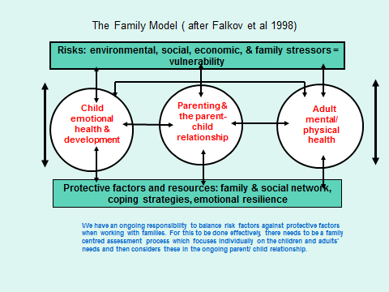
The following diagram illustrates the six key areas of the strengthening families approach. These areas need to be considered throughout the contact with the child and family and need to be rated on a 1-10 scale.
