REFERRING FOR A PLACEMENT &

STARTING CLA WORKFLOW

The Decision to Seek Accommodation step is available as a next action from the following steps:
- Child and Family Plan Review
- Follow Up Information Received (CYP)
- Child and Family Assessment
- Legal Proceedings - Service Leader Decision
- SDS CIN Support Plan
- SDS CIN Initial Review
- SDS CIN Ongoing Review
- Short Break Care Review
- Pre-birth assessment
- Significant Information on Open Case

If you do not have one of these open/ready then start at number 1 below (Significant Information on Open Case), if you have one of these start at number 3.

- On the child’s front screen go to Start >, New … and choose Significant Information on Open Case from the list.
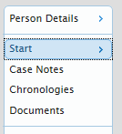

- Complete the Significant Information on an Open Case form:

- Choose ‘Decision to Seek Accommodation’ in the Next Actions form and then choose ‘Assign to Me’:

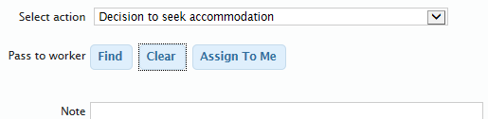

- Click ‘Add and Close’ and then choose the green tick to finish:

Decision to Seek Accommodation

- In your incoming work - start work.

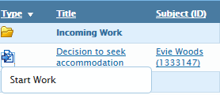

- Complete the ‘Request for a placement or change of placement form’

- If the child is not currently CLA and s20 accommodation is required, select the Send to Service Leader request and assign to the Service Leader for your team

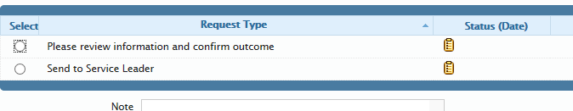

- Select the relevant Placement Referral Form and complete it:

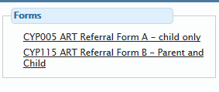
- Select the Please review information… request and assign to your manager

- Once all requests have been signed off and forms have been completed go to the Next Actions Form and choose the following outcomes:
  - Initial Health Assessment and select yourself in the Pass to Worker
  - Field (if not already a CLA).
  - Refer to PFT for Placement Search and assign to PFT Duty.
  - Start LAC Planning and select yourself in the Pass to Worker field (you will need this for a placement change/respite as well as it includes paperwork for the new placement).

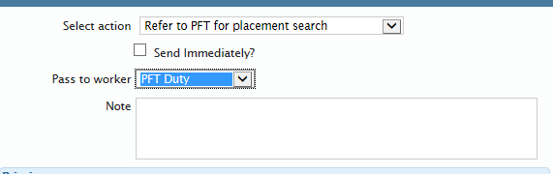

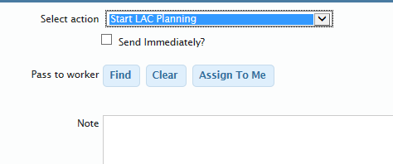

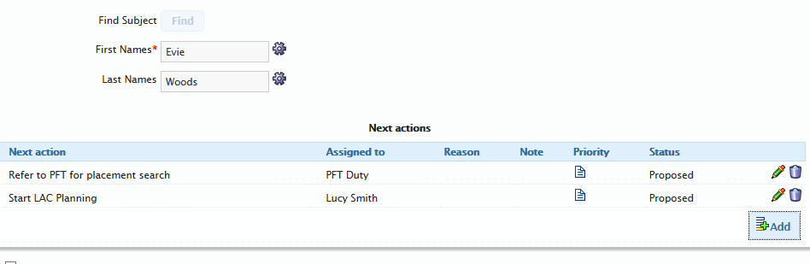

- Click ‘Add and Close’ and then choose the green tick to finish:

The LAC Planning episode will appear in your incoming work folder and the referral form will be sent to the Placement Finding Team.

We recommend that you ring through to ‘Placement Finding Duty’ to check that the referral has come through correctly.
*****

Generating the LAC Paperwork

In your Incoming Work Folder, click on LAC Planning and start work. This should bring up the following documents:

- Child or young person care plan

- Consent to medical treatment and placement

- Child or young person placement plan

