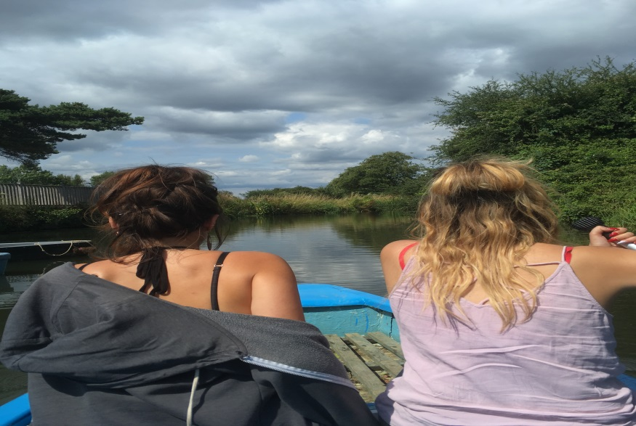
Newsletter

Missing and Exploited Children

January 2019

Protecting Missing and Exploited children

When children begin to go missing, behave differently, have mood swings, become secretive or display other unusual behaviours - and when parents who do not know that sexual exploitation or county lines exists, or understand the effects it has on children, we know that neither they, or us can tackle this on our own - there needs to be a multi-agency coordinated approach to awareness-raising with children, parents and the wider local community, as well as disruption and prevention of those perpetrating exploitation.

Missing and Exploited children Operation Group, (MEOG)

Each Wednesday afternoon, our multi agency Missing and Exploited children Operation Group, (MEOG) tracks the response to the children who have gone missing each week, monitors changing risks and needs of children through timely information-sharing and provide real-time responses to emerging concerns. Our Missing and Exploitation Coordinators, Jan Hawkins and Kathy Redman work together as Advanced Practitioners to ensure MEOG results in clear action planning, coordination of work across agencies and close monitoring of plans so that children are protected and supported.

MEOG will also review all Child Exploitation Risk Assessments that have been sent to the CSEHub (csehub@westsussex.gov.uk) to review the level of risk agreed, the safety plans and interventions in place and seeks to consider the best use of the contextual safeguarding, making key links between individual vulnerable children and groups of children and identifying where specialist interventions are appropriate. In December, 31 Child Exploitation Risk Assessments were completed and reviewed by MEOG - this includes both child sexual exploitation and child criminal exploitation. Of the 31, 14 were reviews and 17 were new identification of risk of child exploitation; 20 were females, and 11 were males 11; and of the 31 there were 5 who were at risk of criminal exploitation.

All of us that work with children need to ensure that we recognise the signs of child sexual exploitation and child criminal exploitation and understand that a child may be being exploited, even when the activity appears ‘consensual’ – Serious Case Reviews (SCR’s) and research in relation to Child Exploitation and Missing Children are found on the LSCB website, under information for Professionals – do have a look and if you spot the signs then fill out a CE Screening Tool and Risk Assessment – send a copy into the CSEHUb csehub@westsussex.gov.uk and MEOG will help you to put the right level of support around the child.

Complex High Risk Adolescent (CHRA) Team

Our Complex High Risk Adolescent (CHRA) team work alongside a child’s professional network, and Clare Harvey, Advanced Practitioner is coordinating support for social workers and other professionals to reduce risk and increase safety and stability for our most challenging and vulnerable teenagers. Oversight and leadership of the team is provided by Catherine Mouatt, the Service Development Manager for Adolescents and additional supported is provided by Sara Slinger, Advanced Practitioner, and Adolescent Mental Health who provides specialist support when the emotional well-being of a child needs attention.
Children’s needs and safety must come first. This means that as professionals we need to work flexibly and continue to ‘stay with the child’, even when they are unwilling to engage. We have the additional support of Paul Wilkinson and his team of 6 workers who are all youth work trained have provided consistency and creativity in building trusting relationships with children working together to increase placement stability and improve emotional resilience.

We have set up a Complex High Risk Adolescent operational Group that meets weekly to assist the professional group with the most complex and high risk children identified by Children’s Social Care and YOS. Working with 15 children at a time, the multi-agency group completes a deep dive review of the child’s history to form a trauma informed understanding of what their experiences means for the child, what their behaviours are telling us now, and we look at organising and coordinating interventions and support though the use of the Trauma Recovery Model¹ (¹ Sequencing Youth Justice Interventions For Young People With Complex Needs Dr Tricia Skuse Independent Clinical Child and Adolescent Psychologist and Jonny Matthew Consultant Social Worker and Criminologist). If you think one of the children you support is a ‘High Risk’ adolescent, please contact Clare Harvey - the criteria for the support of CHRA is:
- Consistent Intelligence of reported/disclosed harm or exploitation
- The need for improved multi-agency response to reduce risk of exploitation.
- Regular or continual missing episodes of where harm is disclosed or suspected
- Victim of serious sexual offences or links as perpetrators of serious criminal offences

With Complicating Factors:
- Non-attendance or sudden change in school attendance
- Concerns of significant self-harm
- Increase in offending behaviours
- Often avoidant or hard to engage

We see many examples of social workers and CHRA workers ‘going the extra mile’ to keep young people engaged, for instance staying in touch by text when young people are missing, doing activities such as boating (see picture at top of this newsletter), cooking and artwork. We have learnt that building trust and stability is vital to bringing about change with this vulnerable group. We can see young people contacting their trusted workers when they were at risk to seek advice and support.

Missing Children Team – Return Home Interviews

In addition to all this, since August we have started to provide Return Home Interviews (RHI’s) from within our service. Leadership of the team is provided by Paul Wilkinson, and Leah Greenwood coordinates the RHI’s to arrange for the most appropriate person to meet with the child and find out where they were when missing, who with and if they came to harm – sometimes the RHI is completed by the allocated social worker or child and family worker who has a good relationship with the child, and each week there are some who are unknown to either CSC or IPEH and these are completed by Leah or one of the 3 RHI workers. For the last quarter the Missing Children Team arranged and completed an outstanding 80% (Target 60%) Return Home Interviews for those children that required one, and 80% (target 75%) of these were addressed within 72 hours.
All children are vulnerable to exploitation

The most recent Ofsted Report ‘Protecting children from criminal exploitation, human trafficking and modern slavery: an addendum’ published after Joint Targeted Area Inspections (JTAI) were completed in Spring of 2018 reminds us that:

‘All children are vulnerable to criminal and sexual exploitation, not just specific groups. The scale and nature of child exploitation in England in the 21st century are shocking. The impact is devastating for the children, their families and their communities. Professionals and parents should not assume that the most vulnerable children are the only vulnerable children’.
The National Crime Agency (NCA) has recently published an update on the drug dealing model known as ‘County Lines’. It is the NCA’s third assessment of this criminal methodology, which involves networks from urban centres expanding their drug dealing activities into smaller towns and rural areas, often exploiting young or otherwise vulnerable people to do so. Dealers will usually use a single phone line to facilitate the supply of class A drugs – primarily heroin and crack cocaine - to customers. The line becomes a recognised and valuable brand and is therefore protected with violence and intimidation.
Based on the data provided, the NCA estimates that there are at least 720 County Lines across England and Wales, although the actual figure may well be higher. Based on the data provided by forces, at least 283 of those lines will originate in London, many coming to the South Coast, although other urban hubs continue to emerge. The NCA estimates that the majority of those 720+ lines will involve the exploitation of multiple young or otherwise vulnerable people.
The recently established National County Lines Coordination Centre has been developed to support a more sophisticated understanding of national intelligence. This should then inform a more coordinated approach to disrupt and prevent county lines. It will help support local areas to develop a multi-agency response to local risk and need. The centre has only just been established, so it is still vital that local, regional and national police forces share information on known risks, work together across boundaries and work with other agencies to fully understand the extent and nature of criminal exploitation.

www.gov.uk/government/news/national-county-lines-coordination-centre-to-crack-down-on-drug-gangs

In West Sussex we know that children targeted for the purpose of county lines come from a wide range of backgrounds. Local children can be groomed into selling drugs, as well as children from outside the area that will either travel into West Sussex or might be looked after children placed here by another local authority.
One young person was seen getting into a car with an adult male where there were significant concerns regarding Class A (Crack Cocaine) use by the young person. This resulted in a multi-agency professional meeting (MAP) which was convened to consider a move of placement to safeguard the child along with the allocation of a CHRA caseworker. Another example of concern was of a Unaccompanied asylum seeking child (UASC) who had been trafficked; when located at a Cannabis farm he said that he was in ‘fear of his life’. National Referral Mechanism (NRM) referral has been requested, service lead notified and joint operation with Missing Person Police team.

County Lines activity is dynamic and perpetrators will change their method of exploitation quickly, such as by targeting new groups of children to exploit in order to avoid detection. Examples include:

- targeting vulnerable older children, such as those who are neglected and less likely to be reported missing by parents
- targeting other groups of children who may be particularly vulnerable, such as those who have special educational needs, looked after children, children with poor mental health and children not in full-time education.
- grooming affluent children attending public school, who are less likely to
be identified as ‘drug running’ by the police

For us to provide the most effective interventions, the signs of exploitation need to be recognised early. This means that children can receive early intervention to prevent risk escalating.

Along with our Police Partners our tactical partnership response is to develop multi-agency intelligence on local risk through Serious Organised Crime (SOC) Groups. In Crawley, Arun and Adur and Worthing we are developing a more sophisticated understanding of the prevalence, nature and scale of criminal exploitation and county lines activity, alongside similar profiles for sexual exploitation and children missing. The police use the profiles to prioritise their activity to ensure that those who are most at risk receive a timely response.

The National Referral Mechanism is the framework for identifying victims of human trafficking and modern day slavery (which includes exploitation) to ensure that the child receives the right support and recognise them as a victim of crime. A referral can be made by any professional and there is a checklist to assist in identification. If you make a referral it is helpful to let CSEHub know so that we can map this kind of activity across the county.

www.nationalcrimeagency.gov.uk/about-us/what-we-do/specialist-capabilities/uk-human-trafficking-centre/national-referral-mechanism

Prevention and awareness raising

We have developed a whole-system approach to not only protect and support children but to try to prevent exploitation through raising awareness in the community and disrupting criminal activity.

Across our Police and Children Social Care partnerships, along with YOS, Districts and Boroughs, Health and Education we aim to work together with parents and children to alert them to the signs of grooming, exploitation and county lines. One example of this is our partnership with ‘asphaleia’ to provide interventions in schools SAFE West Sussex, provided by asphaleia have been funded by The Big Lottery for five years. Since starting in February 2017 they have been providing prevention and intervention activities; specialist interventions related to risks of exploitation, and workshops to YR 6 and parent/family support. This innovative work is aimed at Years 6 and Year 7 because research and data have shown that by year 8 children are especially vulnerable to being targeted by gangs. 575 year 6 children accessed workshops this year, 139 children had regular 1:1 sessions focussing on reducing risk of exploitation and 66 parents had support to help recognise signs and know what to do.

We also have the support of Barnardo’s, commissioned to work with vulnerable older children. They understand the very fast pace at which children can be groomed into exploitation and together with police are developing a good knowledge of local gangs and how they operate. The B You CSE service is currently working with 48 young people. Of these, 11 are on the current WSCC Red lists for Child Exploitation. The remainder are on the WSCC Amber list (24) or are young people for whom the risks have reduced as they are nearing the end of their work with the service (13).

Our Deputy Designated Nurse for Safeguarding Children, Jenny Whyte, joins us in the CHRA Operational Team and in Missing and Exploitation Operational Group to bring specialist knowledge of the health of our missing and exploited children from a range of health services such as sexual health and school nurse services. Jenny ensures that in turn, sexual health, school nurses, GP’s, A&E and other health providers are all informed when a child is known to be at risk of exploitation and she works with our local primary care practitioners to give them the knowledge and tools required to protect children at risk of exploitation.

In the Adolescent Service we are about to start training on trauma-informed practice to underpin our approaches to interventions. We hope that all our service will understand the value of investing time and effort to establish meaningful relationships with children who will have been let down and abused by adults.

Working in Partnership

Whatever the child’s home circumstances, the risks from exploitation spread beyond risks to the child. For some, their homes will be a place of safety and security; for others this will not be the case. Their families may also be threatened or be highly vulnerable to violence from the perpetrators of criminal exploitation.

For us to respond in the most effective way we must include families in the interventions to support exploited children, and not focus our work with children in isolation. For example, helping them to put clear boundaries and structures in place for children who frequently go missing from home.

We cannot run the risk of thinking: ‘this does not happen in our area’. The dangers of delayed responses to any child who may have been criminally or sexually exploited can have very serious consequences for the child, and other children linked to them.

There are well-documented links between children missing education and safeguarding risks, including the risk of exploitation. Even being absent from school for a short time, such as being missing for part of the school day, can increase the risk of both sexual and criminal exploitation. Staff within the multi-agency safeguarding hub (MASH) and early help and duty teams understand the high risks these children face and the need to promptly coordinate a multi-agency response.

We have seen some great examples of support from social workers, child and family workers and our Complex High Risk Adolescent workers providing flexible support, such as home visits at the weekends and in the evenings to monitor a child’s safety.

A recent example of effective partnership working has been in Littlehampton, where we noticed that a group of looked after children were going missing together from residential homes and their behaviour was deteriorating, they were becoming violent and disruptive to staff and to the home itself. To find out what was happening we started with asking the residential staff to follow them – and discovered they were going to a porta cabin on a local building site. A return home interview enabled a child to provide information about a group of builders who were providing cannabis and alcohol to the children and we noticed the process of grooming had begun. A partnership meeting was arranged and a disruption plan was put in place: Community Safety Officers from the District and Borough and Environmental Health visited the site; the building site owner was contacted and questioned about the children; Child Abduction Warning Notices were serviced on the site manager by Police; the local schools and health services were alerted; and a referral to Adults Safeguarding was made in relation to the mother of one of the looked after children who was vulnerable and had become involved. All of this resulted in the children stopping going missing, the site manager moved back to Poland and the mother received treatment for her poor mental health. We have no doubt that these children who had started to go missing and show signs of deteriorating behaviour were likely to become exploited without this responsive and dynamic intervention.

For more information or advice please do ask !

Catherine Mouatt
Service Development Manager for Adolescents

catherine.mouatt@westsussex.gov.uk

CSEHub@westsussex.gov.uk
Missingchildrenteam@westsussex.gov.uk
Administrator: Justene Edwards Jorger, Justenejorger@westsussex.gov.uk

