Informal/Formal Dispute Resolution Escalation Process
INFORMAL PROCESS

C

A

F

C

A

S

S

Embedded Co-ordinator records on spreadsheet and tracks progress
CPA/IRO raises concern with Social Worker and/or Practice Manager/ Group Manager by face-to-face or telephone discussion.

CPA/IRO enters summary case note onto Mosaic using drop-down ‘Informal Issues Resolution’ box

CPA/IRO enters case note to confirm dispute is resolved.
PROCESS ENDS
CPA/IRO continues to escalate until issue is resolved with TM/PM
CPA/IRO adds final comments and closes
PROCESS ENDS

CPA/IRO E-MAIL ALERT to Team Manager/Principal Officer/ Embedded Co-ordinator to confirm date of formal process

Stage 5 (DCS & Executive Director informed)
PROCESS to be resolved within 20 working days
PROCESS ENDS

HEAD OF QAPI ADDS FINAL COMMENTS AND CLOSES PROCESS ENDS

Head of QAPI starts Stage 4 and notifies Head of CSC
Head of CSC completes Stage 4 and notifies Head of QAPI in 5 working days

Principal Manager starts Stage 3 and notifies SL
SL completes Stage 3 and notifies Principal Manager in 5 working days
Completed by SL in timescales and satisfactory response?
YES NO

Team Manager starts Stage 2 and notifies GM
GM completes Stage 2 and notifies PM in 5 working days
Completed by GM in timescales and satisfactory response?
YES NO

Principal Manager adds final comments and closes
PROCESS ENDS

Team Manager adds final comments and closes
PROCESS ENDS

CPA/IRO opens ‘Dispute Resolution Process’ step on MOSAIC, starts Stage 1 and notifies PM
PM completes Stage 1 and notifies CPA/IRO in 5 working days
Completed by PM in timescales and satisfactory response?
YES NO

FORMAL PROCESS STARTS

NO
ISSUE RESOLVED within 20 working days?
YES

Starting a Formal Dispute Resolution:
Go to the record of the child that relates to the dispute you wish to resolve.
Go to ‘Start’ then ‘Dispute Resolution Process’
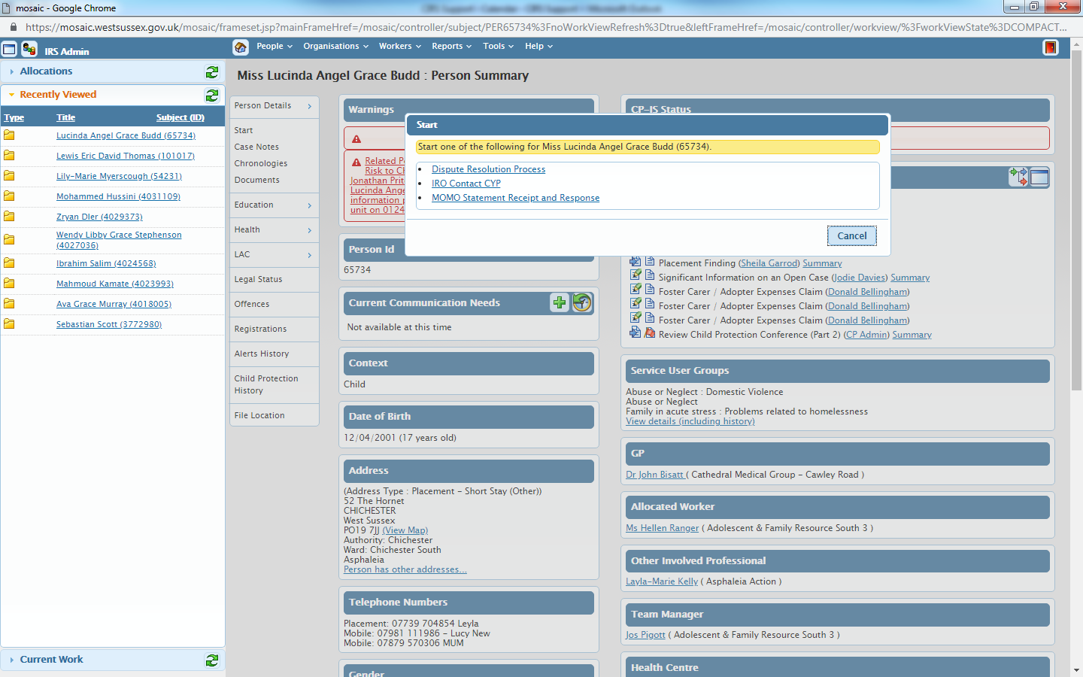
This will open a new screen where you can fill in Stage 1 as appropriate entering details for who should be copied into the form.
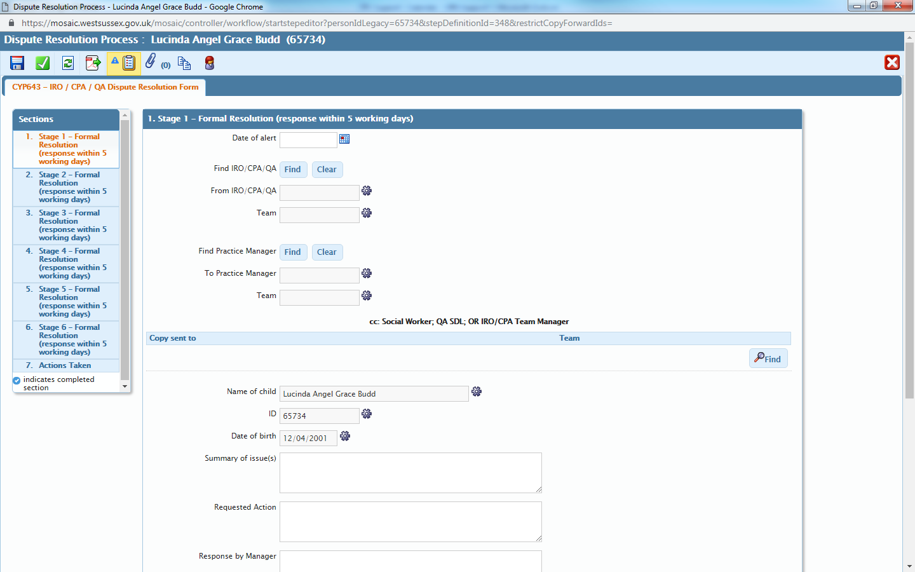
Fill in date of alert.
Put your details in here.

PM goes here
Anyone else you feel may be useful to list goes here by selecting from drop down boxes.

Please add here the reason for creating the dispute resolution.

What you would like to happen in here.

The manager should add their response here when working on the resolution.
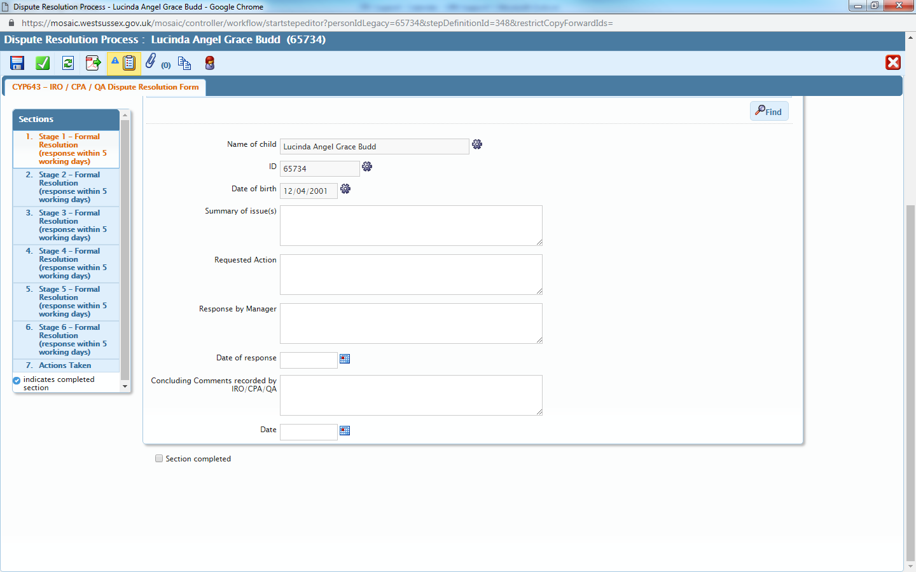
This is the same step as above but now has the rest of the step in view.

The manager should add the date of response here.

You can add further comments here,
And date that here.

Stage 2
Once you have complete stage one as above then you should email the people involved to let them know this has been created. The task system is not available for this step.
The timescale for this to be completed is 5 working days. Should the Dispute not be resolved to a standard you were expecting then you must raise this to a Stage 2.
Stage 2 is raised between your line manager and the line manager of the person you have raised stage 1 with. This is to be done via email and your manager will fill in stage 2 on Mosaic.
Once the dispute has been resolved you will get notification of this and can move onto completion.

Completion:
Once you have received notification that the dispute has been resolved then you can go back to the step.
Here you will need to complete ‘REQUIRED IRO/CPA/QA Please sign off Dispute Resolution’
Found in the task tab.
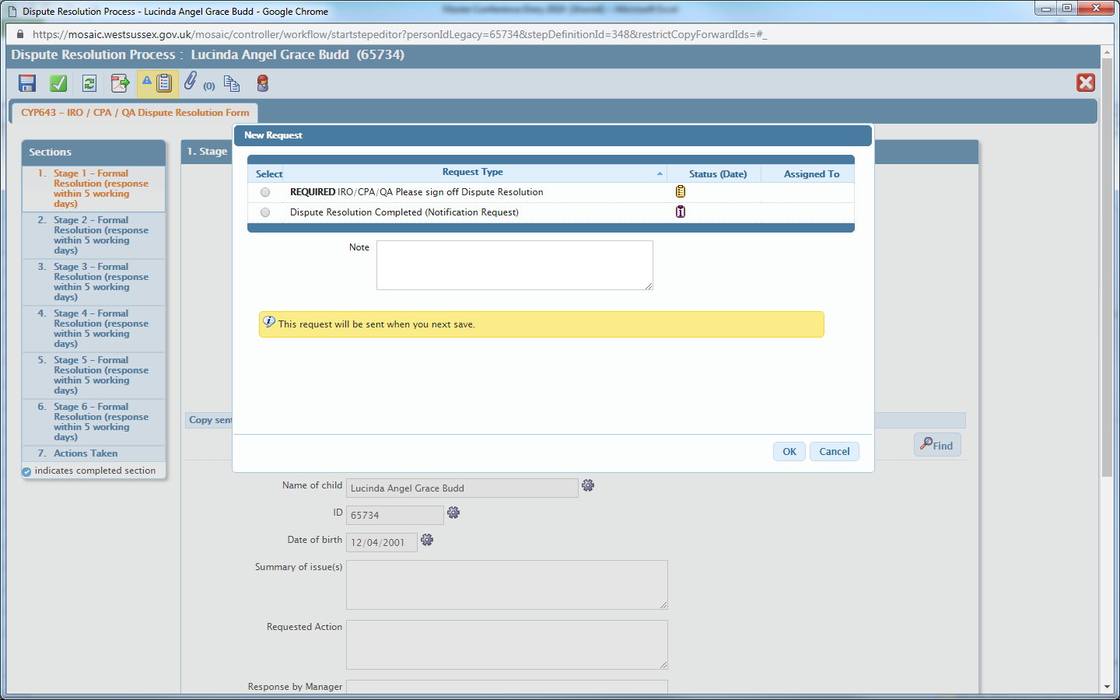
You will need to task to yourself, save the step and then complete.
Once you have completed the task the go to ‘Section 7’
Once here you can select the outcome ‘Issues Resolution Concluded’
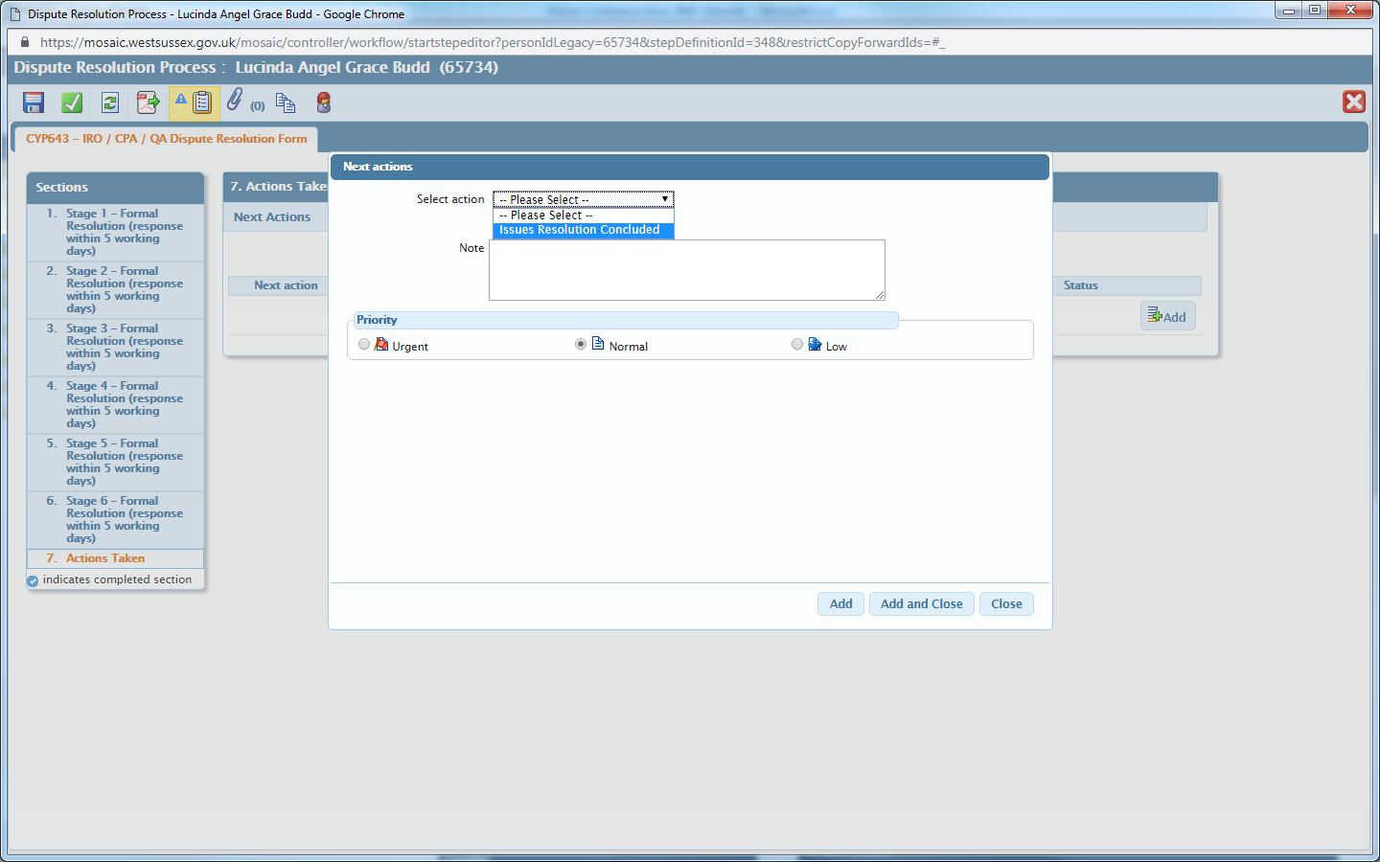
‘Add and close’, then ‘Complete’.
This will complete the step.

