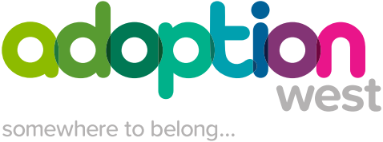

Adoption West Family Finding - Information Checklist

Name of Child or Sibling Group

Name of Social Worker | Name of Family Finder

Date of birth of child(ren)

Gender:

Ethnicity:

Children and Families Social Worker: (name, team, contact details)

Permanence (or other) Social Worker: (name, contact details)

Legal Services Contact: (name, role, contact details)

Legal Status:

Date of SBP decision

Date of final hearing

Date of next CiC review:

Date child or children became ‘looked after’ (if applicable):

Current Plan for child or children e.g. Twin tracking:

Background Information
Family history, reason for issuing Care Proceedings:

Health in relation to the child or children:

Health in relation to the parents (including mental health and substance use):

Geographical restrictions in relation to a potential placement:

Proposed contact arrangements with birth family members:

Is there any potential need for consideration of an Adoption Allowance?

This will need to be considered by the Adoption Manager/ Local Authority Adoption Lead.

Please provide full details:

The plan should be reviewed at a minimum of three monthly intervals if no family has been identified. The review meeting should be attended by a Manager from Adoption West and the Local Authority Social Work/Permanence Team
Date of Review (minimum of 3 months):

