Financial Assessment Requests - Non Residential

- When a referral from the community is received, it will be screened and processed by HSCD. If the person is eligible for a Social Care assessment and has an e-mail address, HSCD will send an e-mail sign-posting them to the Connect to Support website for a link to the Online Financial Assessment to be completed and will note this on the Referral or a Case Note.
- If the person does not have an e-mail address or requests a paper based finance form, HSCD will send documentation to them via Civica letters.
- Whenever HSCD send a finance pack a task (Pre-Service Financial Assessment Request) is created in Protocol for the ASC team and this task is passed to wherever the Referral is allocated.
- Once the Financial Assessment paperwork is received by the Financial Assessment Team and contributions completed - the task in Protocol changes to 'Financial Pre-assessment result'. This will notify the allocated Team or Worker to view the result in the Assessment Tab - Completed Financial Assessments.
- If a person is discharged from hospital and a financial assessment is required, the Tech Admin - Hospital Team will make a request for a financial assessment via Protocol (Pre-Service Financial Assessment Request). The Financial Assessment Admin team will pick requests up, on a weekly basis via a Controcc report, and send out finance packs accordingly.
- Please note that Reablement can be provided for up to 6wks and is not a chargeable service. This only applies to Reablement. All other services are chargeable and will require a financial assessment.
- When a SW or a CM is assigned a case, they must check the outstanding Protocol task and Protocol to establish if a financial assessment is still outstanding. (Once a financial assessment is on Controcc, it's also viewable on Protocol.) If in doubt, contact should be made with the Financial Assessment Team to check the status of the assessment.
- A financial assessment can be requested via Protocol by any ASC staff when you know that a chargeable (non res) package of care is likely. A report is run weekly, by the Financial Assessment Team, to identify and process any new requests. Please do not send requests for financial assessments to the team’s generic e-mail. Requests must be made via Protocol.
- Where possible, always direct people to Connect to Support, where they can complete a financial assessment online and upload their supporting information. This process is quicker and saves money for the council.
- If you have requested a pre-service financial assessment and circumstances change meaning the financial assessment is no longer required, please ensure you cancel your request. Every request you make for a financial assessment starts a process within the Financial Assessment Team that must be followed.
- The Financial Assessment Team run a report weekly to identify packages that have been entered on the system without a corresponding financial assessment linked to it. The team's Admin section will progress, offering a visit if required. This option is a last resort and is a ‘tidy up’ process when pre-service financial assessments haven’t been requested at an earlier stage. By the time cases reach this stage, the potential for income loss is extremely high.
- Please ensure requests for pre-service financial assessments are made, via Protocol, at the point you know someone is likely to receive a chargeable service or direct them to Connect to Support where they can submit a financial assessment on line. Requesting at a later stage could lead to a loss of income to the authority.

Scroll down to see how you:

Request a pre-service financial assessment in Protocol.

Cancel a pre-service financial assessment request.

View details of financial assessment contribution amounts in Protocol.

How to request a pre-service financial assessment request in Protocol:

Bring the service user record up in IAS Protocol

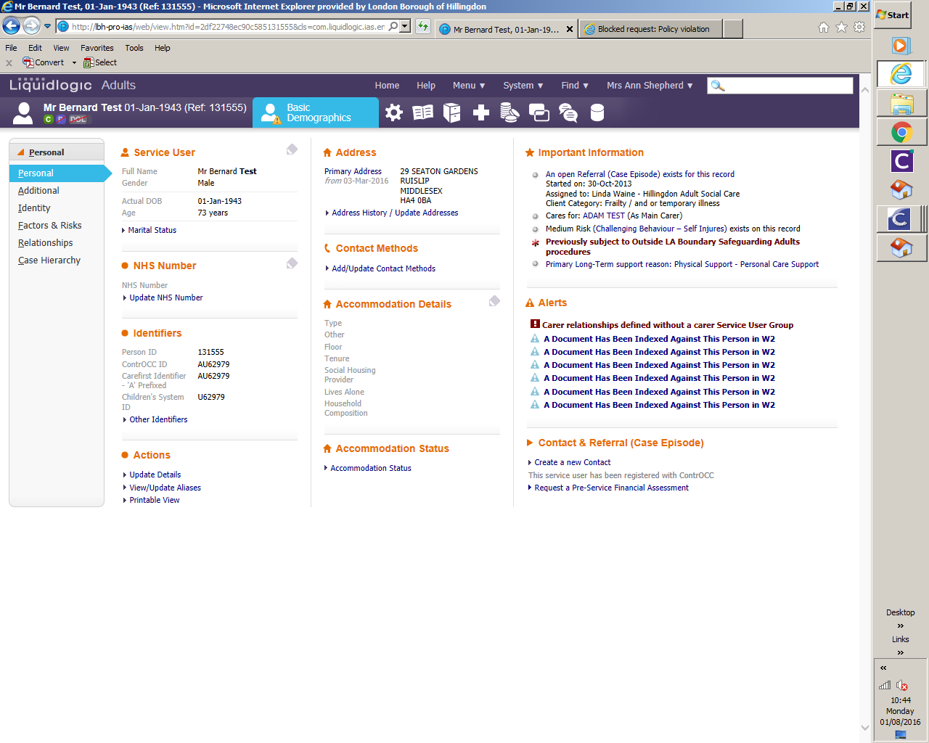

Check on the right hand side whether the service user has been registered with Controcc.

If they have not, click on Register the service user with Controcc. You will then see a message to confirm this.

Click on the Request a Pre-Service Financial Assessment option, choose Non-Residential then click on Create. The request will then be sent through to the Financial Assessment Team.

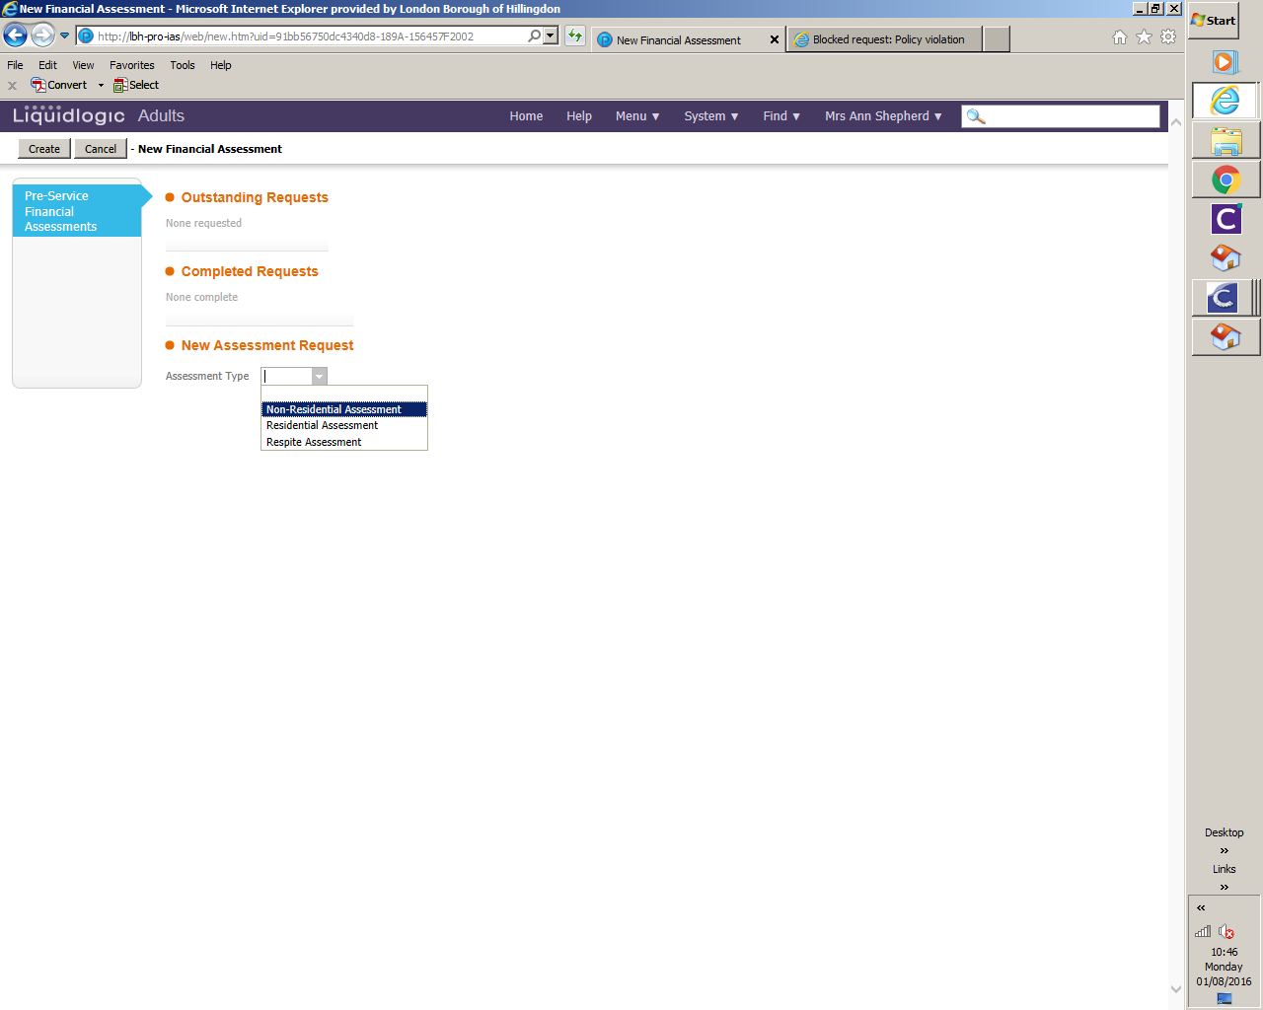

How to cancel a pre-service financial assessment request in Protocol:

Case Files/Professional Involvements

Select the Pre-service Financial Assessment Request

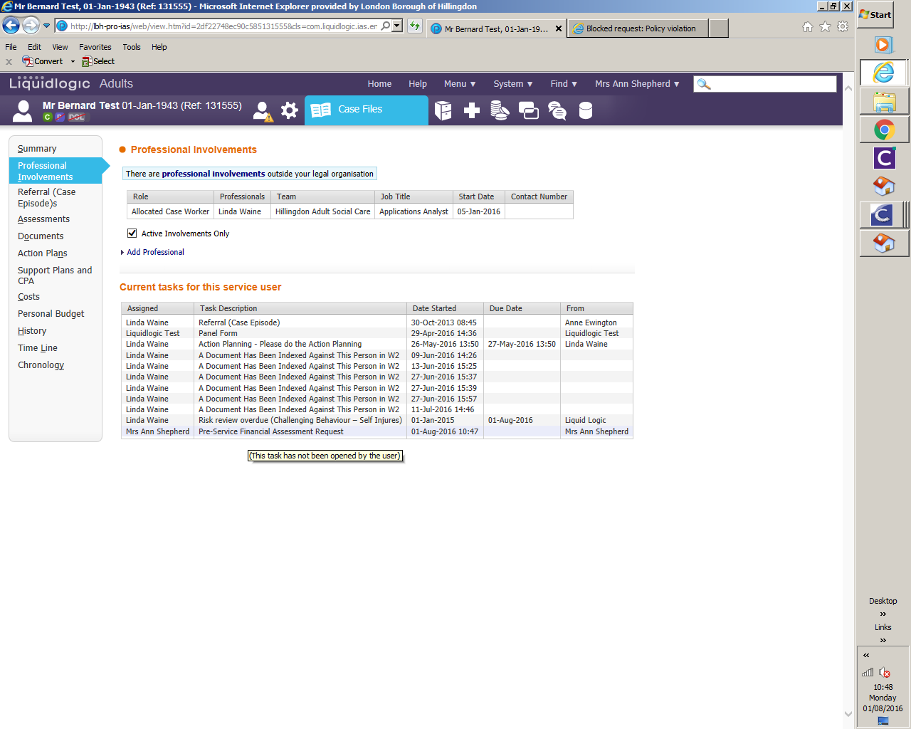

This will open a new window, once open, select Cancel Request.

This request will now be removed from future Financial Assessment Reports.

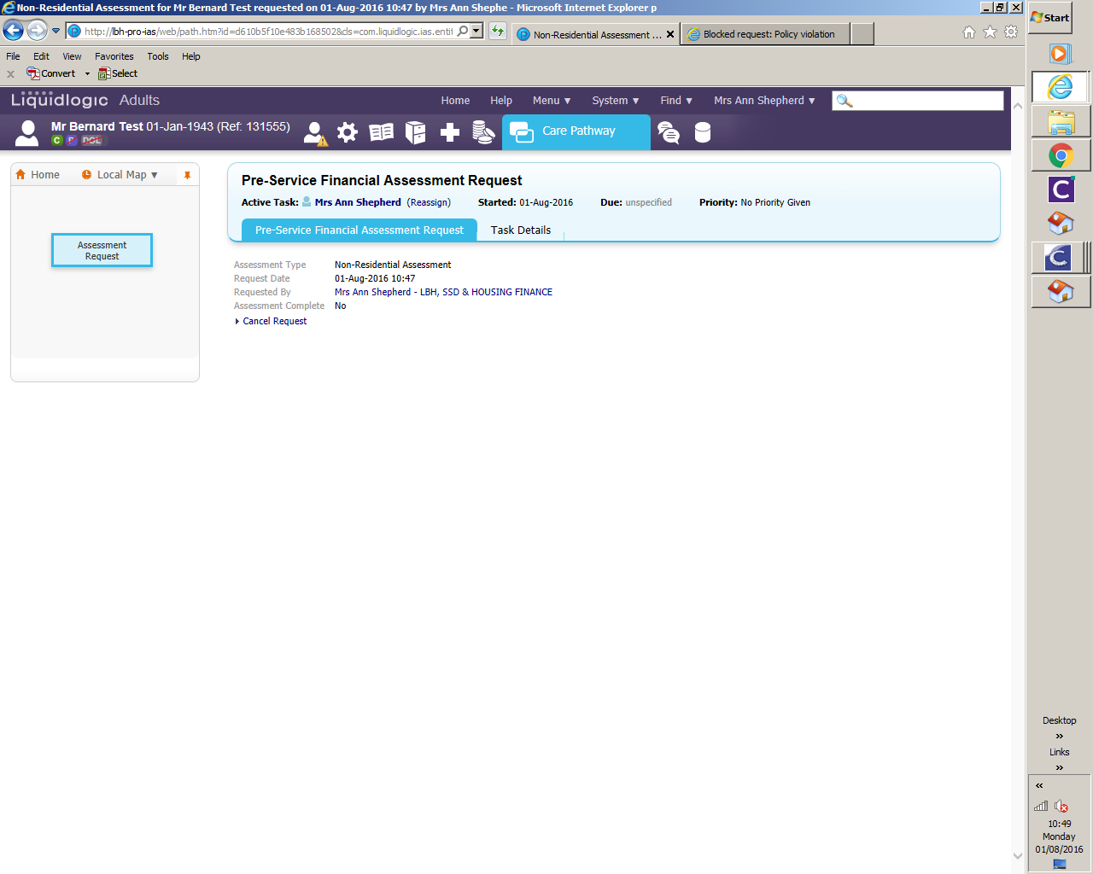

How to view Financial Assessment Data in Protocol:

Find your client in the usual way and click on 'Case Notes' (the book icon) at the top of the screen.

Click on the 'Assessments' tab on the left hand side of the screen.

On the right hand side of the screen you will see 'Completed Financial Assessments' and the dates.

Click on the latest date.

The details of the financial assessment will be displayed.

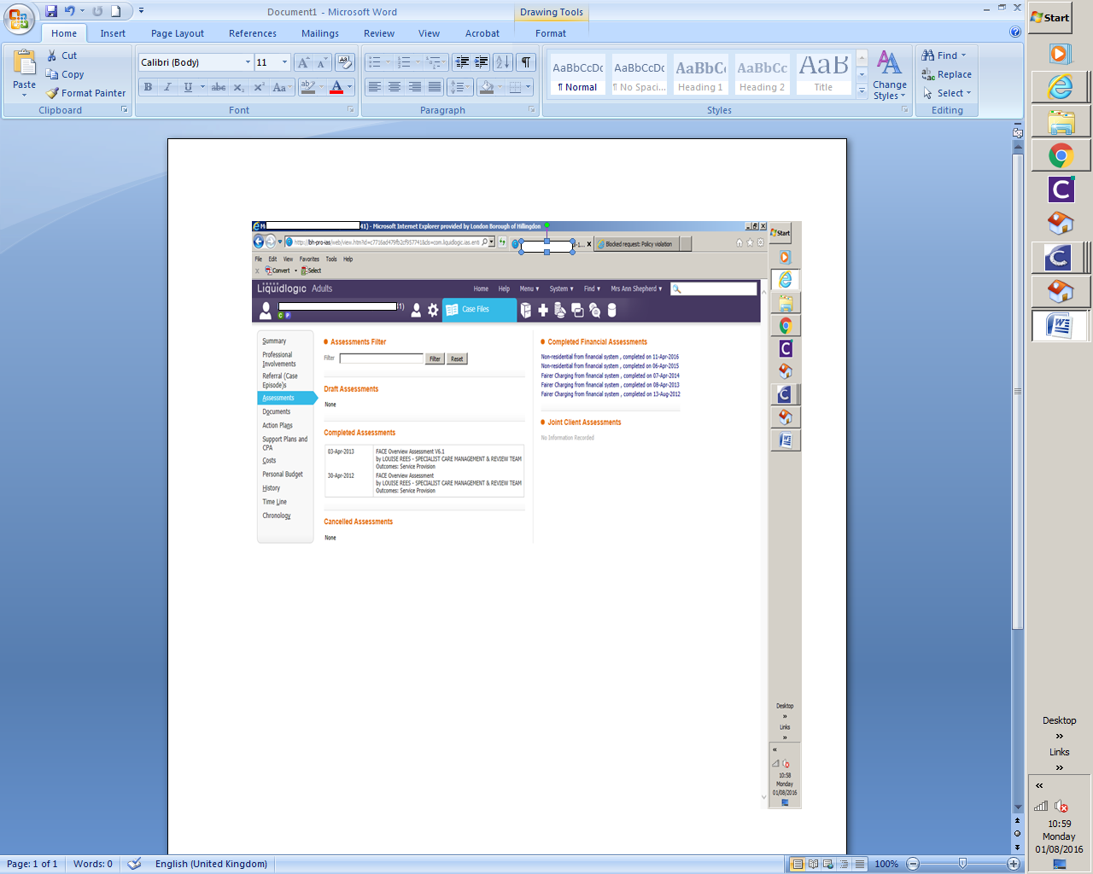
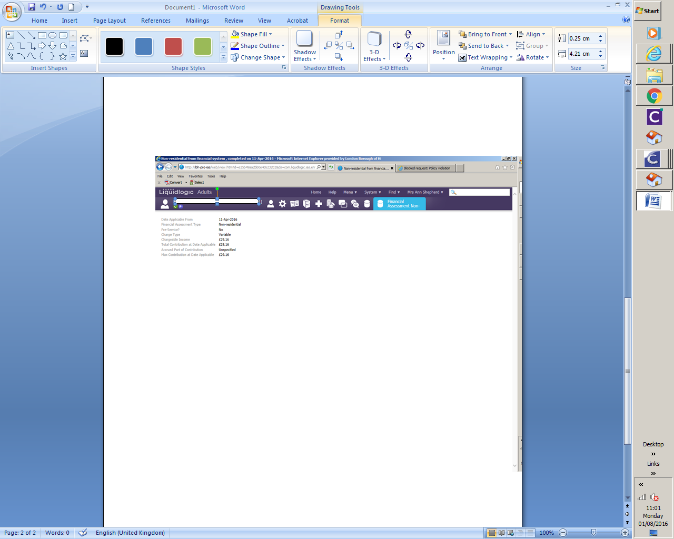

Date Applicable From - date the financial assessment applies from.

Financial Assessment Type - this will be either:
· Residential assessments
· Non residential assessments e.g. home care, day care, respite, outreach and supported housing/living.

Pre-Service? - this indicates whether a provisional non-res financial assessment has been carried out, prior to the service being set up on the system. Non-Res cases only.

Charge Type - will be either:
· Full = client to pay full cost of the service
· None = client does not have to pay for their service
· Variable = client is paying an assessed charge for their service.

Chargeable Income - this is the amount of income the client has left per week after deducting all allowable expenses.
Total Contribution at Date Applicable - this is the amount that the client needs to contribute towards their care per week.

Accrued Part of Contribution - if the client has a deferred payment agreement, this is the amount of their contribution which is deferred against their property per week.

Max Contribution at Date Applicable - this is the maximum amount that the client will contribute per week.

All residential cases initially have a provisional rate added until a full financial assessment can be carried out. This is different to a pre-service financial assessment. If you’re unsure on the contribution amount for a residential case, please check with the Financial Assessment Team.

Financial Assessment Generic E-mail: Financialassessment@hillingdon.gov.uk

