Direct Work Resources

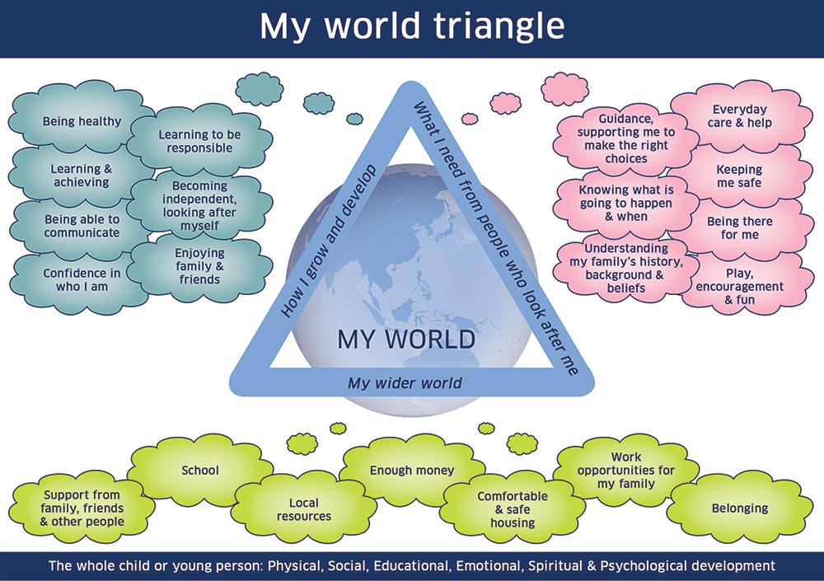

Index
- How to use this resource
- Basic principles of direct work with children
- How to explain to a child

- Three Houses
- Scaling
- Three Islands
- Feedback tool about social workers
- Helping Hands

- Whose Job

- Faces and Feelings
- Safety House
- Conversation Starter Cards

- My World Ecomap
- Chatterbox Origami Question and Answer

- Conversation Starters – getting to know you
- Conversation Starters – worries
- Direct Work Resources
- Sibling Relationship Game Cards
- Who Job Cards
- Face and Feeling Cards
Another card game-

How to use this resource

This folder contains ideas and resources for direct work activities with children.
All the resources that are needed are included in this folder and/or in the direct work bag.

Please do not remove any of the pages in this folder – the pages give the instructions on how to do the activities, which can all be done with blank pieces of paper, and these are found at the back of the folder.

If you would like your own copies of any of these resources, or if they get lost or damaged, they can be found on:
http://teamspace.westsussex.gov.uk/teams/CSC/FSP/Shared Documents/Tools and resources for direct work with children and parents/Direct Work Folder resources

This resource is not a ‘finished product’ so if you have any feedback or suggestions for direct work tools that can be added to it, please contact Anna Chime, Advanced Practitioner on Anna.Chime@westsussex.gov.uk.

Basic principles of direct work with children
Planning and preparation:
- Consider what is the child’s understanding of the role of a social worker and the reason for Children’s Services involvement – Do these need to be explained during the session?
- What is the aim and purpose of the session?
- What is the best venue for the session?
- What resources are needed?
- What is the best way of communicating with this child (e.g. talking, playing with toys, drawing, playing a game, doing something active?)?
- Are there issues of difference between the worker and the child, e.g. in terms of language, gender, race, faith, physical or other disability?
- How to record the work? (e.g. taking a photo of the completed work, having time straight afterwards to write it up)
A suggested format for the sessions:
- Beginning
  - Explain your job, confidentiality, the length of the session and use an icebreaker
  - Aims and purpose – what you aim to achieve
  - Choose equipment – toys – games
- Middle
  - Session in progress
- Ending
  - Recap what you have done during the session. Be clear about any information that may share with the child’s parents or other people (if relevant).
  - Agree a time and date for follow up session (if relevant)
  - Tidy up
  - Do an activity of the child’s choice, e.g. play a game or read a book. This will help to lighten the mood, and bring the child out of the grim things you may have been talking about.
Using observation – listen with your eyes as well as your ears
- Eye contact?
- Physical proximity and body contact?
- Child’s emotional state?
- Is the child’s body language congruent with what is happening? E.g. does the face match the words?
- Pay attention to what is not being said – are there times when the child changes the topic / doesn’t want to talk about certain things / goes silent?
- How does the child cope with the ending of the session?
- Is the child looking to please you / tell you what they think you want to hear?

Three Houses

Purpose: explore with the child what they are worried about, what is working well and what their hopes are

What you need: paper and pens

What to do: Introduce the activity with something like:

“Part of my job as a social worker is to talk with children when there may be some things that people are worried about, and then to help everybody to sort those worries out. I’ve talked with X (the person who raised the concerns) and they’ve told me that there are some things that they are worried about, and now I’d like to talk with you to hear your ideas about how things are going.

I’d like to do something called the “Three Houses” with you, which is something I do with lots of children. We draw three houses together and in those houses you can draw or we can write down the things that you are worried about, the things that are going well in your life, and the things that you would like to happen in the future that will make the worries go away”.

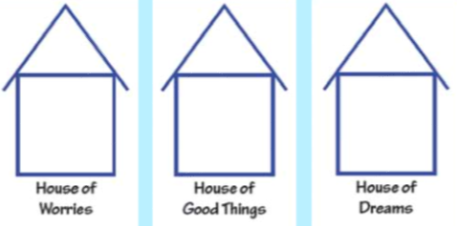
Draw together each house on a separate piece of paper and label them with ‘House of Worries’, ‘House of Good Things’ and ‘House of Dreams’. You can also invite the child to name the houses themselves. (If you want to, instead of house, use other images the child can relate to, such as footballs, cars, flowers etc).

Ask if the child would like to start with the ‘House of Worries’ or the ‘House of Good Things’. If you are doing the writing, use the exact words used by the child. Read back to the child what you have written to check that they are happy with it. Ask clarifying questions such as ‘tell me more about that’.

If the child struggles with the activity, try prompts such as:
- What is good about where you are living at the moment?
- What is good about school?
- What is good about your visits with your mum?

Then you can explore what is not good about these things.
Before finishing the activity, ask the child if there is anything else that they would like to add to any of the houses. This is because children often leave until the end the thing that they are most worried about.

Once the activity is completed, talk to the child about who they would like to share the Three Houses with. Check if they are worried about it being shared with their parents.

Talk to child about the next steps so that the child knows what is being done about the worries.

Scaling

Preparing children for scaling:

Explain that sometimes it is hard to say how much you like or don’t like something, and this is a way to measure how you feel.

“Can you show me how much you like chocolate? If zero means that you hate it and don’t like it at all, and ten means that you love chocolate, show me where you are on the scale?”

“Can you show me how you are you feeling about the next school holiday, with zero being really worried about it, and ten being that it feels amazing. Show me where you are on the scale”.

“Can you show me how you feel about spiders? Zero means that you are really scared of them and ten means that you love them. Show me where you are on the scale”.

When the child understands what scaling is about, build up to different topics

- How are you feeling today? (0=really worried = 10=not worried at all)
- How safe do you feel at home? (0=not safe at all – 10=really safe)
- I feel confident that I’ve got someone I can talk to if I need to (0=there is no one I can talk to – 10=there is someone I can talk to and I feel confident in talking to them)

If you are using a scaling strip with a character, you can say “let Superman show me”.

Use visual aids depending on the child’s interests, e.g. draw ten footballs/flowers/stars and ask the child colour in or circle the number of items that they scale themselves at.

Follow up questions:

- What would make you move up to the next number?
- Before – now questions: You have scaled yourself at 8 on how safe you are feeling. Where would you have scaled yourself a week ago, when step-dad was living in your house?

Three Islands

Purpose: The three islands technique helps gain an insight into a child’s life without having to rely on question and answer interviews, which can be intimidating for some children.

What you need: paper and pens (or small figures if the child doesn’t want to draw)

What to do:

- Draw two islands close to each other on the piece of paper and a third island further away. Draw a bridge between the first two islands and a gate in the middle of it. If it helps, name the islands i.e. the ‘Island of Always’, ‘The Island of Sometimes’ and the ‘Island of Far-Away’.
- Explain to the child that this is a game and that they live on the first island. Ask them to draw themselves or use one of the toys to represent them. They can then draw anything else they want to be on this island with them (which could include people, animals, activities, objects).
- On the second island, ask the child to draw or put anything that they want to see but not all the time. Explain they have the only key to the gate on the bridge, so anything on the second island can only cross when the child lets them.
- On the third island, ask the child to draw or put anything that they want to be far away from them or never see again.

Feedback tool about social workers

Purpose: Enable the child to give feedback about their social worker

What you need: The origami feedback tool

What to do:

- Explain that you would like to find out from the child what it is like to have a social worker and that you would like to play this game with them.

- Show the child how to hold the origami in their hands and how they can open and close it by moving their fingers
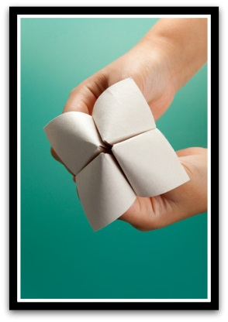

- Ask the child to choose a number between 1 and 10.

- Then ask the child to open and close the origami while counting up to the number they said.

- Ask the child to choose one of the numbers that are showing and then read the question that is under the number.

- There are eight questions all together and do as many as the child wants.

Helping Hands

Purpose: Find out from a child the people in their world whom they feel can keep them safe.

What you need: A4 size paper, felt tip pens

What to do:

- Start with some free drawing.
- Introduce the activity with something like: ‘Let’s draw around each other’s hands’.
- Suggest that the child draws around your hand.
- Introduce the idea of ‘helping hands’ by saying something like: “You know, when I was little, people used to hold my hand when we crossed the road to keep me safe”.
- Draw around the child’s hand.
- Suggest that you write down the names of people who keep us safe or help us on the fingers of the hand.
- Offer prompts if needed, e.g. “who would you like to hold your hand when:
  - you are crossing the road
  - are watching a scary movie
  - are visiting the dentist.
- Finish the activity by decorating the hand. Take a photo of the completed work so that the child can keep it.

Whose Job?
Purpose: Discuss roles and responsibilities within a family.
What you need: ‘Whose Job’ cards, pens, paper
- Explain that you would like to learn more about how the child and how their family works, and that every family is different and there are no right or wrong answers.
- Ask the child to draw a picture of each family member on a separate piece of paper.
- Then draw a picture of a person called ‘Mr Nobody’.
- Lay the cards face down and ask the child to pick one.
- Read the card with the child and ask ‘Whose job is it?’.
- Ask the child to place the card beside the person that they name (if they choose Mr Nobody, ask if there is anyone else who does this for the family)
- Throughout the activity, discuss with the child the different jobs and different family members.
- Once all the cards have been used, take a photograph so that you have a record of the activity.

You can add your own cards as well with questions that are specific to your case.

Faces & Feelings

Purpose
- Identifying and talking about different feelings
- Exploring children’s feelings about different things
- Exploring how the child perceives their family

What do I need?
- A large piece of paper and colouring pens
- For children unable or unwilling to draw, use the Faces cards that are in the direct work pack, or draw/print out pictures of facial expressions.

How to do it:

- Explain to the child that you want to know more about them and their family.
- Show them or draw some pictures of different facial expressions – ask the child to name the feeling and help if needed.
- Once the child knows what each feeling means, here are some suggested activities:
- Exploring feelings
  - Together with the child, copy the facial expression for the different feelings
  - Talk about what kind of things make the child feel that way – e.g. ‘show me an excited face – when was the last time you felt that way?’, or ‘show me a sad face, can you tell me about the things that make you feel sad’.
- Feelings in the family:
  - Ask the child to draw a picture of everyone in their family. Then ask them to choose a Face card that best suits each person, e.g. ‘what kind of a face does daddy have’. Then talk about why daddy has that kind of face.
  - For each person, talk about the things that make the person have certain feelings. E.g. using a Sad Face card, ask ‘what kind of things make mummy have a sad face’.

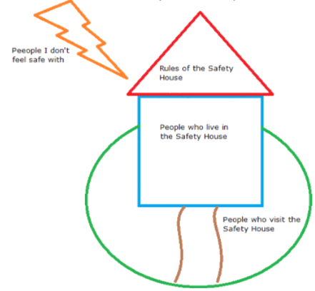
Safety House

Purpose: To explore and/or explain safety plan to a child

What you need: Pen and paper

What to do:

1. Inside the Safety House
Draw the house (blue section) and the roof and ask the child to draw themselves inside the house. Ask the child:
- Who else would live in your Safety House with you?
- Imagine that you’re home/ back with mummy and daddy, what sort of things would be happening that would make you feel safe and happy?
- What are the important things that ______ (eg Mummy and Daddy) would do in your Safety House to make sure that you are safe?
- Are there any important objects or things that need to be in your Safety House to make sure that you are always safe?

2. Visiting the Safety House:
Draw the circle around the house (green section) and ask:
- Who would/will come to visit you in your Safety House to help make sure that you are safe?
- When _______ (each of the safety people identified above) come to visit you in your Safety House, what are the important things that they need to do to help you be safe?
3. Unsafe people
Draw the lightning (orange section) and ask the child:
- When you’re at home, is there anyone who might live with you or come to visit who you would not feel completely safe with?
4. The Rules
Draw the roof (the red section) and say:
- “Remember we talked about how all those adults are talking together to make a safety plan to keep you safe? One of the things they are trying to decide is what the rules of the safety plan should be. What do you think? What would the rules of the house be so that you and everyone one would know that nothing like ________ (use specific worries) would ever happen again?”
- “If your _______ (sister/brother/Nana etc) was here, what would they say?”
5. The Safety Path (scaling)
Draw the path (brown section) and say:
- If the beginning of the path is where everyone was very worried (and you weren’t able to live with Mum and Dad and you had to go and live with _______ ) and the end of the path at the front door is where all of those worries have been sorted out and you will be completely safe living with Mum and Dad, where do you think things are right now? If you’d like to give it a number, the beginning of the path is 0, and being at the safety house is 10, which number would you give it?
- You can also ask questions specific to the worries, e.g:
  - If the beginning of the path is that you feel very worried that if you go home to live with Mum (or have an overnight stay) that Mum will start using drugs again and then not be able to look after you properly and the end of the path at the door is that everything in your Safety House is happening and you’re not worried at all that Mum will use drugs again, where are you right now?
Conversation starter cards
Purpose: A ‘getting to know you’ activity
What you need: Conversation starter cards

- Place the cards face down in front of you and the child or spread them on the table.
- Take it in turns to pick up a card and answer the question. If you want, you can both answer each question.
- When appropriate, talk about the questions and the child’s answers in more detail.

My World Ecomap

Purpose: Exploring the child’s relationships

What you need: Paper, colouring pens, character cards

What to do:

- Explain to the child that you would like to learn more about the important things in her life. Explain that the child can draw or use the character cards, or both.
- Spread out the character cards and invite the child to choose a character to represent themselves. Place this in the middle of the paper.
- Invite the child to choose characters/draw for the people who are most important in her life, and to place these on the paper.
- Talk about why the child has chosen a particular character for each person, and about their relationship with the child.
- Ask the child about other people in their life, explaining that some may be important because you like them/get on well with them, or because you strongly dislike them/each other. Invite the child to use more animals to represent these people and to place them around the tree where they best fit.
- Invite the child to decorate the picture and draw other things that might be important to them, e.g. pets, games or toys.

Chatterbox origami Question & Answer

Purpose: This activity can be done as a ‘getting to know you activity’ or to ask the child specific questions about their circumstances. It also gives the child to ask you questions that they have on their mind.

What you need: Two pieces of paper, scissors, pens, stickers to decorate. Use the ‘conversation starters’ sheet for ideas for the questions.

What to do:

- Explain that you would to play a game with the child where you can ask questions from each other by doing an origami chatterbox.
- Prepare the chatterboxes together:

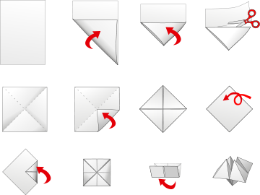

- Open up the chatterboxes so that you can write in the questions and decorate them according to the following chart:

- Do a mixture of lighter and more serious questions (use the ‘conversation starter’ sheets for ideas)

- Show the child how to hold the origami in their hands and how they can open and close it by moving their fingers

- Ask the child to choose a number between 1 and 10.

- Then ask the child to open and close the origami while counting up to the number they said.

- Ask the child to choose one of the numbers/pictures/colours that are showing and then read the question that is under the number.

- There are eight questions all together and do as many as the child wants.

Conservation Starters-
Getting to know you-
Family
Who is part of your family?
How many brothers and sisters do you have?
Are your brothers and sisters older or younger?
What are their names?
How do you like being a big/little sister/brother?
What are your parents’ names?
Do they go to work or stay at home?
Do you have other family members who you see but who don’t live in your house?
Which member of your family is most like you?
What is the best thing about being part of your family?
If there was one thing you could change about your family, what would it be?
What is your favourite thing to do as a family?
Do you have any pets? What are their names?

Personal
How old are you?
When is your birthday?
What did you do for your last birthday?
If you could have the perfect birthday party, what would it be?
What is your favourite food?
What is one thing that your Mum/Dad makes for dinner that you just can’t stand?
What is your favourite kind of ice cream?
What is your favourite kind of sweet?
What is your favourite kind of crisps?
What is your favourite colour?
What is your favourite animal?
What is your favourite time of the year?
Do you share your bedroom with anyone?
If you could receive one thing in the whole world as a present right now, what would it be?
What do you want to be when you get older? Why?
What is the silliest thing you have ever said or

School
Where do you go to school?
What year are you in?
Do you like the year you are in more or less than last year?
Do you walk to school or go by car or a bus? Who takes you to school?
What is your teacher’s name?
What is your favourite thing to study at school?
What things are you learning in school right now in math? … arts? ..science? ..etc?
What is your least favourite thing to study?
Do you get homework?
Who do you spend time with at school?
Do you have a best friend?
What do you like to play at playtime?
Do you ever stay home on school days? What do you do on these days?
When was the last time you stayed home?
What was the best (or worst) thing that happened at school today?
What was something that made you laugh today?
What was your favourite part of lunch or playtime?
What part of the day do you look forward to?
What part of the day do you dread?
Which class are you learning the most in?
Which class are you learning the least in?
What do you think you want to do when you finish school?
Are there any bullies in your school? Have they ever bullied you?

Social:
Do you get pocket money? What do you like to spend it on?
What is one thing you don’t know how to do that you wish you did?
What is something you like about yourself?
What is one of your earliest memories?
What’s one of your favourite memories?
What’s the hardest part of your life right now?
What do you worry about the most?
What helps you feel better when you’re upset or stressed?
What can I do to help you when you’re upset or stressed?
How often do you feel sad?
When have you felt angry recently?
What kind of things hurt your feelings?
What’s the best compliment you’ve ever gotten?
What does your perfect day look like?
If you could be famous, would you? What would you want to be famous for?

Who is your best friend? What do you like about him/her? What do you think they like about you?
Who do you wish would listen more closely to you?
Do you have any friends you’re worried about right now?
Are you happy with the number of friends you have?
Do you ever feel lonely or left out?
What makes a good friend?
Who in your class is a really good friend to others?
What makes someone a bad friend?
Has anyone ever been a bad friend to you?
What does it mean to be popular at your school? Do you want to be popular?

Activities
What do you like to do for fun?
Do you go to any clubs?
What do you do at weekends?
What is your favourite thing to do on the weekend?
Do you like to spend your time inside or outdoors?
Do you like to draw? What kinds of things do you draw?
What do you do when you get home from school?
Does your family ever go on a holiday?
Where is the most exciting place you have been to?
Do you have a bike? What does it look like?
Cultural Things
What is your favourite TV show?
Why do you like it?
What is your favourite movie ever?
What was the last movie you saw?
Did you like it or not, and why?
What is the best toy that you have?
Do you like to read?
What is your favourite book?
Do you play computer or video games? What kind of console do you have? What are your favourite games?
Do you have your own mobile phone? What is it like? Can you play games on it or use the Internet?
Do you like to go out to eat?
What is your favourite place to eat?
What kind of music do you like?
What is your favourite song?
Do you like to dance?
Do you know how to play any instruments? Which one(s)?

Randoms:
What is your favourite letter of the alphabet? Why?
What is your favourite day of the week?
Would you rather scream or whisper?
Would you rather take a picture or be in the picture?
If you could do one thing, everyday, for the rest of your life, what would it be? If you had a robot for one day what would you ask it to do?
What is your favourite thing about yourself?
How do you make friends?
If you could design a zoo, which animal would you have the most of?
When you woke up this morning what was the first thing that you thought about?
What’s the best smell you’ve ever smelled?
Can you remember a time when you made someone smile?
Do you think you could go an entire day without talking?
Have you ever told a small fib so as not to hurt someone’s feelings?
Who do you talk to the most on the phone?
If you became the Prime Minister, or the Queen/King, what would you do?
What makes someone a good friend?
How would you feel if, for one day, you were the parent and your mum and dad were the kids?
If you could trade places with anyone for one day, who would it be?
Pick one fruit to combine with one vegetable to make a “fruitable”.
Do you think it would be fun to be famous?
If you design your own playground, what kinds of things would you want to play on?
What is the quickest way to make someone smile?
Do you like how old you are now or do you wish you were older or younger?
Once you lie down in bed, how long does it take you to fall asleep?

Conversation Starters-
Worries
Neglect
Can you tell me about what happens in your house in the mornings / after school / at dinner time / at bedtime?
Who is at your house when you come home from school (when you get up in the morning, go to sleep at night)?
Who helps you get ready for school? What do they do?
Have there been times when you have been hungry and there hasn’t been food for you at home?
Do you ever worry about food and about being hungry?
Do you sometimes have to fix your own meals because no one else will do it for you?
Is it sometimes difficult to find clean clothes to wear?
Do you think your mum and dad could do with some help with getting all the housework done?
Can you tell me about times when you are feelings poorly? Who looks after you and what do they do?
Are there times when you feel bad about yourself? How does that happen?
Do you ever feel like your mum/dad/home is different to other mums/dads/homes?
Do you sometimes wish that your mum/dad would make you feel really special and take extra special care of you? What would that look like?
Do your friends visit your home? Have you ever felt bad about your friends visiting your home?
Domestic abuse
What happens in your family when grownups have a disagreement?
Tell me about the last time your mum and dad were arguing?
Why do you think your mum and dad argue?
Have your mum or dad ever got hurt when they have been arguing? What about you, have you gotten hurt?
What do you do when your parents are having an argument?
What is the worst thing that your mum/dad has ever done?
Do you think that you/your Mum/your Dad do things to stop arguments from happening,
(for example, play really quietly so that Mum/Dad don’t get annoyed)?
What’s your biggest fear when your parents are arguing?
Do your parents say sorry if they have hurt each other?
Is there anything you wish you could say to your parents when they are arguing?
Do you think it’s anyone’s fault that there are arguments in your house? (use this question with caution so that the child won’t think it’s their fault)

Mental health
Are there times when you are worried about how your mum or dad is feeling, or about their health?
Do you sometimes wonder why your mum/dad act the way they do?
Do you ever feel that there is a problem, but no one will talk about it or tell you what it is?
Have you heard your parents or other people saying things that make you worried, and you are not sure what it means?
Do you sometimes wonder why your mum/dad is poorly? – do you worry that you might get poorly as well? – do you worry what might happen if your mum/dad won’t get better?
Are you ever worried that your mum/dad might hurt themselves when they are feeling poorly?
Do you ever feel like it’s your fault that your mum/dad is poorly? (use this question with caution so that the child won’t think it’s their fault)
Do you ever feel like it’s your job to make your mum/dad feel better?
What do you do when you are feeling scared or worried? Is there anyone who can make you feel better?

Drug and alcohol use
What kind of things have you heard about drugs/alcohol?
Do you know anyone who uses drugs/alcohol? What happens when they do this?
How do you feel when your mum/dad uses drugs or alcohol?
Has anything ever happened when your mum/dad has been using drugs/alcohol that has made you worried?
Does your mum/dad behave in a different way when they have used drugs/alcohol?
How much do you think your mum/dad like using drugs/alcohol?
Do you wish that your mum/dad would never use drugs/alcohol ever again?
Do you worry about what might happen if your mum/dad use drugs/alcohol?
Are you ever worried to talk about drugs/alcohol because you are worried that someone will get into trouble?
What do you do when your mum/dad are using drugs/alcohol? Is there anyone who can make you feel safe?

Physical abuse
Have you ever been hurt by someone taking care of you?
If someone is naughty in your house, what usually happens to them? Is this the same for everybody?
What does your mum/dad say and do when they are cross?
Do you sometimes feel scared at home?
If you’ve been in trouble at school, are you ever scared about what might happen when you get home?
Do you think it’s okay for grownups to hit/smack/hurt children?
What do you think parents should do if their children have done something naughty?
If there is one thing that you wish you could stop your parents from doing, what would it be?
What do you think happens in other children’s homes, when the children have been naughty?
Have you ever been told off or hurt, even if you haven’t done anything wrong?
Have you ever had any marks or bruises on your body when you have been hurt by someone?
Has anyone told you not to tell anybody if they have hurt you? Are you worried about what might happen if you did say that someone has hurt you?

Emotional abuse
Tell me about times when you have felt really loved and really special?
Which person do you feel happiest to be with?
Has anyone ever made you feel really bad about yourself, or really scared?
If a child is scared or hurt, what should happen to them?
Do you think it’s ever okay for grownups to say things to children that make them feel bad? Has this ever happened to you?
Do you think that all children should be loved by their mums and dads?
What kind of things do mums and dads do that makes children feel that they are loved? Do your mum and dad do these things?
Do you sometimes feel like you don’t want to go home after school?
Is there any person you wish that you never had to see again?

Sexual abuse
Has anyone tried to make you do anything that you feel uncomfortable about?
What do you think ‘good touch and bad touch’ mean?
What would you do if someone were trying to touch you in a bad way? What if it was someone that you know? Has anything like this ever happened to you?
Do you know what ‘good secrets and bad secrets’ mean? Does anyone want you to keep bad secrets?
Are you worried about what might happen if you spoke to anyone about being worried about bad touch or bad secrets?
Sibling relationship game

Purpose: Explore how a child is feeling about their relationship with a sibling, both in terms of how they feel about the sibling, and how they perceive the sibling feels about them.

What you need: Sibling relationship cards (these should be in a little envelope along with this guidance), one blank piece of paper, three smaller pieces of paper, scissors, sticky tape, pens/felt tips,

- Explain that you would like to learn more about how the child gets along with their brother or sister.
- On the blank piece of paper, invite the child to draw their sibling
- Cut out three pieces of paper and attach these to the drawing with a sticky tape so that they form little pouches that are open at the top (see photo).
- Write ‘Often’, ‘Sometimes’ and ‘Never’ on the pouches.
- Place the cards face down on the table and read them out one by one, filling in the blanks with the sibling’s name.
- Give the card to the child and ask if this happens often, sometimes or never, and ask the child to place it in the correct pouch.
- Use the activity as a prompt to talk about the different things in the cards.
- When the activity is completed, it will be good to close the top of the pouches with a sticky tape so that the cards do not fall out and get muddled up.

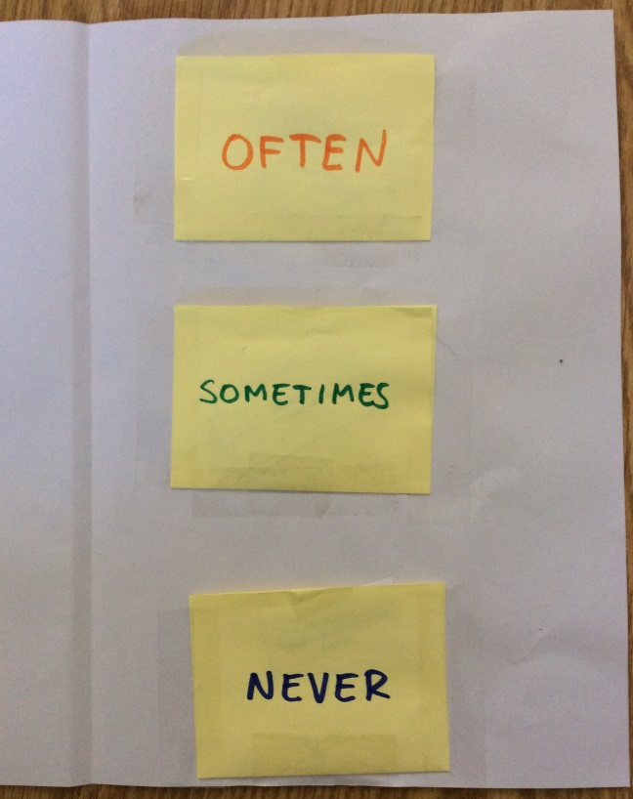
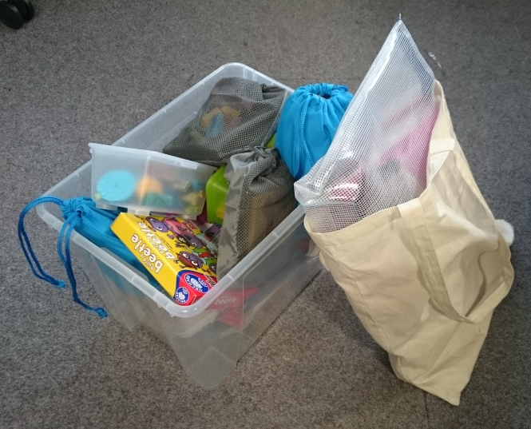
Direct work resources

The purpose of the resources is to help social workers develop increased skill and confidence in direct work with families, particularly children and to equip them with materials and resources.

These resources help:

1) provide a focus and dilute the intensity of the interaction for the child
2) allow the child to express themselves creatively/ symbolically through play or art
3) builds a relationship by being a collaborative activity for worker and child

What’s included?

The resource includes six ‘Basic Packs’ and ‘Add Ons’. The Basic Pack consists of a canvas bag which has basic resources needed for a session, and the Add Ons are extra resources that can be taken to sessions, depending on the needs of the child.

The Basic Pack:

A canvas bag and an A3 Zip bag for storing all the Basic Pack resources | An A5 Zip bag with craft paper, scissors, glue, stickers and post-it notes | A folder with ideas for direct work activities | A Worry Eater pencil case, with felt tip pens | A Wise Old Owl hand puppet / cuddly toy  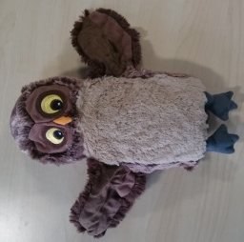 | Play-Doh and a fidget toy
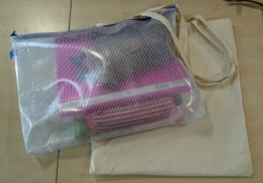 | 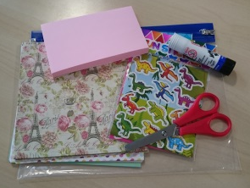 | 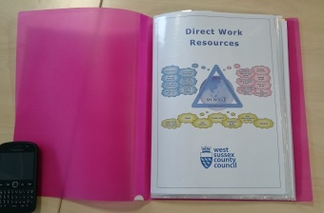

‘Add Ons’

Emotions hand puppet x 2  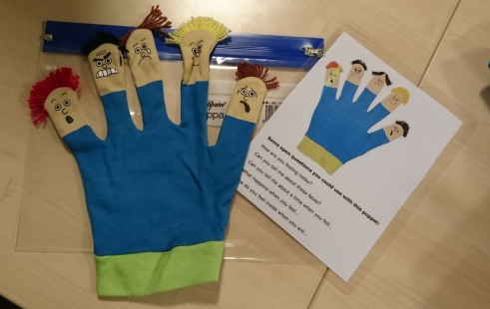 | 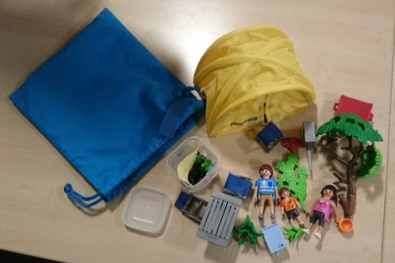  Playmobil family set | 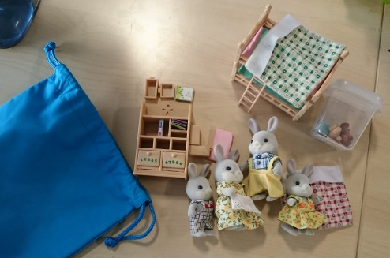  Sylvanian family set
Box of Lego x 3 | Build a Beetle game | Top Trumps game
Shape by Shape puzzle  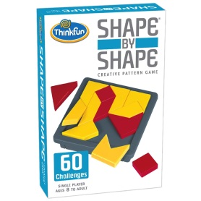 | 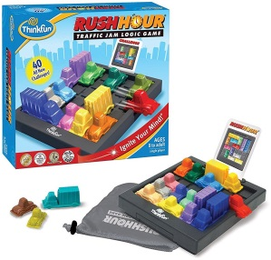  Traffic Jam logic game

‘Work’ Books

How Are You Feeling Today?  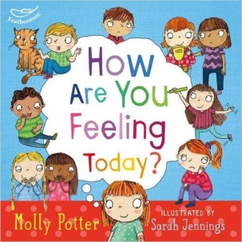 | 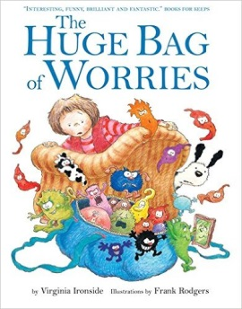  Huge Bag of Worries x 3 | 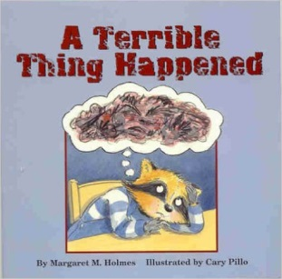  A Terrible Things Happened x 3

Books for fun
Only One of You  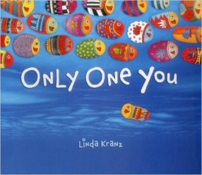 | 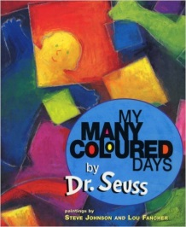  My Many Coloured Days | 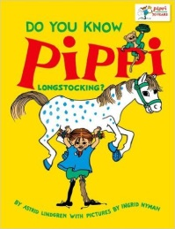  Do You Know Pippi Longstocking

Sibling Relationship game cards
 | I like spending time with _____. | I miss _____ when I'm not with him/her
_____ makes me feel good. | I feel sad when _____ is upset. | When I'm upset, _____makes me feel better.
If _____ won a prize, I would feel happy for him/her. | _____ helps me with things. | If someone is being mean to me, _____ will try to protect me.
When _____is feeling sad, I know how to cheer him/her up. | _____ loves spending time with me. | _____thinks that I am an amazing person.
_____ thinks that I am fun to be with. | If anyone is being mean to _____, I try to protect him/her. | I help _____ with things.
I know that _____ misses me when we’re not together. | I know that _____ feels sad when I am upset. | I think that _____ is annoying.
_____ makes me feel hurt or upset. | _____ tries to get me into trouble. | _____ messes things up for me.
I like it when _____is in trouble | _____ gets treated better than I. | I feel happy when I am not with _____.

Open the mail | Make tea | 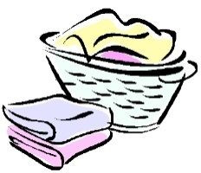  Wash clothes
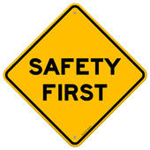  Keep things safe | Collect medicine | Wash dishes
Buy food | Give out bus fare | 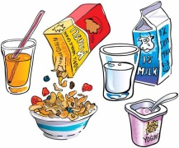  Make breakfast
Get to school | Help with worries | Help with homework
Provide treats | Buy presents | 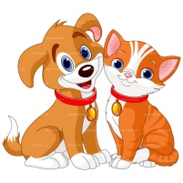  Look after pets
Keep the noise down | Make the beds | Decide what to watch on TV

Keep me safe | 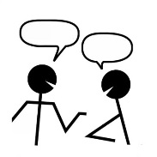  Speak to the social worker | Make a doctor’s appointment
Keep the fridge clean  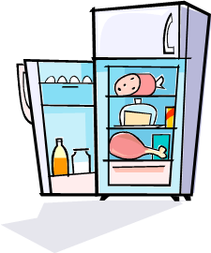 | Buy clothes | Boil the kettle
Use the microwave  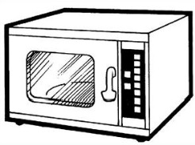 | Bake a birthday cake | Order a take away
Lock the door at night | 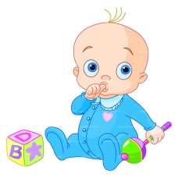  Watch the baby | Help me get to clubs and activities
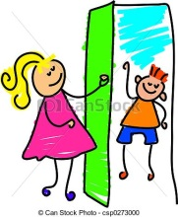  Decide who visits | 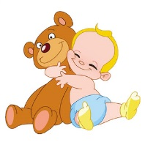  Give cuddles | 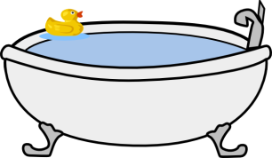  Tell me when to have a shower or bath
Make sure I have soap and toothpaste | Help me when I hurt myself | Look after me when I’m ill

Read me a story | 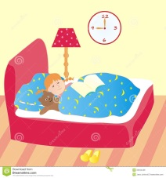  Put me to bed | Make me laugh

Faces and Feelings Cards
