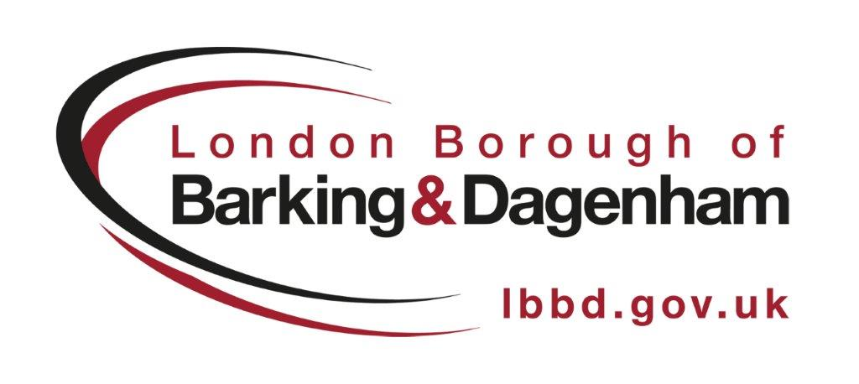
Adults

Best practice UPDATE
  - LBBD – 11 MARCH 2019 – Edition 2/Version 1

WELCOME
FUTURE FEATURES
If you would like to contribute to topics covered in the Adults Best Practice Update:
- Best Practice Story
- Compliments
- Information
Please let me know…
CONTACT DETAILS
Liana Kotze
Principal Social Worker
Liana.kotze@lbbd.gov.uk
07816 131699

Welcome to the second edition of the Adults Best Practice Update (ABPU). This newsletter aims to keep practitioners in Adult Social Care updated on all things related to social work and best practice on a local and national level.

WORLD SOCIAL WORK DAY – 19 MARCH 2019
The theme of World Social Work Day this year is:

“Promoting the Importance of Human Relationships."

The International Federation of Social Work (IFSW) says “- it is the key date in the year that social workers worldwide stand together to celebrate the achievements of the profession and take the theme message into their communities, workplaces and to their governments to raise awareness of the social work contributions needed for further action”.
More can be found on the IFSW website World Social Work Day 2019

This theme is particularly relevant to Barking and Dagenham given the importance we are currently putting on human relations in our current social work model with adults in the borough.

The British Association of Social Work (BASW) is running many events across the country to celebrate World Social Work Day. Details of these can be found here.

Adult Social Workers of LBBD are invited to celebrate World Social Work Day together with a Bring & Share Lunch.

Where: Roycraft House 5th Floor Room 1
When: 19th March 12:00
What To Bring: Food/Snacks

You are also encouraged to come and discuss some of your successes and best practice examples with regards to relationships you have built with service users, carers, other support agencies and professionals in the community.

The celebration is also a networking opportunity, so come and build relationships with colleagues. I will also be providing an update on the Stories project and holding a discussion about the Strength Based Framework and Practice Handbook and how it may be used in LBBD.

STORIES
A big thank you to all of the practitioners that have submitted their stories. The purpose of these, was to capture the person that we provide social work services to. There were some great examples, some of which can be found at Stories Online.

The next phase will be for us in LBBD Adult Services to think about how we do assessments with residents that are more strength based and really capture the person and their story as part of what we do. This will likely lead to a more flexible recording tool which will support us in providing optimal social work outcomes for our service users.

STRENGTH BASED SOCIAL WORK
You will likely be aware that the Department of Health published a Framework & Practice Handbook on the strength based approach in February 2019.

“A practice framework seeks to integrate empirical research, practice theories, ethical principles and experimental knowledge in a compact and convenient format that helps practitioners to use their knowledge and principles to inform their everyday work”
Connolly & Healy, 2009
DO YOU HAVE A STORY?
If you would like to write a story, please do and send it to the PSW, as we would like every practitioner to have a go. The experience will help you moving forward with regard to working with strength based and support assessments with our new direction of travel for social work in LBBD.

INTRESTING FACT
The Framework & Practice Handbook was co-authored by Carmen Colomina who recently completed the SCIE review of the Disability Service within LBBD.

This was also co-authored by Carmen Colomina who recently completed the SCIE review of the Disability Service within LBBD.

The handbook has a range of examples of strength-based interventions and reflections from practitioners which are current, informative and relevant for what we want to achieve in Barking & Dagenham.

LBBD will likely be adopting a number of elements from the handbook, including the KcVETS model of practice. Please discuss this with your colleagues during World Social Work Day, in terms of how it could work in our local community.

B&D ONE VIEW TOOL – COMING SOON!
At LBBD we are constantly looking to support improved working practices. A key aspect of this is looking to reduce administrative tasks which will subsequently free up our care and support workers enabling them to spend more time with our service users. One of the ways we are doing this is by implementing the ‘B&D One View’ Tool.

The B&D One View tool is based on technology developed as part of the
London Ventures Programme and is designed to bring together a range of data sources to automatically generate a case note, giving staff an immediate record of the history of an individual, all set within the context of their broader household. The tool will appear as a button within Liquid Logic and we are looking to implement it in Summer 2019. A version of the tool is also being developed within Children’s Services and Community Solutions.

The solution is fully GDPR and Data Protection compliant and is already being successfully being used by Children’s Services teams in Thurrock Council.

To ensure B&D One View adds as much value to Adult Support Teams as possible we are looking to create a B&D One View Adults Working Group which will be made up of 1-2 Social Workers and a Care Navigator.

We are inviting staff to volunteer for this group whereby they will have the opportunity to:

- Shape how and where the tool is used with your teams
- Feed into design of the tool’s key functions, such as the automatically
generated case notes
- Voice the most effective approach to training and implementation within your
teams
- Provide constructive challenge, enabling this to be a success for you and your
service users

The time commitment will be confirmed in due course but will not be more than a few hours per month, so the work of this group does not impact on existing workloads.

If you would like to be involved, have a query or would like more information please contact Liana or Heeral (details in pane).

TRI.X
All procedures for Adult Services are kept on TRI.X in one place. If you have any suggestions for changes to any of the procedures or would like updates or additional documents to be added, please contact the PSW.

The Strength Based Framework & Practice Handbook will be added in due course.

We plan to relaunch TRI.X in the Spring, so watch this space for invites and more information.

RESEARCH IN PRACTICE
Remember that LBBD subscribes to the amazing resource of RIPFA. There are lots of free resources, research and training you can access. However, in order to keep it we need to make it count for our CPD requirements, thus please make sure that you log on and utilise the resources available.

You can access all of the information and book courses/workshops through ‘MyRiPfA’. If you have log in problem’s please contact Liana.

AUDIT THEMES
A number of Safeguarding Adults Learning Audits have been completed across Mental Health, Integrated Care and the Disabilities Pathway.

A few key themes from January 2019 have been:

          - All practitioners should log safeguarding concerns in an appropriate and timely manner to ensure legally defensible practice throughout their work
          - The views of service users should be gathered as early as possible. If it isn’t possible to do this, for example if the person is medically unwell, then this should be documented as the reason for the delay. This is particularly relevant to cases whereby criminal activity may be present, to support to the securing of evidence.

“Home visits would be a better option than a phone call, to service users that may be vulnerable and or elderly, to discuss sensitive and wider issues. This approach would also provide them with emotional support following a safeguarding concern"
B&D ONE VIEW TOOL
WORKING GROUP

Would you like to be involved?

Liana Kotze
Liana.kotze@lbbd.gov.uk

Heeral Dave
hdave@uk.ey.com

RESTORATIVE PRACTICE
LEARNING EVENT
Some practitioners from LBBD recently attended a ‘Restorative Practice’ Learning Event run by RiPfA which they provided feedback as being ‘very good’ and a worthwas well received.

AUDITS
The PSW will be doing a dip-sampling of cases each month.

It is likely Consultant Social Workers will be asked to support case audits in the future.

          - If you think a crime has been committed always report matters to the Police. If no action is being taken – please record a reason for this.
          - When LBBD social workers are advising other agencies that a safeguarding enquiry will end, please remind them of the Making Safeguarding Personal Agenda and the Guidance for Safeguarding as part of the Care Act 2014, which mean they will likely first talk to the service user with a view to ascertain the outcomes they desire.
          - Where there is a high risk to personal safety – ensure that a Mental Capacity Assessment is completed even if the service user is disagreeable. Doing such an assessment for a service users, that do not seem to be able to protect themselves, must be balanced against the risks they would otherwise encounter and harm they could experience.
          - In line with the Best Interests model, remember to consult with service users family or friends when they are unwell and not managing the risks to their safety effectively. They may be able to provide vital information relating to the service users usual presentation, health and mental health that could inform your intervention.
          - It may be sometimes best to support the service user by having medical services present in order to prevent serious harm or prevent their health or mental health deteriorating. When risks are very high please discuss such cases immediately with your Manager and escalate the case to a more Senior Manager, Head of Service or Principal Social Worker to provide professional advice.
          - Where a service user is not in agreement with your proposed intervention, and it may impact on their human rights, discuss with your Head of Service so that legal advice can be sought and the matter referred to court if no less restrictive intervention can be followed.
COMPLIMENTS

Student social worker, Esther Isaac, has received a compliment from working with one of our service users in LBBD.

She is supported by her PE, Shahina Navapurwala. Esther is based in the Locality West Team, Integrated Care.

The compliment from the carer said:

‘I would like to thank you for all your help with my mother, you really do go above and beyond in your job, not everyone does. You made me stay positive and I feel very supported.’

