Child Trafficking Definition
Any child transported for exploitative reasons is considered to be a trafficking victim - whether or not they have been deceived

The Palermo Protocol; Pan London Procedures June 2018

Child Trafficking Concern Received
-All Child trafficking is a crime and needs to be reported to Children’s Services and the police
NEW REFERRAL:
-Complete CFAN outlining child trafficking concerns and return to
csll-socialcare@hounslow.gcsx.gov.uk
-MASH Manager / Screening agree/disagree to MASH checks and progress to Children’s Social Care.

Allocated Case
Referrer to contact allocated social worker directly to share trafficking concerns.

If CSE is identified also follow CSE workflow process

Strategy Discussion/Meeting
SW to complete 87A, ATM to complete strategy discussion within 3 days of concern being identified, 5 days if holding a strategy meeting

CS Assessment
Child and Family Assessment to be completed by the SW within 45 working days with agency checks.
Section 47 Child Protection Investigation
Single or joint agency s47 to be agreed at the strategy discussion and completed within 15 working days.

MASH Rag Rating
Blue- Information only, case to close
Green –Following screening no Trafficking concerns identified, case to close.
Amber- MASH checks completed, case referred to CS or re-ragged to ‘Blue’ and closed.
Red- Case referred to CS.

National Referral Mechanism
SW to complete the NRM within 5 days of trafficking concern being identified

Notify Trafficking SPOC
SW has to notify Hounslow’s trafficking SPOC, Donna Howard donna.howard@hounslow.gov.uk once NRM is completed

Check List
-87A completed
-Strategy discussion with police
-S47 or Child and family assessment initicated and complete
-Agency checks
-NRM referral
-Trafficking SPOC notifed
-Child spoken to alone

Practice Guidence
Child Trafficking Typology
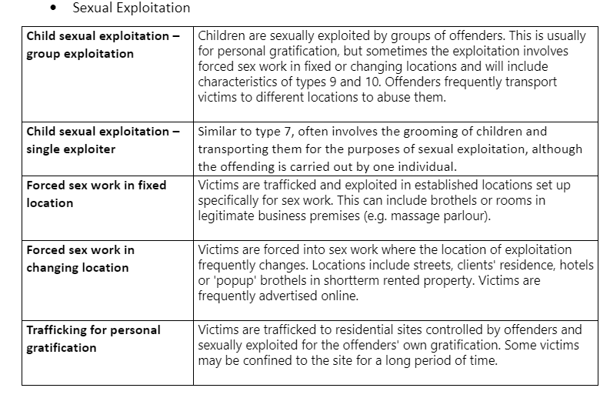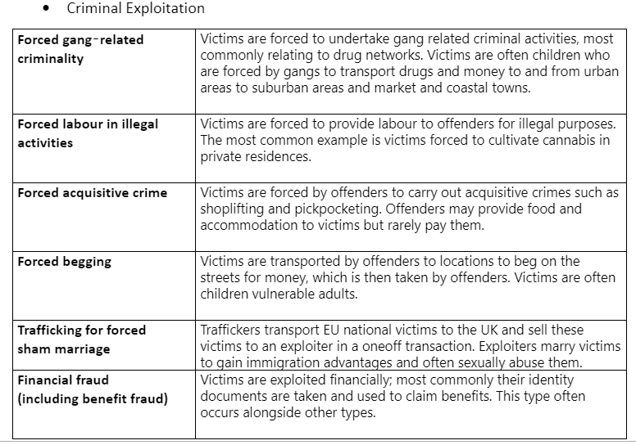
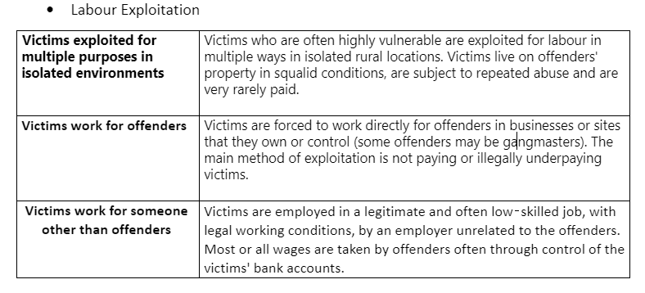
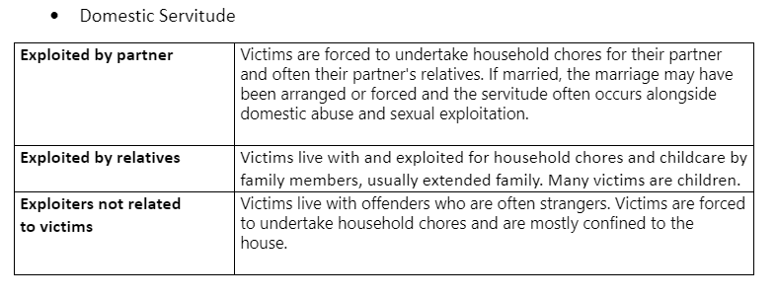

The NRM process

In order to make a referral in to the NRM the police and LA need to be notified first. For children 18 and under the First Responder does not need consent to make the referral and discussions with the child around the referral need to be had in the context of safety planning. Should the child be at risk of being coerced or manipulated in to sharing that the referral has been made this may place them at risk

Completed forms should be sent to the MSHTU Competent Authority via e-mail at nrm@nca.x.gsi.gov.uk or by fax to 0870 496 5534.

Stage one – “Reasonable grounds”
The NRM team has a target date of 5 working days from receipt of referral in which to decide whether there are reasonable grounds to believe the individual is a potential victim of human trafficking or modern slavery. This may involve seeking additional information from the first responder or from specialist NGOs or social services. The threshold at Reasonable Grounds stage for the trained decision makers is; “from the information available so far I believe but cannot prove” that the individual is a potential victim of trafficking or modern slavery.
If the decision is affirmative then the potential victim will be:
- allocated a place within Government funded safe house accommodation, if required
- granted a reflection and recovery period of 45 calendar days. This allows the victim to begin to recover from their ordeal and to reflect on what they want to do next, for example, co-operate with police as required, return home etc.
The potential victim and the first responder are both notified of the decision by letter.

Stage two – “Conclusive decision”
During the 45 day reflection and recovery period the Competent Authority gathers further information relating to the referral from the first responder and other agencies.
This additional information is used to make a conclusive decision on whether the referred person is a victim of human trafficking or modern slavery. The expectation is that a Conclusive Grounds decision will be made as soon as possible following day 45 of the recovery and reflection period. There is no target to make a conclusive grounds decision within 45 days. The timescale for making a conclusive grounds decision will be based on all the circumstances of the case.
The trained decision makers threshold for a Conclusive Decision is that on the balance of probability “it is more likely than not” that the individual is a victim of human trafficking or modern slavery.
The first responder and the potential victim will both be notified of the decision. If the potential victim is conclusively identified as a victim of trafficking or modern slavery, what happens next depends on their wishes.

Section A: child’s details

†Last name: ………..………….…………………… †First name(s): ………..………….…………………………………….........

†Also known as: ………………………...……………………………………….…………………………… Sex: …………...........

†Date of birth: ……/......../……......... known / claimed (delete as appropriate)

Age (approximate if not known): ………........... known / claimed (delete as appropriate)

Place of birth: …….…………........................................................................................................................................................

†Nationality: ………...……………………………………………...……………………………………………...………………………....

Immigration status (where known):………………...............………...……………………………………................................

Language(s) spoken: …………….............................................................................................................................................

Any English spoken / interpreter needed (delete as appropriate)

Home Office reference (where known): ……………………..............................................………...……………...............

UK visa reference (where known): ………....................................................………...…………………………………….....

Any other reference numbers:..……………………………………………………………..........................................................

UK home address: …………………….………………………….……………………………….......................................................

…………………………………………….................................................................................................................................................

UK Port of entry (where known)…………………………………………………..... known / claimed (delete as appropriate)

Method of entry to UK (where known) …………………………………………………………………………..........................

Carrier (where known): ………………………………………………….................…………………………………….....................

Section B: contact details of person making referral

Name: …………………………………………………………………………………………………………………………....................

Job title: ....………………………………………………………………………………………………………………………................

†Organisation: ..…………………………………………………………………………………………………....................................

Unit or area: …………………….................................................................................................................................................

Tel: ………………………………………………………......... Fax: ……………..………………………………………………...........

Mobile: ……………………………………………Email: ……………………………………………................................................

Signature……………………………………………………………………………………….............Date: ……/......../……............
Section C: General details of the encounter

Date encountered (if relevant) or date of first agency contact: …………………………………………………

Address encountered or place of first contact with your agency (if different from above):

……………………………………………………………………………………………………………....................................................

……………………………………………………………………………………………………………....................................................

Date of referral to local authority: ......……/........../……......................

Local authority area ……………………………………….................

Local authority / social worker contact details: ………..................………..................…..................……….........

.........................................................................................................................................................................................................

†Responsible police force area for this location:

……………………………………….......................................………………………………………........

†Have you reported the case to the police:
◻ †yes
◻ †no
◻ NRM referral is being made by the police

†If yes, was the case reported to the police in England, Wales, Scotland or Northern Ireland?

……………………………………….......................................………………………………………........
†If reported to the police in England or Wales, which police force was the case reported to?

……………………………………….......................................………………………………………........

Crime reference numbers relating to this incident of modern slavery (where available):

……………………………………….......................................………………………………………........

If you have not referred the case to the police, what was the reason for this?

……………………………………….......................................………………………………………........

Section D: General information about the suspected modern slavery

†Suspected victim of (tick any that apply):

◻ †human trafficking

◻ †Slavery, servitude, forced or compulsory labour

†The country or territory where the modern slavery is believed to have occurred

……………………………………….......................................………………………………………........

†Suspected form of exploitation or forced service:

◻ †domestic servitude (i.e. occurred wholly or partly within residential premises )

◻ †forced or compulsory labour

◻ †provision of sexual services or the commission of sexual offences by the victim

◻ †criminal services (i.e. involved the commission of an offence by the victim)

◻ †removal of organs

◻ unknown

◻ other (please state).................................................................................................

Section E: potential indicators of children who may have been victim of modern slavery
(Y = Yes, S = Suspicion)

Child development |  |  | Parenting Capacity |  |  | Family/environment
Expolitation | Y | S | Expolitation | Y | S | Expolitation | Y | S
Claims to have been exploited through sexual exploitation, criminality, labour exploitation or domestic servitude by another person |  |  | Required to earn a minimum amount of money every day |  |  | Located / recovered from a place of exploitation (for example brothel, cannabis farm, involved in criminality)
Physical symptoms of exploitative abuse (For example sexual or physical) |  |  | Involved in criminality highlighting involvement of adults (for example recovered from cannabis farm / factory, street crime, petty theft, pick pocketing, begging) |  |  | Deprived of earnings by another person
Underage marriage |  |  | Performs excessive housework chores and rarely leaves the residence |  |  | Claims to be in debt bondage or “owes” money to other persons (for example for travel costs, before having control over own earnings)
Physical indications of working (For example overly tired in school, indications of manual labour – condition of hands/skin, backaches) |  |  | Reports from reliable sources suggest likelihood of sexual exploitation, including being seen in places known to be used for sexual exploitation |  |  | Receives unexplained / unidentified phone calls whilst in placement / temporary accommodation
Sexually transmitted infection or unwanted pregnancy |  |  | Unusual hours / regular patterns of child leaving or returning to placement which indicates probable working |  |  | No passport or other means of identity
Story very similar to those given by others, perhaps hinting they have  been coached |  |  | Accompanied by an adult who may not be the legal guardian and insists on remaining with the child at all times |  |  | Unable or reluctant to give accommodation or other personal details
Significantly older partner |  |  | Limited freedom of movement |  |  | False documentation or genuine documentation that has been altered or fraudulently obtained; or the child claims that their details (name, date of birth) on the documentation are incorrect
Harbours excessive fears / anxieties (for instance about an individual, of deportation, disclosing information) |  |  | Movement into, within or out of the UK |  |  | Movement into, within or out of the UK
Movement into, within or out of the UK |  |  | Gone missing from local authority care |  |  | Entered country illegally
Returning after missing, looking well cared for despite no known base |  |  | Unable to confirm name or address of person meeting them on arrival |  |  | Journey or visa arranged by someone other than themselves or their family
Claims to have been in the UK for years but hasn't learnt local language or culture |  |  | Accompanying adult previously made multiple visa applications for other children / acted as the guarantor for other children’s visa applications |  |  | Registered at multiple addresses
Other risk factors |  |  | Accompanying adult known to have acted as guarantor on visa applications for other visitors who have not returned to their countries of origin on visa expiry |  |  | Other risk factors
Withdrawn and refuses to talk / appears afraid to talk to a person in authority |  |  | History with missing links or unexplained moves |  |  | Possible inappropriate use of the internet and forming online relationships, particularly with adults
Shows signs of physical neglect – basic care, malnourishment, lack of attention to health needs |  |  | Pattern of street homelessness |  |  | Accounts of social activities with no plausible explanation of the source of necessary funding
Shows signs of emotional neglect |  |  | Other risk factors |  |  | Entering or leaving vehicles driven by unknown adults
Socially isolated – lack of positive, meaningful relationships in child’s life |  |  | Unregistered private fostering arrangement |  |  | Adults loitering outside the child’s usual place of residence
Behavioural - poor concentration or memory, irritable / unsociable / aggressive behaviour |  |  | Cared for by adult/s who are not their parents and quality of relationship is not good |  |  | Leaving home / care setting in clothing unusual for the individual child (for example inappropriate for age, borrowing clothing from older people)
Psychological – indications of trauma or numbing |  |  | Placement breakdown |  |  | Works in various locations
Exhibits self assurance, maturity and self confidence not expected in  a child of such age |  |  | Persistently missing, staying out overnight or returning late with no plausible explanation |  |  | One among a number of unrelated children found at one address
Evidence of drug, alcohol or substance misuse |  |  | Truancy / disengagement with education |  |  | Having keys to premises other than those known about
Low self image, low self esteem, self harming behaviour including cutting, overdosing, eating disorder, promiscuity |  |  | Appropriate adult is not an immediate family member (parent / sibling) |  |  | Going missing and being found in areas where they have no known links
Sexually active |  |  | Appropriate adult cannot provide photographic identification for the child
Not registered with or attended a GP practice
Not enrolled in school
Has money, expensive clothes, mobile phones or other possessions without plausible explanation

Y= Yes S= Suspicion
Section F: evidence to support reasons for referral (2 pages available)

Please use this section to:
- expand on the circumstances and details of the encounter or contact
- provide supporting evidence for the indicators that you have identified in the matrix (please number the indicator you are referring to)
- Provide details of any other indicators you feel are relevant but are not listed.
- provide any other relevant information that you consider may be important and wish to include for example details of behaviour, abuse and neglect
- provide details of any movements into, within or out of the UK, including dates (if known)
- provide name of any adults, exploiters or traffickers (if known)
- provide details of any linked victims (if known)
- provide suspected place of exploitation (if known)
- provide details of suspected form of exploitation (whether this had taken place or was yet to take place)
- detail any action you have taken including referral to other agencies such as police, local authorities.
- provide reasons why you think individual is a child
details of any adults or other children the individual was encountered with, or whether the child was unaccompanied.

(if a separate sheet is required, please indicate that section D is continued and provide with referral)

Section D: evidence to support reasons for referral (continued) if required

