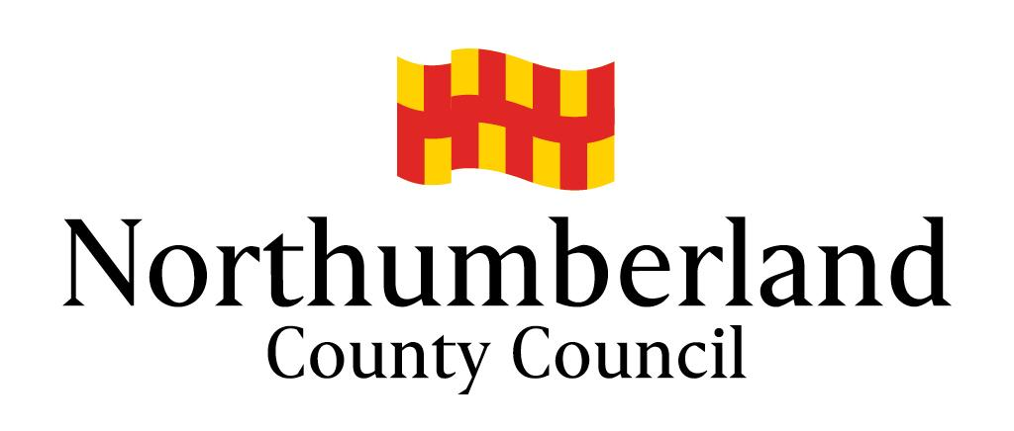

Audit Report of the Public Law Outline

Letter Before Proceedings within the Pre-Proceedings Stage

Audit Commenced March 2019

Report Dated 8 July 2019

Report completed by

Adele Wright, Acting Head of Service (Safeguarding)

Helen Thompson, Solicitor

Contents

- Introduction
- Objective
- Methodology and Sample Size
- Findings
- Analysis of Findings
- Views Gathered
- Conclusion
- Action Plan
- Annexed Documents

- Introduction
  - The purpose of this report is to provide the details of a recent audit undertaken by Northumberland Children’s Services into the Letter before Proceedings, within the Pre-Proceedings Stage of the Public Law Outline (PLO) along with an action plan of how the area can be improved.
  - By way of introduction, the PLO was brought into practice by the Children and Families Act 2014, though in some areas of the UK was in pilot stage from 2013.
  - Prior to the PLO, it was recognised by the Family Division that the length of care proceedings was far too long, with some children waiting an extremely long time for decisions to be made on their long term placements. A review of practice within the Family Courts was carried out and as a result the PLO was initially piloted then formally introduced into practice.
  - The PLO refers to the entirety of working with families, from referral stage through to the making of any orders. The PLO is split into 4 stages (in accordance with Practice Direction 12A, Family Procedure Rules):
    - Pre-Proceedings
    - Stage One - Issue and Allocation
    - Stage Two - Case Management Hearing
    - Stage Three - Issues Resolution Hearing
  - The emphasis on the PLO is the streamlined approach to cases, with template orders and timescales set for what should be achieved in each stage.
  - In addition to streamlining and setting out common standards for Court Processes within Stage One to Three, the review also looked at the work Local Authorities were undertaking pre-proceedings. Much of the delay within care proceedings resulted from lengthy assessments, either by social workers or experts. The review identified that, where possible, Local Authorities should gather evidence about a family outside of court proceedings and present a case to court in a ‘pre-loaded’ manner. This stage of the PLO is referred to as the Pre-Proceedings Stage.
  - The Pre-Proceedings Stage captures work undertaken by Local Authorities from initial referral through to the application to Court.
  - In practice, the PLO is commonly used in Northumberland to refer to the Letter before Proceedings part of Pre-Proceedings work. This element of Pre-Proceedings is initiated when the Local Authority are considering issuing proceedings and the level of urgency does not require an immediate application. The Letter before Proceedings has a number of elements; to gather evidence and completion of assessments of families should the decision be taken to issue proceedings; to continue to encourage and engage families in services with a view to improving the lives of children and their families with the hope of reducing/removing concerns; provide families with the opportunity to seek independent legal advice.
  - Within this report, references henceforth to the PLO shall refer to the Letter before Proceedings part of Pre-Proceedings work.
- Objectives
  - The objective of the audit was to review the procedure of Northumberland Children’s Services in relation to the Letter before Proceedings element of the PLO.
  - The audit looked at the decision to instigate the PLO, the letters written to families, the meetings held, the effectiveness of the meetings and the PLO process, recording of the PLO process and assessments undertaken within the PLO.
- Methodology and Sample Size
  - The audit was carried out on 40 cases and undertaken by senior managers and team managers from Children’s Services, the principal lawyer and two lawyers from Legal Services. Within this report, they shall be referred to as the auditors.
  - Each person was given 4 cases to audit. The cases were from across the Authority and were from the locality social work teams. It is recognised that some cases within Disabled Children’s and 14+ Team may follow the PLO process but due to the large amount stemming from the locality teams, the focus of the audit was on these cases.
  - The audit was carried out over a period of approximately 2 weeks. The auditors were asked to complete a form, provided by way of a Google Form, for each case audited.
  - Auditors were granted access to ICS, the system used by Children’s Services, for the purpose of the audit.
  - The audit looked at 3 key areas of the PLO process:
    - Planning
    - Quality
    - Administration
  - In addition to the form, the auditors met for a meeting to discuss the findings. These are detailed below.
- Findings
  - Each question asked shall be looked as a chart to show the findings alongside additional views gathered at the meeting.
  - A copy of the full outcomes can be found at
https://docs.google.com/spreadsheets/d/1kXXOniCVltvHSjqgfAdz8AZoeY0xghx3H5kVn9IzuI0/edit#gid=1881822563
Planning
  - 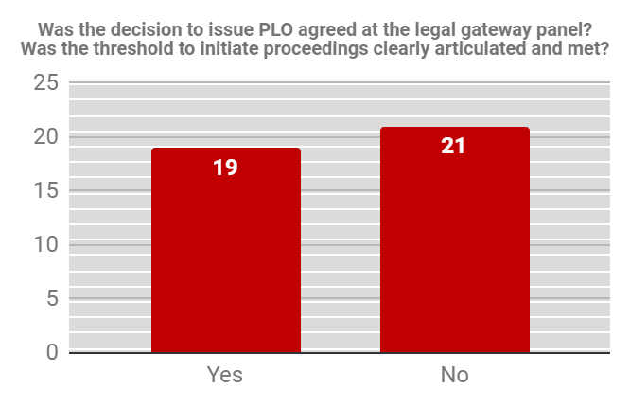
  - 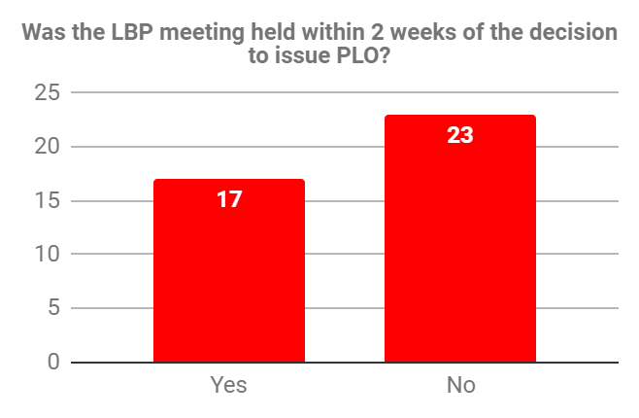
  - 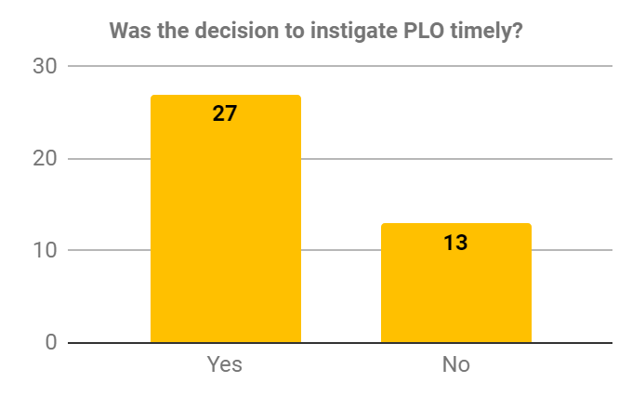
  - 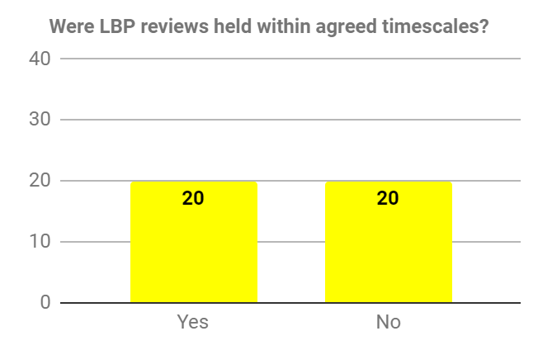
  - 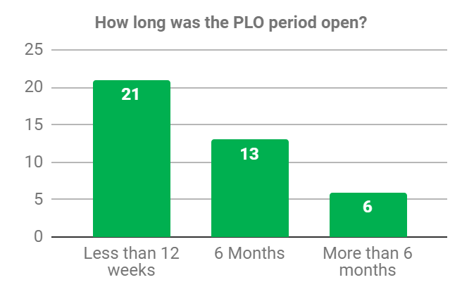
Quality
  - 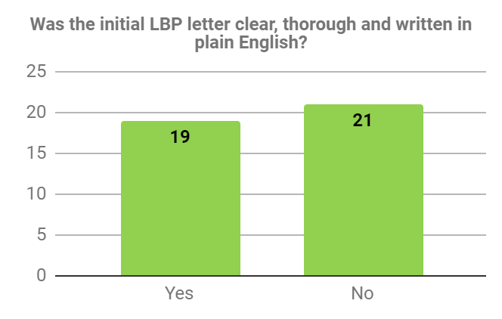
  - 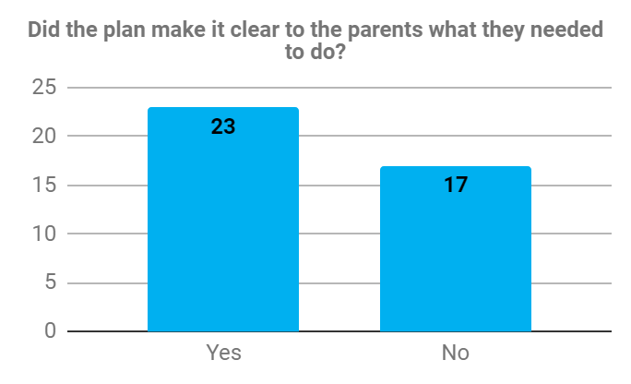
  - 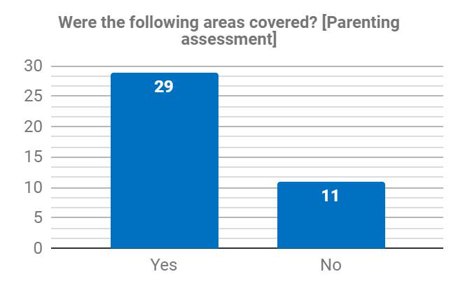
  - 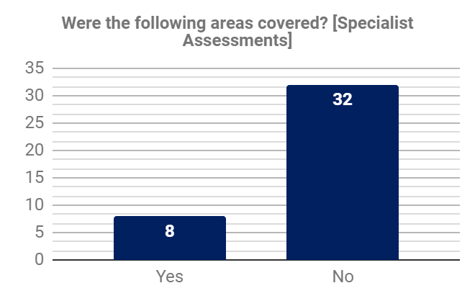
  - 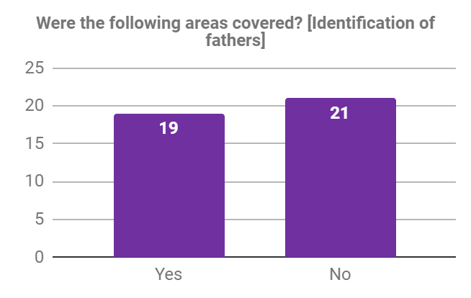
  - 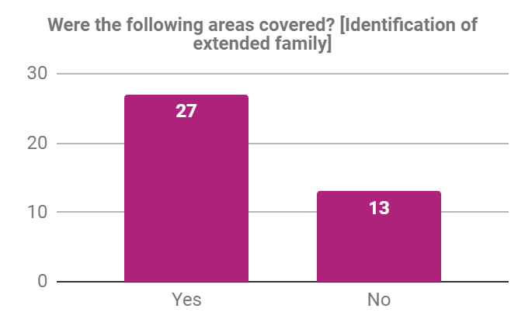
  - 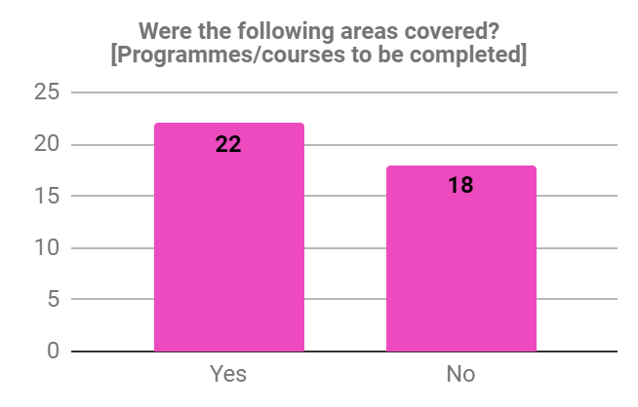
  - 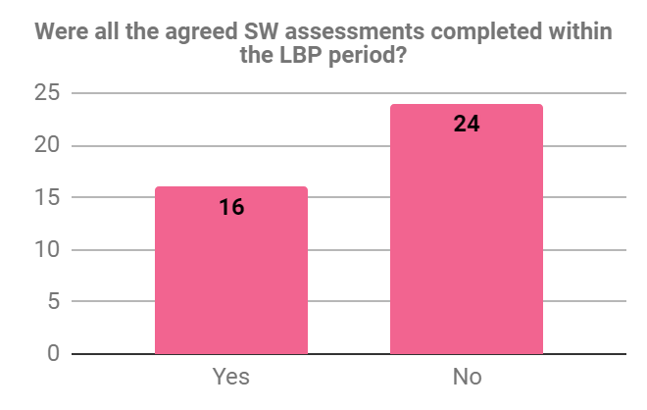
  - 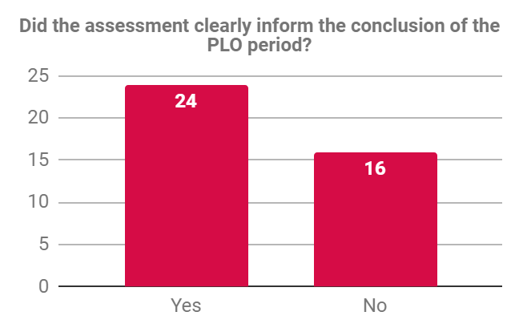
Administration
  - 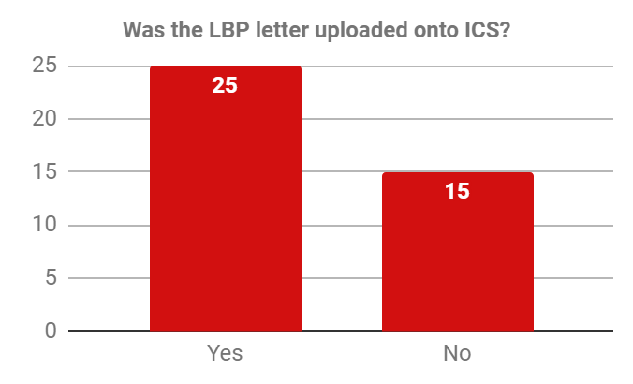
  - 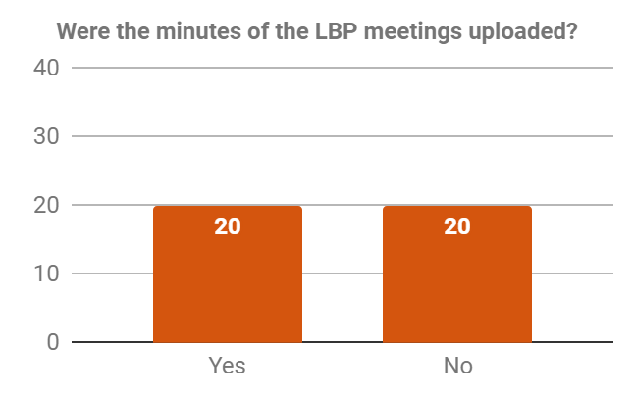
  - 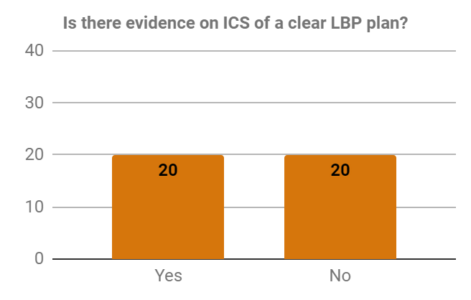
  - 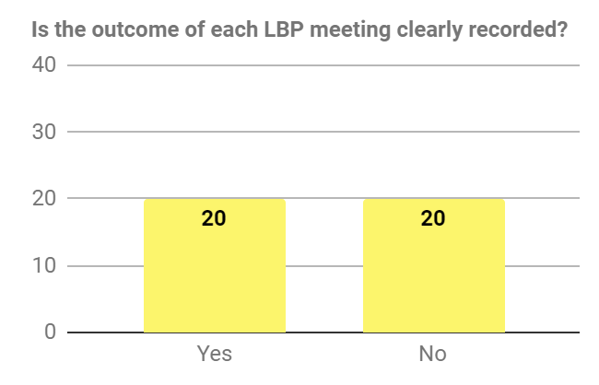
  - 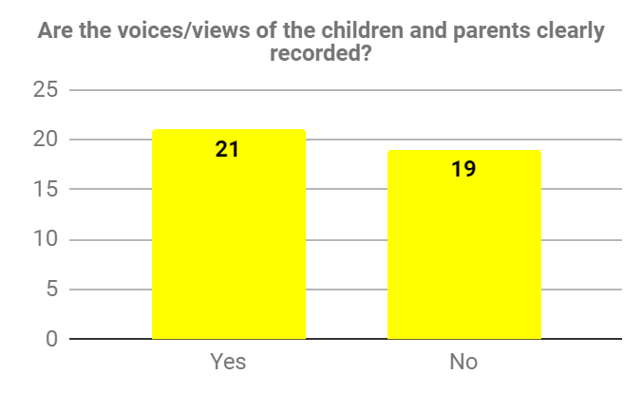
  - As previously mentioned, a meeting was held to discuss the findings within the audit and gather any other comments from the audit. The following comments were shared within the meeting:
    - There was no middle ground - either the process was good or bad.
    - Examples of good practice involved; effective work; loaded work; clear letters; minutes all uploaded.
    - Examples of poor practice involved; no letters uploaded; minutes missing; no final review minutes; drift; reason behind ending the PLO was not clear; in consistency with minutes (too long v too brief); variance in minutes; quality of letter variable with some far too long and lacking basic details; PLO plan replicating Child Protection (CP) plan and nothing new; no voice of the child in the whole process; PLO process separate from other planning (core groups/LAC reviews); minutes not reflecting timescales for assessments.
    - The use of the PLO also varied. In some cases it was not always possible to see guidance or effectiveness in the process.
    - One area which caused issues within the PLO and impacted on the effectiveness of the process was the consistency of the social worker, with some cases having a change which then impacted upon the timescales and completion of assessments.
    - A discussion was had generally about the assessments and it was felt that some of the parenting assessments lacked in analysis, lacked in the impact on the child, was largely based on self reporting and not always detailed.
    - The audit also highlighted that the running of the meeting needed to be improved.
    - There were a number of recommendations from the meeting:
      - Refresh the letter template.
      - Format for minutes needed.
      - Need a PLO plan, with table to check off the completed tasks.
      - Timescales for reviews and actions to be set and recorded.
      - There to be guidance on the PLO process.
      - A guide to be uploaded for letters/minutes and a protocol.
      - Need to ensure legal documents are shared with legal and uploaded onto the system.
      - A genogram was recognised as a good tool.
      - Refresh the PLO training and ensure it is compulsory.
- Analysis of Findings
  - Looking at each of the areas of the audit separately and starting with Planning.
  - What must be borne in mind with the first question asked about legal gateway panel is some of the cases audited commenced before the legal gateway was introduced and therefore the higher proportion of no answers to this question reflects this.
  - Again, when looking at whether the PLO meeting was held within 2 weeks of the decision, this needs to be looked against whether the case was taken to the legal gateway panel for the decision to be made. However, prior to legal gateway the decision to instigate PLO required the approval of a senior manager following a legal planning meeting (LPM). Given the nature of the question, it is not clear whether this was considered as part of the answer to the 23 cases that answered no. Overall however it can viewed that once a decision is made to commence PLO, there already is delay being seen in the process.
  - It is positive that the audit recognised the decision to follow the PLO process was done in a timely manner, with over half of the cases answering yes to this question.
  - There was an equal split in relation to whether the reviews were held in the agreed timescales. Given the questions asked later, this could be due to there being no minutes uploaded to answer this question correctly, the lack of timescales recorded within the minutes or due to the assessments not being completed in the timescales agreed, which may have resulted in meetings being pushed back. There is also whether there was no review held due to, for example, the decision to issue proceedings taken prior to the review.
  - When looking at the duration of the PLO, it is positive to see that the majority of the cases where completed within 12 weeks. Against this question though needs to be looked at the recording of the process; in some cases the recording of the start or end of the PLO was not apparent and therefore it should be questioned whether this is a true reflection of the duration of the PLO.
  - Overall, when looking at the planning side of the PLO it would appear that positive steps are being taken when looking at the decision making process of the PLO, being the timely manner in which the PLO is commenced and that the process is ending within the recommended 12 weeks. However there would appear to be improvements needed in the execution of decision making and ensuring the PLO process is commenced without delay.
  - Turning next to the quality of the PLO process.
  - There was almost an equal split between the quality of the letter from the audit but extending this to include the views from the meeting held would seem to suggest there can be improvements made to the letter. This would seem to stem from the templates used by social workers. It was identified that the letters were far too long, had too much information and did not identify clear enough a plan that was to be followed by the parents. The meeting also identified that the letters were lacking in details around who the letter was addressed to, a date and where the letter was sent/how it was delivered.
  - It is positive that the audit recognised that the plan made clear to parents what they were required to do. However, when looking at this further within the meeting it was questioned whether the plan was the correct plan. This was recognised as an area for improvement.
  - The audit looked at the process of the PLO in identifying areas of work within the process. When looking at the answers to these questions, it has to be considered that, as discussed later, the auditors did struggle on some cases to find minutes and records of meetings. Therefore it may be that all the cases did identify the need for various types of assessments and family members, but without clear recording of such, it is difficult to determine this for certain.
  - It is positive that the majority recognised the need for a parenting assessment, though the meeting did discuss whether one was completed on time and the quality of such.
  - A high proportion of the cases audited did have a lack of identifying specialist assessments. This needs to be looked against the cost implications of these assessments. Within the PLO process the Local Authority will bear the full cost of these assessments however in proceedings the costs are usually split. However, this should not defer away from a review of whether such assessments are required and noting such within the PLO process. It may be that drug and alcohol testing, for example, is not required due to the parent’s engagement with drug services. This should be taken as an area for improvement in terms of recording decisions around specialist assessments and not a blank ban on such assessment due to funding implications.
  - The audit showed an equal response to the question of whether fathers were identified. This does require improvement as fathers, especially those with parental responsibility should be engaged with the PLO process.
  - It is positive that the identification of family members was actively looked at in the PLO process and recognised within the meeting that the majority of the plans asked for parents to give details of any persons they wanted to be assessed. It was felt that a genogram may assist with this process. The question did not extend to consider whether there were any assessments stemming from the identification of the family members and whether these were shared as part of the PLO process, both to the person who the assessment was about and the outcome to the parents, especially if a negative assessment was undertaken. This may be an area that needs further review.
  - When looking at whether programmes/courses are to be completed, this should be looked against whether there was a need. However, as with the specialist service, the recording of these should be made a part of the Local Authority’s decision making process and accurate recording keeping, especially if a case was to be taken to court.
  - What is clear from the audit is that the majority of social worker assessments were not being completed within the timescales set. Again, the meeting looked at some of the reasons behind this, the main being a change in social worker. As already mentioned, the lack of clear recording of the PLO process means that the full reason for the completion of the assessments cannot be fully understood.
  - The majority cases did find that the assessment identified and informed the conclusion of the PLO process. Whether the cases that answered no were as a result of further information or incident that led to a decision to issue, it is not clear but one aspect that cannot be ignored.
  - Moving onto the administration of the PLO.
  - The majority of the letters were uploaded to ICS, but it was recognised within the meeting that there was a lack of consistency about when they were uploaded and to which part of ICS, which meant the finding of the letter was difficult.
  - There was an equal split as to whether the minutes of meetings, the PLO plan and outcome of each meeting were recorded on ICS. Again, the meeting recognised a lack of consistency in where this information was held (case notes v documents).
  - The above shows that some structure is required around the administration of the PLO to provide consistency across the County.
  - There appeared to be an equal response to whether the voice of the parents/child were seen in the PLO process, though the meeting expanded on this to reflect that in the majority of the cases, there was no voice of the child. This needs to be looked against the age of the child in question but was felt that, were possible, the child’s voice should be recorded within the PLO process.
- Views Gathered
  - In addition to the audit, Helen Thompson was asked to visit 3 of the locality teams to gather their views of the PLO process. As well as the locality teams, views of Legal Services were also gathered.
  - Looking first at the views of the locality teams.
  - The teams felt they understood the purpose of the PLO process, what it was intended to achieve and the basic running of the process. They felt it was, when used correctly, effective both in terms of improvements seen by parents but also as an evidence gathering exercise for taking the case to Court. It was felt, when used correctly, cases that were taken to Court were done so in a more organised manner, with a clear plan and outline of what steps had been taken by the Local Authority todate.
  - Feedback suggested that whilst the templates were helpful, they were cumbersome in the style. It was recognised there was a lack of a template for an unborn baby and felt this was the most difficult of the PLO letters to write. Social workers felt the chronology was a large task to complete and some struggled with what to put in the plan other than repeating the CP plan. When discussing the idea of an amended letter, with a separate plan to set out the concerns and steps parents would need to take, this was largely welcomed and felt to be beneficial.
  - Managers felt they understood the purpose of the meeting. The suggestion of a format for minutes and an agenda for the meeting was welcomed, especially in Hexham where there are not a large amount of PLO cases, though there was some concern that the meeting could become too prescriptive.
  - Most felt that a protocol or procedure for the PLO process would be helpful as a refresher and for those new to the Authority or newly qualified workers.
  - One comment that came back was the lack of understanding of external agencies as to the PLO process and requesting information from them. Many social workers felt external agencies did not understand the importance of the PLO.
  - Some felt a review legal planning meeting or discussion after legal gateway would be beneficial to discuss the steps to be taken in the PLO, especially when the case was put to panel with a suggestion of issuing but the recommendation from legal gateway was one of PLO.
  - It was recognised the geography of Northumberland did not always allow a lawyer to attend a meeting in person. However, in some cases it was felt this would have been beneficial to the meeting.
  - When discussing with Legal Services, it was agreed by all that the decision making of the PLO had improved, in terms of use of the PLO and understanding of it by social worker. However when looking at the elements of the PLO, there were still some improvements to be had.
  - The letter sent to parents was too long and did not focus enough on the plan. The suggestion of a separate plan was welcomed. The letter was sometimes not shared prior to the meeting and therefore unclear what had been asked of parents.
  - Looking at the assessments, it was felt the lawyer was not being provided with assessment/s in sufficient time to consider and if required provide legal advice on any recommendation/outcome. In many cases it was recognised the assessments were shared immediate before or during the meeting, meaning in some cases the parents/their solicitors had not had a chance to read the document.
  - Further to the sharing of the assessment, it was felt that it was not always clear prior to the review meetings what the plan of the Local Authority would be.
  - In addition, it was felt that parents were sometimes not given enough opportunity between being provided with the letter and the meeting taking place to seek independent legal advice.
- Conclusion
  - It is clear there are good practices within Northumberland in relation to the PLO process. This was recognised both as part of the audit but also in the views gathered from social workers, team managers and legal services.
  - Northumberland’s decision making around the PLO process is improved and the understanding of the PLO is good. It was felt the PLO was being used more and more effectively in terms of evidence gathering and improvements seen with families.
  - However what is clear is there is a lack of standard practice, both in terms of the way the PLO is run and the administration of it. This was one item that came from the meeting as auditors had difficulty knowing where to look for information and documents.
  - Within both the audit and the views gathered, it was clear there were areas for improvement, with some suggestions made being welcomed across the board.
- Action Plan
  - It is recommended that a standardised practice is set for the PLO process to include:
    - Protocol, including the administration of the PLO process
    - Revised letter templates
    - Standards of Reference/Agenda for the running of PLO meetings
    - Template minutes
    - Template PLO Plan
  - Provided alongside this report is a suggestion for each of the documents above. It is recommended that these are distributed to relevant members of the locality teams/legal services for comments by a set date. Once an agreed set of documents are reached, then they should be rolled out from a date. It is hoped this could be achieved by September 2019.
  - In addition to the above, training and work with external agencies as to the PLO and why it is important is also recommended. This could be delivered via the LSCB.
  - Once a new procedure is in place, it is recommended that training on the PLO is delivered to the locality teams in the first instance and then to the Disabled Children’s and 14+ plus (and any other teams who may benefit, such as IROs).

- Annexed Documents
Annex A - Pre-Proceedings Flowchart
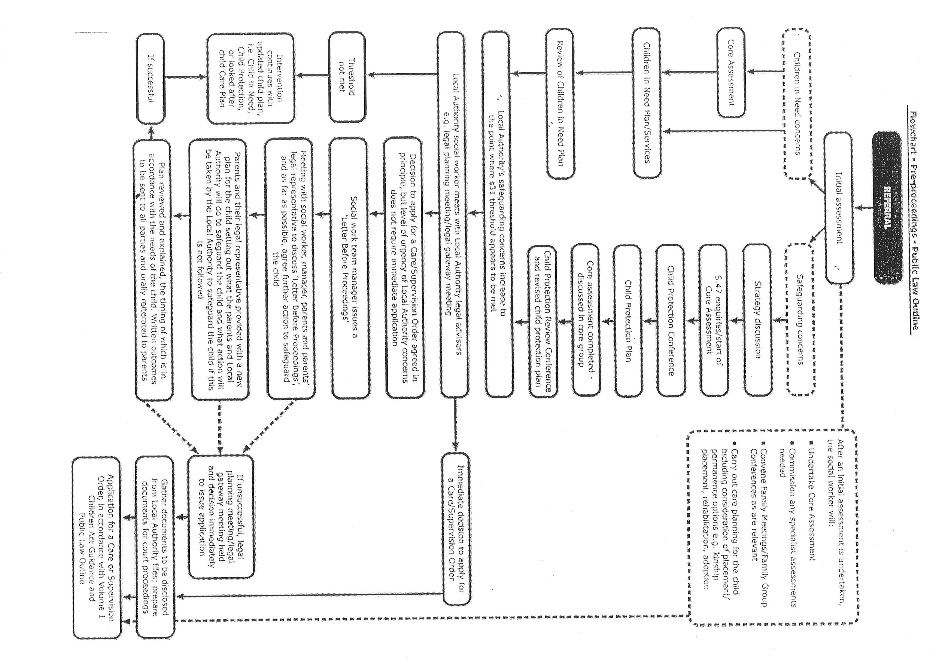

Annex B - Audit Form

PLO Audit Form *Required

1. Case Number *
2. Name of Social Worker *
3. Social Worker Team *
4. Name of Auditor *
Planning
5. Was the decision to issue PLO agreed at the legal gateway panel? Was the threshold to initiate proceedings clearly articulated and met? * Mark only one oval.
OYes o No
6. Comments
7. Was the LBP meeting held within 2 weeks of the decision to issue PLO? *
Mark only one oval.
O Yes O No
8. Was the decision to instigate PLO timely? *
Mark only one oval.
O Yes O No
9. If no, please comment on the delay and impact on the child
10. Were LBP reviews held within agreed timescales?
Mark only one oval.
O Yes O No
11. Was the PLO period ended within; *
Mark only one oval.
O Less than 12 weeks O 6 months O More than 6 months
12. Comment on the effectiveness of the use of PLO *
Quality
13. Was the initial LBP letter clear, thorough and written in plain English? *
Mark only one oval.
O Yes O No
14. Comments *
15. Did the plan make it clear to the parents what they needed to do? *
Mark only one oval.
O Yes O No
16. Comments *
17. Were the following areas covered?
Mark only one oval per row.
Parenting Assessment O Yes O No
Specialist Assessments O Yes O No
Identification of father O Yes O No
Identification of extended family O Yes O No
Programmes/Course to be completed O Yes O No

18. Were all the agreed SW assessments completed within the LBP period? *
Mark only one oval.
O Yes O No
19. Comments about the quality of assessment *
20. Did the assessment clearly inform the conclusion of the PLO period? *
Mark only one oval.
O Yes O No
Administration
21. Was the LBP letter uploaded onto ICS?*
Mark only one oval.
O Yes O No
22. Were the minutes of the LBP meetings uploaded? *
Mark only one oval.
O Yes O No
23. Is there evidence on ICS of a clear LBP plan? *
Mark only one oval.
O Yes O No
24. Is the outcome of each LBP meeting clearly recorded? *
Mark only one oval.
O Yes O No
25. Are the voices/views of the children and parents clearly recorded? *
Mark only one oval.
O Yes O No
26. Comments *

Newcastle Combined Court, the regional court for Northumberland, was a pilot court.
It is recognised within the Family Courts that some cases cannot follow a pre-proceedings stage, for example injury cases or where a family may not be previously known to the Local Authority and such is the risk that immediate action is required.
Please see Annex A
Please see Annex B
North, Central and Hexham

