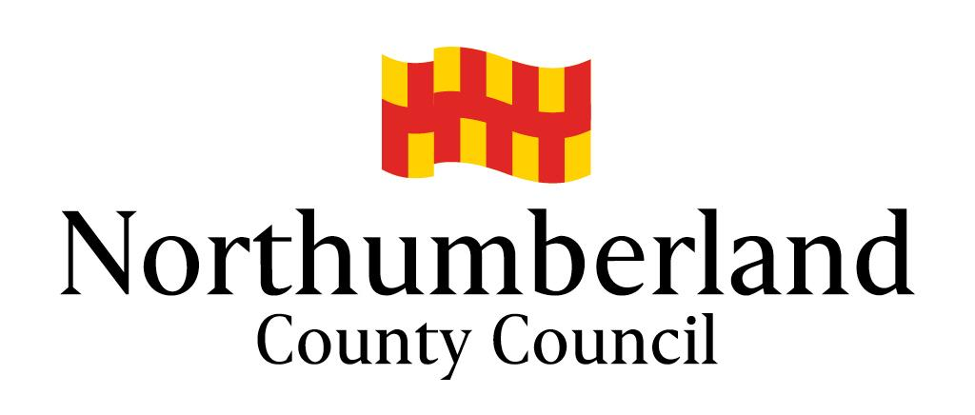

Protocol for Pre-Proceedings

of the Public Law Outline

Children’s Services
First Drafted: October 2019
Review Due: October 2020
Completed by: Helen Thompson, Legal Services

Contents

- Introduction
- Legal Planning Meeting
- Legal Gateway Panel
- Letter before Proceedings - Issuing Proceedings
- Letter before Proceedings - Unborn Babies/Children
- Letter before Proceedings - the Plan
- Letter before Proceedings - Meetings
- Letter before Proceedings - Assessments
- Ending the PLO

- Introduction
  - By way of introduction, the Public Law Outline (PLO) was brought into practice by the Children and Families Act 2014, though in some areas of the UK was in pilot stage from 2013.
  - Prior to the PLO, it was recognised by the Family Division that the length of care proceedings was far too long, with some children waiting an extremely long time for decisions to be made on their long term placements. A review of practice within the Family Courts was carried out and as a result the PLO was initially piloted then formally introduced into practice.
  - The PLO refers to the entirety of working with families, from referral stage through to the making of any orders. The PLO is split into 4 stages (in accordance with Practice Direction 12A, Family Procedure Rules):
    - Pre-Proceedings
    - Stage One - Issue and Allocation
    - Stage Two - Case Management Hearing
    - Stage Three - Issues Resolution Hearing
  - The emphasis on the PLO is the streamlined approach to cases, with template orders and timescales set for what should be achieved in each stage.
  - In addition to streamlining and setting out common standards for Court Processes within Stage One to Three, the review also looked at the work local authorities were undertaking pre-proceedings. Much of the delay within care proceedings resulted from lengthy assessments, either by social workers or experts. The review identified that, where possible, local authorities should gather evidence about a family outside of court proceedings and present a case to court in a ‘pre-loaded’ manner. This stage of the PLO is referred to as the Pre-Proceedings Stage.
  - The Pre-Proceedings Stage captures work undertaken by local authorities from initial referral through to the application to Court.
  - In practice, the PLO is commonly used in Northumberland to refer to the Letter before Proceedings part of Pre-Proceedings work. This element of Pre-Proceedings is initiated when Children’s Social Care are considering issuing proceedings and the level of urgency does not require an immediate application. The Letter before Proceedings has a number of elements; to gather evidence and completion of assessments of families should the decision be taken to issue proceedings; to continue to encourage and engage families in services with a view to improving the lives of children and their families with the hope of reducing/removing concerns; provide families with the opportunity to seek independent legal advice.
  - This protocol sets out the steps from decision taken to seek legal advice through to the end of the PLO.
- Legal Planning Meeting
  - Prior to a decision being taken to instigate the PLO, a legal planning meeting should be held.
  - A discussion should be had between the social worker and deputy/team manager as to whether legal advice should be sort. The CSM should also be informed of this decision.
  - A legal planning meeting template should be completed and sent to the Principal Lawyer (Lynsey Wafer) and Legal Officer (Michelle Thompson) for allocation to a solicitor.
  - The legal planning meeting template must include a genogram.
  - When sending the legal planning meeting template, a list of possible dates and times for the meeting (in accordance with the social worker and deputy/team managers available) should be provided.
  - When a request for a legal planning meeting is sent, a case note recording should be made on ICS alongside the template being uploaded to the documents section.
  - The legal planning meeting template is then used as the minutes of the legal planning meeting.
  - The legal advice should be completed by the allocated solicitor within 1 working day of the meeting being held.
  - The plan following the meeting should be completed by the deputy/team manager within 1 working day of the meeting being held.
  - Following the conclusion of the meeting, a case note recording should be made that a legal planning meeting has been held and brief outcome (i.e. further work required and no threshold met, threshold is met but there are interim measures in place to safeguard the child[ren] while parents are given one last opportunity to engage under pre-proceedings PLO (commonly referred to as PLO), threshold is met and there are no safeguarding measures in place therefore immediate issue required).
  - Once the allocated solicitor and team manager have completed their relevant sections, the completed template should be uploaded to ICS within the documents section.
- Legal Gateway Panel
  - If the decision is taken following the legal planning meeting that the case should be put before the legal gateway panel, the legal gateway panel referral form should be completed.
  - The legal advice from the legal planning meeting should be copied and pasted into the referral form.
  - There is a separate document setting of the terms of reference for the legal gateway panel and this should be referred to.
  - Following the panel meeting, the minutes of the meeting shall be recorded and the completed form shared with the allocated social worker, deputy/team manager, CSM, Principal Lawyer and allocated lawyer.
  - The following timescales are to be met for cases determined at panel, unless otherwise specified. Any timescales other than below shall be clearly marked in the legal gateway panel minutes.
Outcome | Timescale from date of Panel
Issuing Proceedings | Letter to be sent to parents within 5 working days  Papers to be provided to Legal within 10 working days.  Legal to issue within 5 working days of receipt of papers.
PLO - Unborn Baby/Children | Letter to be sent to parents within 5 working days  Initial Letter Before Proceedings (LBP) Meeting to be held within 5 working days following service of letter

  - In determining the date for when pre-proceedings work began, it shall be the date of the legal gateway panel.
  - Should panel determine the case is to return to panel for review, the review date shall be set at panel. This can later be cancelled/amended if no longer required.
- Letter - Issuing Proceedings
  - Should the decision be taken that the case requires court proceedings to be issued, the issuing proceedings letter shall be sent to parents, along with a list of local solicitors, in accordance with the table above (or timescales set by panel).
  - The allocated social worker shall draft the letter and send to the deputy/team manager for approval. The deputy/team manager shall send to the allocated solicitor for information purposes.
  - The letter must be provided to everyone with parental responsibility.
  - The letter shall be hand delivered to parents by a social worker/social work support assistant.
  - Once the letter is hand delivered, the social worker/social work support assistant shall make a case note recording of the date and time of delivering, including the address of where the letter was delivered and whether it was handed to a person, and if so, who.
  - The letter shall be uploaded by the allocated social worker following the delivery of the letter to ensure the correct version is uploaded onto ICS. The letter shall be uploaded into the documents section in ICS.
- Letter before Proceedings - Unborn Babies/Children
  - Should the decision be taken that the case requires a letter before proceedings on an unborn baby, the letter before proceedings - unborn baby shall be sent to parents, with the PLO plan and a list of local solicitors, in accordance with the table above (or timescales set by panel).
  - The allocated social worker shall draft the letter and send to the deputy/team manager for approval. The deputy/team manager shall send the letter to the allocated solicitor for review.
  - The letter must be provided to everyone with parental responsibility.
  - The letter shall be hand delivered to parents by a social worker/social work support assistant. If possible, the social worker/social work support assistant shall go through the letter with the parents, including the plan and that both will be discussed further in the meeting.
  - Once the letter is hand delivered, the social worker/social work support assistant shall make a case note recording of the date and time of delivering, including the address of where the letter was delivered and whether it was handed to a person, and if so, who.
  - The letter shall be uploaded by the allocated social worker following the delivery of the letter to ensure the correct version is uploaded onto ICS. The letter shall be uploaded into the documents section in ICS.
- Letter before Proceedings - the Plan
  - The plan for the letter before proceedings process shall be set out on the PLO Plan Template.
  - The plan shall follow the signs of safety model.
  - The plan shall not be a repeat of the Child Protection Plan.
  - The plan shall initially be dated with the date it is given to parents.
  - The allocated social worker shall draft the plan and send to the deputy/team manager for approval. The deputy/team manager shall send the letter to the allocated solicitor for review.
  - The plan shall be sent to the parents with the appropriate cover letter prior to the initial meeting.
  - The plan shall be discussed in the every PLO meeting. Should there be any amendments to the plan, the plan shall be updated, titled with amended plan and re-dated with the date of the meeting and a copy of the new plan shall be provided to parents.
- Letter before Proceedings - Meetings
  - The initial meeting shall be held in accordance with the above table or the timescales set by panel.
  - Prior to the meeting, it should be considered what assessments are required, including any specialist assessments such as drug/alcohol testing and psychological. Should it be felt that a specialist assessment is required, discussion should be had between team manager and CSM to approve funding.
  - The pre-proceedings meeting is chaired by a deputy/team manager and attended by:
    - the parent/s - consideration should be given as to whether there needs to be separate meetings for parents, especially those where domestic violence is a feature or there is a restraining order/injunction in place.
    - any person with parental responsibility.
    - their solicitor
    - social worker
    - Local Authority solicitor
  - During the meeting the social worker and parents should:
    - agree and sign a pre-proceedings plan
    - specify what assessments and services the parents need to engage in and agree timescales for those assessments
    - identify family members’ details for a Family Group Conference or family meeting, if appropriate
    - set down dates for review and anticipated conclusion of the PLO process
    - clearly outline what steps the local authority will take at the end of the process depending on the progress or otherwise of the plan
    - set out what support the local authority will provide to the family
  - To minimise drift under pre-proceedings, there should be a:
    - midway review meeting—six to eight weeks to consider the progress of the plan and outcome of assessments
    - a final PLO meeting—12–16 weeks
    - review legal planning meeting between the local authority solicitor, social worker and deputy /team manager to discuss the impact of assessments on the threshold criteria, parallel planning, any developments influencing the care plan. This shall be held in sufficient time for the case to be taken to legal gateway panel, if required. The meeting shall be held prior to the final PLO meeting.
  - These time scales are subject to the needs of the child and the progress by the parents and therefore pre-proceedings can be concluded sooner.
  - To assist with the running of the meeting, the deputy/team manager may wish to use the agenda for PLO meetings.
  - Immediately after the PLO meeting, the social worker shall make a case note recording that a PLO meeting was held.
  - Should parents not attend the meeting, a case note recording shall be made to that effect.
  - All meetings, whether attended by the parents or not, shall be minuted in accordance with the template minutes.
  - The minutes shall be circulated within 1 working day to the social worker, deputy/team manager and solicitor for any amendments to be provided within 1 working day. Therefore 3 working days after the meeting, the minutes shall be provided, signed by the deputy/team manager, to the parents, their solicitor and anyone else in attendance at the meeting.
  - The minutes shall be uploaded to ICS in the document section.
- Letter before Proceedings - Assessments
  - There shall be agreed timescales set and recorded in the minutes for all assessments undertaken in the letter before proceedings.
  - Should any timescales not be achievable, the person responsible for the assessment shall discuss the reasons why. If necessary a new timescale should be agreed, parents informed and the new timescale recorded as a case note recording on ICS. At the next meeting, the minutes shall record the amended timescale.
  - Any social worker assessment shall be provided to the deputy/team manager 5 working days prior to the review meeting.
  - The deputy/team manager shall provide the allocated solicitor with the approved assessment 3 working days prior to the review meeting.
  - The solicitor shall circulate a copy of the final version of the assessment to the parents’ solicitors at least 2 working days prior to the review meeting. The social worker shall ensure the parents are given a copy of the assessment following approval from the solicitor, at least 2 working days prior to the meeting.
  - The final version of the assessment shall be uploaded onto to ICS in the document section.
- Ending the PLO
  - As above, prior to the review meeting, a legal planning meeting/discussion shall be held to determine whether threshold continues to be met for the PLO process and can be stepped down or whether proceedings need to be issued.
  - Should a case be stepped down, it is likely there will be continued involvement under either a child protection plan or child in need plan. The parents should be provided with a copy of the most recent plan at the review meeting or Core Group/CIN Review held shortly after the review PLO meeting to set the new plan.
  - Should it be determined that the case requires care proceedings to be issued, parents should be given a copy of the issuing proceedings letter.

Newcastle Combined Court, the regional court for Northumberland, was a pilot court.
It is recognised within the Family Courts that some cases cannot follow a pre-proceedings stage, for example injury cases or where a family may not be previously known to the Local Authority and such is the risk that immediate action is required.
Please see Annex A

