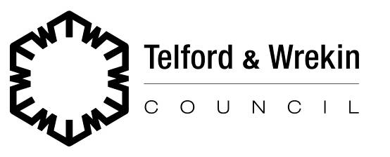

|  |
| --- |
| (For Telford & Wrekin Council Official Use Only)  This is not part of the instruction to your Bank or Building Society |
| **Sales Ledger Account Reference Number:**   |  |  |  |  |  |  | | --- | --- | --- | --- | --- | --- | | **2** |  |  |  |  |  | |

**Please fill in the whole form, including the official use box above, using a ball point pen, then send it to:**

|  |
| --- |
|  |
| Telford & Wrekin Council |
| Revenues Service |
| PO Box 249 |
| Addenbrooke House |
| Telford |
| TF3 4LP |
|  |

**Name(s) of account holder(s)**

|  |
| --- |
|  |
|  |

**Bank/Building Society Account Number**

|  |  |  |  |  |  |  |  |
| --- | --- | --- | --- | --- | --- | --- | --- |
|  |  |  |  |  |  |  |  |

**Branch Sort Code**

|  |  |  |  |  |  |  |  |
| --- | --- | --- | --- | --- | --- | --- | --- |
|  |  | **-** |  |  | **-** |  |  |

**The Direct Debit Guarantee** 

1. This Guarantee is offered by all Banks and Building Societies that take part in the Direct Debit Scheme.   
   The efficiency and security of the Scheme is monitored and protected by your own Bank or Building Society.
2. If the amounts to be paid or the payment dates change, Telford & Wrekin Council will notify you at least 10 working days in advance of your account being debited or as otherwise agreed.
3. If an error is made by Telford & Wrekin Council or your Bank or Building Society, you are guaranteed a full and immediate refund from your branch of the amount paid.
4. You can cancel a Direct Debit at any time by writing to your Bank or Building Society. Please also send a copy of your letter to Telford & Wrekin Council.

Banks & Building Societies may not accept Direct Debit Instructions for some types of account.

**This guarantee should be detached and retained by the payer**



**Instruction to your Bank or Building Society to pay by Direct Debit**

**Originators Identification Number**

|  |  |  |  |  |  |  |  |
| --- | --- | --- | --- | --- | --- | --- | --- |
| **9** | **8** | **2** | **8** | **0** | **4** |  |  |

**Reference Number**

(For Telford & Wrekin Council Official Use Only)

|  |  |  |  |  |  |  |
| --- | --- | --- | --- | --- | --- | --- |
|  |  |  |  |  |  |  |

**Name and full postal address of your Bank or Building Society**

|  |  |
| --- | --- |
| To: The Manager | Bank/Building Society |
|  | |
| Address | |
|  | |
|  | |
|  | |
| Post Code | |
|  | |

**Instruction to your Bank or Building Society**

Please pay Borough of Telford & Wrekin Direct Debits from  
the account detailed in this Instruction subject to the safeguards assured by the Direct Debit Guarantee.   
I understand that this Instruction may remain with   
Telford & Wrekin Council and, if so, details will be   
passed electronically to my Bank/Building Society.

|  |
| --- |
| Signature(s) |
|  |
| Date |
|  |
| Contact Telephone Number |
|  |