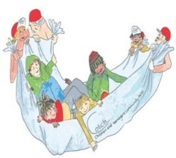
Young Person’s Exploration
What areas of family life am I finding difficult and struggling with?

What areas of family life I am happy, content and confident in and feel I am doing well with?

What change/s do I think will have the most positive impact on my family?

What is stopping me (us) making these changes?

