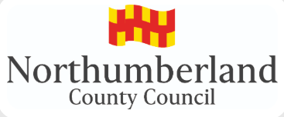

Guidance for the provision of Social Care advice for Education, Health and Care Assessments and Plans (EHCPs)

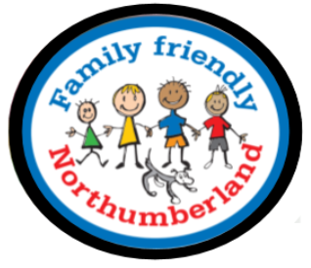

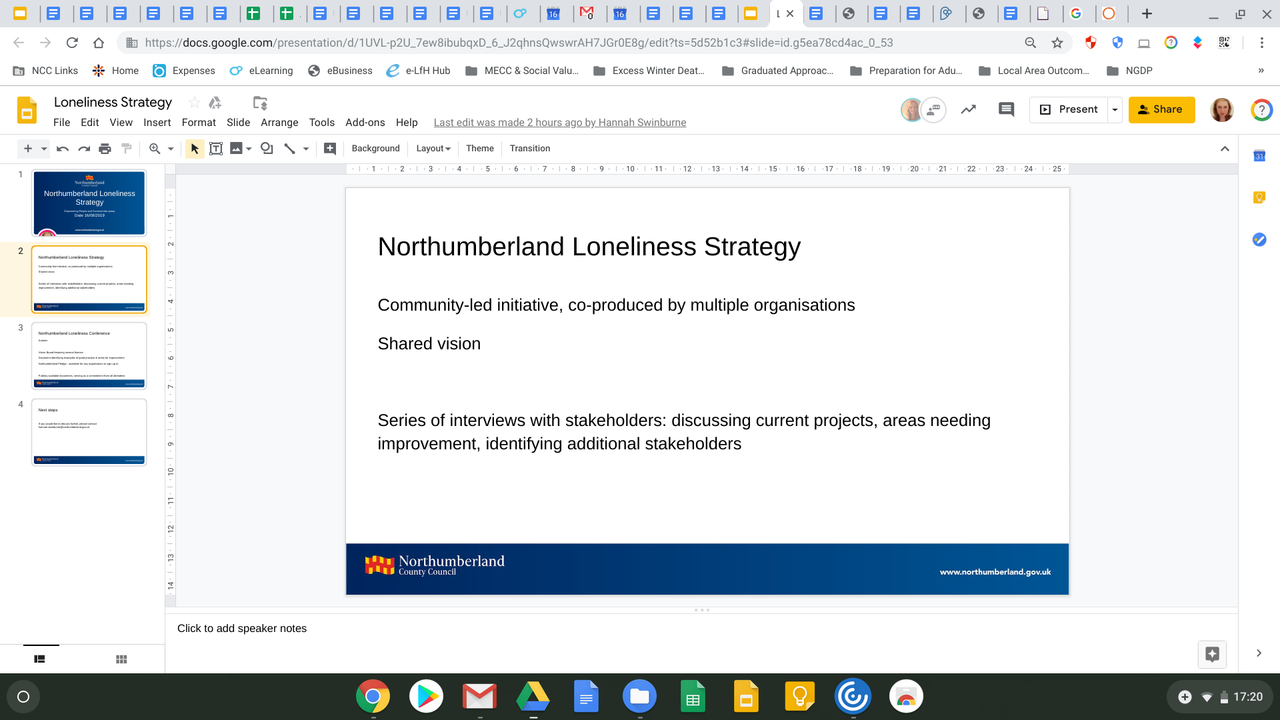

Contents

Contents | Page | 2
Introduction | Page | 3
Brief Link to How Requests for Advice Come to the Service  Providing advice as part of an EHCP Annual Review | Page  Page | 3  4
Developing an Understanding of Social Care Needs | Page | 5
The Education, Health and Care Plan (Section D) | Page | 6
The Education, Health and Care Plan (Section H1) | Page | 7
The Education, Health and Care Plan (Section H2) | Page | 9

Introduction
The purpose of an Education, Health and Care Plan is to make special educational provision for the child or young person, to secure the best possible outcomes for them across education, health and social care and as they get older and to help prepare them for adult life.
This guidance will assist you to provide good quality social care advice for the child or young person that you know or are working with.
Everyone needs some kind of support for their social care needs. For many children and young people that support is provided by friends, family and local groups, for example universal services, youth groups or community groups. At times it may be necessary for particular support to be provided through services delivered or commissioned by Northumberland County Council, for example services within our Short Breaks Local Offer or specialist short break carers.
This guidance is aimed at everyone who could be asked to provide social care advice for an Education, Health and Care Plan, for example (but not limited to), youth workers, family support workers, Early Help workers and social workers from both Children and Adult Services.
Identifying the social care needs of a child or young person with a disability does not necessarily require an assessment by a social worker. In most cases needs can be met through universal services or early help without the need for a formal assessment, provided there is a good understanding of those needs and families have access to clear information about what support is available and how to get it.
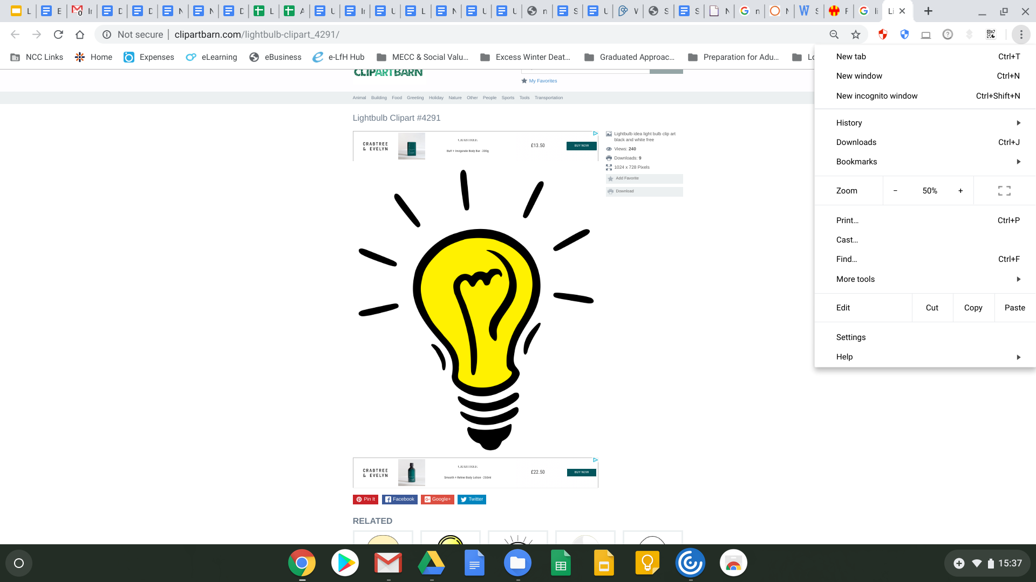
In developing an understanding of the child or young person’s social care needs, revisiting the legal definitions may be helpful and this is contained in the link below under Annex A (page 36) https://councilfordisabledchildren.org.uk/sites/default/files/field/attachemnt/socialcare _implementationofcfa2014_online.pdf

Top Tip

Social care provision means the provision made by a local authority in the exercise of its social services functions. This does not necessarily mean a social work provision. Many children and young people’s social needs will be met by universal services which will be outlined in the local offer.
Requests for input into an EHC needs assessment (direct request)
All requests for social care input come from the Special Educational Needs and Disabilities (SEND) Team once a decision has been made to undertake an Education Health Care Needs Assessment.

Providing advice as part of an EHCP Annual Review

You may also be asked for input as part of an EHCP Annual Review (which takes place at least once every 12 months). You MUST provide updated information about the child or young person and the support package that is in place to meet the needs that you have identified. You must send this to to the SEND Team in time for the Annual Review. Below is a range of relevant vocabulary that social care need to be utilising and keeping in mind when completing their updates in preparation for the review meeting.
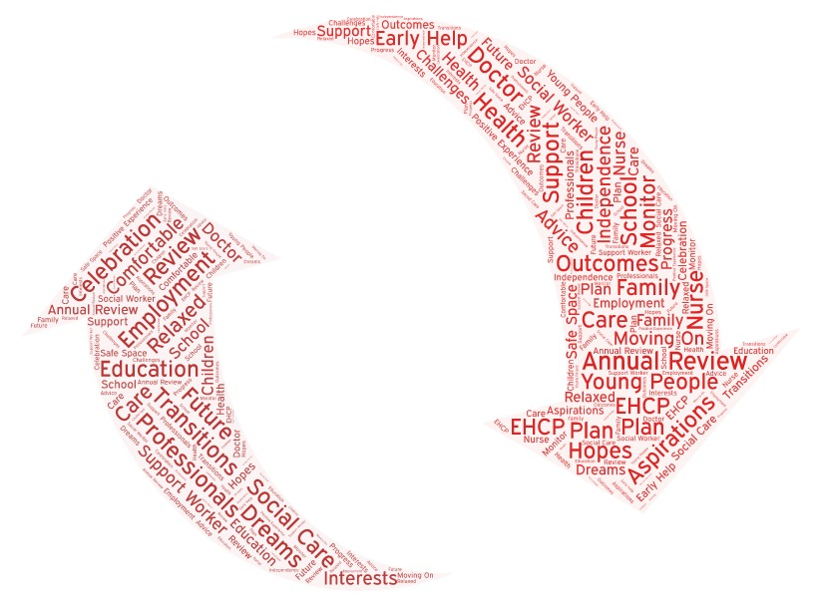

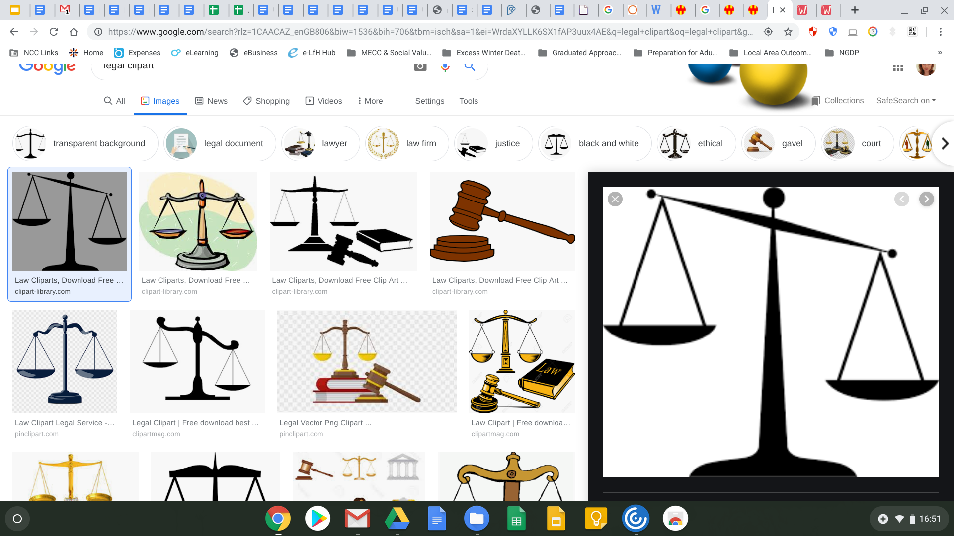
Legal Requirements

Once the request has been received you MUST return your completed advice WITHIN 6 WEEKS. This is a legal requirement under Section 31 of the Children and Families Act 2014. This is to ensure adherence to the legal time frame within which an EHCP must be completed and issued to the child or young person and their parents. If you are late with your advice it is likely to have a detrimental impact on our ability to issue the EHCP within the statutory 20 weeks. This may in turn result in a delay to the child or young person’s needs being appropriately met, which we all want to avoid.

Engaging children, young people and their parents or carers is the starting point for establishing social care needs. This engagement may have already taken place as part of your ongoing relationship or work with the child or young person.

Developing an Understanding of Social Care Needs
There may have already been an assessment either an Early Help Assessment (EHA) or a Children and Families Assessment (C&F) completed by a social worker, where the needs of the child or young person may already be known.
You may wish to look at the link below. Annex B on page 39 provides useful information on how assessments, processes and plans link to the EHC needs assessment process and or an ongoing EHC Plan: https://councilfordisabledchildren.org.uk/sites/default/files/field/attachemnt/socialcare _implementationofcfa2014_online.pdf.
You may also want to consider the following questions:

What is important to the child or young person?
What do they do outside of school?
Do they see their friends; attend groups, clubs or activities? What are their hobbies or interests? Where do they go to do these things?
Do they face any challenges or barriers accessing these activities?

What is going well for the child or young person and their family?
What support do they receive from family, friends, community members and other professionals?

What do the child, young person and family find difficult, challenging or stressful? What is not working well?
Is the child or young person safe at home and in the community? Do they feel safe?
Has the family had any previous assessments or involvements?
Does the family know how to access the ‘Local Offer’ and Family Information Service?

Accessing the ‘Local Offer’ and signposting children, young people and their families to the services contained within the ‘Local Offer’ is an important task to undertake for anyone developing social care advice for the EHC and then recording this within the social care section of the plan itself.

Top Tip

The Education, Health and Care Plan (Section D)
Once you have received the request for advice from the SEND Team or as part of the EHCP Annual Review you are only required to provide information relating to the parts of the EHC Plan that relate specifically to social care needs (Section D).
Within Section D, you should record all of the needs that you have identified. Please avoid compiling a list; remember this is the child or young person’s plan and they need to understand what you have written.
Examples provided by the Council for Disabled Children include:

Toby (18 years old) has a learning disability and is at the early stages of developing his adult independence skills. He understands how to use public transport but not how to maintain personal safety while using it. He has little understanding of how to manage his money and is at risk of others taking advantage of him.

Adam (12 years old) finds it difficult to engage in social activities as he cannot easily recognise social cues. This results in him being socially isolated outside the structure of the school day.

Matthew (14 years old) has Down Syndrome and finds it difficult to express himself. This can result in challenging behaviour in the home and in the community and is very difficult for his family to manage. He can have periods requiring both parents to contain his behaviour if he does not feel safe.

Kian (6 years old) presents with difficult behaviour at home arising from his learning difficulties and autism means that there are times when his personal safety and that of his siblings can be at risk

Emma (11 years old) has extremely limited mobility, as described within the health needs section. This means that she faces significant challenges in joining in with social activities of her choosing, including family outings and holidays.

The Education, Health and Care Plan (Section H1)

Legal Requirements
One of the pieces of legislation that enables the local authorities to deliver social care support to disabled children is Section 2 of the Chronically Sick and Disabled Person’s Act 1970 (CSDPA 1970).
Any support that is being delivered in relation to the needs that you have identified in Section D that are being delivered under this legislation must be recorded within H1.
You should set out exactly what the support is, where it is taking place, how often it takes place and when it will be reviewed. The services that can be delivered under the CSDPA (1970) are broad and include support at home, support across the community and help with adaptations to the home.

Top Tip
It is worth noting that overnight short break support is not delivered under CSDPA (1970) so should not be recorded in this section (please see H2).

Examples, some of which are provided by the Council for Disabled Children, are as follows:

Anna (16 years old) will receive two hours per day help at home from a personal assistant to support feeding and dressing/undressing. The time will be split across morning and afternoon and be provided 7 days per week.
This will be funded via a direct payment through the Children with Disabilities Team.

Amir (12 years old) will have his home adapted to provide a lift from the ground floor to the first floor and for a walk in shower.
This will be provided from a Disabled Facilities Grant and organised by the Occupational Therapy service.

Jack (10 years old) will access the specialist summer scheme operated by one of our commissioned providers through our ‘Local Offer’. Jack will attend every day for half the day; this will also provide his parents with a break from their caring responsibility.

Maria (5 years old) will access Early Help Individual Payments (EHIPs) of £650 and purchase an annual pass to her local trampoline club. Maria will be able to access ‘rebound therapy’ and 60 group sessions over the next 12 months. The EHIP will be provided by the Short Breaks Team and managed through the pre-paid card process.
This will be reviewed in line with Maria’s re-application for Disability Living Allowance.

Mike (10 years old), Mike’s family and his short breaks worker will plan an individual activity programme for him which will give him access to a range of leisure activities away from his family home. Planning will be completed by the last week of the summer term to ensure that he has activities during the summer holidays.
The activity programme will consist of:
• One activity per week for two hours delivered on a one to one basis.
• One activity per month within a group setting of children with similar needs to Mike. This will be accessed via our commissioned services.

The Education, Health and Care Plan (Section H2)

Legal Requirements
This section relates to support delivered outside of the CSDPA (1970). This will include that is provided under the Children Act 1989, for example overnight short break support, cared for and child protection support, as well as some early help support. Support that is provided under the Care Act 2014 for young people who have eligible needs for care and support from adult services, must also be recorded in this section.

Examples, some of which are provided by the Council for Disabled Children, are as follows:

Alan (19 years old) will have his accommodation adapted to give him:
• A self-contained bedroom with a walk in shower.
• Storage space for the equipment that he uses on a day to day basis
This will be commissioned through Occupational Therapy by the Adult Learning Disabilities Team.

Marcus (14 years old) will receive 76 overnight short breaks at an independent residential short break provision. As this is over the 75 night threshold, Marcus will become a ‘cared for’ child for the purpose of short breaks under Section 20 of the Children Act 1989. His case will remain allocated within the Children with Disabilities Social Work Team and he will be allocated an Independent Reviewing Officer, who will review his care plan in line with the ‘looked after procedures.
This will be funded via a direct invoicing arrangement and be paid for by the Children with Disabilities Service.

John (17 years old) will work with his social worker from the Children with Disabilities Team and his identified worker from adult services to identify two community based activities for him to take part in on the days that he is not at College.

Top Tip

Joanna (13 years old) will be provided with 12 overnight short breaks within our own Short Break Foster Carers. Joanna, her parents, the foster carer and the foster carers supervising social worker will agree the dates of these overnight breaks, however they should be on an approximate monthly basis. This will be funded through the fostering team and reviewed in 12 months.
It is worth highlighting that there may well be situations where
children and young people have support recorded in both H1 and H2, for example:

In addition to his 76 overnights at Together Trust , Marcus also receives 6 hours support per week, via a personal assistant who helps with his personal care needs for 3 hours on a Saturday and Sunday
This equates to 312 hours support per year, which is a personal budget of £3,238.56. This is provided by the Children with Disabilities Service and will be reviewed in 6 months.

