Children Missing from Care and Home Protocol

Policy directive valid from January 2018 - updated September 2019

Contents

1. Introduction 3
2. Purpose 3
3. Principles 4
4. Definitions 4
5. Looked After Children who may have been trafficked from abroad…………….6
6. Out of borough placements by Newham 7
7. Actions when a child is missing from care 7
8. Actions when a child is missing from home 9
9. Senior Management Reporting for Children Looked After 10
10. Senior Management Reporting for Children Missing From Home. 10
11. Strategy meetings 11
12. Informing the Media 12
13. Planning for the Child’s Return 13
14. Police Prevention Interviews 13
15. Recording on Azeus Case Management System 14
16. Return Home Interviews 15
17. Vulnerability and Exploitation Panel 17
18. Children Not Resident in Newham 17
19. References 18
Appendix A – Child and Young Person’s Trigger Plan 19
Appendix B - Missing Process Workflows 20
Appendix C – Recording a Missing Episode - Azeus User Guide 23
Appendix D - Strategic Missing Person Notification Form 24

Introduction

1.1 This Missing from Home and Care protocol for LBN should be followed when children go missing from home or care.

1.2 A protocol document of this nature cannot anticipate every situation. It seeks to set out the overarching principles which should guide any response to a child who is missing from home or care. Individual judgement – based on an assessment of risk - will be needed to determine what action is deemed necessary on a case by case basis to promote the safety of a child.

1.3 The reasons why children go missing from home or care are complex and frequently involve a number of ‘push’ and ‘pull’ factors which should not be viewed in isolation from a child’s daily life experiences.

1.4 Every absence or missing occurrence should warrant professional attention, and practitioners need to offer a consistent and coherent response in order to safeguard children from any risk of harm.

Any missing episode should always be treated as an indicator that something may not be right in the child’s life.

Purpose

2.1 Children going missing from care, home and education is a key safeguarding issue for local authorities and their partner agencies. This protocol is designed to ensure that when a child goes missing there is an effective, collaborative safeguarding response from all agencies involved.

2.2 It sets out the actions that should be taken by professionals to locate the child, to assist with their safe return and to identify the issues which caused, and may continue to cause, the child to go missing.

2.3 This protocol is based on guidance issued under Section 7 of the Local Authority Social Services Act 1970[2] which requires local authorities in exercising their social services functions, to act under the general guidance of the Secretary of State. Local authorities should comply with this guidance when exercising these functions, unless local circumstances indicate exceptional reasons that justify a variation.

2.4 This protocol has taken account of the Department for Education statutory Guidance 'Children who run away or go missing from home or care' (January 2014).
2.5 This protocol applies to:

- All children under 18 who go missing from their family home
- All children in the care of Newham local authority, whether they are placed within Newham or placed outside Newham with a ‘host authority’

- All children in the care of any other local authority placed within Newham

- All children admitted to hospitals and mental health units in Newham

Principles

3.1 The following safeguarding principles form the basis of our approach in relation to identifying and locating children who go missing:

- The safety and welfare of the child is paramount (Children’s Act 1989)

- Locating and returning the child to a safe environment is the main objective

- Child protection procedures will be initiated whenever there are concerns that a child who is missing, may have suffered, or is likely to suffer, significant harm.

- Every child that goes missing will be offered a return home interview

- Plans and intervention must reduce the likelihood of further missing episodes

Definitions

  - Absent child: A child not at a place where they are expected or required to be. Where new information comes to light or if the subject has not made contact with the informant and been seen by them (within a maximum timescale of 24 hours) the case can be re-categorised as ‘missing’, the local borough informed and an investigation commenced.
  - Away from placement without authorisation: A Child Looked After whose whereabouts are known but who is not at their placement or place they are expected to be. The carer has concerns or the incident has been notified to the local authority or the Police.

This category is critical to the clarification of roles of the Police and Children’s Social Care.

Some children absent themselves from care for a short period and then return. Often their whereabouts are known or may be quickly established through contact with family or friends or are unknown but the children are not considered at risk.

Sometimes children stay out longer than agreed as a boundary testing activity which is well within the range of normal teenage behaviour.

These children are ‘away from placement without authorisation’ and would not usually come within the definition of ‘missing’. Absence from placement without authorisation must be carefully monitored as the child may be in an environment likely to increase risk to them. They must be monitored over periods of time with consideration given to escalating the response if there is a change to the circumstances which has increased the level of risk.

4.3 Child: Anyone who has not yet reached their 18th birthday. Any child who is 12 years old or younger should automatically be considered as high risk and classed as ‘missing’. They must be reported to the police immediately.

4.4 Child Looked After/Looked After Children: A child who is looked after by a local authority by reason of an Interim Care Order/Care Order, or accommodated under section 20 of the Children Act 1989

4.5 Child sexual exploitation (CSE): is a form of child sexual abuse. It occurs where an individual or group takes advantage of an imbalance of power to coerce, manipulate or deceive a child or young person under the age of 18 into sexual activity (a) in exchange for something the victim needs or wants, and/or (b) for the financial advantage or increased status of the perpetrator or facilitator.

The victim may have been sexually exploited even if the sexual activity appears consensual. Child sexual exploitation does not always involve physical contact; it can also occur through the use of technology. (Refer to the Complex Safeguarding Resources Handbook).

4.6 Child Criminal Exploitation (CCE): The term ‘county lines’ is becoming more widely recognised and used to describe situations where people may be internally trafficked for the purpose of criminal exploitation. The Home Office define ‘county lines’ as: ‘the police term for gangs supplying drugs to suburban areas and market and coastal towns using dedicated mobile phone lines or ‘deal lines’. It involves child criminal exploitation as gangs use children and vulnerable people to move drugs and money. Gangs establish a base in the market location, typically by taking over the homes of local vulnerable adults by force or coercion in a practice referred to as ‘cuckooing’. (Refer to the Complex Safeguarding Resources Handbook)

A child who is known or thought to be at risk of CSE or CCE should only be categorised as ‘missing’ and not ‘absent’, because there is an established link between children going missing and risk of exploitation.

4.7 Host local authority: The local authority in which a Child Looked After is placed when placed outside of the responsible local authority’s area.

4.8 Missing child: A child reported as missing to the Police by their family or carers. A child is “missing” when their whereabouts cannot be established AND where the circumstances are out of character or; the context suggests the child may be subject of crime or; at risk of harm to themselves or another.

4.9 Responsible local authority: The local authority that is responsible for a Child Looked After care and care planning.

5. Looked After children who may have been trafficked from abroad
5.1 There are complex issues facing children who may have been trafficked from abroad including risks of going missing from care after becoming looked after. Children whose whereabouts cannot be established after becoming looked after should be treated as potential victims of trafficking into, within and out of the UK. Consideration should be given that they may have been abused and exploited for commercial gain, including through sex, for domestic servitude, or drug distribution.

5.2 Proportionate safeguarding measures should be put in place to minimise the risk of these children going missing from care, or from being contacted by those who seek to exploit them. There will need to be consideration to the child’s accommodation location only being shared on a need to know basis.

5.3 Where there are concerns linked to international and internal trafficking a National Referral Mechanism (NRM) referral must be completed. Guidance and referral form can be found here: https://www.gov.uk/government/publications/human-trafficking-victims-referral-and-assessment-forms.
.

Out of borough placements by Newham

6.1 When a Newham child has been placed in another local authority area, a notification process for absent and missing from placement should be in place between Newham and the host local authority. This would be addressed as part of the placement arrangement.

6.2 It should include that the foster carer or the manager of the placement is responsible for informing the local police and the child’s social worker (Newham), who will be responsible for informing the child’s parents/those who hold parental responsibility (unless the latter is inconsistent with the child’s welfare).

They should also report to the local police when the child has returned, and inform the child’s social worker (Newham) who will update the child’s parents/those with parental responsibility.

6.3 All actions within this protocol must be followed, including convening strategy meetings (see section 10) with the placement and local missing police (via conference call where necessary).

7. Actions when a child is missing from care

7.1 For all looked after children the care plan and the placement plan should include details of the arrangements that will need to be in place to keep the child safe and minimise the risk of the child going missing from their placement.

7.2 When a child is reported missing from care, the exploitation screening tool should be completed/reviewed. (Please refer to Complex Safeguarding Resources Handbook).

7.3 If concerns are identified in relation to CSE or CCE an Exploitation-Team Around the Child (E-TAC) meeting should be convened, led by the Complex Safeguarding Hub in collaboration with the allocated social worker and partner agencies.

7.4 A trigger plan should be completed as part of the E-TAC and shared with the placement and professional network. This is a tool to plan a multi-agency response should a child go missing. It ensures there are clear roles, responsibilities and actions to locate the child (Appendix A – Complex Safeguarding Resources Handbook – Trigger Plan).

7.5 Where a looked after child already has an established pattern of going missing, the care plan should include a strategy to keep the child safe and minimise the likelihood of further episodes. (Please refer to Complex Safeguarding Resources Handbook for details of the screening tool, ETAC and disruption plan).
7.6 The E-TAC must be reviewed every month until the risk and episodes of missing are reduced. (Please refer to Complex Safeguarding Resources Handbook).

7.7 The strategy to reduce the missing episodes should be discussed and agreed as far as possible with the child and with the child's carers and should include detailed information about the responsibilities of all services, the child's parents and other adults involved in the family network.

7.8 Independent Reviewing Officers (IROs) should be informed about missing/ absent episodes and they should address these in statutory reviews.

7.9 Whenever the whereabouts of a looked after child are not known, the foster carer or the manager on duty in the residential unit/semi-independent placement is responsible for carrying out preliminary checks to see if the child can be located. If these initial checks do not succeed in locating the child or there are still concerns that, despite contact being made with the child, they are at risk, the local authority, police and parents (where relevant and consistent with the child’s welfare) should be informed.

7.10 An initial strategy discussion/meeting should take place between the social worker, the police and key professionals involved with the child/family if after 24 hours the child remains missing – or before if there are significant concerns - to agree an immediate strategy for locating the child. This should include a range of actions to locate and ensure the safe return of the child, including:

- Arrangements for attempts to be made to contact the child on a daily basis by, for example, calling their mobile phone or the phones of friends or relatives that they may be with
- The Independent Reviewing Officer (IRO) should also try and contact the child
- Visiting their parents' address/es and addresses of any friends or relatives with whom they may be staying
- The social worker should request the police cell site (trace) of the child's mobile phone and/or oyster card.

If the decision of the strategy meeting is that a Section 47 enquiry is not the appropriate way forward, the strategy meeting process will conclude.

Actions when a child is missing from home

CHILDREN MISSING FROM HOME ARE SUBJECT TO RISKS AND VULNERABILITIES SIMILAR TO THOSE FOR CHILDREN WHO ARE LOOKED AFTER.

8.1 An initial strategy discussion/meeting should take place between the allocated social worker, the police and key professionals involved with the child/family to agree an immediate strategy for locating the child including;
:
- Arrangements for attempts to be made to contact the child on a daily basis by, for example, calling their mobile phone or the phones of friends or relatives that they may be with;
- Visiting their parents' address/es and of any friends or relatives with whom they may be staying
- The worker can consider requesting the police cell site (trace) of the child's mobile phone and/or oyster card in consultation with their parent/s.

8.2 When a child is reported missing from home, the exploitation screening tool should be completed/reviewed. (Please refer to Complex Safeguarding Resources Handbook).

8.3 If concerns are identified in relation to CSE or CCE an Exploitation-Team Around the Child (E-TAC) meeting should be convened, led by the Complex Safeguarding Hub in collaboration with the allocated social worker and partner agencies.

8.4 A trigger plan should be completed as part of the E-TAC and shared with the family and professional network. This is a tool to plan a multi-agency response should a child go missing. It ensures there are clear roles, responsibilities and actions to locate the child (Appendix A – Complex Safeguarding Resources Handbook – Trigger Plan).

8.5 Where a child missing from home already has an established pattern of going missing, a plan to keep the child safe and minimise the likelihood of further episodes should be established. (Please refer to Complex Safeguarding Resources Handbook for details of the screening tool, ETAC and disruption plan).

8.6 The ETAC must be reviewed every month until the risk and episodes of missing are reduced. (Please refer to Complex Safeguarding Resources Handbook).

8.7 The plan to reduce the missing episodes should be discussed and agreed as far as possible with the child and with the child's parents/carers and should include detailed information about the responsibilities of all services, the child's parents and other adults involved in the family network.

Senior Management Reporting for Children Looked After

  - A strategy meeting must be convened within 24 hours of the child going missing from care (see section 11).
  - After 24 hours of a looked after child being missing: The social worker must notify their Head of Service and the Head of Corporate Parenting that the child has been missing for a period of 24 hours. (Appendix D for the Missing Notification Form)
  - After 72 hours of a looked after child being missing: The Director of Operations must be informed by the responsible Service Manager.
  - After 7 days of a looked after child being missing: the Director of Operations and DCS must be informed by the responsible Service Manager. Decisions to notify the Lead member will be taken by the DCS.

9.5 The responsible Service Manager will immediately inform their Head of Service, the Head of Corporate Parenting and the Director of Operations when a child who is deemed as high risk has gone missing. All missing children under the age of 12 are deemed to be high risk.

Senior Management Reporting for Children Missing From Home

10.1 Where a child has gone missing for 24 hours and is open to Families First: The allocated worker must escalate the case to their Service Manager for the child to be referred to Children’s Social Care (MASH) so that a strategy discussion/meeting can be convened.

10.2 Where a child has gone missing for 24 hours and is allocated in Children’s Social Care: A strategy meeting must be convened by the responsible social work team within 24 hours of the child going missing (see section 11).

10.3 After 24 hours of a child being missing from home: the allocated social worker must inform their Practice Lead, Service Manager and the Head of Service for Safeguarding and Intervention. (Appendix D for the Missing Notification Form).

10.4 After 72 hours of a child being missing from home: The Director of Operations must be informed by the relevant Service Manager.

10.5 After 7 days of a child being missing from home: the Director of Operations and DCS must be informed by the responsible Service Manager. Decisions to notify the Lead member will be taken by the DCS.

10.6 The responsible Service Manager will immediately inform the Head of Service for Safeguarding and Intervention and the Director of Operations when a child who is deemed as high risk has gone missing from home. All missing children under the age of 12 are deemed to be high risk.

Strategy meetings

11.1 A strategy discussion/meeting must be convened within 24 hours of a child going missing from home or care, or before if there are significant concerns. The strategy discussion/meeting must consider whether there is an immediate risk of significant harm and whether a S47 investigation and/or immediate protective action is required. The strategy discussion/meeting should include Children’s Social Care, the police, health and the provider/carer (for looked after children) and any other involved professional. The strategy meeting should be used to inform completion of the exploitation screening tool which will in turn determine whether an E-TAC process should be initiated. Where concerns regarding exploitation are identified a referral to the NRM should be considered (see 5.3 above).

11.2 Initial strategy meetings should be chaired by the responsible Practice Lead and attended by:

Social worker
Police Missing Persons Officer
Missing Co-ordinator (Complex Safeguarding Hub)
Education
Health (school nurse/CFCS/sexual health)
Family First Worker (if relevant)
Youth Service (if relevant)
Relevant workers/organisations engaging with the child including voluntary sector professionals (if relevant)
YOS (if relevant)
Complex Safeguarding Practice Lead (if relevant)

11.3 If the decision of the strategy meeting is that a Section 47 enquiry is not the appropriate way forward, the strategy meeting process will conclude.

11.4 If the child remains missing from home or care after 72 hours, the allocated social work team must liaise with the Complex Safeguarding Hub (CSH) Practice Lead to convene a safeguarding meeting. The CSH Practice Lead will be responsible for chairing this meeting. Thereafter, safeguarding meetings led by the CSH Practice Lead must take place on a weekly basis until the child is located/returned.

11.5 The purpose of these weekly meetings is to review the strategy to locate and recover the child and to make adjustments to the plan based on any new intelligence, in particular any new information which indicates that the child may be at increased risk. The CSH Practice Lead will be responsible for chairing and making a record of these ongoing reviews using the E-TAC and the Trigger Plan for the child. The E-TAC should always be formally reviewed in a multi-agency meeting every 4 weeks and should consider any new risks identified for the missing child and the action/s that will be needed to mitigate the harm arising. The review E-TAC meeting should be led by the Practice Lead for the Complex Safeguarding Hub in collaboration with the allocated SW/PL and partner agencies. The E-TAC meeting will be responsible for reviewing and updating the Trigger Plan for the child and for planning disruption activity to increase the child’s immediate and longer term safety by reducing the likelihood of future missing episodes.
11.6 Consideration should be given to press releases and sharing information on social media – any proposed publicity should be discussed with the child’s parent(s)/carers with parental responsibility so that their consent can be sought. The Director of Operations should be made aware of pending publicity for any missing child and must agree publicity for any Looked After Child for whom the Local Authority has Parental Responsibility via an ICO/CO (see section 12 for further information on informing the media).
11.7 Children who go missing are at increased risk of experiencing CSE, criminal exploitation, trafficking, offending behaviour and these risks must be addressed.

11.8 For young people believed to be missing with other young people or where there are concerns about a network of young people experiencing exploitation, a Complex Strategy Meeting should be convened within 72 hours of the child going missing and should be chaired by a Service Manager. If a young person’s missing episode is being discussed and managed via a Complex Strategy Meeting, individual meetings do not need to be held. Key professionals for each child should receive the record of the strategy meeting whether they have been present or not.

Informing the Media

12.1 A decision to use the media will only be made after consultation between the police and the local authority, and with the child’s parents/carers with parental responsibility. The social worker must inform the Director of Operations for approval, prior to any media involvement.

12.2 The police, in partnership with the local authority have responsibility for advising the media regarding children missing from home or care. The child’s parents/carers with parental responsibility must be kept informed unless this is not consistent with the child’s welfare and safety.

12.3 Where a child is missing from home or from care if they are accommodated under S20, the social worker must always ensure that the child’s parents have been fully consulted about the media publicity and have given their consent for this. Where the child is Looked After subject to an ICO/CO it is always good practice to consult and inform their parents/carers with parental responsibility unless doing so would compromise their safety.

Planning for the Child’s Return

13.1 From the moment a child is reported as missing, parents/carers, social workers, and the Police should start planning for when they are found.

13.2 Planning for a child’s return is extremely important, especially in relation to children who repeatedly go missing and/or those who are assessed as high risk.

13.3 This planning may include identifying suitable alternative short term accommodation for the child. It is important that if alternative accommodation is required, that this is risk assessed and meets the child’s needs without potentially increasing their vulnerability.

13.4 Consideration should be given to who will support the child once they have been found/returned and who is the most appropriate person to conduct a Return Home Interview with the child. (See section 16)

13.5 When the child returns or is located, all individuals who were notified of the child’s absence should be advised without delay so that they can support the child (and their family/carers).

13.6 Where a child is missing from home, once located their parent should be the primary point of contact so that they can arrange their safe return to the home address. Where there is an allocated social worker, they should support the child/family with the return home if requested by the family. This may be directly or by liaising with other agencies who can assist in planning for the child’s safe return.

13.7 The parent or carer should request Police assistance to recover a child if:

• the parent/carer is prevented from obtaining access to the child
• there is evidence to suggest that the child is at immediate risk of serious harm or
• this is necessary to prevent a breach of the peace due to a threat of violence or disorder.

Police ‘prevention interview’

14.1 A police officer must visit a child on their return from a missing episode to conduct a prevention interview, unless the child:

• was returned or was found by the carer before initial Police attendance;
• is a mental health patient;
• is in the care of the local authority and a prior strategy has been agreed between the Police district Missing Person Co-ordinator and Children’s Social Care Services.
14.2 The purpose of a police prevention interview is:
a) to determine the reason why the person went missing and, in particular, if they have been subject to violence, abuse or bullying
b) to establish whether they have been a victim of crime before or while missing
c) to establish if they have been committing crime while missing
d) to discover where and by whom they have been harboured
e) to obtain information which may lead to their early discovery should they disappear again
f) to put in place any support and preventative measures to avoid such a recurrence.
14.3 Unless the Police Missing Person Co-ordinator and the local authority have agreed an alternative strategy, a police prevention interview must always be conducted with a Child Looked After, no matter how many times they have been missing before.

14.4 If a child does not engage in a police prevention interview, it is important for the Police to record the child’s manner, their physical appearance and any other relevant information. The Police must record details of the prevention interview and share them with the relevant local authority.

14.5 It is important to understand the difference between a police prevention interview and a return home interview. (See section 16). The Police will interview all children when they return. The police prevention interview does not constitute a return home interview and thus cannot replace it.

Recording on Azeus Case Management System

15.1 Emergency Duty Team (EDT): When EDT receive notification that a child is missing from home or missing from care, EDT are required to initiate the missing form in Azeus then re-assign it to the allocated social worker. The ‘missing’ flag will appear on the child’s file.

15.2 Recording missing episodes: When a Social worker /Families First practitioner becomes aware that a child allocated to them has gone missing they must fill in the ‘Report a child/young person missing section’ of the ‘Missing/Returned Child or Young Person Home/Care’ form within Azeus with the date of the missing episode. If this is notified via MASH, for example through a police Merlin, MASH will complete this form. The ‘missing’ flag will appear on the child’s Azeus record, highlighting they are missing.

15.3 Recording a return from a missing episode: Once a child/young person has returned from a missing episode, a ‘Returned from missing’ section of the ‘Missing/Returned Child or Young Person (Home/Care)’ form within Azeus needs to completed with the return date. The missing flag will disappear.

15.4 Arranging a Return Home Interview: Once the missing episode and return episode has been completed, the social worker / practitioner will be prompted to arrange a return home interview with the young person. (See section 16). A return interview must be completed with the child within 72 hours of their return.

15.5 For a detailed overview on recording missing episodes on Azeus, please refer to Appendix B – Missing Child Workflows AND Appendix C – Recording on Azeus Missing Guidance.

Return Home Interviews

16.1 When a child is found or returns, they should be offered an independent Return Home Interview which provides the opportunity to identify and understand any risk or vulnerability the child might be experiencing, discuss the child’s needs and explore alternative strategies to help prevent further missing occurrences. It can also determine if any referrals for services are required.

16.2 Return interviews should explore the ‘push’ and ‘pull’ factors as well as any risk and vulnerability factors. This should include exploring with the child:

• Whether they have been hurt or harmed

• Any concerns around Sexual Exploitation, Trafficking, Modern Day Slavery, and Forced Marriage, so called Honour Based Violence and / or Female Genital Mutilation

• Any offending behaviour, CCE and /or substance misuse

• Whether the child has had any contact with people who could be considered as a risk to children

• The frequency of the child’s missing episodes

• Any on-going risk or vulnerability factors that may impact on the child going missing again and

• Any risk or vulnerability factors the child may be experiencing at home or in their placement or in their education and social settings.

16.3 The interview should be initiated and completed within 72 hours of the child returning to their home or care setting and be held in a place where the child feels safe. It should be undertaken by someone independent of the child’s family, placement, or care (unless the child requests or indicates they would prefer the interview with someone they are familiar with).

16.4 Youth Service completion of Return Home Interviews: For children who are open to Children’s Social Care, the youth service leads on arranging/completing the return home interview including those for looked after children, children in need and children on child protection plans

16.5 Families First completion of Return Home Interviews: For children missing from home who are either not known to Children’s Social Care or not open to Children’s Social Care, Families First lead on arranging/completing the return home interview.

16.6 The interviewer needs to:

• Help the child feel safe and understand that they have options to prevent repeat instances of them running /staying away

• Provide the child with information on how to they can stay safe if they run/stay away again, including helpline numbers and

• Make an assessment of whether a child might go missing/stay away again.

16.7 Although Return Home Interviews provide children with an opportunity to speak in confidence about why they went missing, if the child shares information which suggests that they or another child or vulnerable adult are at risk of significant harm this must be shared with Children’s Social Care/the Police via a referral into MASH for children who are not open or allocated to Children’s Social Care or to the allocated social worker where they are known.

16.8 At the start of the interview the child must be helped to understand what types of information might be shared with other agencies and why.

16.9 If a child chooses not to engage with the Return Home Interview, the professional responsible for conducting the interview should offer the child’s parents /carers the opportunity to provide any relevant information. This should help to prevent further instances of the child going missing and identify early any support needed for them.

16.10 The template for Return Home Interviews is accessed through the child’s record on Azeus within the ‘Activities’ section. This will automatically be added to activities once the missing form has been updated with details of the return from missing episode.

16.11 Basic details of the Return Home Interview should be recorded in case notes on Azeus.

16.12 Any intelligence gleaned from the return interview must be shared with Newham’s borough police missing persons unit KF-Mis-pers@met.pnn.police.uk.

17. Vulnerability and Exploitation Panel

17.1 Newham’s Vulnerability and Exploitation Panel is held monthly. The Panel is chaired by the Head of Service for Safeguarding and Intervention.

17.2 If invited to attend this meeting please note that attendance is mandatory for both the social worker and Practice Lead.

17.3 The Panel will review the quality of the plan in place to reduce the missing episodes for that child and ensure that the local partnership is taking all necessary steps to support the child/family and to disrupt the missing activity and reduce the harm to the child (please refer to the Vulnerability and Exploitation Panel Terms of Reference located on TriX).

18. Children Not Resident in Newham

18.1 Whenever a child who has gone missing from another local authority comes to the notice of any professional in Newham, it is essential to assure the child’s safety in the first instance and then gather information about their circumstances.

18.2 All information should be passed to Newham Police who will take the lead role in returning the child to their home authority. In returning a child to their home authority, Police will undertake a risk assessment and liaise with relevant agencies in the child’s home authority.

18.3 A standard letter template is sent by MASH to the local authority advising them of the Missing Notification and requesting that the Missing Episode is followed up promptly within the context of any ongoing risk assessment and plan of intervention to promote the safety/welfare of this child.

18.4 The letter also asks for a child’s Trigger Plan (Risk Assessment/Safety Plan) and an update in respect of the Independent Return Home Interview so that Newham’s records can be updated to provide a better understanding of the risks/vulnerabilities identified. Newham offer to send out details of a wide range of local services that are able to offer a variety of support/intervention to children that reside in the borough.

19. References

DfE. (2014) Statutory guidance on children who run away and go missing from home or care (London: The Department for Education) https://www.gov.uk/government/uploads/system/uploads/attachment_data/file/307867/Statutory_Guidance_-_Missing_from_care__3_.pdf

London Child Protection Committee – London Procedure for Safeguarding Children Missing from Care and Home
http://www.google.co.uk/url?sa=t&rct=j&q=&esrc=s&source=web&cd=1&ved=0ahUKEwihoLXX_NnNAhXMAcAKHWwRC48QFgglMAA&url=http%3A%2F%2Fwww.londonscb.gov.uk%2Ffiles%2Fprocedures%2FSafeguardingChildrenMissingfromCareandHomeProcedure.doc&usg=AFQjCNHMDtO0t-w3Gjt49FVb6y5h5f2oNg

Appendix A - Child and Young Person’s Trigger Plan

The purpose of the plan is to set out an effective tactical response to safeguard and protect children and young people who are at risk because they are missing from home or care.
A Trigger Plan should be completed if there is a risk the young person/child will go missing or has been missing from home and/or care previously.
It is important to include, where possible an up to date photograph of the child/young person.

All relevant professionals and key agencies should be given a copy of the Trigger Plan as safeguarding is ‘everyone’s business’.
A copy must be given to the Police and all other agencies working with the child. A copy must be uploaded on a child’s file once completed.

Please refer to the Complex Safeguarding Resources Handbook for the full trigger plan:

https://onesourceict.sharepoint.com/sites/CSLH/SitePages/Welcome.aspx?from=SendByEmail&e=VYHEt_bBFkmeZzRvLQiPBA&at=9

Appendix B - Missing Child Workflows

Child Missing from home
Not known/Not open to Children’s Social Care
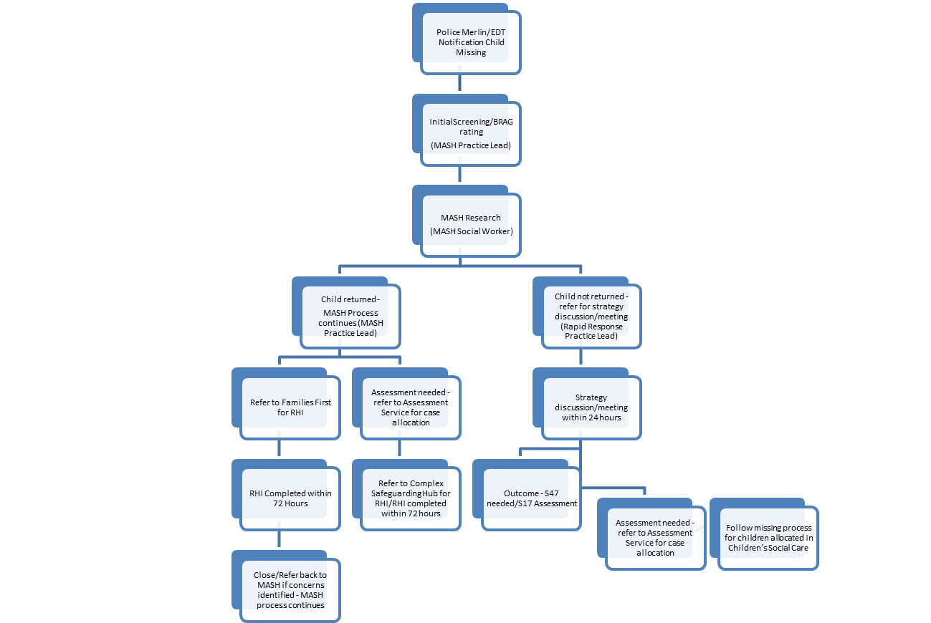
Child Missing from home or care
Child allocated in Children’s Social Care
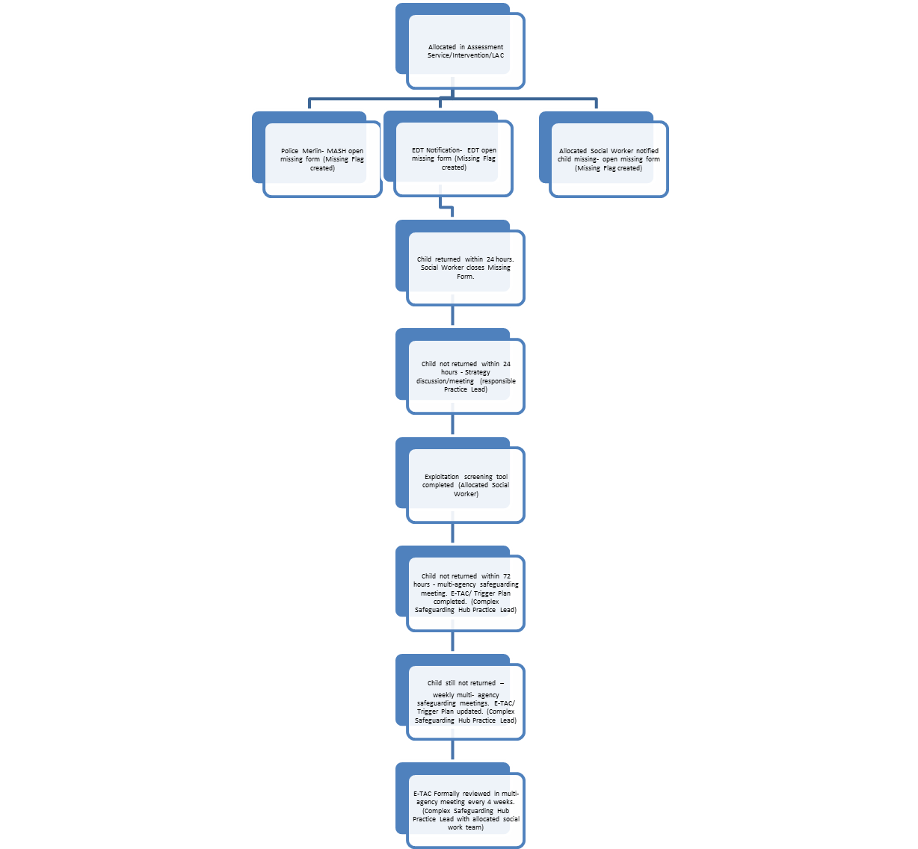

Child Missing from home or care
Child from another local authority or placed in Newham by another Local Authority
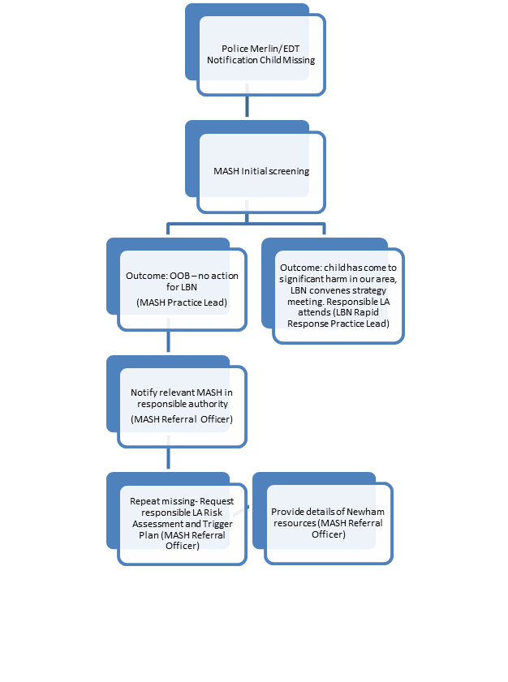

Appendix C – Recording a Missing Episode - Azeus User Guide

For the Azeus User Guide:

http://azeuscare.lbn.newham.gov.uk/Pages/Home.aspx

Appendix D - Strategic Missing Person Notification Form

To be completed when a child is missing: if missing for 24 hours send to your Practice Lead, Service Manager and Head of Service (and Head of Corporate Parenting where the child is Looked After). If a child is missing for 72 hours, send to Director of Operations

Missing from home or care:
Social Worker
Practice Leader
Service Area
Status of Notification
Head of Service |  | 24hrs after missing
Director of Operations |  | 72hrs after missing
Executive Director & Lead Member |  | 7days after missing
Name of Young Person:
DOB:
Azeus ID:
Legal Status:
Home or placement address (LAC):
Date young person went missing:
Number of days missing:
Brief details of circumstances:

Overview of vulnerabilities (e.g. CSE, criminal exploitation, learning needs, health, substance misuse, gang association etc.):
Details of strategy meeting:
(and actions taken / to be taken to locate young person)
Media Required: Y/N  Details: | Y/N
Parents informed: Y/N | Y/N
Has the Exploitation Screening Tool been completed?

Date:
Has the ETAC been completed?

Date:
Has the Trigger Plan been completed?

Date:

https://www.gov.uk/government/publications/children-who-run-away-or-go-missing-from-home-or-care
http://www.londoncp.co.uk/chapters/organised_complex.html

