AzeusCare Help Newham Service Request Process
01 April 2020

Summary Help Newham
The Help Newham Offer will provide targeted support to our most vulnerable residents, who are unable to access support elsewhere.
The aim is to provide them with a regular supply of food, essential items, prescriptions, and a ‘chat’ service offering emotional support. Our plan is to provide this support as long as is needed – initially we are planning this for a three-month period.

Priority is Category A:

The most vulnerable :
- Those identified by NHS ‘Shielding’
- The elderly (70+ years) not known to services without support networks

Residents already known to services. For example:
- Residents with complex health needs and known to adult social care.
- Children known to social care
- Rough sleepers and those in temporary accommodation
- Other client groups known to the council

Service | Details
Food Box Delivery | A box with food & essential supplies is delivered by volunteers in the 8 Community Hubs
Family Box Delivery | A Family Box with nappies, baby milk, etc. is delivered by staff from the Early Help Hub
Prescription Pick up | Prescription medication will be picked up at a pharmacy and delivered to the persons home
Befriending Service | The person will be contacted by a volunteer to help them overcome feelings of loneliness and isolation

Referrals back to Adult Care or Children’s Young Peoples Services
If staff working for Help Newham become aware of additional needs that they cannot meet then they may make a referral to the Adult Care Access Team or the Early Help Hub for the provision of support.

Further Guidance
For further details about how to use the form and a detailed call script please click:
<Here> for Adult Care Staff
<Here> for and Children and Young Peoples Staff
or alternatively please contact the AzeusCare Helpdesk by raising an IT Service Desk call.

Changes to AzeusCare
To support the delivery of the Help Newham initiative the following changes have been made to AzeusCare:
A new Help Newham Service Request AzeusCare form has been developed that functions as a request form for the different services Help Newham Provides:

When an AzeusCare user identifies that a person or family require food, essential supplies, a family box, a prescription pick up or befriending then they need to complete this new form on AzeusCare.

The form needs to be recorded on the AzeusCare record of the vulnerable adult or the parent/carer of the children.
It is essential that the address and phone number on AzeusCare are up to date so that the deliveries go to the correct address.

Records with Access restrictions on AzeusCare:
Please only record the form on a person that is Marked as Restricted on AzeusCare if it is appropriate for the persons details to be shared with the service providers.

Recording Guidance:
- Create a new form: Help Newham – Service Request in the Activity screen or the Client Journey screen

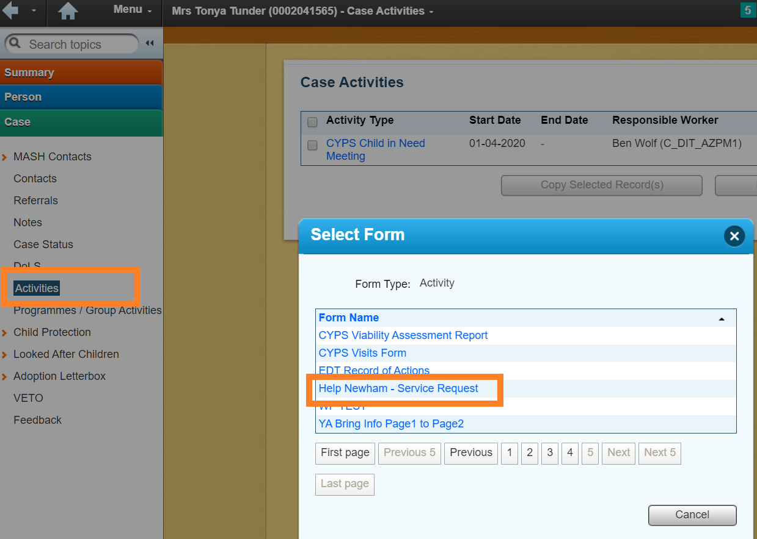

- Complete the form – the form contains a set of agreed questions that are used by different parties therefore some of the questions that need to be completed may not feel directly relevant to AzeusCare users.

- Self-approve the form – once the form has been self-approved the information it contains is automatically passed on to the relevant service provider for delivery of the request support.
If a Family box or formula milk has been requested then an automatic notification activity is sent on AzeusCare to the Early Help Support Coordinator Team Inbox in the Early Help Hub Team to notify them of the request.

Appendix A: AzeusCare Process
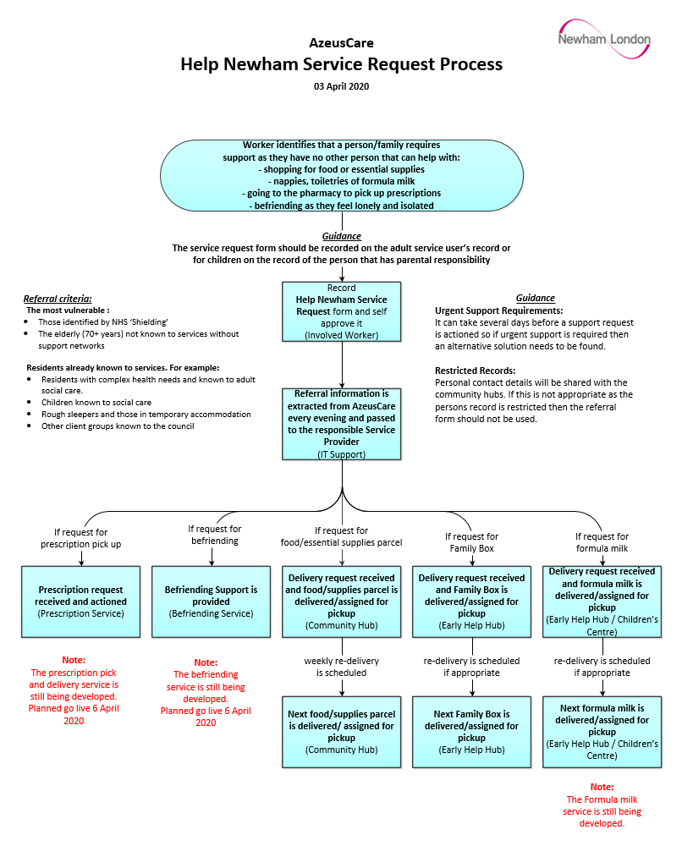

Appendix A: AzeusCare Help Newham Service Request Form
