Contents
1 Introduction 1
2 Telephone / Video Conferencing Interventions 1
3 Information from other Professionals and Schools 3
4 Visiting 3
5 Recording 4
6 Supervision 4
Appendix A - Purposeful, Planned and Focussed 6
Appendix B – Talking to Children about Coronavirus 8
Appendix C - Check List For Essential Visits 9
Appendix D – Personal Protective Equipment 9

1 Introduction
1.1 This Practice Guidance provides information how to keep in touch with children, young people and their families in the current circumstances. It includes guidance on telephone interventions and other ways of monitoring the wellbeing of children and young people as well as when to consider a physical visit.
1.2 Also included is information about how to access practical support for families, how to record your interventions and the importance of supervision and team meetings. This guidance will be updated in the light of experience and as further government guidance is published.
1.3 Each service in children’s social care has compiled a matrix of the families that they are most concerned about. This will be reviewed by managers weekly with practitioners in order to prioritise which families may need home visits. You should discuss with your manager how best to engage with the other families that you are responsible for in the light of this practice guidance.
1.4 The MASH and Assessment Service will continue to offer urgent responses to child protection concerns in conjunction with the police and other partner agencies.
1.5 If required, personal protection equipment (PPE) will be available for social care staff if face to face contact is urgent with a family that is symptomatic – full PPE can be obtained from Claire Belgard at Dockside (Claire.belgard@newham.gov.uk); a grab bag will be made available at Becton Road as soon as possible; we hope to have masks, gloves and hand sanitiser available via the duty manager(s) at Dockside or Becton Road. Visits should only be undertaken following discussion with your line manager and with the agreement of your Head of Service / the Director of Operations.
1.6 The government has issued guidance for children’s social care services which is available here:
https://www.gov.uk/government/publications/coronavirus-covid-19-guidance-for-childrens-social-care-services/coronavirus-covid-19-guidance-for-local-authorities-on-childrens-social-care

2 Telephone / Video Conferencing Interventions
2.1 Keeping children safe is our core business. And an essential part of doing that is visiting them, talking to them and recording what you see and hear. However, for the foreseeable future, we will be unable to do that except in very specific circumstances.
2.2 With immediate effect and in accordance with government guidance issued in response to the spread of the Covid 19 virus, physical visits to children, young people and their families should not be undertaken except in exceptional circumstances (see below). This includes children in need, children subject to protection plans, children looked after and care leavers as well as visits by fostering supervising social workers to foster homes.
2.3 The world has become so much more complex in such a short time for the children, young people and families that we work with as well as ourselves. Everyone is having to manage the new uncertainties. The task of supporting families and children has become very different very quickly and our tools for doing this are changing daily.
2.4 In most cases, we will be using telephone contacts, skype and other social media approaches to interact. This brings with it constraints and some opportunities to try to do things differently. We want to remind you that we need to practice in a Purposeful, Planned and Focussed way. At this time, it’s even more important to be clear about our purpose, to plan to meet it and stay focussed on achieving the plan to meet that purpose.
2.5 Attached, at Appendix A, is some guidance on thinking, planning and undertaking telephone, skype or other social media interventions with children, young people and their families. Remember, that any contact with a family, child, young person or their family is an opportunity for change to be constructed. Attached at Appendix B is a link to materials that may be of assistance in engaging with some primary school age children.
2.6 Most of the children and families with whom we work have mobile phones, tablets or laptops. You can therefore use FaceTime or Skype to keep in contact and “see the children”. Ask them to show you around using the phone camera; ask them to “take you” to a quiet space where you can talk to them in your own. It is important that you stay in touch, particularly during a period of time when the other professionals who may have been in contact with a child may not be doing so.
2.7 You will also need to assess how the child, young person or family are coping with the additional stress of social isolation (and the additional stress that this may have caused the family, both emotionally and financially). The council is providing practical support for vulnerable people and families:
https://www.newham.gov.uk/Pages/ServiceChild/Coronavirus-(Covid-19).aspx#NewhamsOfferHelpNewham
However, you can access this support directly for children in need (including children with disabilities or an education, health and care plan) and children subject to protection plans by completing a “Help Newham” referral form in Azeus which is to be found in “Case / Activities” – scroll to the end of the list. These referral forms can be used to provide families with essentials between 24 and 48 hours after the referral form has been completed. The referral form should only be completed once per family and on the record of a parent / person with parental responsibility.
2.8 For all children, especially care leavers, it is important that we keep in touch on a regular basis and are able to provide practical support / advice as well as check in calls. Please as a team spend some time researching as well as sharing good online tools and sources of virtual support. If any care leaver is not responding to contacts then please discuss what this may mean with your line manager/service manager.
2.9 Don’t forget:
- Prepayment cards will be available for emergency situations;
- Existing payment arrangements will continue;
- Court hearings will not be taking place “in person” – see guidance in the “Local Resources” section of the Tri.X procedures.
2.10 The Tri.X Web Site which includes our procedures and local resources is at the following address: https://newhamchildcare.proceduresonline.com/
You can access this link from any computer, not just your Newham laptop.
2.11 The following link shows you how to set up a Skype call using your Newham laptop:
https://youtu.be/7_c4zVJ739M
If you do not have video conferencing facilities available on your laptop and / or you mobile phone, please raise this with your line manager.

2.12 For the avoidance of doubt, physical child protection conferences, statutory reviews and other review meetings will not take place although conference chairs and reviewing officers will be expected to make arrangements to hold meetings “virtually” where possible.

3 Information from other Professionals and Schools
3.1 Some families will continue to be in contact with other professionals. Where appropriate, you may seek information from them about their contact with a child / family and record that as part of your overall intervention with a family.
3.2 All of the children that we work with are defined as “vulnerable children” and should, therefore, be able to continue to attend school. Information should be available about whether or not children are continuing to attend school and their presentation when they do so. You should ascertain from the family and / or the school whether or not children are continuing to attend.
3.3 If children are not attending school, you should discuss with their parents / young people why they are not doing so and encourage them to attend. If they are not attending school because they are in one of the categories encouraged to self-isolate, then record the reasons and keep in regular contact with the family.
3.4 If the child or young person is not attending school for any other reason, then you should encourage their parents to ensure that the child / young person does attend school. Contact the school and agree a plan to keep in contact with the family and to encourage school attendance. You may find that families will respond to a call from a teacher.
3.5 If children / young people do not attend school, you should discuss their circumstances with your manager and consider whether or not a visit should be made to see the children.

4 Visiting
4.1 There will be some occasions when the nature or seriousness of the concerns will mean that consideration should be given to seeing the child and family in an office or at home, particularly during the course of child protection enquiries, an assessment, if they are considered to be at significant risk or when there has been an incident that requires an urgent response.
4.2 There are two options to be considered for undertaking a physical visit to a family home. The first of these is a “doorstep visit” during which you do not enter the family home and maintain a safe distance from members of the family. Depending on the age of the child / young person, you may also consider asking them to temporarily leave their home to talk with you in the local area whilst maintaining a safe distance from them. A “doorstep visit” is most likely to be appropriate where you want to be reassured that the child / young person is safe but do not need to undertake a confidential discussion. Discuss with your line manager before undertaking such a visit and see flow chart below at Appendix C
4.3 If it appears that direct contact with a child / family is required, then you should follow the following steps: Assess the degree of risk; is there any reason to believe that the child or a member of their household is currently unwell? You will need to undertake a screening call, either with a family member or another professional that has been in contact with the family. Discuss the need for the visit with your line manager and ensure that you keep a safe distance from those that you are visiting. If there are concerns about the health of the child or another member of the household then you and your manager should discuss the need for a visit with your head of service before undertaking that visit. Remember:
- Is the visit really necessary?
  - No – telephone / video call / contact another professional who may have seen the child / family.
  - Yes - assess the risk of visiting including making a screening call.
- Confirmed or suspected case?
  - No – discuss the need for a visit with your manager; consider “doorstep visit”; if a physical visit is required, then do so using a mask and gloves and make use of hand sanitiser.
  - Yes – Full PPE required, line manager to email request to CYPS SPOC (Claire Belgard) with confirmation of Head of Service approval

4.4 Where a home visit is required and there appears to be a risk to your health or that of the child / family in undertaking that visit, then personal protective equipment is available. See Appendix C.

5 Recording
5.1 It is essential to maintain a record of the work that you are doing, especially when normal services are disrupted and you may be covering for a colleague. Azeus will continue to be available and you should record your work as normal – be purposeful, planned and focussed in your work and in your recording.
5.2 In the Person / Medical / Health and Disability section of Azeus, there is now the ability to record Covid 19 status which will also create a flag on that person’s record and those associated with them.
5.3 The visiting form now allows you to record the type of visit that you have undertaken – by telephone, by video call, by gathering information from another professional, a “doorstep visit” or a physical visit.
5.4 There may be occasions when you do not have access to Azeus. Copies of some of the common forms will be downloaded from Azeus and made available to staff. These will be distributed and loaded onto the local resources section of the Tri.X procedures web site. They are only for use in the event that Azeus is not available.
5.5 Alternatively, you may summarise a visit in an email and send it to yourself (copy in your manager) and copy that into Azeus at a later stage.

6 Supervision
6.1 Face-to-face supervision may not always be possible because you or your manager are working from home or not able to be in the office at the same time. In those circumstances, Skype / FaceTime or other conferencing software provides an opportunity for you to have a “face-to-face” discussion which is preferable to a telephone call. This may be used for either individual or group supervision.
6.2 Team meetings are a valuable source of support and information. Whilst is will not be possible for teams to physically meet together, Skype or other forms of video conferencing should enable teams to maintain contact with each other.

Appendix A - Purposeful, Planned and Focussed
Before the Call
Purpose
- What is your purpose for making the call? Make sure you are clear about this and how it links with the presenting safeguarding risks. How will it help in addressing these?
- Keep your purpose for the call specific. If it’s to check they have food then keep it to that. If it’s to discuss risks then keep it to that. Having wide ranging calls are tricky for all. But especially so for stressed families/YP who are not used to these types of interventions in their lives
- Seek agreement with the family about having this discussion. Families have had to re organise as well as us. So it may not be that the time we have free fits for them. This may not be them avoiding but rather them making better choices in the moment.
Plan
- Have a clear plan to achieve agreed purpose, including,
- Length of calls and how many calls are needed to have to achieve your purpose?
- Who is needed to be present today and how will you share what has been spoken about with those not present.
- How will you review your purpose and plan? At the end of the call or by a follow up call.
- What questions do you need to ask, how can you ask them in a way that invites the other person to respond?
- Who and what do you need to listen to/hear know things are ok?

Focus

- Prepare for possible distractions from your purpose and how you might respond to these so that you keep focussed. If another topic takes priority, how will you return to your purpose?
- Prepare some open questions and statements about positive qualities or skills the person/people you are talking to has. (Evidence suggests that asking questions that illicit hope will reduce stress, increase agency and enable people to carry on managing)
- Prepare questions to enquire about safeguarding. How will you ask the difficult questions? How will you check is safe to ask or the person to answer/ People experiencing violence at hoe may not always be able to answer. Think about how you can offer ways of answering without saying the words etc.
- Make sure your choice of questions and statements match the context and stage of intervention e.g engagement, assessment, skills coaching and intervening, ending etc.

A little more on Preparation:
Preparation
- Consider who to call – will you have individual conversations or is there a possibility for a whole family / parents only conference call? This will depend on your purpose but also with consideration of family’s ability to cope. Consider the influence of social graces and distribution of power and the effect this may have on talking and listening. This will inform your planning of duration and frequency of calls as well as who to speak with.
- When planning your call, consider how you will meet different family members’ needs, including their capacity to focus, turn taking etc.
- Due to our reduced service we need to prioritise safety so that calls finish with the family feeling OK about one another. Consideration may therefore need to be given to changing your levels of relational risk taking.
- Prepare your questions, responses in relation to the purpose, plan and focus of your call.

The call
- Explain your rationale to for continuing our intervention over the phone.
- Explain how the intervention will need to continue as part of a CIN/CP plan. In terms of how we plan this with the family, this will be done collaboratively.
- Talking about the talking: Plan a convenient time to call – let the family know how long you expect the call to last (this will vary from family to family and according to your purpose). Decide on frequency of contact and who is needed to be present.
- Discuss how you will all manage this way of talking by phone – is this something they are used to? How will you allow for thinking time, manage pauses?
- Plan how distractions might be dealt with, agree how the family will let you know they if they need to pause etc.
- Check out how well people are feeling and impact of this on their engagement. If mum is unwell, who, if feasible, could be spoken to instead?

Suggested Techniques
- Emphasise resilience building, highlighting positives and developing strengths.
- Draw on techniques that promote engagement and motivation.
- For example, Permission seeking, open questions, validating, talking about the talking, warming the context, relabelling negative words or expressions to less emotive or negative words, reframing statements to bring out positive intent.
- Offer parenting strategies. It’s OK to suggest ideas or work in a more first order way than usual.
- Regarding skills coaching – if a conference call is carried out this will require listening and turn taking in order to work! When the family manage this, use examples of these as opportunities for reinforcing the skills they already have.
- Discuss relapse prevention / safety planning
- At the end of the call check out how everyone is and agree when you will next call. Calls may need to be more frequent, depending on the safeguarding concerns, capacity for family to focus.
- Make sure you speak with every child in the family – even if this is just to ask how they are. For older children, request a separate conversation by phone or skype, following the call, with an older child/children.

Checklist:
- Have you seen and spoken with every family member including each child ? If not ensure you try to do this ASAP. Note who you did and did not speak to.
- Have you addressed the concerns about risk in the new context of covid-19? Everyone living on top of each other may increase risks or develop new ones
- Have you agreed a next appointment to talk and with whom?
- Do the family know the procedure of who to contact and how, should risk escalate?
- Is there anyone I need to sign post this family on to or contact after this conversation?

Have you recorded accurately and pasted on any concerns to the appropriate person.

Appendix B – Talking to Children about Coronavirus
Axel Scheffler has illustrated a digital book for primary school age children, free for anyone to read on screen or print out, about the coronavirus and the measures taken to control it. Published by Nosy Crow, and written by staff within the company, the book has had expert input: Professor Graham Medley of the London School of Hygiene & Tropical Medicine acted as a consultant, and the company also had advice from two head teachers and a child psychologist.
The book answers key questions in simple language appropriate for 5 to 9 year olds:
• What is the coronavirus?
• How do you catch the coronavirus?
• What happens if you catch the coronavirus?
• Why are people worried about catching the coronavirus?
• Is there a cure for the coronavirus?
• Why are some places we normally go to closed?
• What can I do to help?
• What’s going to happen next?
https://nosycrowcoronavirus.s3-eu-west-1.amazonaws.com/Coronavirus-ABookForChildren.pdf

Appendix C - Check List For Essential Visits
YES
Does the child / any family member meet any of the following criteria:
- They have a new cough or a high temperature
And / or
- The child / any family member is self-isolating due to COVID-19
And / or
- The child / any family member has been diagnosed with COVID-19

A visit may be undertaken with the agreement of your line manager.
NO

Visits in these circumstances will be rare and often undertaken with other professionals – discuss with your manager and only visit with the agreement of your Head of Service or Director of Operations
YES
In these circumstances, consideration should be given to a “doorstep visit”: discuss with your manager and only visit with the agreement of your Head of Service or Director of Operations
NO
Does the visit involve close contact with the child / any family member?
NO
YES
Conduct visit online or by phone
Can the visit be carried out online or by phone?
NO
Do not visit / conduct visit online or by phone
Follow advice on good hygiene:
• wash your hands on arrival and often or use hand sanitiser
- cover your mouth and nose with a tissue or your sleeve when you cough or sneeze
• put used tissues in the bin immediately and wash your hands afterwards
• do not visit if you are unwell.
YES
Is the visit essential?
YES or DON’T KNOW

Appendix D – Personal Protective Equipment

Quick Guide: Putting on (donning) Personal Protective Equipment (PPE)
Do this outside of the room / property

Pre-donning instructions:

Perform hand hygiene before putting on PPE
- Ensure you are hydrated
- Tie hair back
- Remove jewellery
- Check PPE is the correct size

Put on FFP3 mask or water repellent surgical mask
Put on the plastic Apron
- Apron 2. Mask -

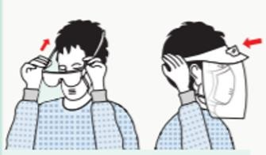

Wear eye protection/googles/visors

  - Eye Protection -

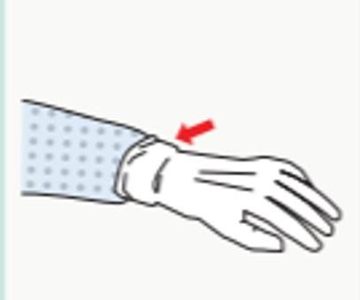
  - Lastly, put on your gloves.

Quick Guide: Removal (doffing) Personal Protective Equipment (PPE)
PPE should be removed in an order that minimises the potential for cross contamination.
The order if removal of PPE is as follows:

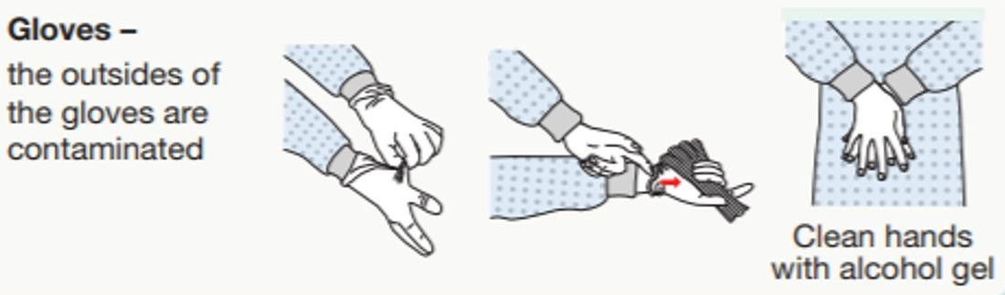
- GLOVES:

- Gown – take off the plastic apron

- Eye Protection 4. Mask –
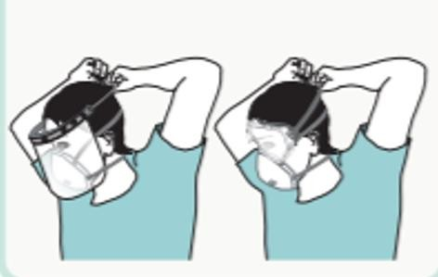
Wash hands with water and soap

Clean hands with alcohol hand rub. Do not touch the front of the mask as it will be contaminated.
Eye Protection – the outside will be contaminated
5. Wash hands -

Make sure shoes are washed down with detergent and disinfectant once home and wash clothes at 60C.
Change gloves- to remove-
- Grasp the outside edge of the hand which opened the door near the wrist.
  - Peel the glove away from the hand, turning the glove inside out. Hold it in the opposite gloved hand.
  - Slide an ungloved finger under the wrist of the remaining glove, then peel it off from the inside, creating a “bag” for both used gloves.
  - Discard in the PPE bag you bring with you. (A sealable / tie-able bag you bring with you for contaminated waste.)

Guidance on how to complete the referral form is in the local resources section of the Tri.X Procedures https://newhamchildcare.proceduresonline.com/local_resources.html

