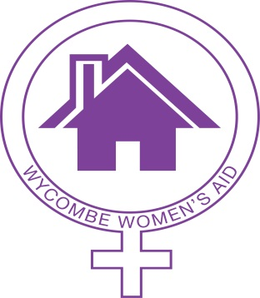
Wycombe Women’s Aid Ltd
PO Box 1477
High Wycombe
Bucks HP11 9HP
Tel: 01494 461367
Email: wwal@btconnect.com
www.wycombewomensaid.org.uk

WWA SERVICES UPDATE
6 April 2020

In light of the COVID-19 epidemic and the on-going risks, Wycombe Women’s Aid has suspended all face to face activities. We will not be taking any new families into the refuge at the moment and this will be reviewed again at the end of April. There are some refuges across the country that are able to take new referrals into their refuges and we are supporting local women to access these refuges via our helpline as usual.

Wycombe Women’s Aid will continue to provide:

- Helpline

- Support for women and children living in the refuge

- Counselling

- Outreach

- IDVA

- Youth Work

The above are available via telephone and a variety of video and messaging platforms.

How you can contact us: Helpline: 01494 461367

Website: www.wycombewomensaid.org.uk

You will also find further information about our services on our website.

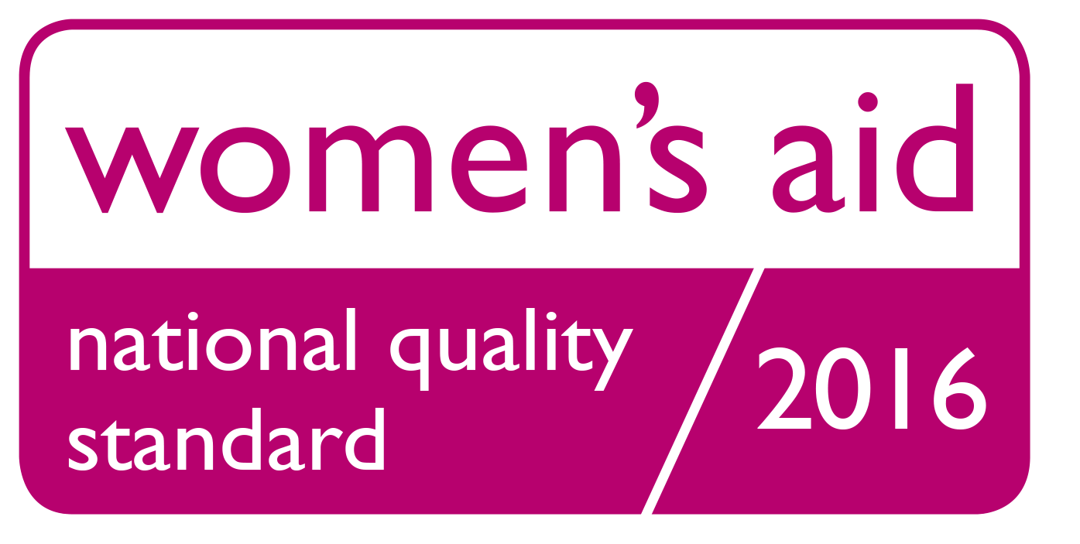
Registered Charity No.299946 Registered Company No. 2245478
Registered Office: Abbey Place, 24-28 Easton Street, High Wycombe, Bucks. HP11 1NT

