Logging into LCS
We are changing the way that the screen looks where you enter your password
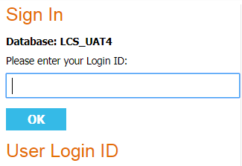
After you have entered your user name in the normal way in the box above, you will be presented with a new format for entering your password see below.
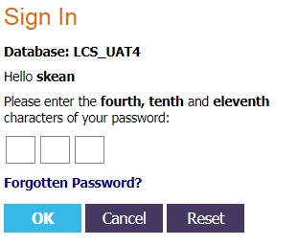
You will need to enter the specific letters in your password, as before, however, you will now not see the grey circles that represented the other letters in your password. So if your password was Superannuation, you would enter into the boxes ‘e’, ‘a’ and ‘o’.
You would complete your log in process with the answer to the appropriate secret question.
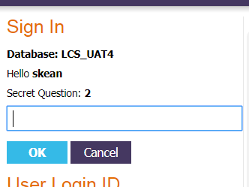
END

