Permanency Meetings and Review
There are now 2 new forms for Permanency Meetings and review. The new forms are

Permanency Planning Meeting Agenda and Permanency Planning Meeting Review

Permanency Planning Meeting Agenda
When you launch the form you will be presented with the screen below:
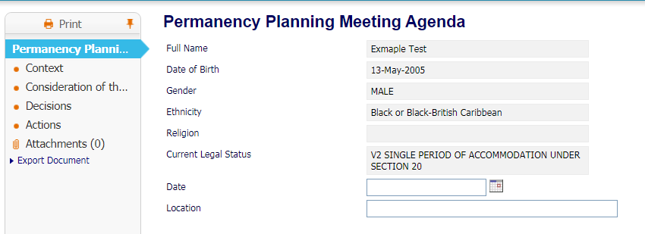
You will need to complete the date and location fields at the bottom of the screen as shown above.
The form has four tabs as seen above.
First Tab – Context
The boxes on this form will need to be completed as fully and accurately as possible. This will be the discussion at the permanency meeting.

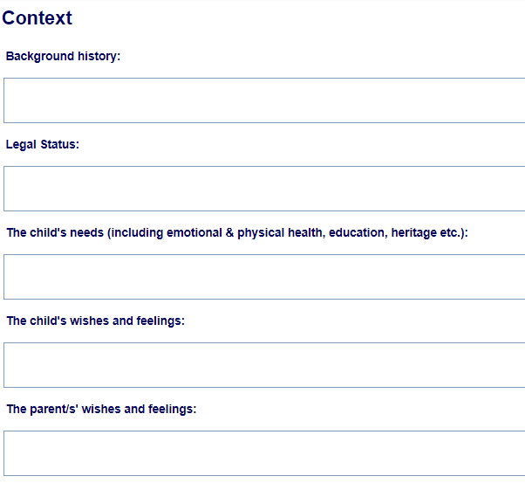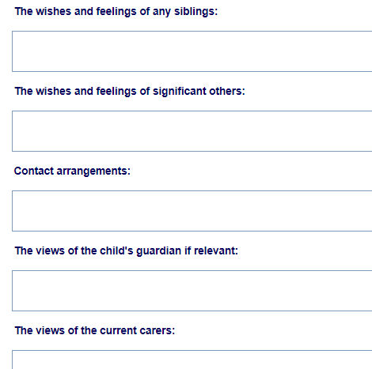
Second Tab – Consideration for the options for Permanency.
Again this should be completed at the meeting
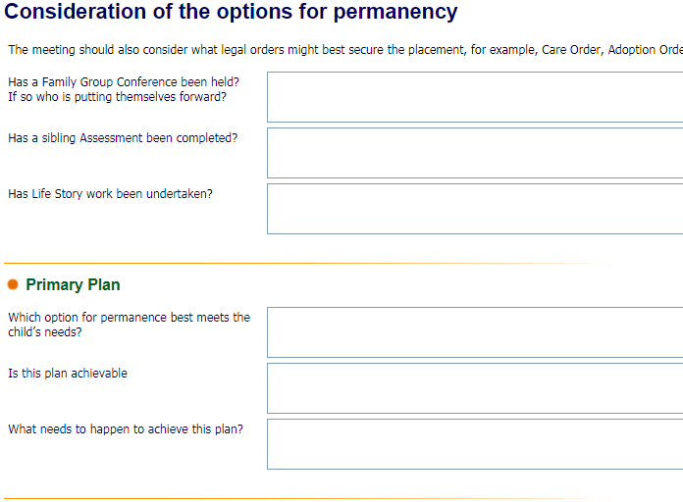
Third tab – Decisions
The decisions of the meeting should be entered onto this form as completely as possible.
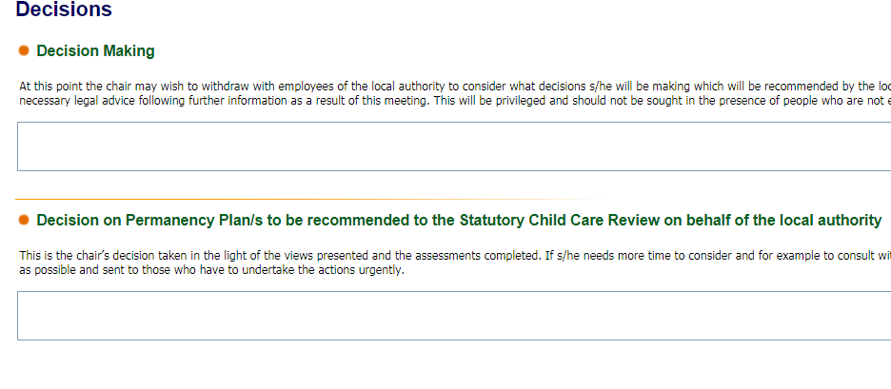
Fourth Tab – Actions
This tab shows the actions to be taken by the social worker.
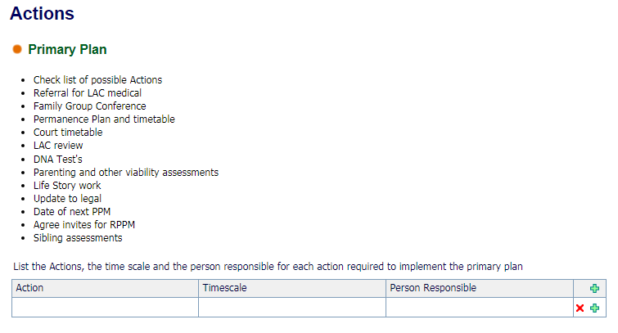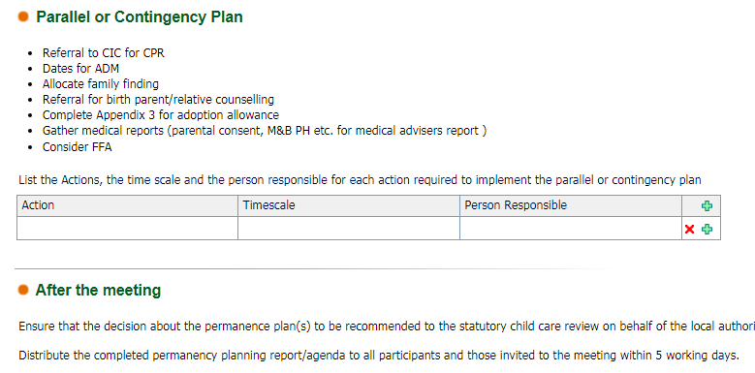

Permanency Planning Meeting Review

The planning meeting will have set a date for the review meeting this form can be launched from the forms drop down.
When the form is launched the following screen appears. You will need to complete the date, location and legal status if not completed already. The form has 2 tabs.
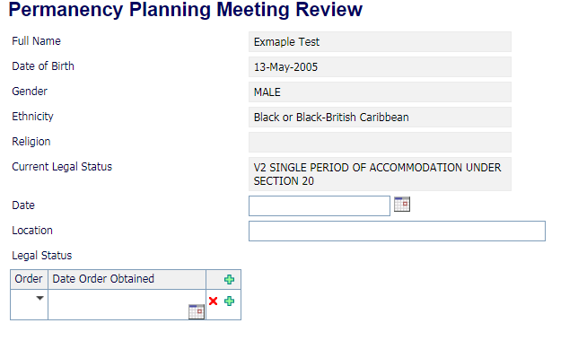
First Tab – Meeting details
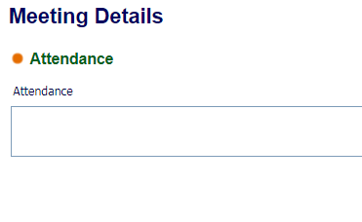
Add the attendance of the meeting.

Second Tab – Updates
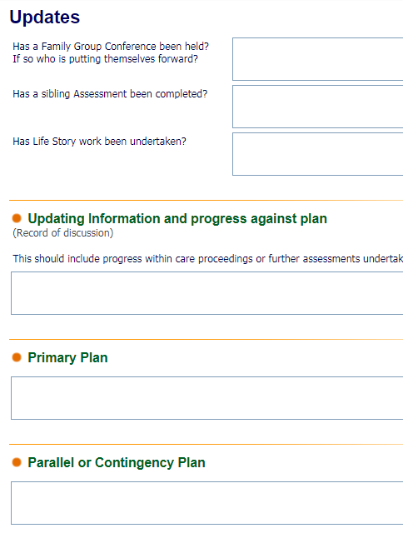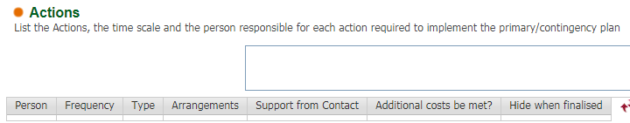
This will need to be completed fully

End

