Raising a referral request for Mediation or Family Group Conferences
When in the child or young person’s record you need to select the forms tab as highlighted below.
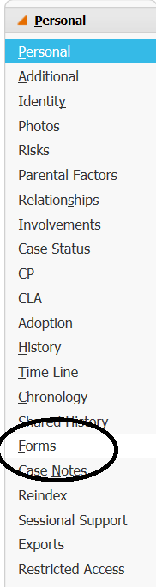
On the resulting page you need to use the drop down start new form and select the Family Group Conferences form as highlighted below:
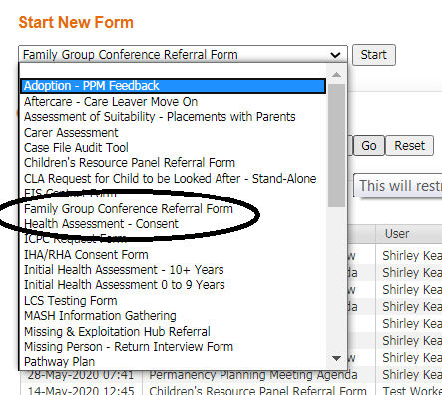

The form you are presented with will have the following tabs, you will need to complete all of the sections of the form before being able to send for authorisation.
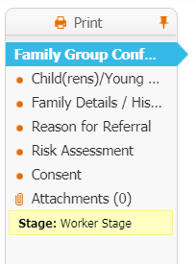
The first thing you will need to complete is whether this referral is for a Family Group Conference or mediation. Select the correct button as below.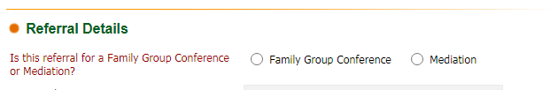
Please note as you go through the tabs, you should complete as much as you can, as your information will be used to assess the requirement of either a Family Group Conference or mediation.
When all the form is completed correctly you will be able to send for Authorisation. This authorisation will go directly to your manager.
Managers Authorisation
As a manager you will receive into your worktray the Family Group Conference Referral form task, see below.
You will need to select the pickup as highlighted above; you will then be presented with the form. As the manager you should review the form and then go to the managers decision as highlighted below.
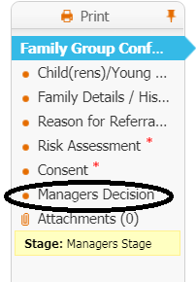
You will need to select yourself as the manager authorising and either select yes or no depending on whether you are in agreement with the referral. You can add comments and you must put the date of your decision in, see below
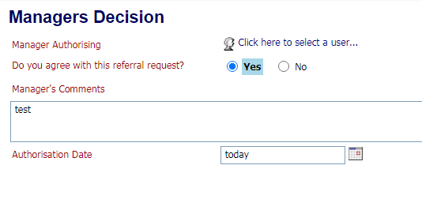
You will have the choice of whether to ask for further information or if you are happy with the form you can select ‘Send to FGC to review’
End

