Co-ordinators doing the FGC Plan and Review
When you have been assigned a FGC/Mediation you will see the task in your work tray (the worktray can be accessed via the Home page on LCS
The task will be as below use the Pickup to select the item.
You will then be presented with the following screen. Select the FGC plan as highlighted
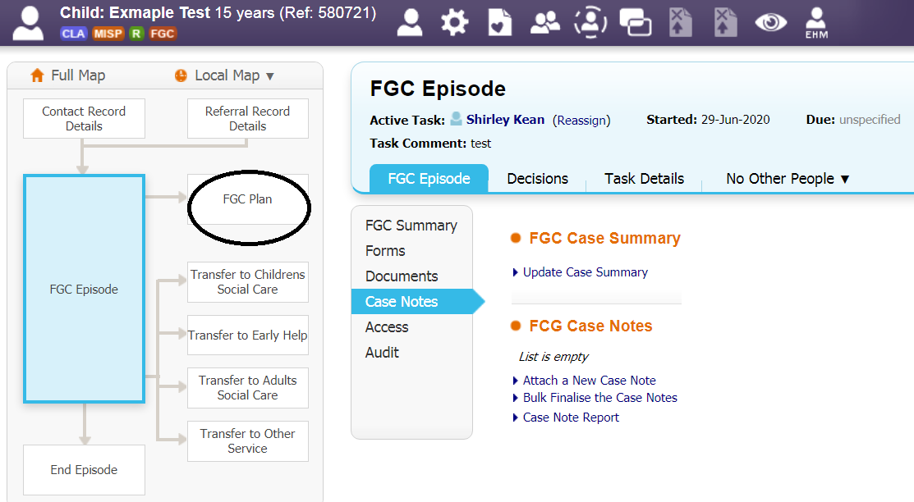
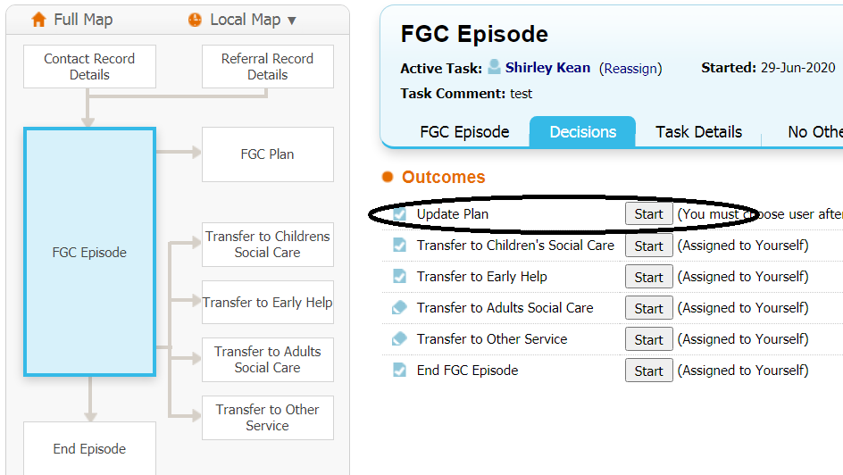
Select the update plan as highlighted above.
You will be presented with this screen, add the date and any text you wish and then select confirm as highlighted.
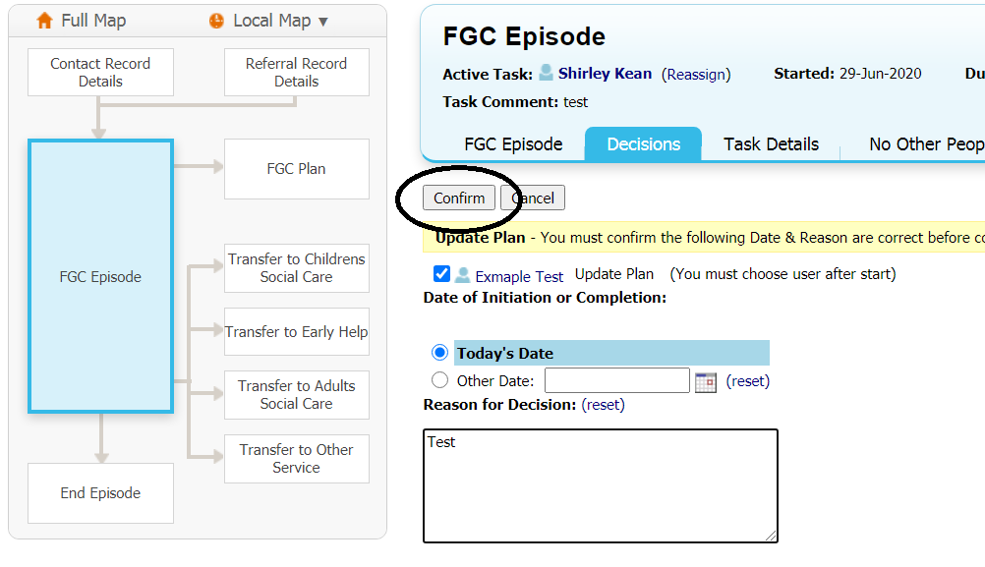
The following screen appears, this allows you to assign the case to someone else, or to yourself. Click the assign button.
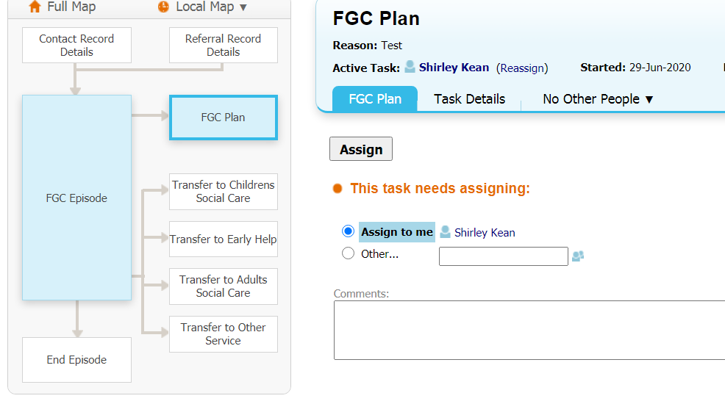
The next screen allows you to start the FGC Plan select Start as highlighted below.
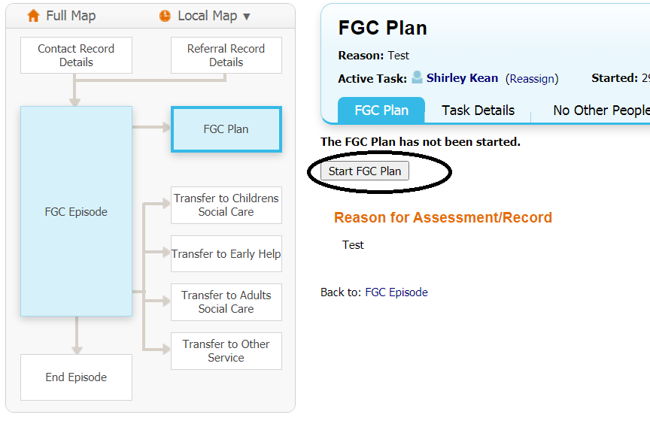
You will be asked to copy forward or to start blank ALWAYS start blank.
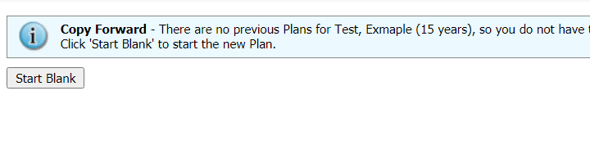
The following screen appears with 2 tabs the first is regarding the meeting and details Family Group Conference, and the second tab Summary of Risks. Each tab will need to be completed. Please note anything in Red is mandatory and will need to be completed

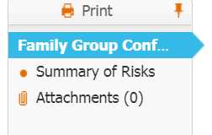

Family Group Conference Plan/Mediation Agreement

You will need to complete all of information requested on this form. Noting the mandatory questions.

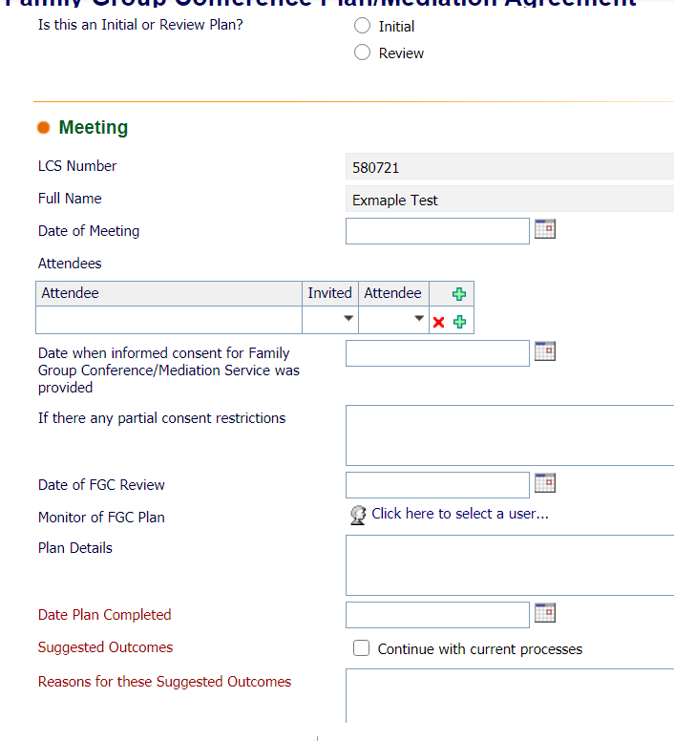
On tables that have a plus sign next to them you can add lines so that a full list of attendees can be included. See below. These are free text fields so you can add individuals who do not have a record on LCS.
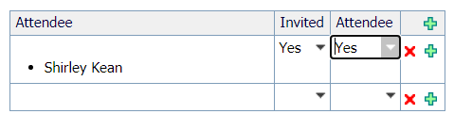
The summary of risks tab also has tables where you can add lines.
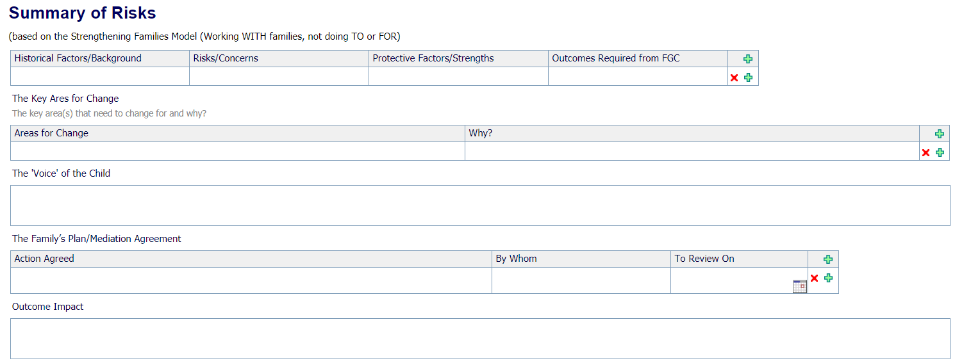
You will then need to finalise the plan by selecting finalise from the top right of the screen
When you have finalised the plan the plan will need to be authorised by the manager.
There will be a task in the FGC worktray as below. The manager will need to pickup this task.
You will then need to review the plan and if happy with the plan finalise the plan, as above, and then you will be able to authorise the plan as highlighted below.
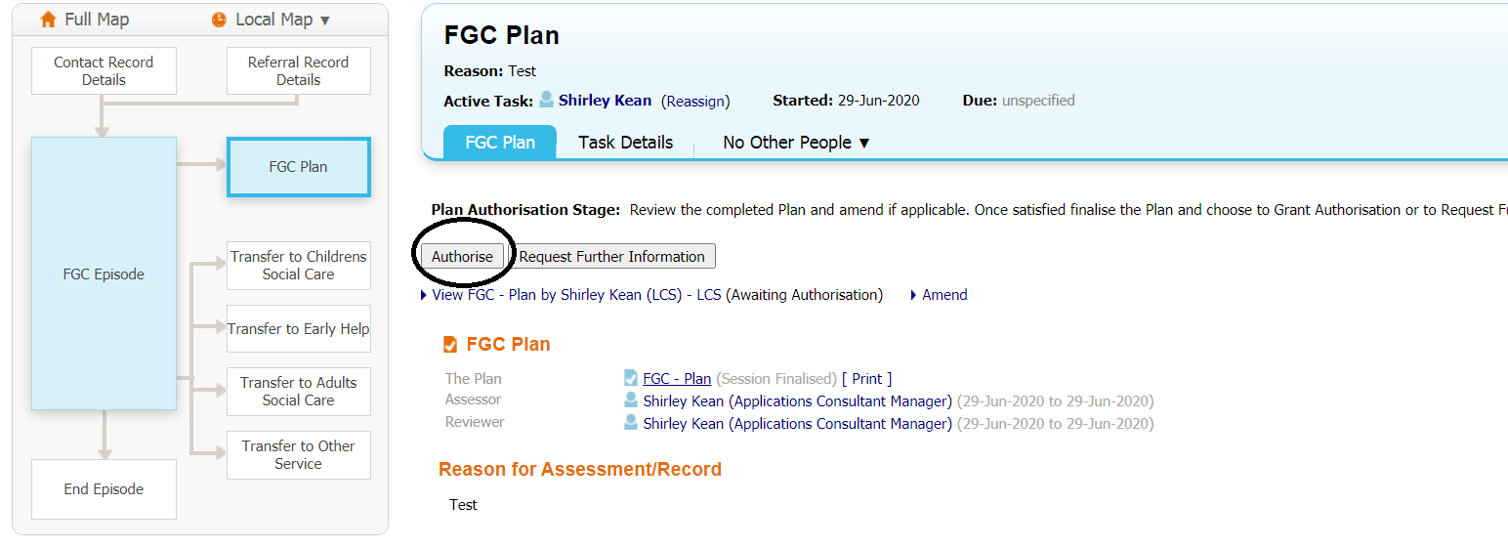
Once authorised you will now note that the FGC plan box has now been greyed out see below

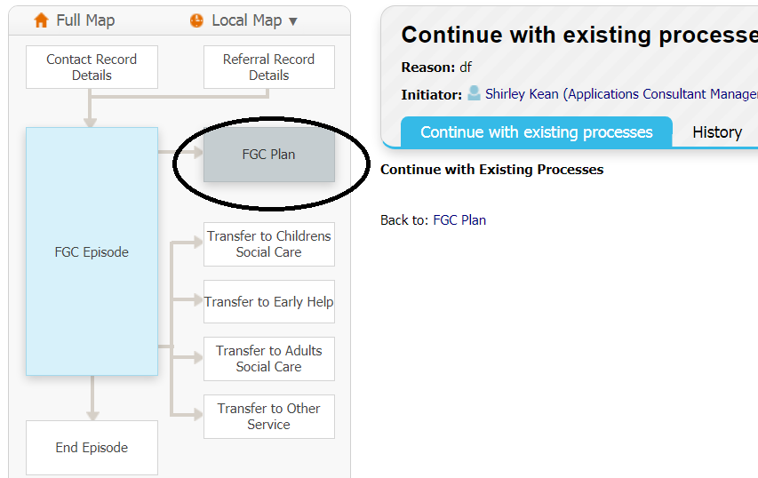
You can review the plan as many times as you wish by selecting the Update Plan and following the processes as above. You will see at the bottom of the screen the number of times the plan has been modified or updated. See blow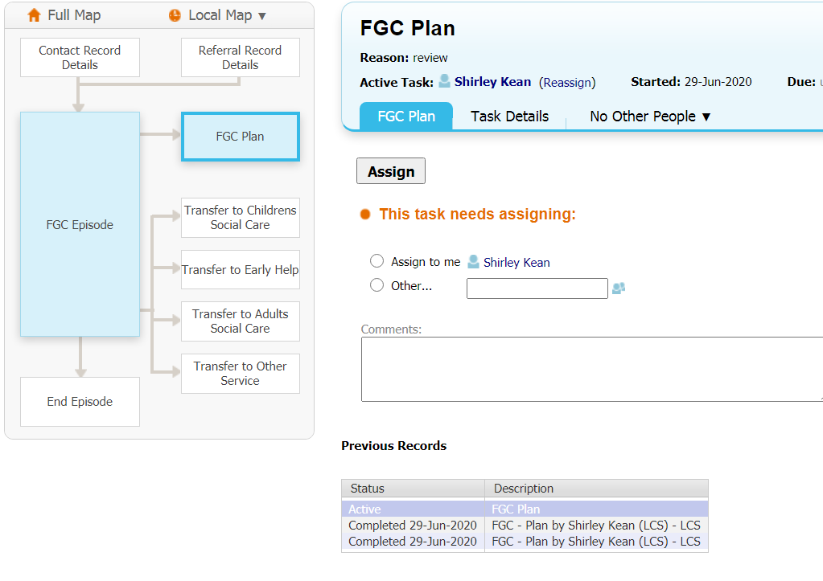

Ending the FGC episode.
When the FGC episode has been completed you will need to end the episode. By selecting the end FGC episode as highlighted below.

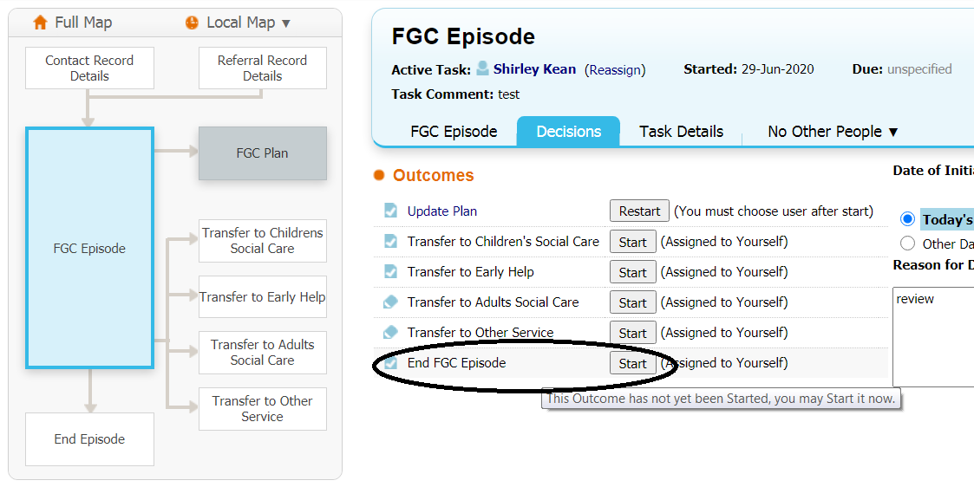 You will need to confirm that you want to start the End FGC episode
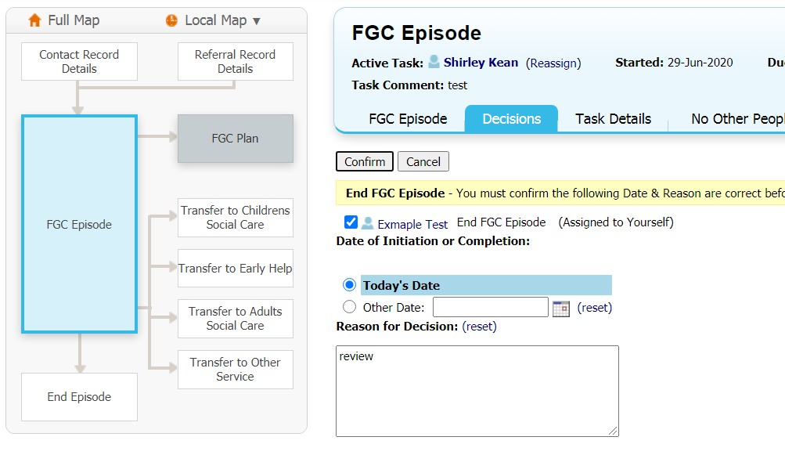
You will be presented with the following screen you will need to select Start the FGC Episode closure button as highlighted below
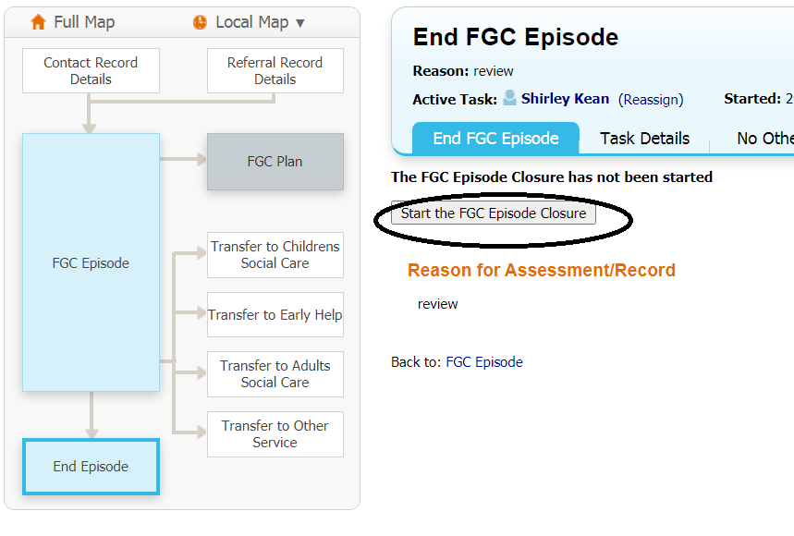
The following screen is displayed first you must select the reason for closing the episode using the drop down
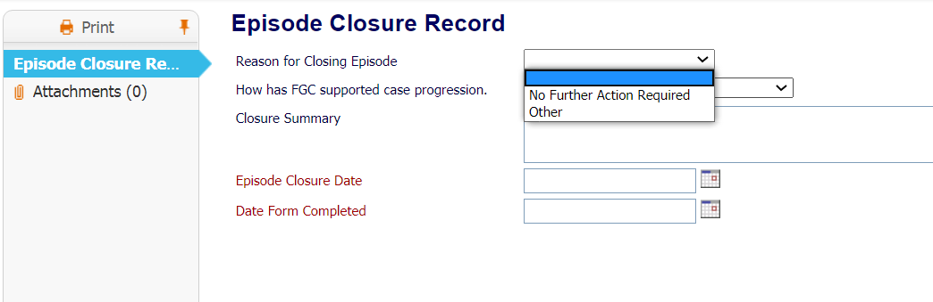
If other is selected then a text box will appear for you to type in what reason.
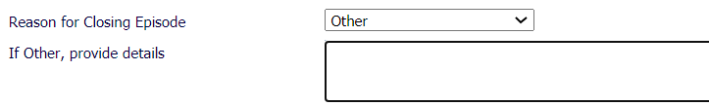

Then using the drop down for how the FGC supported case progression select from the drop down
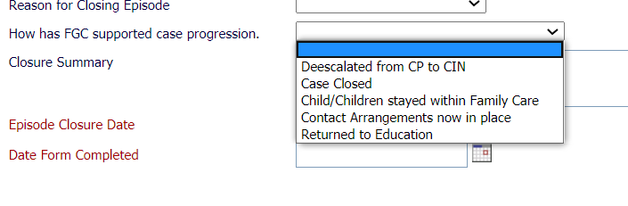
Complete the closure summary box and end the date of the episode closure date and the date the form was completed. These may differ depending on when the form was updated.
When happy with the form you must press finalise assessment as below
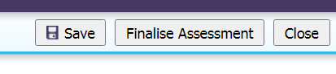
You will be asked to assign the authorisation to the FGC worktray select and continue.
The Manager will pick up the task from the FGC worktray and the following screen will be presented.
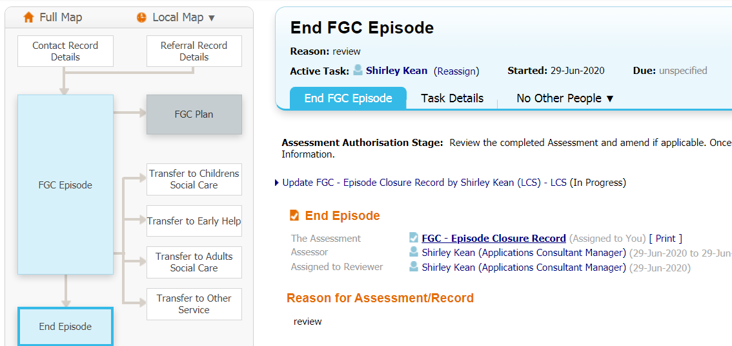
The manager will need to select the FGC – Episode closure record and if happy with the closure summary will need to finalise
The manager will then be presented with authorisation screen and will need to authorise as before.
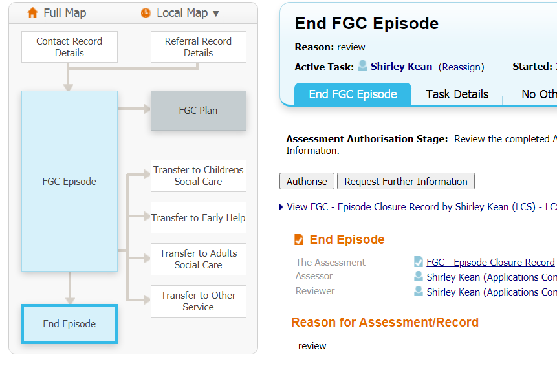
Once the closure summary has been authorised the FGC flag at the top of the page with be crossed through and the FGC episode will be greyed out see below
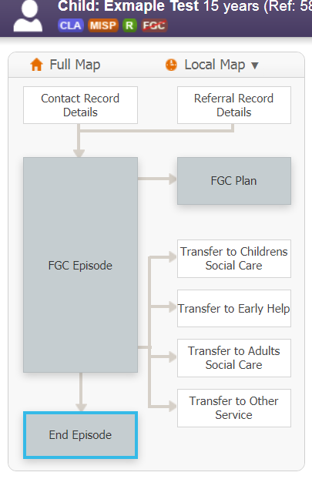
END

