Adoption Module Recording Guidance
This guidance has been created to assist children’s social workers and their managers, family finders and independent reviewing officers in being clear about what information should be recorded on which section of the child’s file, at each stage of the child’s journey. This guidance highlights specific stages of the child’s journey to adoption and where each professional should be recording information at that stage. Also included is a list of tasks generated in the LCS workflow to adoption, and who is responsible for completing the task on LCS. We hope this guidance is helpful and provides clarity for all workers in recording and storing information accurately.
Prior to the Adoption Module being initiated by the IRO (only possible once the child becomes Looked After), the child’s Social Worker will continue to record their interactions with the child/family on the main part of the child’s LCS file (case notes / forms etc.). The Family Finder will record their interactions on the case in the Pre-Adoption folder within Content Server (this is currently the only possible place for the family finding team to record their work prior to the child becoming CLA and the Adoption Module subsequently being initiated).
The Adoption Family Finding Team will become involved where there is a reasonable possibility that adoption may be considered as part of the child’s final care plan. The Family Finding team should be invited to attend a Permanency Planning Meeting for all children under the age of 8 where adoption is an option for the child at the earliest opportunity, even if Adoption seems unlikely at that point. This is so that the Family Finding Team can track the journey of that child and be ready to act quickly to avoid unnecessary delay for a child should Adoption become the primary care plan.

During the care proceedings/care planning stage for a child where adoption is a possible option:
- The Adoption Module will be triggered by the Independent Reviewing Officer at the child’s initial Child Looked After review for all children aged 8 and under.
- The Family Finder will use the Adoption Module to record the majority of their work on the case (e.g. attending PPM’s, supervision). Some of their work, such as drafting children’s profiles, will continue to be saved into relevant pre-adoption folder on Content Server.
- The child’s Social Worker (and their manager or Child and Family Worker) will continue to record all their work on the main LCS file. There should be no reference to family finding activity that could identify potential adopters on the main LCS file.
- The child’s Social Worker will create the Child Permanence Report (CPR) on the main section of the child’s LCS file. The CPR should be written directly into on LCS, not on a Word document. The CPR can be downloaded from LCS into a word document if required for managers to record suggested changes/amendments, but the final document must be completed on LCS.
- The Independent Reviewing Officer will continue to record their interaction with the child on the main LCS file.

After the Agency Decision Maker has endorsed the care plan of adoption for a child but where a Placement Order has not yet been made by the Court:
- The Family Finder continues to record all family finding activity on the Adoption Module. Any reference to prospective adopters will be anonymised, using their initials.
- The child’s Social Worker and Independent Reviewing Officer continue to record on the main LCS file for all interactions with the child and birth family, but will record anything relating to prospective adopters for the child on the Adoption Module (for example where an early family finding visit is undertaken, or communication with the family finder about prospective adopters). As above, any reference to prospective adopters will be anonymised, using their initials.
- There should be no reference to family finding activity on the main LCS file.

After a Placement Order is made (but before Matching Panel):
- All family finding activity continues to be recorded on the Adoption Module by the Family Finder. Any reference to prospective adopters is to be anonymised until adopters have been agreed as a suitable match at the Selection Meeting.
- Within the Selection Meeting form (on Adoption Module, completed by Family Finder), where two sets of adopters are being considered as potential matches for the child, the adopter/s not selected should be referred to only by their initials within the minutes of the meeting which are written and saved onto the Adoption Module. This secures confidentiality. Following the selection meeting the prospective adopter’s details must be created in LCS and then linked to the child in the selection form.
- The child’s Social Worker and Independent Reviewing Officer continue to record on the main LCS file. This includes statutory visits to the child in foster placement or contact with their birth family (including the Wish You Well contact). No family finding activity or specific plans for adoption should be recorded on the main LCS file – this should all be recorded on the Adoption Module. For statutory visits where no information relating to adopters is included (e.g. to see the child and ascertain their welfare/development), these should be recorded in the usual way on the main case note section on LCS.
- Where a Family Finding Visit has taken place, this should be recorded on the Adoption Module. Who records this (i.e. Family Finder or Social Worker) is to be mutually agreed between those who attend the visit.
- On any occasion where the child has contact with the prospective adopters and where this is observed by the Social Worker who subsequently needs to record this (e.g. observation of a ‘bump into’ or a playdate), a case note will need to be added on the main LCS file to reflect that a visit has taken place by ticking ‘child seen’ / ‘seen alone’ etc., but all details of this visit should be recorded on the Adoption Module to reflect the child’s adoption journey. An example of such case notes are shown below:
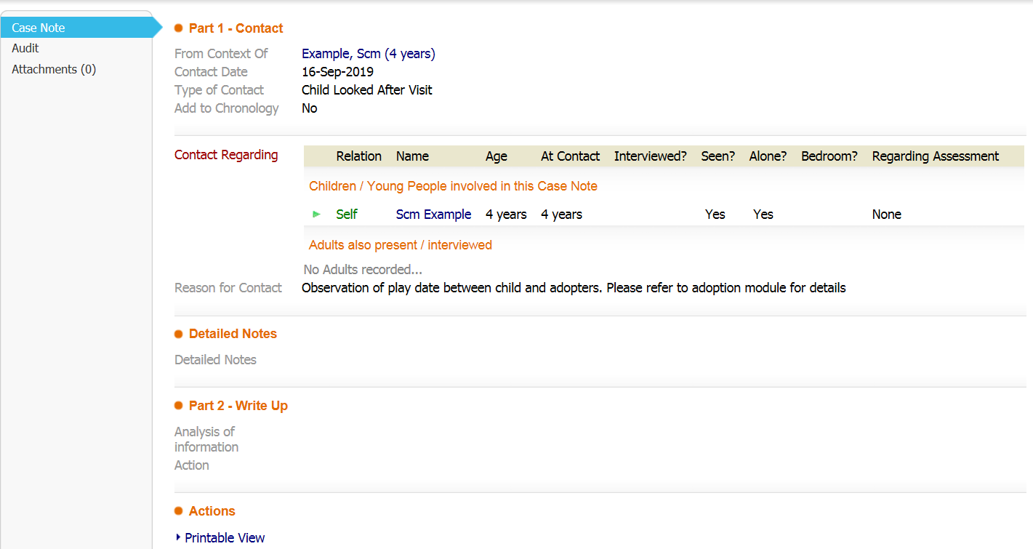

After Matching Panel, including where a child has been placed in their adoptive placement:
- All visits or interactions with the child (by the Social Worker or Family Finder) should be recorded on the Adoption Module. For statutory reporting purposes, a case note must also be added to the child’s main LCS file to reflect that a visit has taken place, but no “detailed notes” should be added other than to signpost the reader to the Adoption Module for further details.
- Where the Social Worker is recording that the child has been moved to their adoptive placement, this should be case noted on the main LCS file (e.g. Billy moved to his adoptive placement) but no further details of this placement should be recorded on the main file. All relevant details then need to be added to the Adoption Module (e.g. observations of Billy during the move, intended follow up visits, communication with adopters etc.).
- Any interaction with the birth family which relates to the child’s adoption journey (e.g. their intention to appeal to Adoption Order) should be recorded on both the main LCS file and the Adoption Module.

Key Principles of recording in Adoption cases:
Please remember:
- No details of adopters (prospective or confirmed) should ever be recorded on the child’s main LCS file. This includes in case notes, forms, or documents.
- No details of prospective adopters should be recorded on the Adoption Module until they are confirmed as a selected match via the Selection Meeting. Any prospective adopters being considered as a match for the child should be referred to only by their initials.
- Where the Family Finder and Social Worker are completing joint visits or observations, a mutual agreement between the two parties will be reached regarding who will write this up. The write up should be agreed between the two parties before being finalised on file.
- If in doubt, please check with an Adoption Team manager before recording anything on either file. The process of removing information incorrectly placed on either file is a lengthy process and can cause delays in progressing the file correctly.

Who does what tasks on Adoption Module Workflow?
Step 1. Create the Adoption Module – Independent Reviewing Officer at the initial CLA review
Step 2. Create the Child’s Permanence Report (CPR) – child’s Social Worker
Step 3. Upload the Adoption Plan decision onto file – Adoption Panel Administrator
After these tasks have been completed, the pathway will proceed to “Family Finding” section. The tasks and person/s responsible are below:
TASK | PERSON RESPONSIBLE
Selection Meeting* | Family Finder/Adoption Manager
Selection Form | Family Finder
Update CP | Child’s Social Worker
Adoption Placement Report (triggered manually from “forms” in Adoption Module) | Family Finder jointly with Child’s Social Worker, Adopters and Adopters’ Social Worker.
Panel Matching Meeting Minutes | Adoption Panel Administrator
Panel Matching Meeting Outcome | Adoption Panel Administrator
Adoption Matching Meeting ADM Decision | Adoption Panel Administrator
Update CPR | Child’s Social Worker
*Actions agreed within the Selections Meetings will always consider whether adopters need to be set up on LCS (this applies to external adopters). If they do, the Family Finder will take responsibility for contacting the ICT Service Desk to request their address be added to the system and then adding the adopters onto LCS. Guidance on this is below:
The system will then progress to “Planning for Placement”. The tasks and person/s responsible are below:
TASK | PERSON RESPONSIBLE
Notify parents of ADM Decision | Adoption Panel Administrator
Notify adopters of ADM Decision | Adoption Panel Administrator
Adoption Placement Plan (triggered manually from “forms” in Adoption Module) | Family Finder and Child’s Social Worker
Placement Planning Meeting** | Family Finder
Introduction Plan** | Family Finder in conjunction with child’s Social Worker, Adopters, Adopter’s Social Worker, Foster Carer.
Placement Planning Review | Family Finder
Adoption Placement Agreement | Child’s Social Worker
Child Placed with Adopters | Child’s Social Worker
**these notes will already be contained within the Adoption Placement Plan and therefore will be saved on Content Server, so the Family Finder can choose to signpost the reader to the document on Content Server to avoid duplication

The system will then progress to “Child Placed”. The tasks and person/s responsible are below:
TASK | PERSON RESPONSIBLE
Child Placed with Prospective Adopters | Child’s Social Worker
Essential Information Record | Child’s Social Worker
Update Care Plan (this will need to be updated to reflect an Adoption Plan for the child) | Child’s Social Worker
Apply for Adoption Order | Child’s Social Worker
Prepare Rule 29 (Annex A) | Child’s Social Worker
Directions Hearing | Child’s Social Worker
Adoption Order Hearing | Child’s Social Worker
Celebration Hearing | Child’s Social Worker
Leaving CLA | Child’s Social Worker

