**Chronologies**

Please see below details of the support and training that is available to all practitioners to ensure that each child’s record has an up to date Chronology which reflects the child’s journey and captures significant events.

A chronology is a clear account of significant events in a child/families life based on the information held by the agencies involved and should be used to identify early indicators of emerging patterns of concern.

* **What are the expectations regarding timescales?**

All children are expected to have a new format chronology started on their files by the 31st August 2020. All children’s records must have a chronology that meets the practice standard by 30th November 2020 - timeframes for achieving this need to be agreed with your team manager/supervising manager.

* **How do I create a chronology on LCS using the new template and how can I transfer the relevant information from the archived template into the new format?**

To start a chronology on a child where no chronology exists or where a chronology has been archived, you go to ’Chronology’ and select ‘Add new Chronology item’, this starts a chronology. If you retrieve an archived chronology it automatically pulls it forward into the new template.

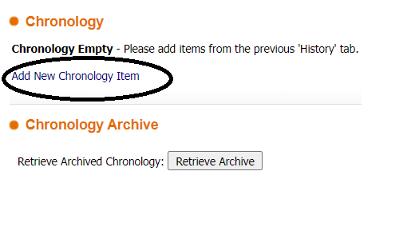

* **Why do the archived chronologies need to be edited to ensure they meet the practice standard?**

Chronologies should only contain details of significant events that enable you to track the child’s journey. They should not detail every interaction with the child or family including phone calls, home visits and emails. Entries that commence ‘contact type’ need to be edited to only include the significant events.

If you are confident that your archived chronology meets the practice standard or it only requires editing/deleting for 10 or less entries, with your managers agreement this can be retrieved and used as the working chronology. A date for editing/deleting must be agreed and added to manager’s oversight.

If the archived chronology needs more than 10 entries to be amended you will need to retrieve, print/save the archived chronology and then archive it again. The saved chronology should be saved to the N Drive not content server. A new chronology will need to be triggered by the 31st August 2020 and the relevant information from archived chronology added

* **What is a significant event?**

A significant even is an event that has had either a positive or negative impact on the child/family well-being. This should include births, deaths, relationships, house/placement moves, schools and an overview of social work interventions and the impact.

* **Can business support assist with ensuring the chronologies are edited and brought up to date?**

Business support colleagues are aware of the challenges that we are facing in ensuring that the practice standard for chronologies is met for all children. In order to assess what support can be offered Team Managers will need to provide an overview of how many chronologies by worker/team and what needs to be done to Clare Brown so that a decision can be made on what support can be offered. Business support can assist in editing and adding agreed entries on to the new chronology template.

* **Is there guidance on creating chronologies?**

Yes there is guidance and examples of good practice available in our local procedures manual via this link – they are stored in the PSW folder. The practice standards can also be found here.

[https://www.proceduresonline.com/buckinghamshire/chservices/local_resources.html](https://eur03.safelinks.protection.outlook.com/?url=https%3A%2F%2Fwww.proceduresonline.com%2Fbuckinghamshire%2Fchservices%2Flocal_resources.html&data=02%7C01%7Csandra.carnall%40buckinghamshire.gov.uk%7Ccd0d3496cada4d88f87d08d832d978ba%7C7fb976b99e2848e180861ddabecf82a0%7C0%7C0%7C637315256893627510&sdata=bxBuSaxwdMXTYwEpl6QH1RIzW%2FKGCFZPoal0coNJFdM%3D&reserved=0)

* **Is there formal chronology training available?**

Yes this can be booked via SAP or if you are an agency worker by contacting the Workforce Development Team mailbox. The next available dates are –

7th October 2020

18th November 2020

10th December 2020

15th March 2021

* **What support is available from the LCS Support Team either to individual practitioners or teams?**

The LCS team can offer individual support to Practitioners to show them how to generate the new chronology template or if there are a number of practitioners from the same team they could attend a team meeting or supervision group session. This can be booked directly by contacting the LCS Support Team mailbox.

* **How will progress be tracked in ensuring the practice standards are consistently applied across the service from September – December 2020?**

The Practice Development Team will be reviewing chronologies through the quality assurance activity planned form September to December 2020. Feedback from these reviews is recorded on the child’s record and an overview of findings is shared with Team Managers, and the Senior Management Team. This highlights good practice and areas for further development.

* **Is there any other support available?**

Yes the Practice Development Team will be able to answer questions about case specific entries.

A number of teams will be joined by students from September 2020 – undertaking chronologies at the start of your placement is a good way to gain insight and understanding of social work processes and procedures and to learn the value of a good chronology.

Some Teams have introduced an admin day each week which have been used to work on creating and updating chronologies.

Sandra Carnall

Principal Social Worker

July 2020