**LBN COVID-19 Guidance**

**A Quick Guide to COVID-19 safe working**

Adeola Agbebiyi & Elizabeth Owen

London Borough of Newham Public Health Team

Enquiries: [PublicHealthEnquiries@Newham.gov.uk](mailto:PublicHealthEnquiries@Newham.gov.uk)

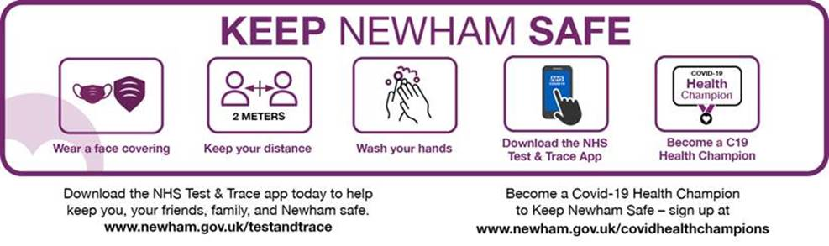

# GOALS of this guide

1. Protect staff from public, colleagues and clients being Covid-19 positive
2. Protect clients, colleagues and pubic from staff being Covid-19 positive
3. Reducing transmission via staff from Covid-19 positive clients to negative and shielded/vulnerable clients or staff.

## **HOW TO STAY SAFE - 7 SIMPLE WAYS**

1. **If you are unwell stay at home stay away from others & get a test**

SYMPTOMS to isolate and test for

* A new continuous cough (3 episodes of coughing in 24 hours)
* or/ and a fever > 37.8C (feel hot to touch on back or chest)
* or loss of or change to sense of smell or taste

**Key tips-**

* Test in the first 5 days of symptoms
* Stay home for at least 10 days
* Don’t go to work, or the shops, the doctor, your friends or school
* Can’t get a test? Isolate for 10 days act as if you have COVID-19

**When can I go back to work?**

After 10 days or 2 days after any fever ends if that is longer than 10 days.

1. **Whether outside or inside stay 2m from people you don’t live with**
2. **If you can’t do this - wear a face covering especially in indoor spaces and keep 1m away from others you don’t live with.**
3. **Where you can, ventilate the room well.**

**WHY?** This virus is spread by droplets of different sizes some form aerosols. When you speak, sing, shout or cough they leave your lungs and mouth they travel around 1-1.5 m and hang around in the air around you for up to 3 hours. People who breathe that in can get infected. If you stay back from people at 2m or more it is much less likely they can infect you. If we all wear a face covering you keep your breath to yourself and everyone else keeps theirs to themselves. We protect each other.

Contact with droplets occurs mainly

* + Within 2m distance and usually 15 or more minutes of contact.
  + Within 1m distance for any length of time around a minute, possibly less.
  + Droplets may be breathed in or also infect a person via the eyes.
  + Coughs and sneezes may travel further than 2m.
    - The most common contact occurs indoors during conversation, eating, drinking etc.
    - In poorly ventilated rooms droplets and aerosol are more likely to persist in the air

Airborne transmission where smaller particles hang in the air happens- it is more likely in poorly ventilated rooms. It is still more likely at close contact less than 1m or 2m.

* Good ventilation is a CO2 level or less than 800 ppm if there is a monitor in the room
* You don’t need a monitor- Keep the windows open, the door open and establish a through current –
  + Don’t - use fans that blow air across people
  + Do - use a fan to blow air out of the window instead
* Air conditioning should be set to 100% clean air intake and turned up

1. **Wash your hands often for 20 seconds with soap and water**

No water? Use Hand sanitiser which must have or 60% alcohol

When to wash hands?

* + When you arrive somewhere
  + Before eating or touching your face
  + Before putting on a face covering or PPE
  + After bathroom breaks
  + When you get home

**WHY?**

Virus can also be picked up by hand contact with surfaces the virus is on-

* 1. If someone coughed or sneezed on an object and then the object is touched by another person.
  2. Virus stays alive on plastics and stainless steel for up to 72 hours and cardboard around 24 hours.

1. **Clean your equipment and your workspace**

Treat all equipment as contaminated and clear before use then clean after use.

Clean surfaces and objects often touched by others

Clean at least 2x a day and between users

Think of your phone as a highly contaminated piece of equipment that needs regular cleaning.

SARS-CoV2 virus is present in sputum, saliva, tears, blood and semen

**What’s effective?**

Detergent, soap

Laundry detergent

Disinfectant with 1000 ppm available chlorine

Alcohol at more than 60%

Heat > 56C

1. **Treat your work clothes and personal items as a possible carriers of bacteria and viruses & don’t become a walking source of infection**

Protect clothes from the environment (e.g. a coat) to limit your clothing picking virus up

Wash each day at 60C (kills all the bugs not just COVID-19)

Clean your phone often.

Follow the above – stay home when not well isolate when asked to and keep your kit and hands clean. Try to arrange your workflow so that vulnerable people are seen before those who may have been exposed.

## **HOW TO GET A TEST**

## **Booking a test:**

**Staff**: For adults call 119 or book online at [NHS site for tests for anyone of any age](https://www.nhs.uk/ask-for-a-coronavirus-test)

Note: Tests can be booked on behalf of others by contacting 119 or online via [NHS portal](https://www.nhs.uk/conditions/coronavirus-covid-19/testing-and-tracing/get-a-test-to-check-if-you-have-coronavirus/). 119 provides translation services although you have to navigate a few questions in English to access this.

**See website—LINK NEEDED**

## **Newham test sites:**

**COVID-19 Walk-up Testing Sites**

1 Hilda Road, (car park at East Ham Care Centre), E6 1DB 8am-8pm, 7 days a week

Outside Beckton Globe (library forecourt) from 7/10/20[E6 5JQ](https://www.bing.com/local?lid=YN1029x104931420&id=YN1029x104931420&q=Beckton+Globe+Library&name=Beckton+Globe+Library&cp=51.51503372192383%7e0.055399101227521896&ppois=51.51503372192383_0.055399101227521896_Beckton+Globe+Library) ·8am-8pm, 7 days a week

Walking/cycling only - No public Transport use. Face coverings necessary.

Booking via 119 or online via [NHS portal](https://www.nhs.uk/conditions/coronavirus-covid-19/testing-and-tracing/get-a-test-to-check-if-you-have-coronavirus/)

**Mobile Testing Unit - As per online schedule**

Xxxxxxxxx E16 1GB

Exact date details are available when you book via 119 or online via [NHS portal](https://www.nhs.uk/conditions/coronavirus-covid-19/testing-and-tracing/get-a-test-to-check-if-you-have-coronavirus/)

Appointment required. Access by vehicle and walking

**Drive throughs @**

Lea Valley Athletics Centre, 61 Meridian Way, Edmonton N9 0AR,

The O2 Greenwich,  [SE10 8FR](https://www.bing.com/local?lid=YN1029x9284735943239368423&id=YN1029x9284735943239368423&q=The+O2&name=The+O2&cp=51.47459030151367%7e-0.019659999758005142&ppois=51.47459030151367_-0.019659999758005142_The+O2)

Newham help and support: Hard to Isolate? Need support?

**COVID-19 Helpline 0207 473 9711** Open 1-7pm, 7 days a week

**WHAT DO I DO? ISOLATION & RESULTS - ADVICE FOR STAFF & FAMILIES**

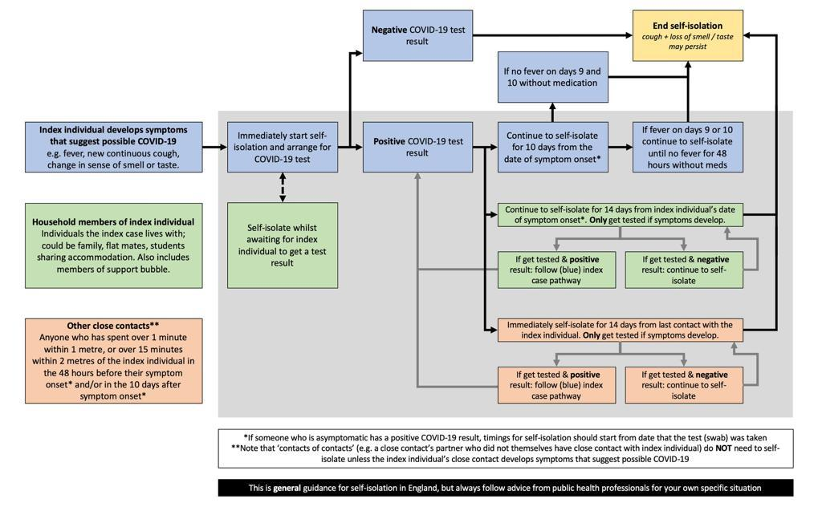

## 

## **FACE COVERINGS**

Face Coverings are mandatory in all indoor spaces with a very few exceptions- (some workplaces, when eating or drinking in a restaurant of bar) and for people below 11 or with medical issues making face coverings difficult. People who need to lips read are also permitted not to wear or have those they are communicating with not wear. Face coverings must be worn by LBN staff for visits to residents houses, in shared vehicles and other indoor spaces not managed by LBN or where indicated by managers.

Face Coverings protect the world from you and work by us all doing this – they should be three ply and washed regularly – at 60C if in highly congested places.

Homemade /cloth coverings have no filtration guarantees and should not be used in work place care and care /health service settings unless specified in the LBN PPE guide.

You must wash your hands /use sanitiser before putting on or taking off, avoid touching when on and always put on at take off by ear loops or head straps.

## **When might I need PPE?**

PPE include medical masks, gloves and aprons. Guidance from PHE and DHSC sets out when and where PPE is used and how PPE will be procured and distributed nationally. This is based on a synthesis of available evidence by the relevant oversight and governing bodies for health and social care.

For prevention of Covid-19, PPE is required for staff who are:

* + providing close personal care (<2 metre) with or without symptoms (gloves, apron, fluid repellent surgical mask (IIR) +/-eye protection – risk assess splashing),
  + Cleaning an area where a person with symptoms has recently been (gloves, apron, fluid repellent surgical mask (IIR) +/-eye protection – risk assess splashing),
  + Entering a closed, poorly ventilated area with one or more possibly symptomatic people (at any distance) (apron, FRSM /IIR) +/-eye protection – risk assess spitting/splashing).

Teams carrying out assessments and home visits should use the decision support flow diagrams and risk assessment principles above to explore the possibility of:

* alternatives to a face to face encounter or visit,
* delayed visit or meeting (until after infection risk has passed 14 days from symptoms onset or test result), or
* Using an outdoor or alternate location with better ventilation with social distancing of **2m** and handwashing.

The majority of LBN staff do not need to use PPE for protection against Covid-19, and/or Covid-19 spread.

Use the decision aid and risk assessment tools to:

* seek an alternative to a face to face service delivery,
* seek a deferred date of 14 days in the same location
* Explore a location with reduced risk or exposure- (open air/well ventilated/space to distance), or
* Check you have the correct PPE for the task.

PPE is intended to be single use except for Eye protection and face masks which are sessional

Also eye protection may be cleaned (detergent followed by disinfectant) and reused. Follow manufacturer’s guidance for details.

### Do I need Eye protection? Risk assessment for eye protection

Needed if:

* There a risk of splashing with infected fluids,
* The client cannot observe respiratory hygiene (‘catch it, bin it, kill it’) with coughs and sneezes,
* There is a risk of spitting, or
* There are multiple people with Covid-19 in a closed space.
* In some cases with good ventilation or outdoors, a face visor can be used alone at 1m or more where social distancing is not possible

**Problems with PPE**

PPE can give a false sense of security and reduce good practice for standard infection prevention and control in both user and public. PPE, if not put on and taken off correctly, can result in contamination of the face and hands especially and this can cause infection in the worker and cross infection for vulnerable clients.

Use the guidance: [Quick guide donning and doffing.](https://assets.publishing.service.gov.uk/government/uploads/system/uploads/attachment_data/file/877658/Quick_guide_to_donning_doffing_standard_PPE_health_and_social_care_poster__.pdf) And [video](https://youtu.be/j3hfEpjAx0E) Please note the distance for the infection zone should now be 2m.

Use the guidance on [best practice hand washing](https://assets.publishing.service.gov.uk/government/uploads/system/uploads/attachment_data/file/877530/Best_Practice_hand_wash.pdf) and videos

Use the guidance on laundry and cleaning Inc. ordering a deep clean in LBN

**What PPE does my task need?**

See document - **PPE by task and type**, adapted from the following latest guidance.

DECISION AID – Screening for COVID risk. Should I visit? Should I wear PPE?

NO

NO

No visit required, **no PPE required**

NO

Box 1

Does the client or household have:

* Any symptoms of COVID-19 e.g. new cough fever, change to smell/taste within 14 days in the house?
* A confirmed test diagnosis within 14 days
* A request from NHS Test and Trace to self-isolate for 14 days.
* Any travel from a country needing 10 or 14 day isolation

Continue with visit as normal, face covering 3 ply **mask** only

**Ask resident to open windows in advance**

Does the visit involve entering the house or close personal contact with the client< 2m?

Or care or repair > 15 minutes, or contact with bodily fluids or client unable to distance or observe respiratory hygiene?

Is visit in a closed unventilated space? E.g. no windows.

YES

YES or DON’T KNOW

**Full PPE required**

Use apron, gloves, fluid repellent surgical mask IIR unless AGP.

Use eye protection if risk of splashing, sneezing, spitting, coughing or prolonged close contact <2m.

Mask and Eye protection may be used for 4-5 hours. Apron and gloves should be changed between each personal care encounter.

*See guidance for safe disposal of PPE* See guidance for donning and doffing PPE +*

Is the visit essential?

For a house – Request pre ventilation by opening a window for at least 30 minutes within an hour of visit time.

To enter **use a simple mask/IIR maintain distance of 2m**.

Wash hands on exit

Hand hygiene and Laundry

***.\**** *See guidance for laundry, cleaning, rubbish disposal*

NO

Can the visit be carried out online or by phone?

YES

Conduct visit by phone/online, **no PPE required**

YES