**Initial Health Assessment for children coming in to care:**

**When a child/young person is received into care an Initial Health Assessment must take place WITHIN 20 DAYS from placement**. The IHA should result in a Health Plan which is available in time for the first statutory review by the IRO which must take place within 20 days of starting to be looked after (Promoting the Health and Wellbeing of Looked After Children, Statutory Guidance March 2015 ref 41)

**Prepare paperwork pack as soon as you are aware of a child may or has come in care.**

All paperwork packs can be found in:

Business Services\Children Services\Children In Care Health Paperwork\IHA,RHA Templates

**(Enter you own location details)**

**8 years and under forms * Over 8 year forms:**

**\*Derbyshire Medical Consent x 2**– To be completed by Social Worker with parent/s

(Upload under Looked after and medical consent – 1 copy is for Originals filing, 1 copy is for the carer)

\***Derbyshire Placement Agreement x 2** – To be completed by Social Worker with parent/s

(Upload under Looked after and placement agreement – 1 copy is for Originals filing, 1 copy is for the carer)

**\*New IHA Part A and consents** – To be completed by Business Services as much as possible and then given to Social Worker for completion with parent/s – **DO NOT PUT IN THE FOSTER CARERS DETAILS AT THIS POINT ADD ONCE RETURNED FROM SOCIAL WORKER**

(Only Upload consent parts - under Looked after and medical consent)

**\*BAAF PH Form** - To be completed by the Social Worker with parent/s (1 x for each parent)

(Upload each form (individually) under Health and health summary)

**BAAF Form M** – To be sent to the hospital where the child was born along with covering letter (If sending to Queens Hospital Burton on Trent then a GC1 form will also be required stating code 1.1 costing £51.27)

(Upload when completed and returned under Health and health summary)

**BAAF Form B** - To be sent to the hospital where the child was born along with covering letter (If sending to Queens Hospital Burton on Trent then a GC1 form will also be required stating code 1.2 costing £51.27)

(Upload when completed and returned under Health and health summary)

**Blood Bourne Infection Consent** - To be completed by the Social Worker with parent/s – only if required

(Upload under Consents and medical consent)

**SDQ Form** – Main Carer all children 4 years and over up to 17 years and a Young persons if 11 years and over up to 17 years and school SDQ

(Upload into the SDQ Scoring workflow step under Looked after and SDQ)

Book IHA appointment within three days of placement - contact must be made with the Derbyshire CIC Health Team on 01246 512524/512245 to arrange IHA. (Contacts for Initials are Gill Kerry and Lynn Massey) The above numbers are also used to obtain a child’s NHS number. Or on completion of the paperwork send to: [CRHFT.cichealthteam@nhs.net](mailto:CRHFT.cichealthteam@nhs.net) who will then send onto Commissioning and out of County authority where the child is placed. **Any incorrect paperwork will be sent back/cancelled IHAs means £450 in charges. REMINDER: IHA form has to be sent as a word document. Forward on the BAAF forms M and B once they are returned from the hospital.**

Once the IHA is booked or you know the date of the assessment (Derbyshire placements) add the date to Mosaic in Health Assessments and that you have sent the paperwork has been forwarded to health.

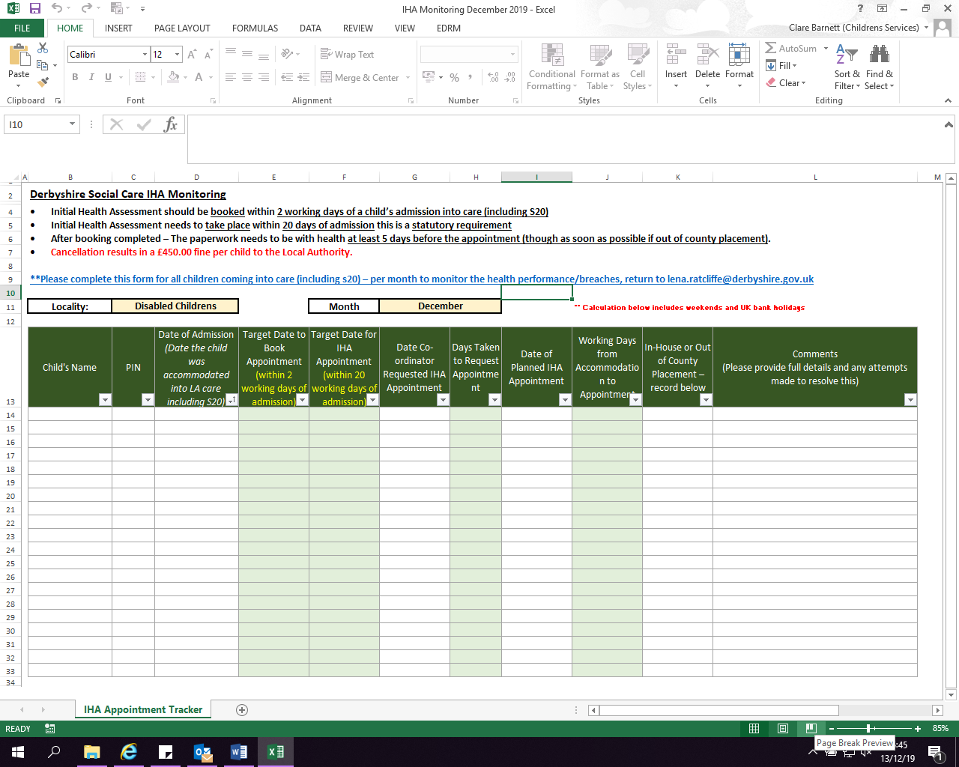All the way through the below spreadsheet must be updated:

* Paperwork to be sent to health for the appointment:

1. Consent form 1 – Scanned version - Page 2
2. Consent form 2 – Scanned version – Page 3
3. Part A – Word version – Pages 4 & 5 - Separate document
4. Part B & C – Word version – Separate document
5. Form P H Mother – Scanned version – Pages 6,7,8 & 9 - Separate document
6. Form P H Father – Scanned version - Pages 10,11, 12 & 13 - Separate document
7. Derbyshire Medical Consent – Scanned version - Separate document
8. If 0 – 8 years Form M – Scanned version (If returned before appointment, if not forward to health as soon as received) – Separate document
9. If 0 – 8 years Form B – Scanned Version (If returned before appointment, if not forward to health as soon as received) – Separate document

Health require one email with all the above documents attached in the said formats to enable them to action them accordingly. This will mean that they will need to be processed in the same way as they were before on return from the operational worker.

* IMPORTANT: When a child moves placement and paperwork has been submitted for health assessment localities MUST send updated Part A paperwork to health to reflect this change otherwise this can result in delays and it has been known that health workers have visited placements only to find the child has moved on.
* Once the Health assessment is completed, Part C will be emailed back to DCC, upload onto Mosaic, enter date the IHA took place under Health Data, Health Assessments and enter the next date which will be the review, and this will also trigger one the reporting system. Under 5 years is every 6 months and over 5 years is annually. A copy of the Health recommendations from the Part C should also be posted out to the Foster Carer.

**Extract all information from the returned Part C:**

**Dental** – check to see if registered with a dentist add organisation relationship and update Mosaic with date of last visit in Health/Dental Visits. Under 1 years does not need to be recorded, however if there is a date still enter this. Needs to be recorded every 6 months, if the dentist has suggested next appointment in 1 year then record two appointments 6 months apart.

**Optical** - check to see if registered with an optician add organisation relationship and update Mosaic with date of last visit in Health/Developmental Assessments/Optical. Needs to be recorded every year again if optician suggests 2 yearly then record an appointment annually.

**Immunisations** – If the Part C states that the child is fully up to date with their immunisations then update Mosaic with this in Health/Immunisations by adding an Administrative Check. If a list of immunisations have also been sent then these need to be uploaded as Health/Immunisation Data. Need to be recorded annually.

**GP** – if there is a GP then add this to the child’s front screen on Mosaic.

Ensure that the spreadsheet is updated:

Business Services\Children Services\Children In Care Health Paperwork/CIC Medical Spreadsheet Current

**(Enter you own location details)**

If the child is known to have a Substance misuse issue then this needs to be recorded onto Mosaic also by Health/Condition/Substance Misuse.